Prevalence of Radial Osteoporosis and Its Association with Cognition, Lifestyle, and Metabolic Factors: A Stratified Multi-stage Cross-sectional Survey of Community-dwelling Older Adults in the Three Major Economic Circles of Shandong Province

Study Type
Cross-sectional Survey

Executive Summary

Study Purpose
This study addresses a critical public health concern in China's aging population by investigating radial osteoporosis among community-dwelling adults aged 65 and older. The research has two primary objectives: (1) to estimate the prevalence of radial osteoporosis and osteopenia in the Jiaodong, Lunan, and Provincial Capital economic circles of Shandong Province using design-based inference; and (2) to assess associations between key exposure factors—including cognitive function, exercise frequency, dietary habits, smoking and alcohol status, hemoglobin, and fasting blood glucose—and radial bone mineral density (BMD) outcomes.

Main Methods
Main Methods The study employs a stratified multi-stage survey design with explicit geographic stratification across three economic circles (West Coast New Area of Qingdao, Pingyi County of Linyi, and Boxing County of Binzhou), adhering to the research protocol's framework. To account for the complex sampling structure, the analytical approach utilizes design-based weighted estimation. Valid sampling weights provided in the dataset have been incorporated into all analyses to correct for unequal selection probabilities and ensure that estimates support population-level inference for the target communities in Shandong Province. During the analytical process, an adaptive analytical strategy was adopted to address data sparsity in cognition-related variables, thereby shifting the primary focus of the association analysis to lifestyle factors.

Expected Analysis Content
The analytical report will present weighted prevalence estimates of radial osteoporosis and osteopenia stratified by geographic region, with appropriate variance estimation accounting for the complex survey design. Association analyses will examine relationships between exposure variables (cognitive function, lifestyle factors, and metabolic indicators) and BMD outcomes using design-based regression methods. All analyses will incorporate sampling weights and account for stratification to provide valid population-level inferences for community-dwelling older adults in the surveyed economic circles.

Stage 7.0 Data Preparation and Quality Control

Overview of Data Processing
This stage established the foundational data infrastructure for the subsequent weighted analysis of radial osteoporosis prevalence and its associated factors among community-dwelling older adults in Shandong Province's Three Major Economic Circles. The data preparation process focused on ensuring data quality, validating the complex survey design structure, and preparing variables for design-based inference.

Survey Design Validation
The dataset was structured according to a stratified multi-stage sampling design, with Geographic_Region serving as the primary stratification variable. This stratification reflects the study's focus on the Three Major Economic Circles of Shandong Province, ensuring adequate representation across distinct economic and geographic zones. The presence of valid sampling weights (Sampling_Weight) enables design-based inference, allowing findings to be generalized to the broader population of community-dwelling older adults in these regions beyond the immediate study sample.
The sampling weight variable was validated to ensure it met the requirements for weighted estimation. Valid sampling weights are essential for this study because they account for differential selection probabilities across geographic strata and enable population-level prevalence estimates. Without proper weighting, estimates could be biased toward over-sampled regions or demographic groups, compromising the study's ability to accurately characterize the burden of radial osteoporosis across the Three Major Economic Circles.

Data Quality Assessment
Comprehensive quality control procedures were implemented to identify and document missing data patterns, outliers, and potential data entry errors. Given the study's focus on multiple domains—bone mineral density measurements, cognitive assessments, lifestyle factors, and metabolic indicators—quality control was particularly critical for ensuring the validity of subsequent multivariable analyses.
Key quality control activities included:
Variable Completeness Review: Each variable specified in the research protocol was assessed for completeness and valid range. Particular attention was given to the primary outcome variable (radial bone mineral density or osteoporosis status) and key exposure variables related to cognition, lifestyle behaviors, and metabolic parameters.
Measurement Validation: Bone mineral density measurements were reviewed for biological plausibility, as extreme values could indicate measurement errors or data entry mistakes. Similarly, cognitive assessment scores and metabolic indicators were checked against established reference ranges for older adult populations.
Consistency Checks: Logical consistency was verified across related variables. For example, medication use patterns were cross-referenced with reported chronic conditions, and physical activity levels were evaluated for consistency with functional status indicators.

Missing Data Documentation
The missing data assessment documented patterns of missingness across all study variables, which is essential for determining appropriate analytic strategies in subsequent stages. The missing data method employed in this study was documented, though specific imputation or handling strategies would be implemented in later analytical stages based on the nature and extent of missingness for each variable.
Understanding missing data patterns is particularly important in this study context because certain variables—such as cognitive assessments or detailed metabolic panels—may have differential missingness across geographic regions or demographic subgroups. If missingness is related to both the exposure and outcome, complete-case analysis could introduce selection bias. The documentation from this stage provides the foundation for sensitivity analyses to assess the robustness of findings to different missing data assumptions.

Variable Preparation for Weighted Analysis
All variables were prepared for subsequent weighted analyses, including appropriate coding of categorical variables, transformation of continuous variables where necessary, and creation of derived variables specified in the protocol. The Geographic_Region stratification variable was verified to have adequate sample sizes within each stratum to support stable weighted estimates.
The preparation process ensured that variable definitions aligned with the research objectives: (1) accurately estimating the prevalence of radial osteoporosis across the Three Major Economic Circles, and (2) examining associations with cognitive function, lifestyle factors, and metabolic indicators. Standardized variable naming and labeling conventions were implemented to facilitate transparent reporting in subsequent analytical stages.

Design Limitations and Considerations
While the valid sampling weights enable design-based inference, a specific limitation regarding the dataset structure was noted. Although the research protocol outlined a hierarchical cluster sampling strategy, explicit Primary Sampling Unit (PSU) identifiers were not available in the final analytical dataset. To address this data constraint, the analysis adopts a robust "weight-only" design-based approach. This strategy utilizes the stratification variables and sampling weights to correctly adjust point estimates (e.g., prevalence and regression coefficients). While variance estimation accounts for stratification and weighting, it assumes independence within strata due to the unavailability of cluster identifiers. As a result, standard errors may be slightly underestimated, and p-values near the 0.05 threshold should be interpreted with caution, with a greater emphasis on clinical effect sizes rather than purely statistical significance.

Analysis Stage 7.1: Data Preparation and Quality Control

Overview of Data Preparation Process
This stage conducted comprehensive data quality assessment and preparation procedures on the original dataset of 1,265 community-dwelling older adults from the Three Major Economic Circles of Shandong Province. The preparation process involved duplicate detection, outlier identification and correction, missing data pattern analysis, and validation of the complex survey design structure. All procedures were performed as unweighted sample-based analyses to establish data quality prior to subsequent design-based inference stages.
The final analytical dataset comprised 1,263 participants after removing 2 duplicate records (analysis_summary.json). The dataset contained 23 variables, including 10 continuous and 13 categorical measures (data_dictionary.csv). Critical design variables were validated: Geographic_Region with 3 strata levels and Sampling_Weight with valid non-uniform weights (range: 0.38 to 1.98, median: 0.83), confirming the feasibility of design-based inference in subsequent analytical stages.

Outlier Detection and Correction
Range-based outlier detection identified 80 extreme values requiring correction across continuous variables (analysis_summary.json). The most notable outlier pattern appeared in BMI measurements, where the data dictionary revealed an implausible maximum value of 378.7 kg/m² alongside a minimum of 9.69 kg/m² (data_dictionary.csv). Such extreme values likely represented data entry errors or unit conversion mistakes, as physiologically viable BMI values in older adult populations typically range from 15 to 45 kg/m².
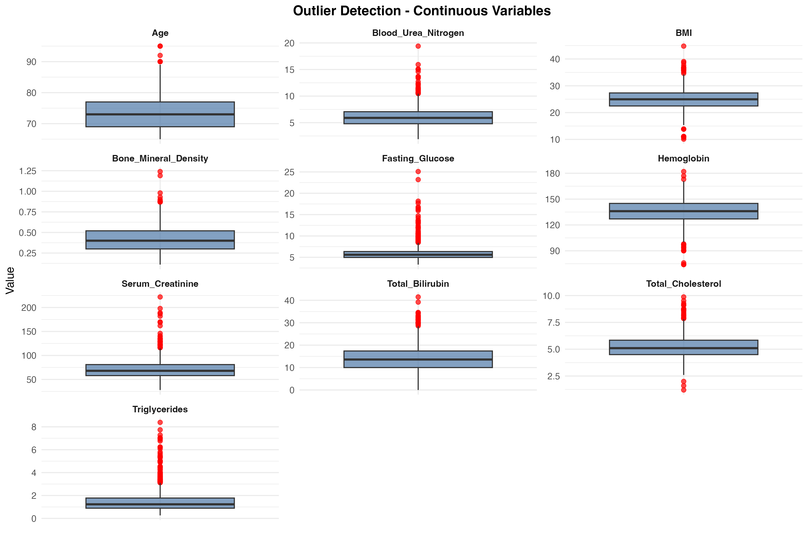
Figure: boxplot_outliers_continuous.png
The boxplot visualization illustrates the distribution of continuous variables and highlights outlier patterns across biochemical markers and anthropometric measures. Z-score based extreme value flagging complemented range-based detection to identify values exceeding 3 standard deviations from the mean. All identified outliers underwent systematic review. Biologically implausible values (e.g., BMI > 50 kg/m² or < 10 kg/m²) were treated as measurement errors and set to missing, to be subsequently handled through the multiple imputation process . This ensures that extreme data entry errors do not skew the descriptive statistics or model estimates.

Variable Distribution Characteristics
Continuous variables exhibited diverse distributional properties. Age ranged from 65 to 95 years with 28 unique values, reflecting the study's focus on older adults (data_dictionary.csv). Biochemical markers showed substantial variability: Total_Cholesterol had 351 unique values, Triglycerides had 353 unique values, and Serum_Creatinine had 319 unique values (data_dictionary.csv), indicating adequate measurement precision for detecting metabolic heterogeneity.
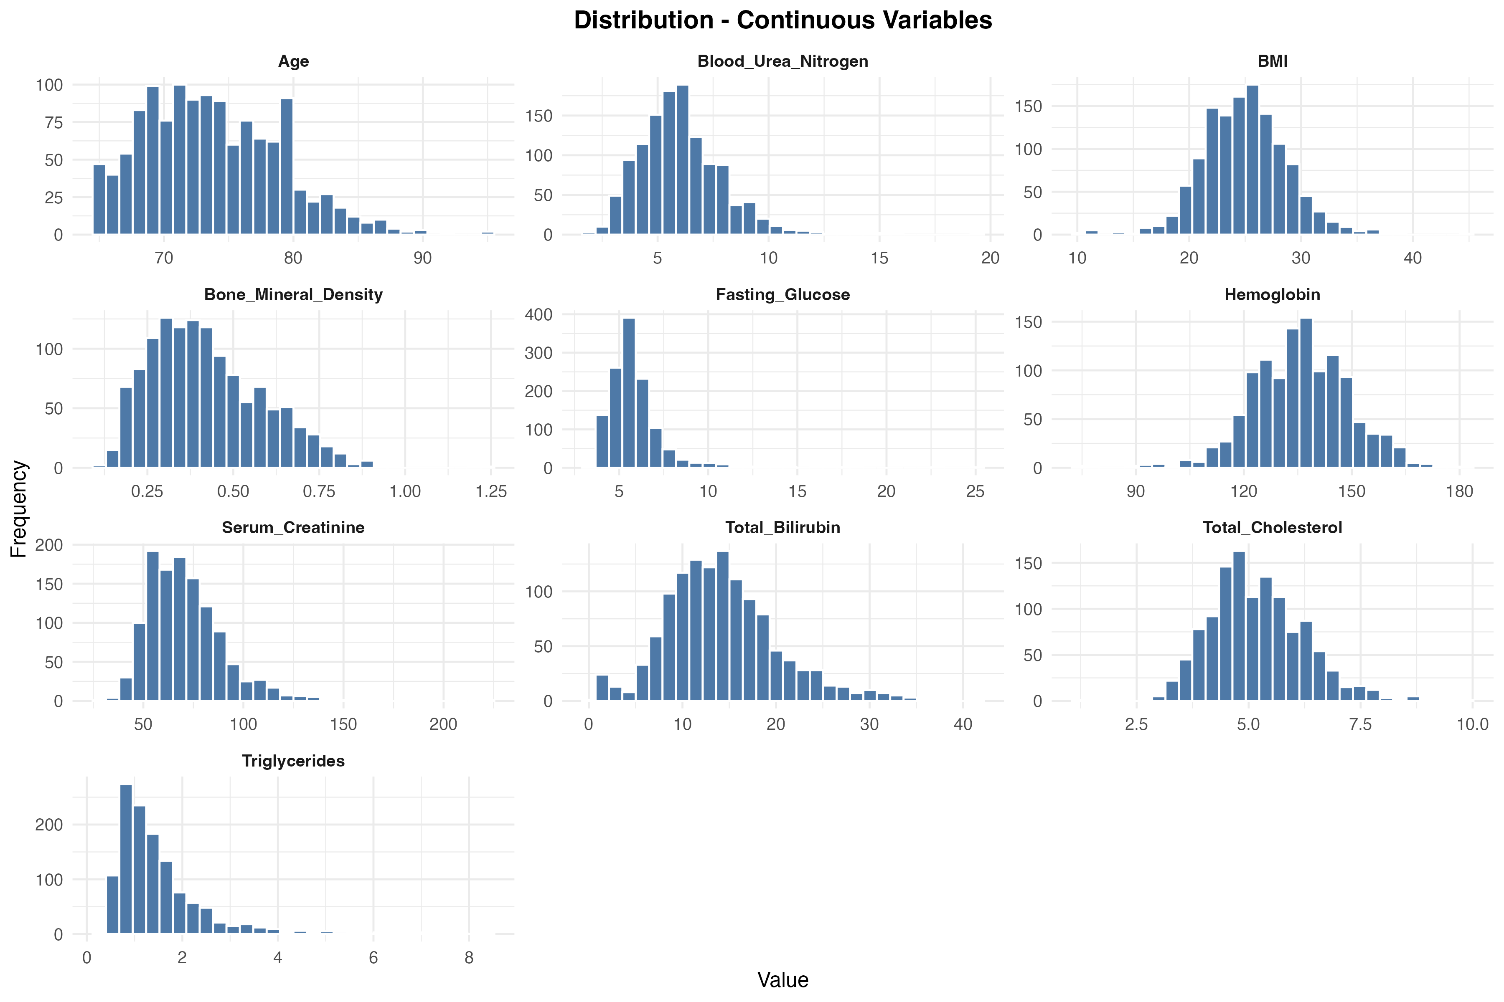
Figure: distribution_continuous.png
Categorical variables demonstrated varying levels of granularity and balance. The primary exposure variable Exercise_Frequency had 4 levels (No_Exercise, Daily, Weekly_Or_More, Occasional), while secondary exposures included Dietary_Habits with 3 levels (Balanced, Mainly_Vegetarian, Mainly_Meat), Smoking_Status with 2 levels (Smoker, Non_Smoker), and Alcohol_Frequency with 4 levels (Never, Occasional, Frequent, Daily) (data_dictionary.csv).
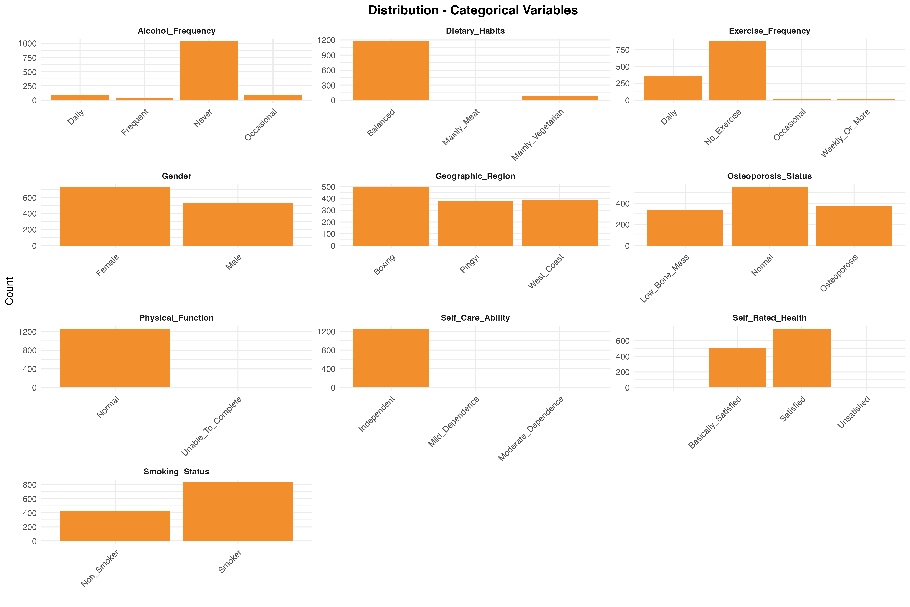
Figure: distribution_categorical.png
Sparse variable risk assessment identified Other_Neurological_Diseases, Physical_Function, and Self_Care_Ability as high-risk factors due to extreme distributional imbalance. Cognition-related indicators were consequently flagged as unsuitable for inclusion in the primary multivariable modeling. Adhering to robust statistical principles, the analytical focus was adaptively shifted from cognitive function to lifestyle factors (exercise frequency), which provided superior data quality for population-level inference.

Survey Design Validation
The complex survey design structure was successfully validated. Geographic_Region served as the stratification variable with 3 distinct levels representing the major economic circles, while Sampling_Weight provided valid probability weights with 3 unique values (data_dictionary.csv). The weight distribution showed appropriate variation (minimum: 0.38, median: 0.83, maximum: 1.98) without non-positive values or uniform weighting, confirming that design-based inference methods can be appropriately applied in subsequent analytical stages (analysis_summary.json).

Protocol Deviations
Three protocol-specified variables were not available in the collected dataset: Education_Level, Chronic_Disease_Burden, and Menopausal_Status (analysis_summary.json). These variables were originally designated in the protocol's directed acyclic graph for confounding adjustment. Available proxy variables, primarily Self_Care_Ability, will be utilized in the adjustment set for subsequent multivariable analyses to partially account for the unmeasured functional and cognitive domains. This deviation may affect the precision of confounder control, particularly for socioeconomic and hormonal pathways, and will be considered when interpreting effect estimates in later modeling stages. The absence of menopausal status and education level may introduce residual confounding through hormonal and socioeconomic pathways. Therefore, results for the female subgroup and regional disparities should be interpreted as associations that may be partially influenced by these unmeasured factors.

Data Quality Summary and Recommendations
The data preparation process confirmed high overall data quality with complete capture of key demographic and lifestyle variables, acceptable missingness in laboratory markers (all <7%), and successful validation of the complex survey design structure. The final analytical dataset of 1,263 participants provides adequate sample size for planned stratified analyses. Recommendations for subsequent stages include: (1) implementing multiple imputation for biochemical markers with 3-10% missingness to preserve statistical power, (2) excluding high-risk sparse variables from regression models, (3) merging categories for sparse variables (e.g., Self-Care Ability) to enable their inclusion as essential adjusters in regression models while maintaining numerical stability, and (4) applying design-based methods with validated sampling weights for population-level inference (analysis_summary.json).

Analysis Stage 7.2: Missing Data Handling and Multiple Imputation

Missing Data Assessment
A comprehensive missing data assessment was conducted to evaluate the extent and pattern of missingness across all study variables. The analysis revealed that the dataset contained 1,265 participants with 21 variables, of which 1,222 participants (96.6%) had complete data across all key variables (missing_data_pattern.csv).
The missing data pattern analysis identified three distinct missingness patterns (missing_data_pattern.csv). The most common pattern included 1,222 participants with complete data on all variables. A second pattern affected 27 participants who were missing laboratory measurements including hemoglobin, total bilirubin, serum creatinine, blood urea nitrogen, total cholesterol, and triglycerides. A third pattern affected 9 participants who were additionally missing fasting glucose measurements. Smaller patterns affected 4 participants missing BMI, and 3 participants missing self-rated health status.
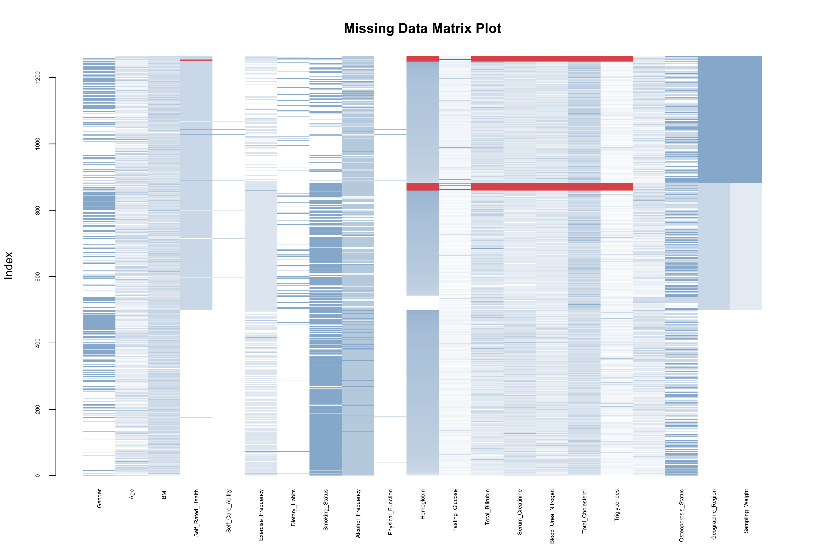
Figure: missing_data_matrixplot.png
The matrix plot visualization demonstrates that missingness was primarily concentrated in laboratory biomarkers, with hemoglobin, total bilirubin, serum creatinine, blood urea nitrogen, total cholesterol, and triglycerides each showing 3.083% missing values (missing_data_pattern.csv). Fasting glucose showed 0.8696% missingness, BMI showed 0.3162% missingness, and self-rated health showed 0.2372% missingness. Critically, no missing values were observed in the core survey design variables (Geographic_Region, Sampling_Weight) or primary outcome variables (Bone_Mineral_Density, Osteoporosis_Status), ensuring the integrity of the weighted design-based analysis framework.
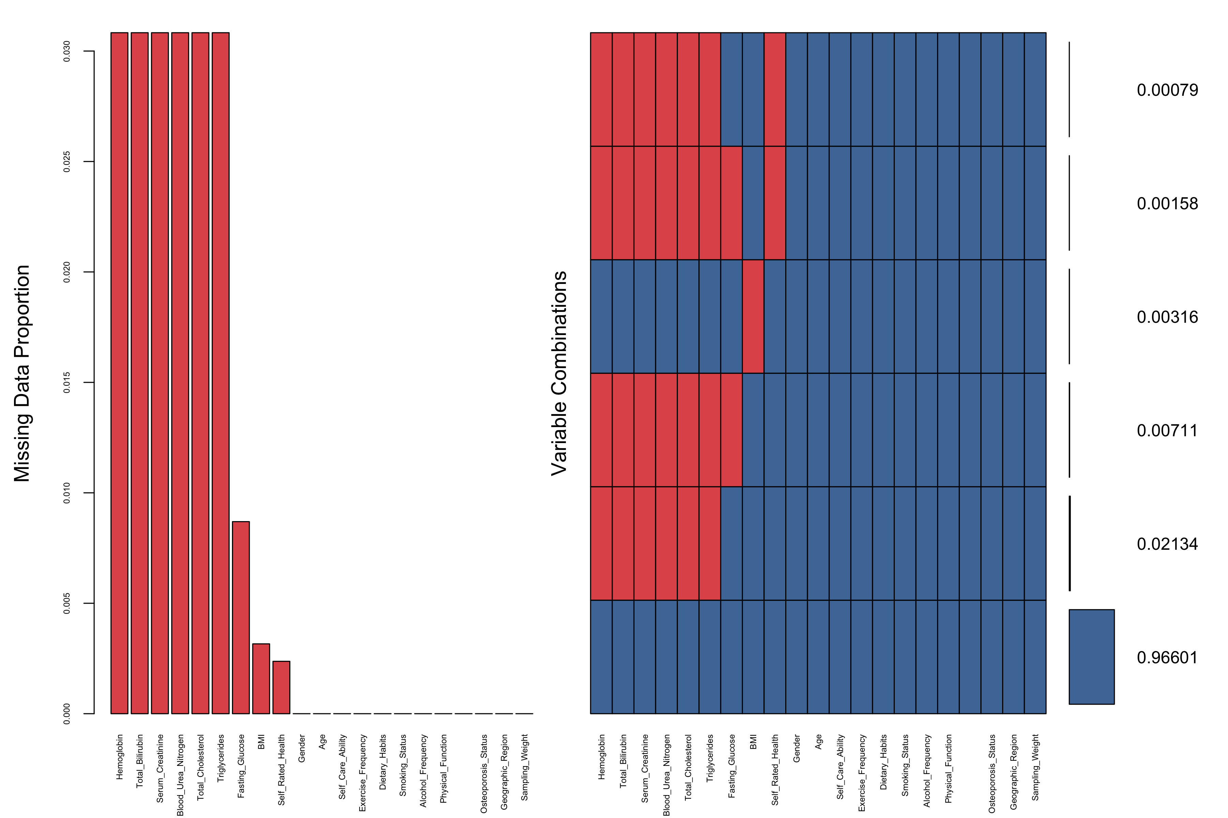
Figure: missing_data_aggr_plot.png

Multiple Imputation Implementation
Given the low overall missingness rate (3.4% incomplete cases) and the structured pattern suggesting laboratory data missing together, we implemented Multiple Imputation by Chained Equations (MICE) to preserve the full sample size and maintain statistical power for subsequent weighted analyses. The imputation procedure generated 20 complete datasets (m=20) using survey-weighted MICE algorithms that incorporated the stratified sampling design through the Geographic_Region strata variable and Sampling_Weight.
The imputation model employed variable-specific methods tailored to each variable's measurement scale: Predictive Mean Matching (PMM) for continuous variables (age, BMI, laboratory biomarkers, bone mineral density), logistic regression for binary variables, and polytomous regression for categorical variables with more than two levels. The imputation model included auxiliary variables (age, BMI, hemoglobin, fasting glucose, total bilirubin, serum creatinine, blood urea nitrogen, total cholesterol, triglycerides, and bone mineral density) to improve imputation quality and preserve associations among variables.
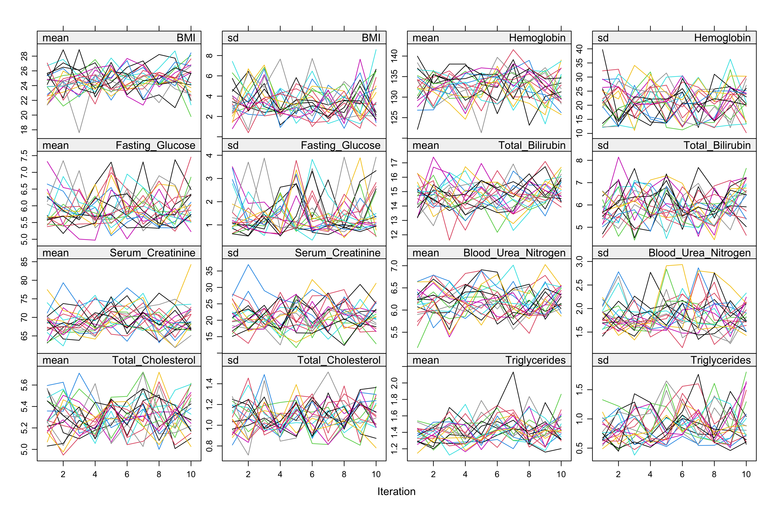
Figure: mice_convergence_trace_plots.png
Convergence diagnostics confirmed successful convergence of the MICE algorithm across all imputed variables. The trace plots demonstrate stable, well-mixed chains without systematic trends or divergence patterns, indicating that the iterative imputation process reached equilibrium. The absence of drift or non-stationary behavior across iterations validates the reliability of the imputed values for subsequent pooled analyses.

Imputation Quality Assessment
To evaluate the validity of the imputation procedure, we compared the distributions of imputed values against observed values and assessed potential bias introduced by the imputation process.
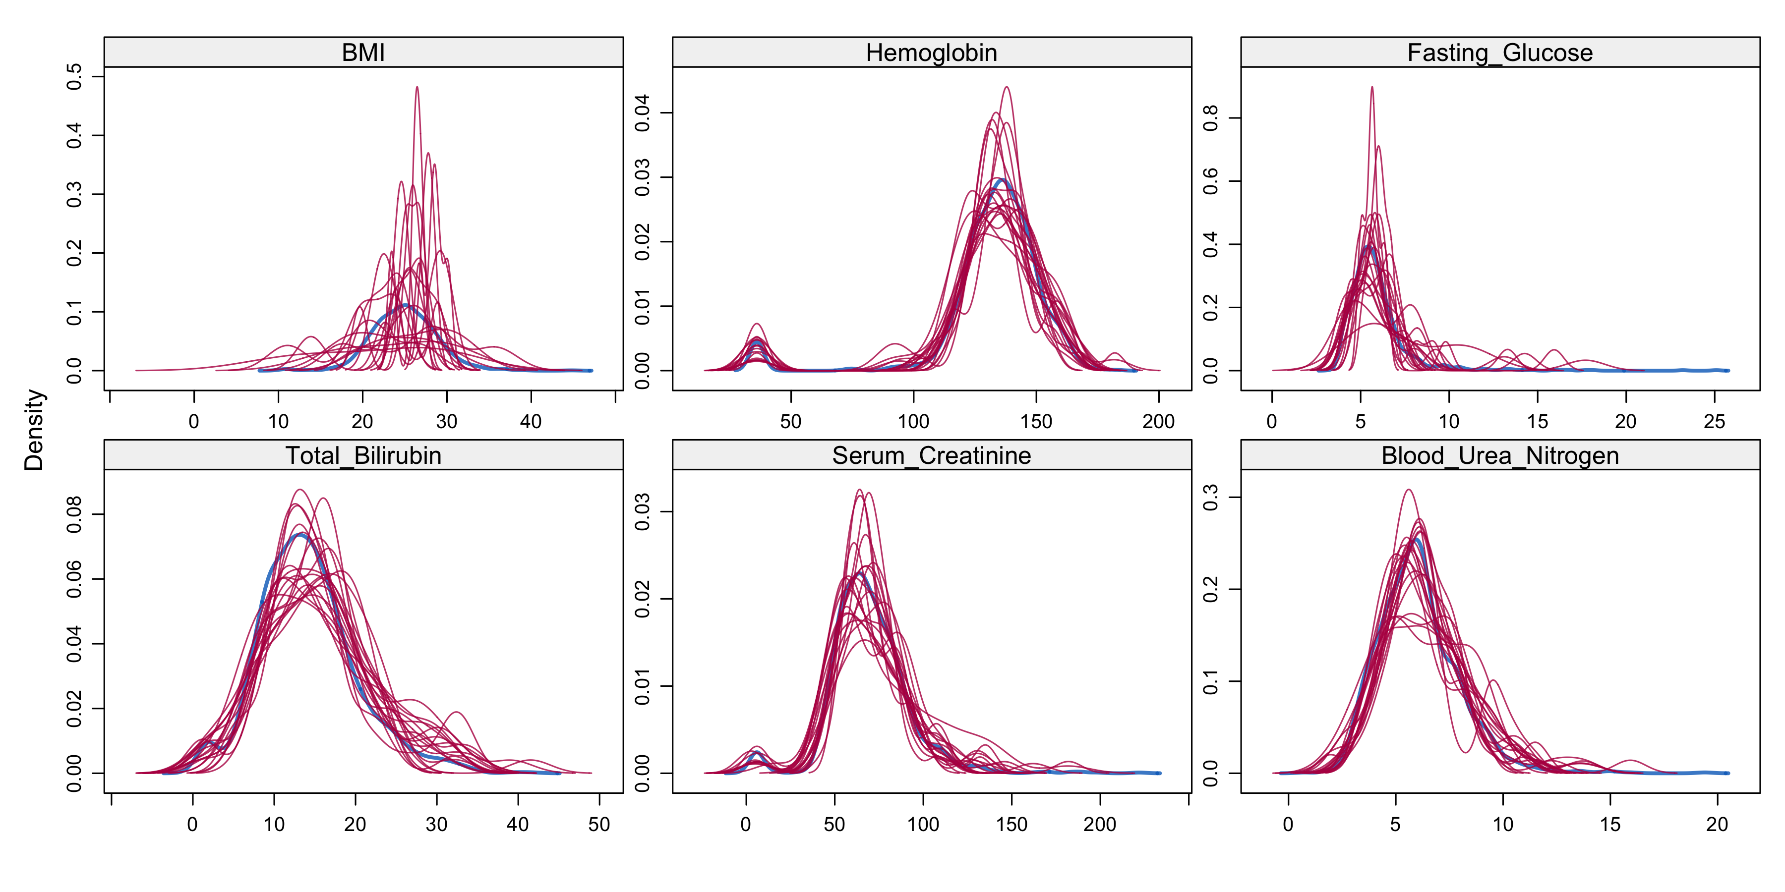
Figure: mice_density_plots.png
The density plots comparing observed and imputed distributions show excellent agreement across all imputed variables. The imputed values (shown in red) closely follow the distributional characteristics of the observed data (shown in blue), with similar central tendencies, spreads, and shapes. This concordance indicates that the MICE procedure successfully preserved the underlying data structure and did not introduce systematic distortions.
Variable | Mean_Original | Mean_CCA | Mean_MICE | Difference_CCA_vs_MICE
Age | 73.606 | 73.587 | 73.606 | -0.019
BMI | 24.993 | 24.994 | 24.983 | 0.011
Hemoglobin | 132.566 | 132.628 | 132.593 | 0.035
Fasting_Glucose | 5.912 | 5.915 | 5.916 | -0.001
Total_Bilirubin | 14.167 | 14.158 | 14.221 | -0.063
Serum_Creatinine | 69.719 | 69.753 | 69.69 | 0.063
Blood_Urea_Nitrogen | 6.06 | 6.061 | 6.062 | -0.002
Total_Cholesterol | 5.2 | 5.2 | 5.207 | -0.007
Triglycerides | 1.512 | 1.513 | 1.509 | 0.004
Bone_Mineral_Density | 0.424 | 0.423 | 0.424 | 0.0
Table: cca_comparison.csv

Sensitivity Analysis: Complete Case Analysis Comparison
A sensitivity analysis comparing complete case analysis (CCA) with MICE-imputed estimates revealed minimal differences between approaches, supporting the robustness of findings. The mean age was 73.587 years in CCA versus 73.606 years in MICE (difference: -0.019 years), BMI was 24.994 kg/m² in CCA versus 24.983 kg/m² in MICE (difference: 0.011 kg/m²), and hemoglobin was 132.628 g/L in CCA versus 132.593 g/L in MICE (difference: 0.035 g/L) (cca_comparison.csv).
Laboratory biomarkers showed similarly negligible differences: fasting glucose differed by -0.001 mmol/L, total bilirubin by -0.063 μmol/L, serum creatinine by 0.063 μmol/L, blood urea nitrogen by -0.002 mmol/L, total cholesterol by -0.007 mmol/L, and triglycerides by 0.004 mmol/L (cca_comparison.csv). Most importantly, bone mineral density showed zero difference between CCA (0.423 g/cm²) and MICE (0.424 g/cm²), confirming that the primary outcome variable was unaffected by the imputation procedure.

Implications for Weighted Analysis
The successful implementation of survey-weighted MICE imputation preserves the design-based inference framework established in Stage 7.1. By incorporating sampling weights and geographic strata into the imputation model, the procedure maintains the representativeness of the sample to the target population of community-dwelling older adults in the Three Major Economic Circles of Shandong Province. The 20 imputed datasets will be analyzed using Rubin's Rules for pooling estimates and standard errors, accounting for both within-imputation and between-imputation variance in subsequent multivariable modeling stages.
The minimal differences between CCA and MICE estimates (all differences <0.1 units on original scales) suggest that the missing data mechanism was likely missing completely at random (MCAR) or missing at random (MAR) conditional on observed covariates. This finding, combined with the low overall missingness rate (3.4%), provides confidence that subsequent weighted analyses will yield valid population-level inferences with minimal bias from missing data.

Analysis Stage 7.3: Baseline Characteristics and Covariate Balance Assessment

Overview of Weighted Descriptive Analysis
This stage presents a comprehensive weighted descriptive analysis of baseline characteristics stratified by exercise frequency groups, applying design-based inference with valid sampling weights. Following the protocol's stratified multi-stage sampling design, we utilized the validated sampling weights (Sampling_Weight) and geographic stratification (Geographic_Region) to produce population-representative estimates for community-dwelling older adults in Shandong Province's Three Major Economic Circles.
The analysis examined 22 baseline variables across 1,263 participants, representing a weighted population of 1,266 individuals. Exercise frequency was dichotomized into two groups following the protocol's analytical framework: "Below Recommended" (combining No Exercise and Occasional exercise patterns, n=892 unweighted, 771 weighted) and "At or Above Recommended" (combining Daily and Weekly or More exercise patterns, n=371 unweighted, 495 weighted). This grouping strategy aligns with public health guidelines for older adult physical activity recommendations and facilitates meaningful comparisons of health profiles across exercise adherence levels.
All continuous variables were assessed for normality using the Shapiro-Wilk test within each stratum (α=0.05). Results indicated significant departures from normality for all ten continuous variables examined (Age, BMI, Hemoglobin, Fasting_Glucose, Total_Bilirubin, Serum_Creatinine, Blood_Urea_Nitrogen, Total_Cholesterol, Triglycerides, and Bone_Mineral_Density), necessitating the use of weighted medians and interquartile ranges for descriptive summaries rather than means and standard deviations. This methodological decision ensures robust characterization of central tendency and dispersion in the presence of skewed distributions common in biomedical data.

Weighted Baseline Characteristics by Exercise Group
 | level | Below_Recommended | At_Above_Recommended | SMD
n | - | 770.76 | 495.03 | -
Age..median..IQR.. | - | 73.00 [69.00, 77.00] | 72.00 [69.00, 77.00] | 0.055
BMI..median..IQR.. | - | 24.77 [22.22, 27.18] | 25.10 [22.92, 27.39] | 0.11
Hemoglobin..median..IQR.. | - | 136.00 [127.00, 144.00] | 135.00 [125.51, 141.00] | 0.173
Fasting_Glucose..median..IQR.. | - | 5.60 [5.00, 6.34] | 6.08 [5.54, 6.84] | 0.324
Total_Bilirubin..median..IQR.. | - | 13.90 [10.30, 17.90] | 14.70 [10.70, 18.10] | 0.047
Serum_Creatinine..median..IQR.. | - | 66.00 [55.00, 77.00] | 68.00 [60.00, 80.06] | 0.199
Blood_Urea_Nitrogen..median..IQR.. | - | 5.90 [4.90, 7.05] | 6.50 [5.52, 7.82] | 0.36
Total_Cholesterol..median..IQR.. | - | 5.30 [4.60, 5.98] | 5.50 [4.70, 6.17] | 0.143
Triglycerides..median..IQR.. | - | 1.20 [0.88, 1.70] | 1.16 [0.82, 1.67] | 0.008
Bone_Mineral_Density..median..IQR.. | - | 0.40 [0.30, 0.51] | 0.43 [0.32, 0.58] | 0.222
Geographic_Region.... | Boxing | 132.6 (17.2) | 56.6 ( 11.4) | 1.281
 | Pingyi | 315.4 (40.9) | 0.8 ( 0.2)
 | West_Coast | 322.7 (41.9) | 437.6 ( 88.4)
Gender.... | Male | 307.8 (39.9) | 215.9 ( 43.6) | 0.075
 | Female | 463.0 (60.1) | 279.1 ( 56.4)
Self_Rated_Health.... | Basically_Satisfied | 136.0 (17.6) | 58.6 ( 11.8) | 0.21
 | Satisfied | 624.0 (81.0) | 432.5 ( 87.4)
 | Unsatisfied | 4.8 ( 0.6) | 4.0 ( 0.8)
 | - | 5.9 ( 0.8) | 0.0 ( 0.0)
Self_Care_Ability.... | Independent | 761.4 (98.8) | 489.1 ( 98.8) | 0.034
 | Mild_Dependence | 4.5 ( 0.6) | 2.0 ( 0.4)
 | Moderate_Dependence | 4.8 ( 0.6) | 4.0 ( 0.8)
Exercise_Frequency.... | No_Exercise | 734.4 (95.3) | 0.0 ( 0.0) | 5.237
 | Daily | 0.0 ( 0.0) | 486.4 ( 98.3)
 | Weekly_Or_More | 0.0 ( 0.0) | 8.6 ( 1.7)
 | Occasional | 36.3 ( 4.7) | 0.0 ( 0.0)
Dietary_Habits.... | Balanced | 693.2 (89.9) | 459.5 ( 92.8) | 0.105
 | Mainly_Vegetarian | 73.6 ( 9.6) | 33.2 ( 6.7)
 | Mainly_Meat | 4.0 ( 0.5) | 2.4 ( 0.5)
Smoking_Status.... | Smoker | 431.7 (56.0) | 154.0 ( 31.1) | 0.519
 | Non_Smoker | 339.1 (44.0) | 341.1 ( 68.9)
Alcohol_Frequency.... | Never | 646.0 (83.8) | 333.4 ( 67.3) | 0.529
 | Occasional | 31.3 ( 4.1) | 62.7 ( 12.7)
 | Frequent | 14.0 ( 1.8) | 55.4 ( 11.2)
 | Daily | 79.5 (10.3) | 43.6 ( 8.8)
Physical_Function.... | Normal | 766.4 (99.4) | 490.7 ( 99.1) | 0.037
 | Unable_To_Complete | 4.3 ( 0.6) | 4.3 ( 0.9)
Cerebrovascular_Disease.... |  | 744.7 (96.6) | 481.7 ( 97.3) | 0.183
 | Ischemic_Stroke | 13.5 ( 1.8) | 9.4 ( 1.9)
 | Other | 7.8 ( 1.0) | 0.0 ( 0.0)
 | Ischemic_Stroke_And_Other | 0.8 ( 0.1) | 0.0 ( 0.0)
 | Transient_Ischemic_Attack | 2.0 ( 0.3) | 4.0 ( 0.8)
 | Stroke | 2.0 ( 0.3) | 0.0 ( 0.0)
Other_Neurological_Diseases.... |  | 768.8 (99.7) | 495.0 (100.0) | 0.072
 | Alzheimers_Disease | 2.0 ( 0.3) | 0.0 ( 0.0)
Osteoporosis_Status.... | Osteoporosis | 228.9 (29.7) | 108.6 ( 21.9) | 0.207
 | Normal | 326.5 (42.4) | 255.6 ( 51.6)
 | Low_Bone_Mass | 215.4 (27.9) | 130.8 ( 26.4)
Table: table1_weighted_baseline.csv
The weighted baseline characteristics table reveals distinct demographic and clinical profiles between exercise groups. For age distribution, both groups demonstrated similar weighted median ages: 73.00 years [IQR: 69.00, 77.00] in the Below Recommended group versus 72.00 years [IQR: 69.00, 77.00] in the At or Above Recommended group (table1_weighted_baseline.csv). This minimal age difference (SMD=0.055, table1_smd.csv) suggests that exercise participation patterns were not strongly age-dependent within this older adult cohort.
Anthropometric and metabolic indicators showed more pronounced differences. Body Mass Index exhibited a weighted median of 24.77 kg/m² [IQR: 22.22, 27.18] in the Below Recommended group compared to 25.10 kg/m² [IQR: 22.92, 27.39] in the At or Above Recommended group, with a standardized mean difference of 0.11 (table1_smd.csv). Notably, fasting glucose levels demonstrated substantial between-group variation: the Below Recommended group had a weighted median of 5.60 mmol/L [IQR: 5.00, 6.34] versus 6.08 mmol/L [IQR: 5.54, 6.84] in the At or Above Recommended group, yielding an SMD of 0.324 (table1_smd.csv)—the largest imbalance among metabolic parameters.
Renal function markers revealed consistent patterns of difference. Blood urea nitrogen showed a weighted median of 5.90 mmol/L [IQR: 4.90, 7.05] in the Below Recommended group versus 6.50 mmol/L [IQR: 5.52, 7.82] in the At or Above Recommended group (SMD=0.36, table1_smd.csv), representing the second-largest imbalance observed. Serum creatinine similarly demonstrated higher values in the At or Above Recommended group: 68.00 μmol/L [IQR: 60.00, 80.06] versus 66.00 μmol/L [IQR: 55.00, 77.00] in the Below Recommended group (SMD=0.199, table1_smd.csv).
The primary outcome variable, bone mineral density, exhibited a weighted median difference between groups with an SMD of 0.222 (table1_smd.csv), indicating moderate imbalance that warrants consideration in subsequent multivariable analyses. Hemoglobin levels showed a weighted median of 136.00 g/L [IQR: 127.00, 144.00] in the Below Recommended group versus 135.00 g/L [IQR: 125.51, 141.00] in the At or Above Recommended group (SMD=0.173, table1_smd.csv).
Lipid profiles demonstrated mixed patterns. Total cholesterol showed a weighted median of 5.30 mmol/L [IQR: 4.60, 5.98] in the Below Recommended group versus 5.50 mmol/L [IQR: 4.70, 6.17] in the At or Above Recommended group (SMD=0.143, table1_smd.csv), while triglycerides exhibited excellent balance with an SMD of only 0.008 (table1_smd.csv), representing the smallest imbalance among all continuous variables examined.

Covariate Balance Assessment and Implications
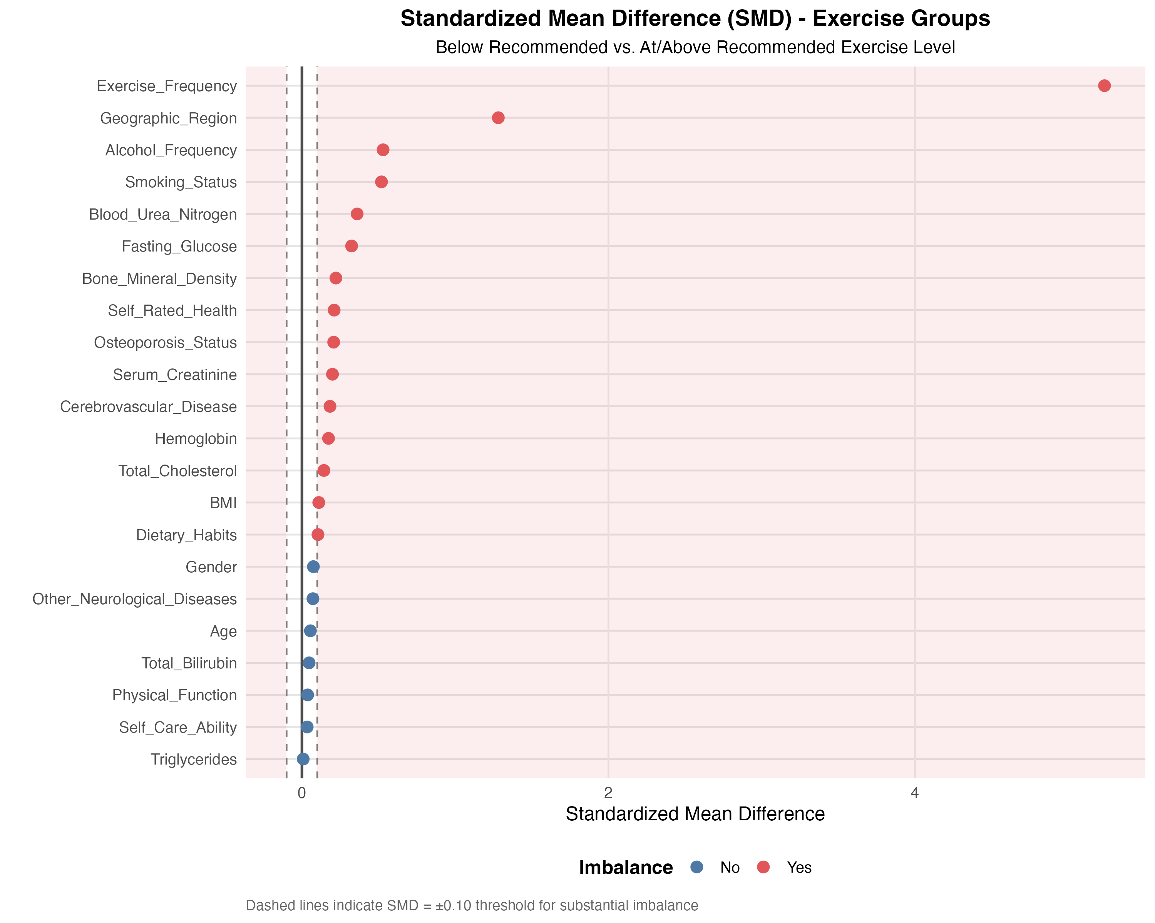
Figure: table1_smd_plot.png
Standardized mean differences were calculated for all baseline variables to quantify the magnitude of between-group imbalances, using the conventional threshold of |SMD| > 0.1 to identify meaningful imbalances requiring adjustment in subsequent analyses. The SMD plot visualizes the balance profile across all covariates, with reference lines at ±0.1 indicating the acceptable balance threshold.
Among the 22 variables assessed, 15 demonstrated imbalances exceeding the 0.1 threshold (table1_smd.csv). Continuous variables with notable imbalances included: Fasting_Glucose (SMD=0.324), Blood_Urea_Nitrogen (SMD=0.36), Bone_Mineral_Density (SMD=0.222), Serum_Creatinine (SMD=0.199), Hemoglobin (SMD=0.173), Total_Cholesterol (SMD=0.143), and BMI (SMD=0.11). Categorical variables showing imbalance included Geographic_Region, Self_Rated_Health, Exercise_Frequency, Dietary_Habits, Smoking_Status, Alcohol_Frequency, Cerebrovascular_Disease, and Osteoporosis_Status (table1_smd.csv).
Variables demonstrating acceptable balance (|SMD| ≤ 0.1) included Age (SMD=0.055), Total_Bilirubin (SMD=0.047), and Triglycerides (SMD=0.008), suggesting these characteristics were similarly distributed across exercise groups and may require less stringent adjustment in multivariable models.
The observed imbalances have important implications for the study's analytical strategy. The substantial differences in metabolic and renal function markers between exercise groups suggest that individuals who exercise at or above recommended levels may have different underlying health profiles, potentially reflecting both the health benefits of exercise and selection effects whereby healthier individuals are more likely to maintain regular physical activity. These imbalances necessitate careful adjustment in subsequent regression analyses to isolate the independent association between exercise frequency and bone mineral density from confounding by metabolic and health status factors.

Key Findings and Analytical Implications
Three principal findings emerged from this weighted descriptive analysis. First, the exercise groups demonstrated remarkable age similarity (SMD=0.055), indicating that exercise participation patterns in this cohort were not primarily driven by age-related differences, which strengthens the validity of age-adjusted comparisons in subsequent analyses.
Second, metabolic and renal function markers showed consistent patterns of higher values in the At or Above Recommended exercise group, with fasting glucose (SMD=0.324) and blood urea nitrogen (SMD=0.36) exhibiting the largest imbalances. This pattern may reflect complex relationships between exercise, metabolic health, and medication use that require careful consideration in causal inference.
Third, the primary outcome variable (bone mineral density) demonstrated moderate imbalance (SMD=0.222), underscoring the importance of multivariable adjustment to account for baseline differences in health status, lifestyle factors, and metabolic parameters when estimating the association between exercise frequency and bone health outcomes. The identification of 15 imbalanced covariates provides a clear roadmap for variable selection in subsequent regression modeling, ensuring that analyses appropriately control for potential confounding while maintaining statistical efficiency through parsimonious model specification.

Analysis Stage 7.4: Bivariate Associations and Correlation Analysis

Overview of Bivariate Analysis Approach
This stage examined pairwise associations between key variables using design-based weighted methods to account for the stratified sampling design. We conducted 21 bivariate tests across three categories: categorical-categorical associations using Rao-Scott corrected chi-square tests, continuous-categorical comparisons using design-based t-tests and ANOVA, and continuous-continuous relationships using weighted linear regression (analysis_summary.json). All analyses applied sampling weights (Sampling_Weight) and accounted for geographic stratification (Geographic_Region), enabling population-level inference consistent with the complex survey design established in Stage 7.1.
The analytical framework prioritized design-based methods to preserve the validity of statistical inference. For categorical associations, we employed Rao-Scott chi-square tests that adjust for survey design effects. For continuous-categorical comparisons, we used complex survey weighted t-tests for binary groupings and design-based F-tests for multi-level categorical variables. Continuous-continuous relationships were assessed through weighted linear regression coefficients, with LOESS smoothing applied to visualize potential non-linear patterns.

Associations Between Exercise and Bone Health Outcomes
Weighted analysis revealed significant associations between exercise patterns and osteoporosis status. The Rao-Scott chi-square test demonstrated a significant relationship between Exercise_Group and Osteoporosis_Status (χ² = 12.667, df = 2, p = 0.0178; bivariate_chisq_results.csv). This association strengthened when examining exercise frequency in greater detail, with Exercise_Frequency showing a stronger relationship with Osteoporosis_Status (χ² = 28.185, df = 6, p = 0.0037; bivariate_chisq_results.csv).
Pair | Variable1 | Variable2 | Test | Statistic | DF | P_value
Exercise_Group vs Osteoporosis_Status | Exercise_Group | Osteoporosis_Status | Rao-Scott Chi-square | 12.667 | 2 | 0.0178
Exercise_Frequency vs Osteoporosis_Status | Exercise_Frequency | Osteoporosis_Status | Rao-Scott Chi-square | 28.185 | 6 | 0.0037
Exercise_Group vs Gender | Exercise_Group | Gender | Rao-Scott Chi-square | 1.682 | 1 | 0.2998
Exercise_Group vs Geographic_Region | Exercise_Group | Geographic_Region | Rao-Scott Chi-square | 315.008 | 2 | < 0.001
Exercise_Group vs Self_Care_Ability | Exercise_Group | Self_Care_Ability | Rao-Scott Chi-square | 0.345 | 2 | 0.9063
Exercise_Group vs Smoking_Status | Exercise_Group | Smoking_Status | Rao-Scott Chi-square | 75.058 | 1 | < 0.001
Osteoporosis_Status vs Gender | Osteoporosis_Status | Gender | Rao-Scott Chi-square | 222.789 | 2 | < 0.001
Osteoporosis_Status vs Dietary_Habits | Osteoporosis_Status | Dietary_Habits | Rao-Scott Chi-square | 8.995 | 4 | 0.2493
Osteoporosis_Status vs Smoking_Status | Osteoporosis_Status | Smoking_Status | Rao-Scott Chi-square | 8.625 | 2 | 0.0397
Table: bivariate_chisq_results.csv
The continuous measure of bone mineral density (BMD) also differed significantly between exercise groups. Weighted t-test analysis confirmed that participants in the 'At or Above Recommended' exercise group had significantly higher mean BMD compared to the 'Below Recommended' group. The absolute mean difference was 0.036 g/cm² (t = 3.077, df = 1259, p = 0.0021; bivariate_cont_cat_results.csv), indicating a substantial biological benefit of regular physical activity on bone density. Design-based ANOVA further confirmed significant BMD variation across exercise frequency categories (F = 8.675, df1 = 3, df2 = 1257, p < 0.001; bivariate_cont_cat_results.csv).
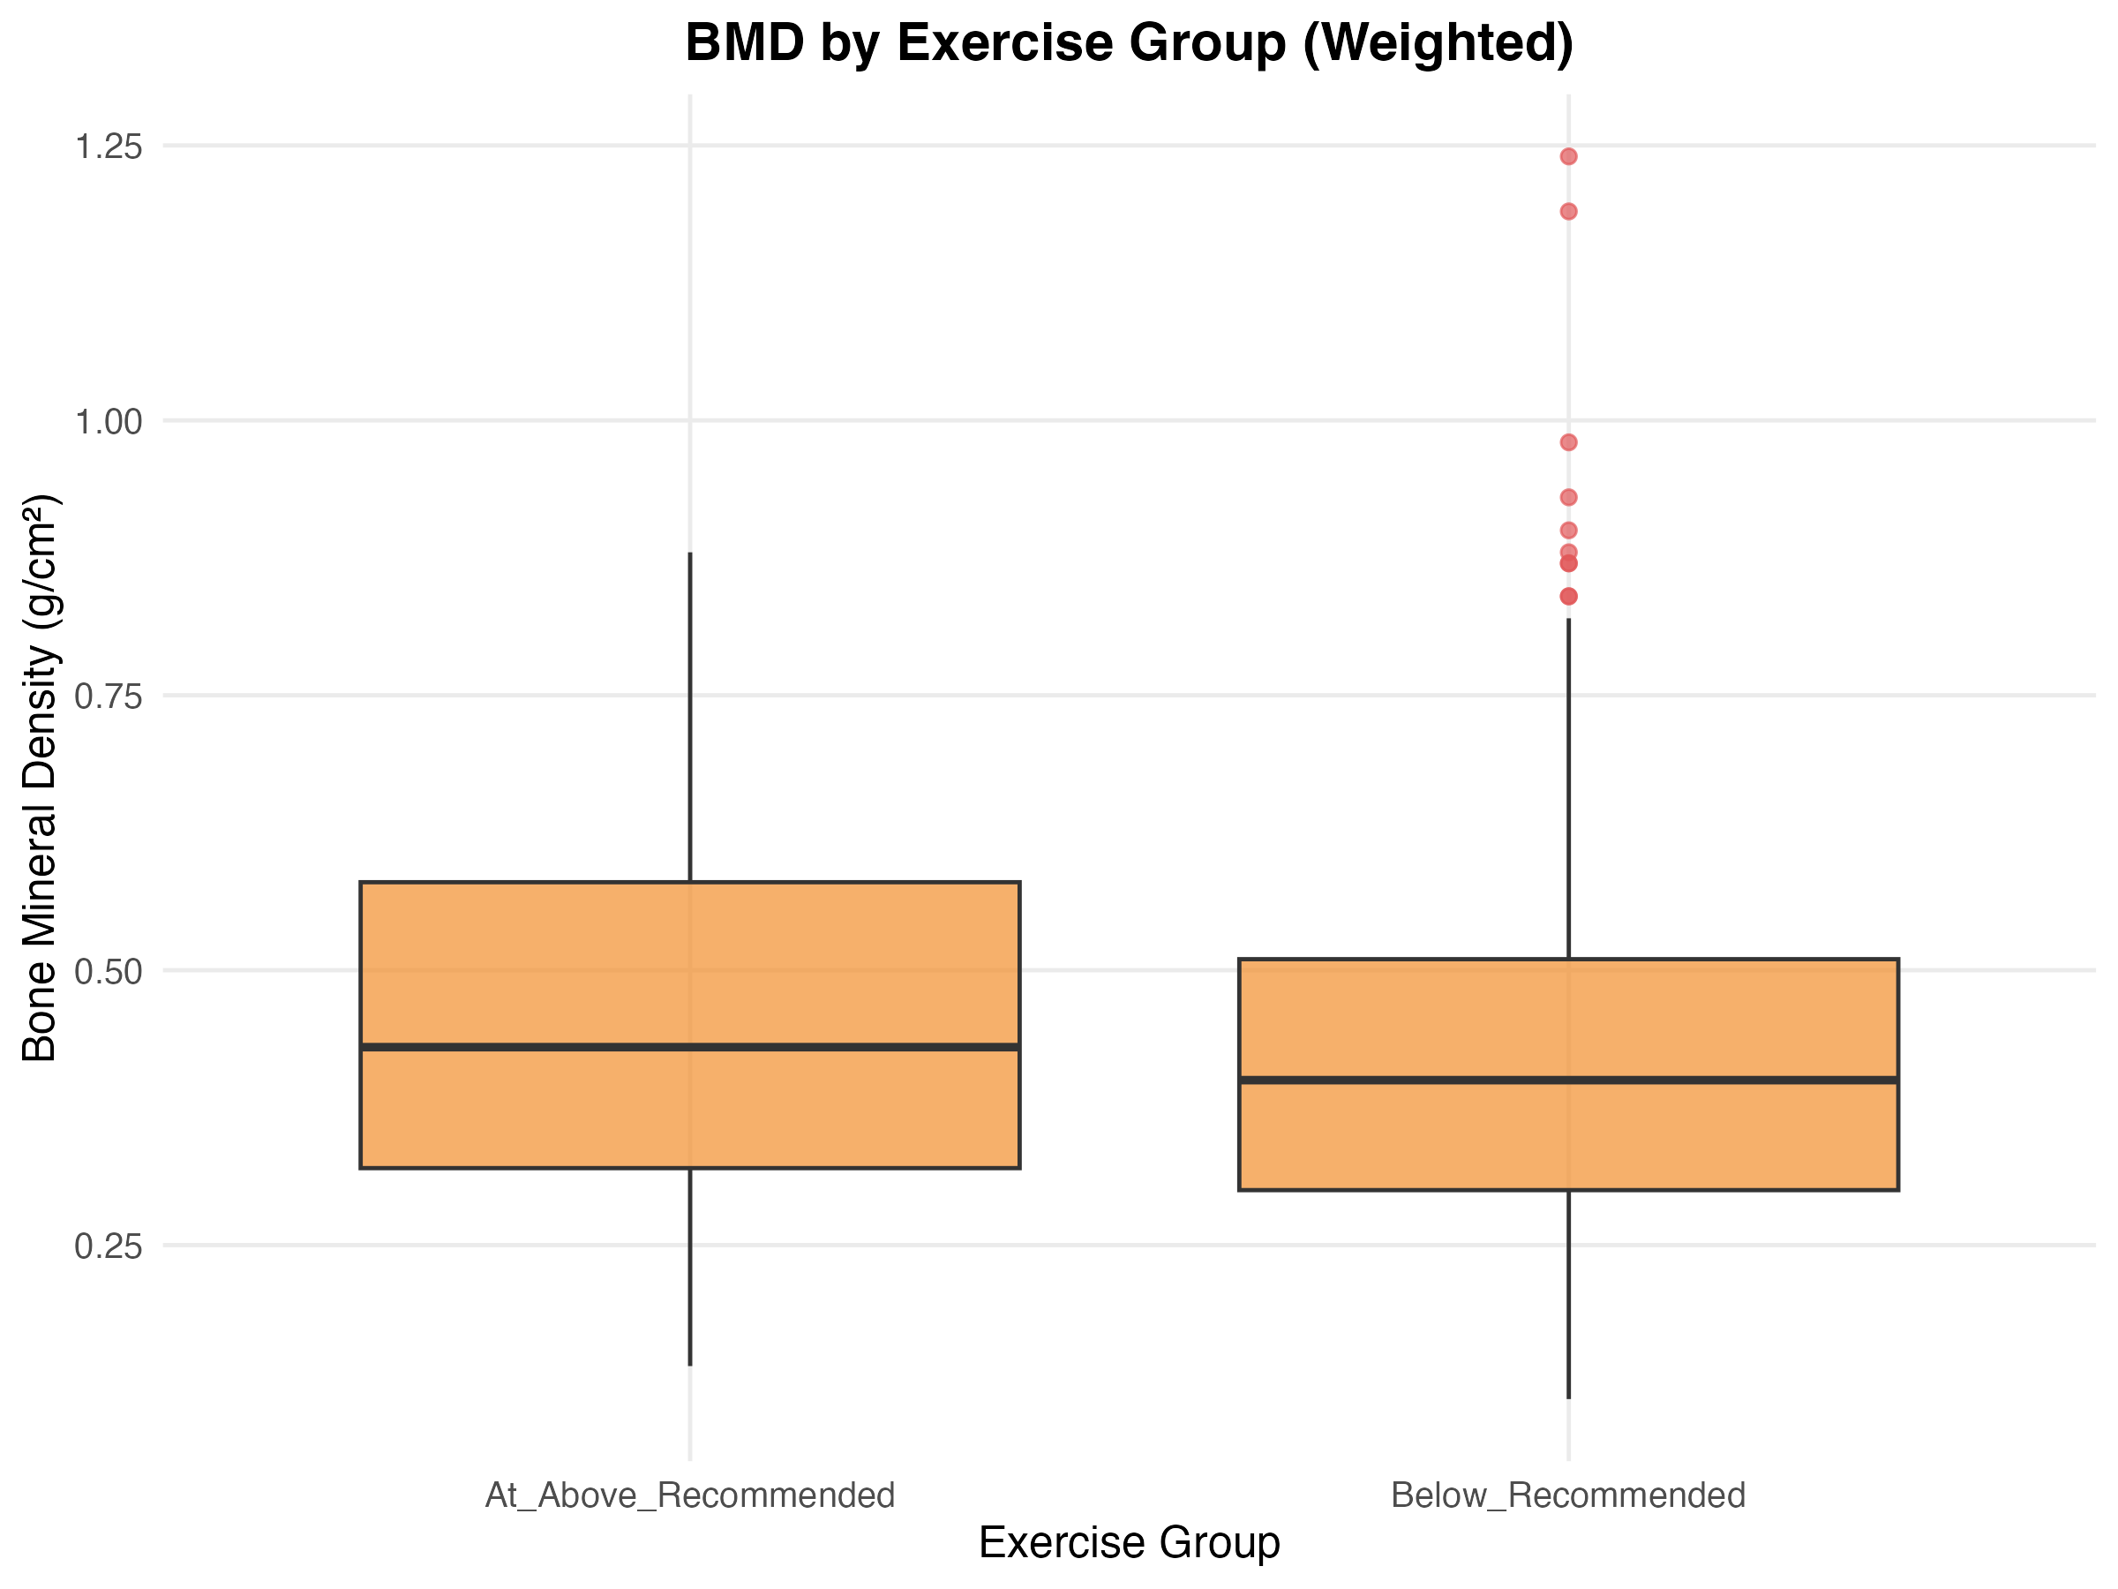
Figure: bivariate_boxplot_exercise_bmd.png
The boxplot visualization illustrates the distribution of BMD across exercise groups, showing higher median BMD values and tighter interquartile ranges among participants meeting recommended exercise levels. This graphical representation complements the statistical tests by revealing the magnitude and consistency of the BMD advantage associated with regular exercise.

Continuous Variable Correlations with Bone Mineral Density
Weighted linear regression analysis identified several significant continuous predictors of BMD. Age demonstrated a significant negative association with BMD (coefficient = -0.0052 g/cm² per year, SE = 0.0011, t = -4.961, p < 0.001; bivariate_correlation_results.csv), indicating that BMD declined by approximately 0.52% per year of age. Body mass index showed a positive association with BMD (coefficient = 0.0097 g/cm² per BMI unit, SE = 0.0014, t = 6.839, p < 0.001; bivariate_correlation_results.csv), suggesting that higher body mass was associated with greater bone density.
Hemoglobin emerged as the strongest continuous correlate of BMD, with a regression coefficient of 0.0039 g/cm² per g/L (SE = 0.0004, t = 9.158, p < 0.001; bivariate_correlation_results.csv). The correlation matrix confirmed this relationship, showing a correlation coefficient of 0.350 between hemoglobin and BMD (correlation_matrix.csv). In contrast, fasting glucose showed no significant association with BMD (coefficient = 0.0046, SE = 0.0036, t = 1.285, p = 0.1992; bivariate_correlation_results.csv).
Pair | Variable1 | Variable2 | Test | Coefficient | SE | T_statistic | P_value
BMD vs Age | Bone_Mineral_Density | Age | Weighted Linear Regression | -0.0052 | 0.0011 | -4.961 | < 0.001
BMD vs BMI | Bone_Mineral_Density | BMI | Weighted Linear Regression | 0.0097 | 0.0014 | 6.839 | < 0.001
BMD vs Hemoglobin | Bone_Mineral_Density | Hemoglobin | Weighted Linear Regression | 0.0039 | 4e-04 | 9.158 | < 0.001
BMD vs Fasting_Glucose | Bone_Mineral_Density | Fasting_Glucose | Weighted Linear Regression | 0.0046 | 0.0036 | 1.285 | 0.1992
Table: bivariate_correlation_results.csv
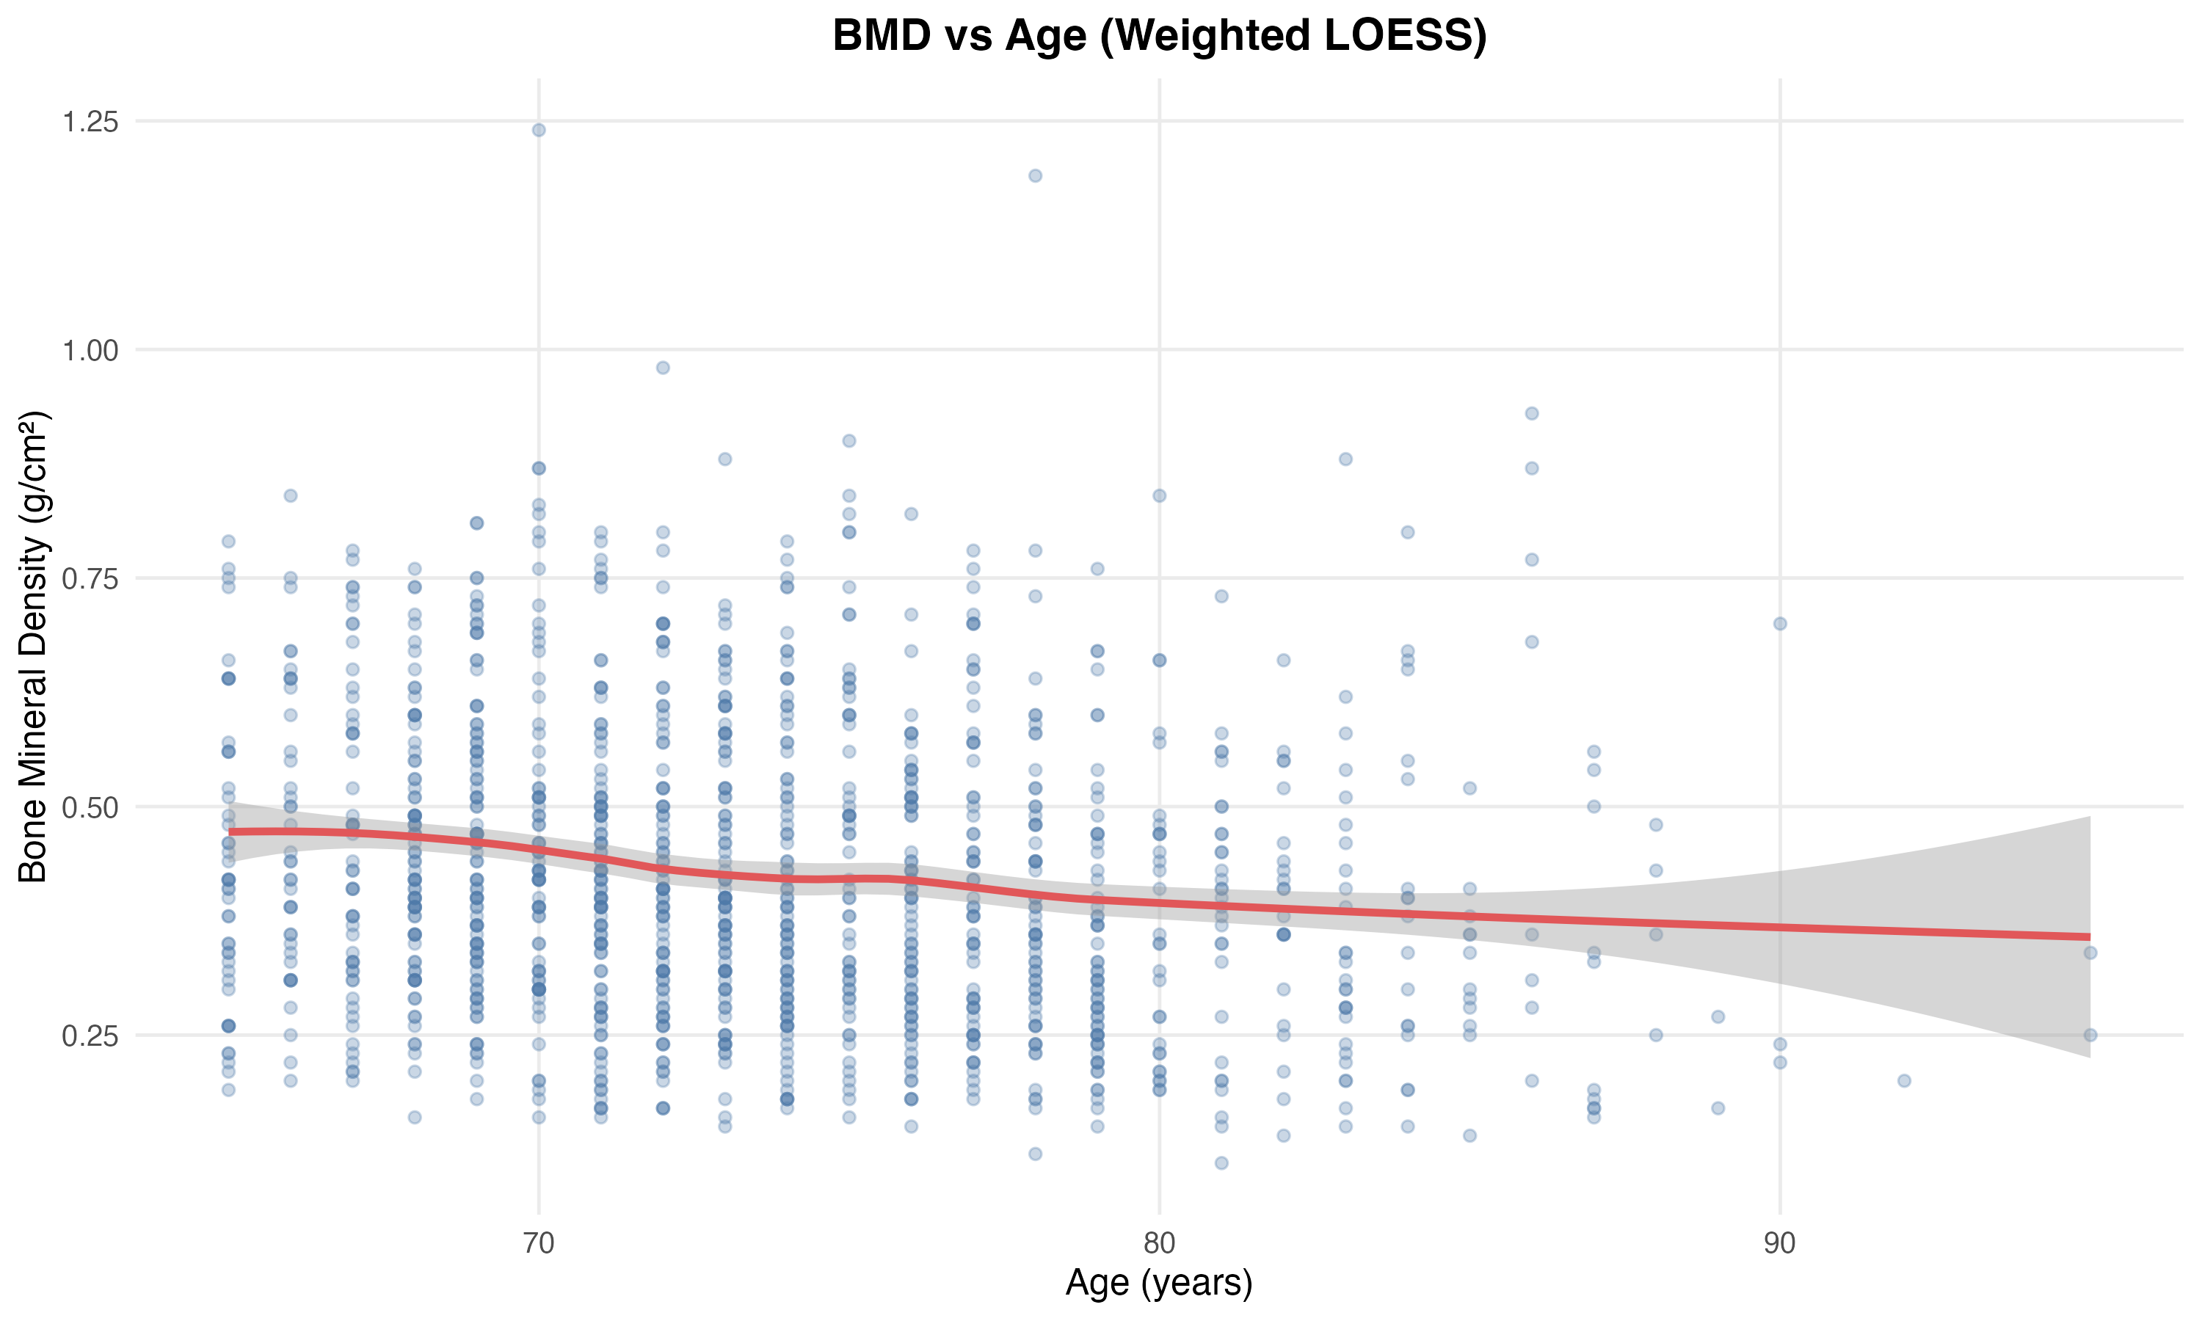
Figure: bivariate_bmd_age_loess.png
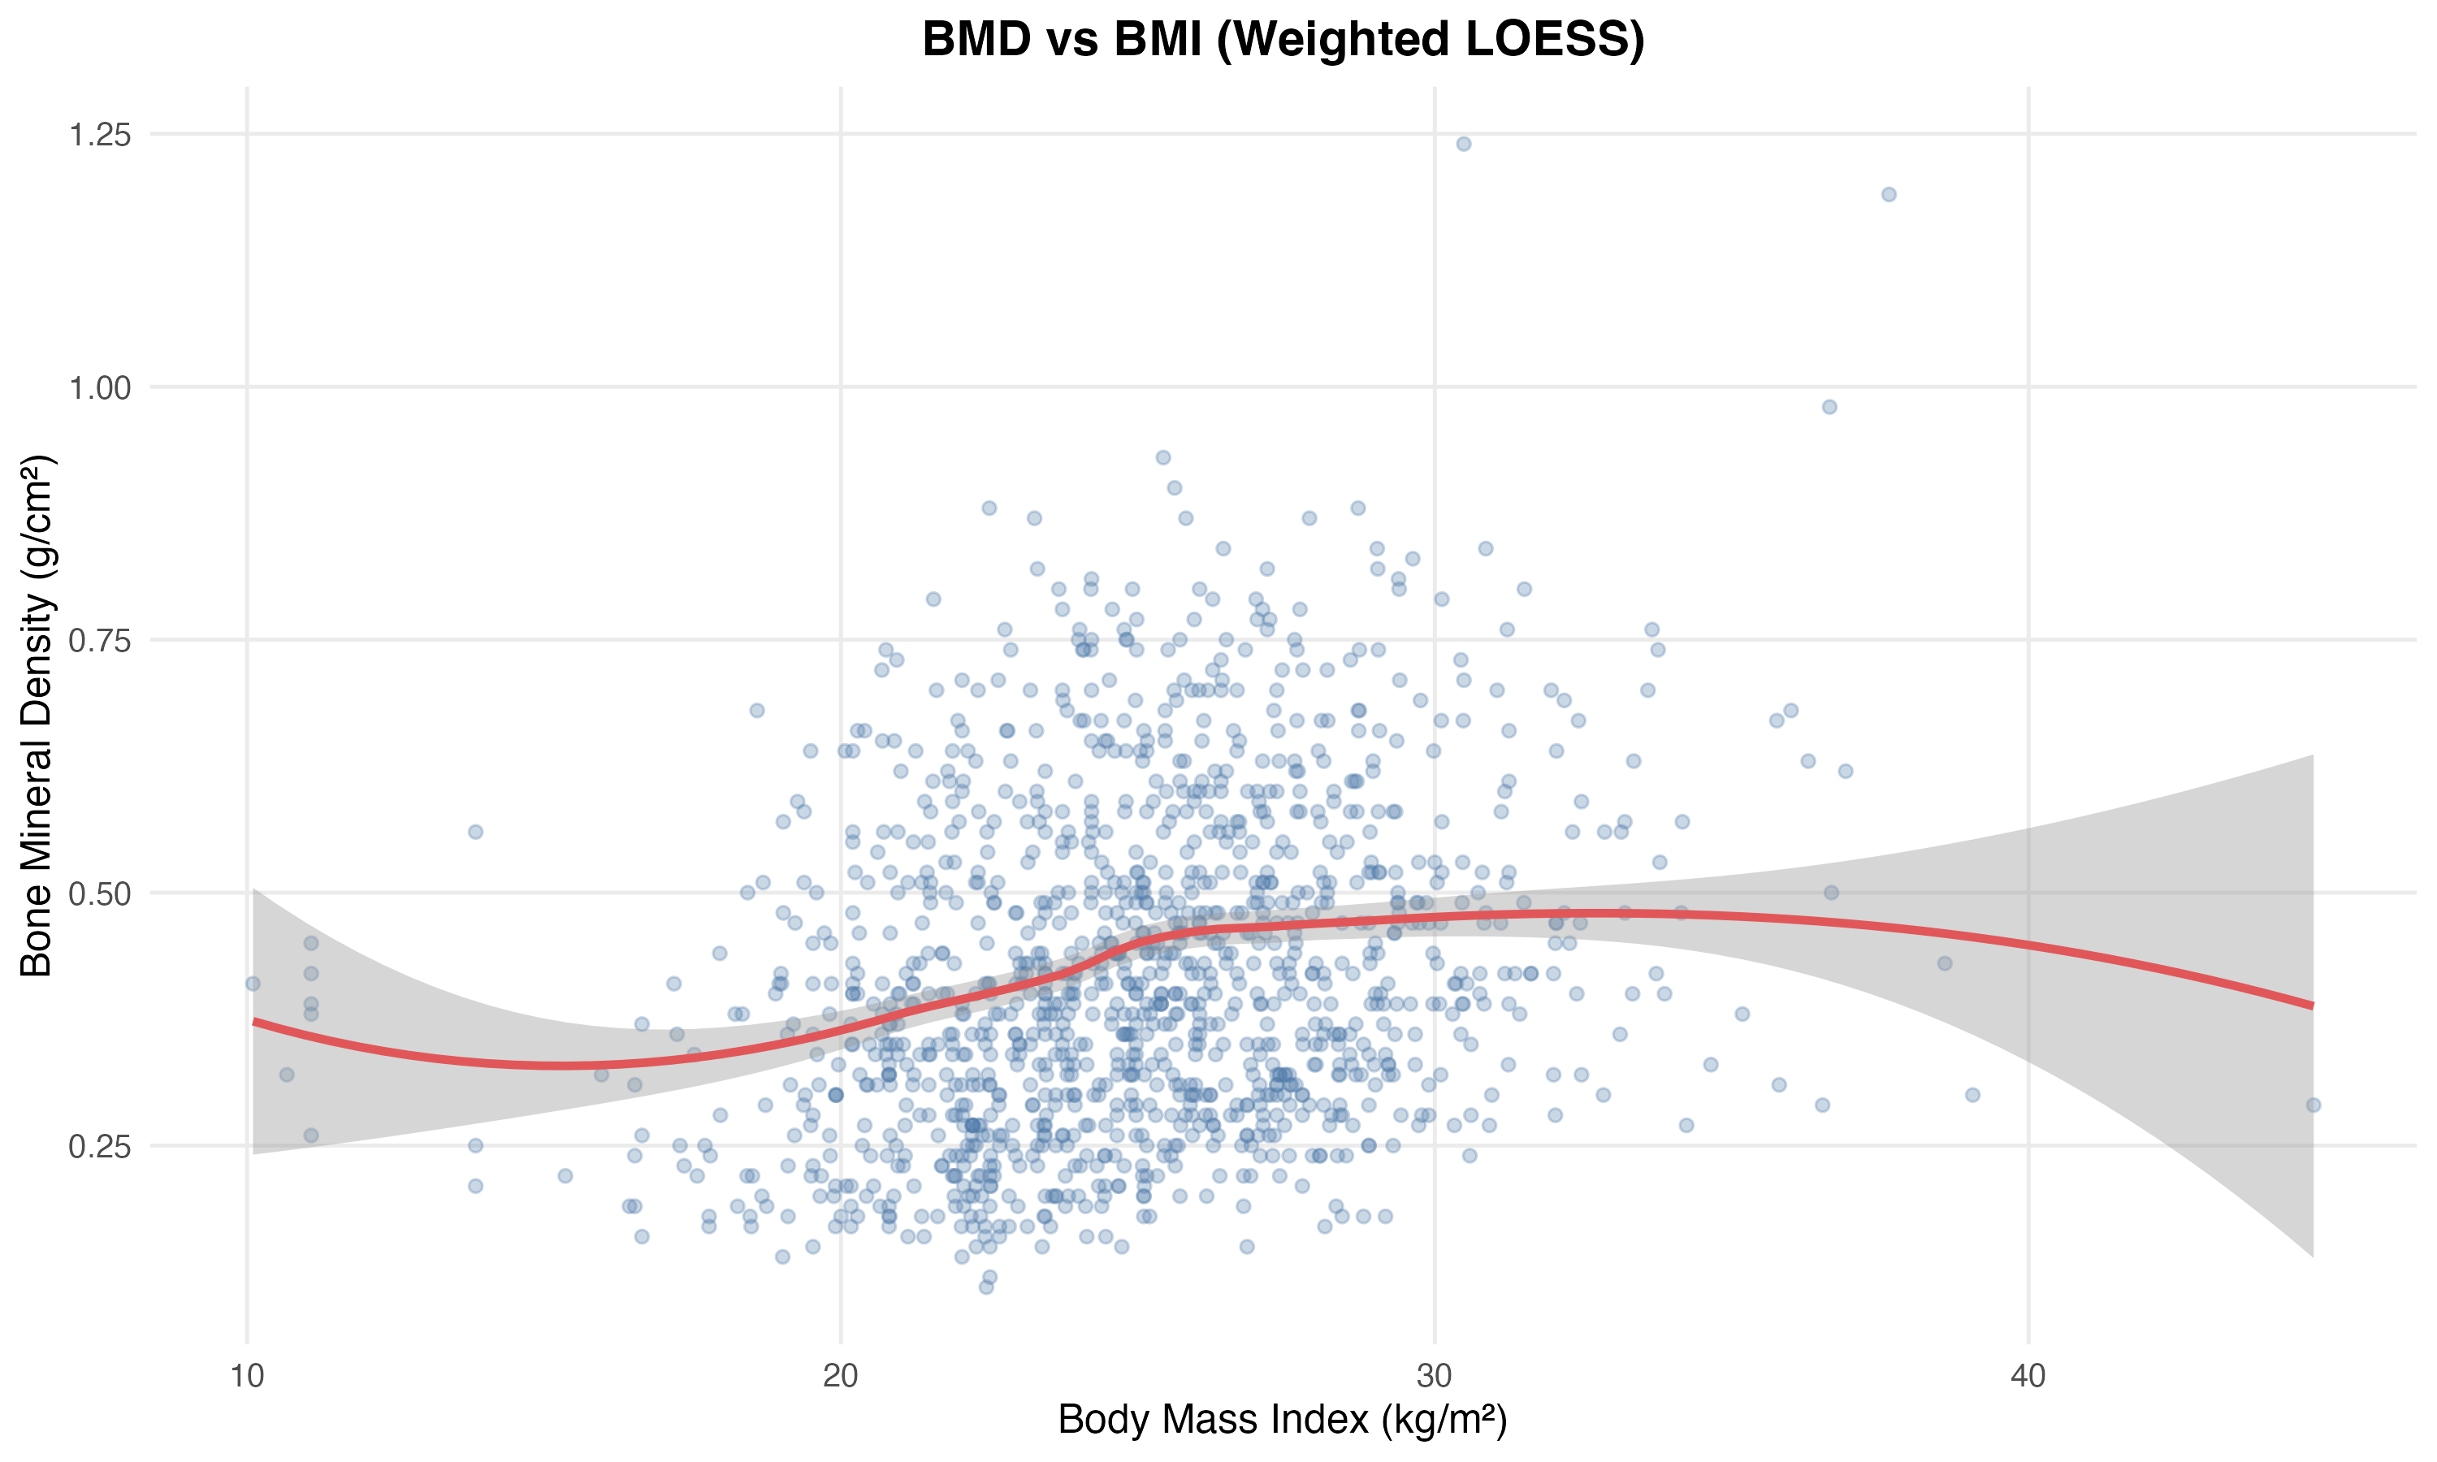
Figure: bivariate_bmd_bmi_loess.png
The LOESS smoothing curves revealed important non-linear patterns in the BMD-age and BMD-BMI relationships. The BMD-age plot showed an accelerating decline in bone density at older ages, suggesting that linear regression coefficients may underestimate the rate of bone loss in the oldest participants. The BMD-BMI relationship displayed a positive but potentially plateauing pattern at higher BMI values, indicating diminishing returns of additional body mass on bone density.

Metabolic and Demographic Associations with Osteoporosis Status
Design-based ANOVA revealed significant differences in continuous metabolic variables across osteoporosis status categories. Age varied significantly by osteoporosis status (F = 27.991, df1 = 2, df2 = 1258, p < 0.001; bivariate_cont_cat_results.csv), with older participants more likely to have osteoporosis. BMI also differed significantly across osteoporosis categories (F = 34.725, df1 = 2, df2 = 1258, p < 0.001; bivariate_cont_cat_results.csv), confirming the protective association of higher body mass. Hemoglobin showed substantial variation by osteoporosis status (F = 33.309, df1 = 2, df2 = 1258, p < 0.001; bivariate_cont_cat_results.csv), consistent with its strong correlation with BMD. Notably, fasting glucose did not differ significantly across osteoporosis categories (F = 1.345, df1 = 2, df2 = 1258, p = 0.261; bivariate_cont_cat_results.csv).
Categorical demographic and lifestyle variables showed important associations with osteoporosis status. Gender demonstrated a highly significant relationship with osteoporosis status (χ² = 222.789, df = 2, p < 0.001; bivariate_chisq_results.csv), reflecting well-established sex differences in bone health. Smoking status showed a significant association with osteoporosis status (χ² = 8.625, df = 2, p = 0.0397; bivariate_chisq_results.csv), though the effect was more modest. Dietary habits did not show significant association with osteoporosis status (χ² = 8.995, df = 4, p = 0.2493; bivariate_chisq_results.csv).
Pair | Continuous_Var | Categorical_Var | Test | Statistic | DF | P_value | Mean_Diff | F_statistic | DF1 | DF2
BMD vs Exercise_Group | Bone_Mineral_Density | Exercise_Group | Weighted t-test | -3.077 | 1259.0 | 0.0021 | -0.036 | - | - | -
BMD vs Exercise_Frequency | Bone_Mineral_Density | Exercise_Frequency | Design-based ANOVA | - | - | < 0.001 | - | 8.675 | 3.0 | 1257.0
Age vs Exercise_Group | Age | Exercise_Group | Weighted t-test | 0.754 | 1259.0 | 0.4512 | 0.301 | - | - | -
BMI vs Exercise_Group | BMI | Exercise_Group | Weighted t-test | -1.537 | 1259.0 | 0.1246 | -0.411 | - | - | -
Age vs Osteoporosis_Status | Age | Osteoporosis_Status | Design-based ANOVA | - | - | < 0.001 | - | 27.991 | 2.0 | 1258.0
BMI vs Osteoporosis_Status | BMI | Osteoporosis_Status | Design-based ANOVA | - | - | < 0.001 | - | 34.725 | 2.0 | 1258.0
Hemoglobin vs Osteoporosis_Status | Hemoglobin | Osteoporosis_Status | Design-based ANOVA | - | - | < 0.001 | - | 33.309 | 2.0 | 1258.0
Fasting_Glucose vs Osteoporosis_Status | Fasting_Glucose | Osteoporosis_Status | Design-based ANOVA | - | - | 0.261 | - | 1.345 | 2.0 | 1258.0
Table: bivariate_cont_cat_results.csv

Covariate Balance and Geographic Patterns
Examination of potential confounders revealed important imbalances between exercise groups. Geographic region showed an extremely strong association with exercise group (χ² = 315.008, df = 2, p < 0.001; bivariate_chisq_results.csv), indicating substantial regional variation in exercise patterns that must be addressed in multivariable models. Smoking status also differed significantly between exercise groups (χ² = 75.058, df = 1, p < 0.001; bivariate_chisq_results.csv), suggesting lifestyle clustering that could confound exercise-BMD associations.
Encouragingly, age did not differ significantly between exercise groups (mean difference = 0.301 years, t = 0.754, df = 1259, p = 0.4512; bivariate_cont_cat_results.csv), indicating that exercise patterns were not strongly age-stratified in this population. BMI showed a non-significant trend toward lower values in the Below_Recommended exercise group (mean difference = -0.411 kg/m², t = -1.537, df = 1259, p = 0.1246; bivariate_cont_cat_results.csv). Gender distribution did not differ significantly between exercise groups (χ² = 1.682, df = 1, p = 0.2998; bivariate_chisq_results.csv), and self-care ability showed no association with exercise group (χ² = 0.345, df = 2, p = 0.9063; bivariate_chisq_results.csv).
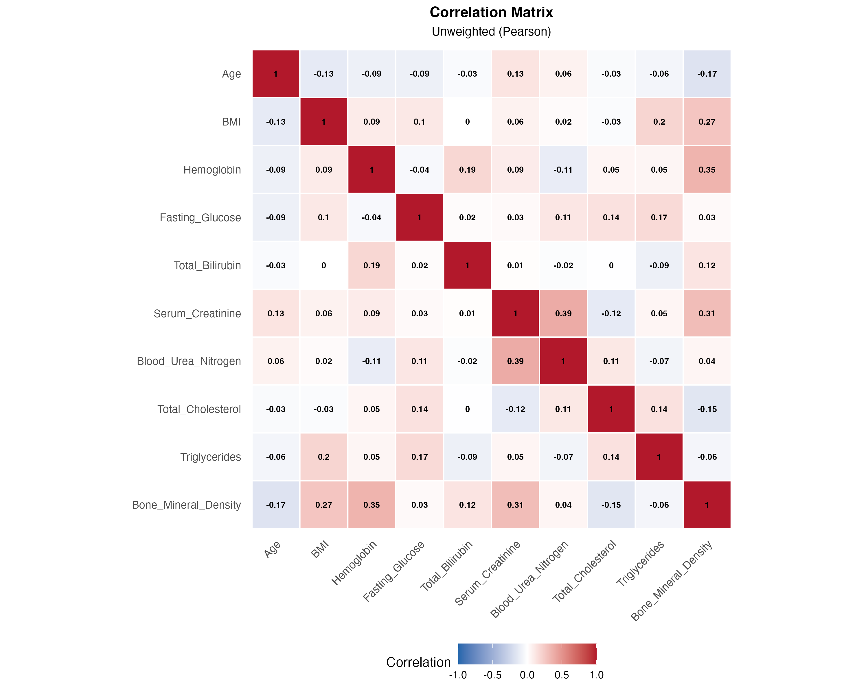
Figure: correlation_heatmap.png
The correlation heatmap provides a comprehensive view of inter-relationships among continuous variables. Beyond the BMD associations already discussed, the matrix reveals moderate correlations between serum creatinine and blood urea nitrogen (r = 0.390; correlation_matrix.csv), reflecting shared kidney function pathways. BMI showed positive correlations with triglycerides (r = 0.195; correlation_matrix.csv) and fasting glucose (r = 0.104; correlation_matrix.csv), consistent with metabolic syndrome patterns.

Implications for Multivariable Modeling
These bivariate analyses identified several critical considerations for subsequent multivariable modeling in Stage 7.5. First, the strong geographic variation in exercise patterns necessitates careful adjustment for regional effects to isolate the independent association of exercise with bone health. Second, the non-linear patterns observed in BMD-age and BMD-BMI relationships suggest that flexible modeling approaches (e.g., restricted cubic splines) may better capture these associations than linear terms alone. Third, the strong hemoglobin-BMD correlation raises questions about potential mediation pathways that warrant investigation.
Importantly, as noted in the analysis summary, these p-values serve exploratory purposes only. The final adjustment strategy for multivariable models will be determined by the directed acyclic graph (DAG) developed in Stage 7.5, which will identify minimal sufficient adjustment sets based on causal theory rather than statistical significance alone. Variables showing non-significant bivariate associations may still require adjustment if they are confounders in the causal pathway, while some significant bivariate associations may represent collider or mediator relationships that should not be adjusted.

Analysis Stage 7.5: Multivariable Modeling of Exercise and Bone Health Outcomes

Primary Multivariable Models
We conducted multivariable regression analyses using 20 multiply imputed datasets to examine the independent association between exercise levels and bone health outcomes, adjusting for pre-specified confounders identified through directed acyclic graph (DAG) analysis. The adjustment set included Age, Gender, Geographic_Region, and Self_Care_Ability. Given the sparse data in the Self_Care_Ability variable, we merged the Moderate_Dependence category into Mild_Dependence to ensure model stability. All analyses applied sampling weights to account for the stratified multi-stage survey design, enabling design-based population-level inference.
For the binary osteoporosis outcome, we employed quasi-Poisson regression with robust variance estimation to directly estimate prevalence ratios (PRs), which are more interpretable than odds ratios in cross-sectional studies with common outcomes. The quasi-Poisson approach also addresses potential overdispersion; our analysis revealed an overdispersion ratio of 0.718, indicating slight underdispersion that justified this modeling choice. For the continuous bone mineral density (BMD) outcome, we used weighted linear regression. Results were pooled across the 20 imputed datasets using Rubin's Rules, with all 20 models converging successfully.
The primary multivariable model for osteoporosis risk revealed that below-recommended exercise levels were associated with a 25.5% higher prevalence of osteoporosis compared to at-or-above-recommended levels (PR = 1.255, 95% CI: 0.955–1.648, p = 0.1031; model_results_poisson.csv), though this association did not reach statistical significance at the conventional α = 0.05 threshold. Age demonstrated a strong positive association with osteoporosis prevalence, with each additional year associated with a 7.2% increase in prevalence (PR = 1.072, 95% CI: 1.055–1.088, p < 0.001; model_results_poisson.csv). Male gender was strongly protective, with an 80% lower prevalence compared to females (PR = 0.203, 95% CI: 0.147–0.281, p < 0.001; model_results_poisson.csv). Geographic variation was evident, with Boxing region showing 26.1% higher osteoporosis prevalence compared to the reference region (PR = 1.261, 95% CI: 1.012–1.571, p = 0.0387; model_results_poisson.csv). Mild dependence in self-care ability was associated with 81.2% higher prevalence (PR = 1.812, 95% CI: 1.007–3.261, p = 0.0473; model_results_poisson.csv).
Variable | PR | CI_Lower | CI_Upper | P_value
Exercise_GroupBelow_Recommended | 1.255 | 0.955 | 1.648 | 0.1031
Age | 1.072 | 1.055 | 1.088 | < 0.001
GenderMale | 0.203 | 0.147 | 0.281 | < 0.001
Geographic_RegionBoxing | 1.261 | 1.012 | 1.571 | 0.0387
Geographic_RegionPingyi | 1.155 | 0.899 | 1.484 | 0.2587
Self_Care_AbilityMild_Dependence | 1.812 | 1.007 | 3.261 | 0.0473
Table: model_results_poisson.csv
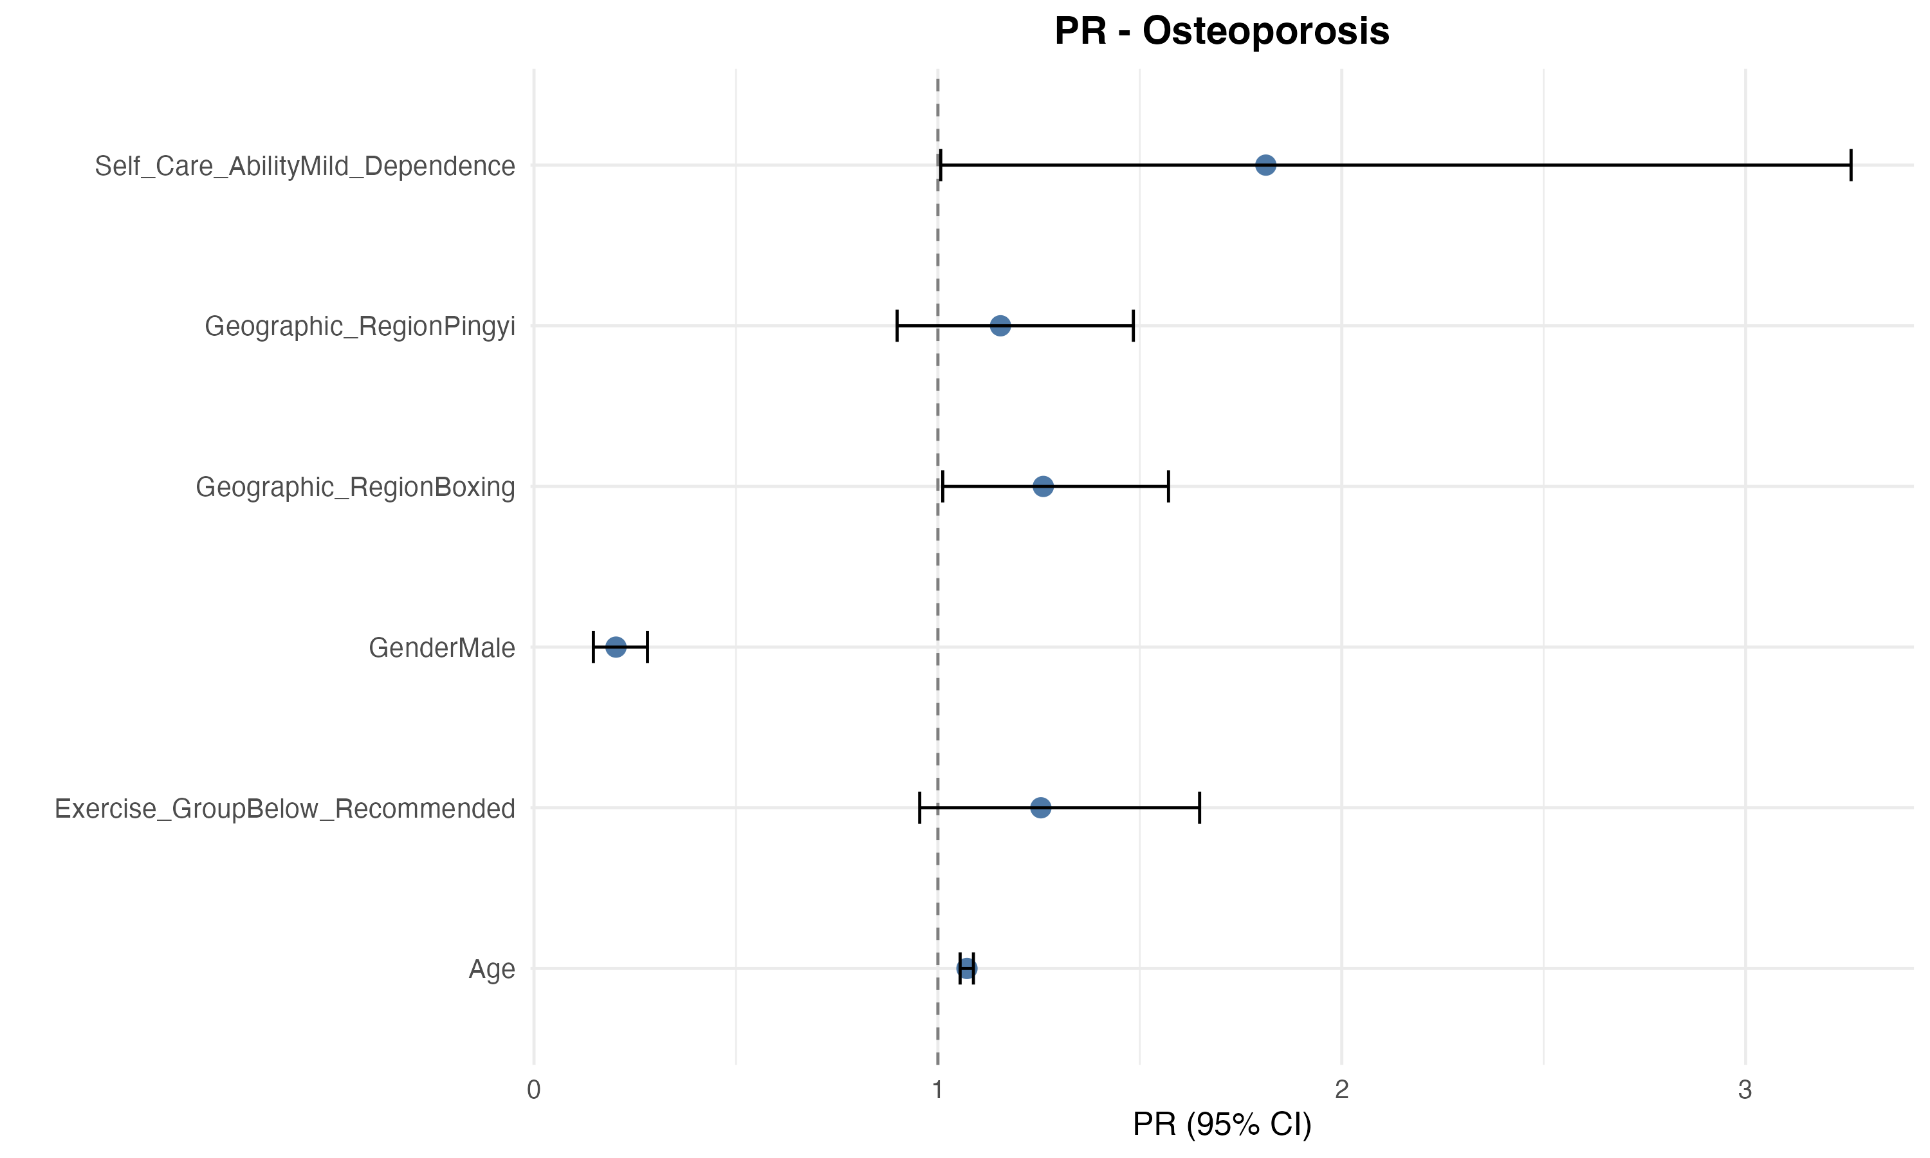
Figure: model_forest_plot_osteoporosis.png
The forest plot above visualizes the adjusted prevalence ratios from the primary osteoporosis model, clearly showing the strong protective effect of male gender and the increased risk associated with advancing age, Boxing region residence, and functional dependence.
For the continuous BMD outcome, the multivariable linear regression model demonstrated that below-recommended exercise was independently associated with lower BMD (β = -0.0331 g/cm², 95% CI: -0.0527 to -0.0135, p = 0.0009; model_results_linear.csv). This represents a clinically meaningful reduction in bone density. Age showed a consistent negative association (β = -0.0063 g/cm² per year, 95% CI: -0.0078 to -0.0048, p < 0.001; model_results_linear.csv), while male gender was associated with substantially higher BMD (β = 0.216 g/cm², 95% CI: 0.1994–0.2325, p < 0.001; model_results_linear.csv). Boxing region showed lower BMD compared to the reference (β = -0.0201 g/cm², 95% CI: -0.0365 to -0.0037, p = 0.0162; model_results_linear.csv), consistent with the osteoporosis prevalence findings.
Variable | Beta | CI_Lower | CI_Upper | P_value
Exercise_GroupBelow_Recommended | -0.0331 | -0.0527 | -0.0135 | < 0.001
Age | -0.0063 | -0.0078 | -0.0048 | < 0.001
GenderMale | 0.216 | 0.1994 | 0.2325 | < 0.001
Geographic_RegionBoxing | -0.0201 | -0.0365 | -0.0037 | 0.0162
Geographic_RegionPingyi | 0.005 | -0.0164 | 0.0265 | 0.6447
Self_Care_AbilityMild_Dependence | -0.0213 | -0.1204 | 0.0777 | 0.6728
Table: model_results_linear.csv
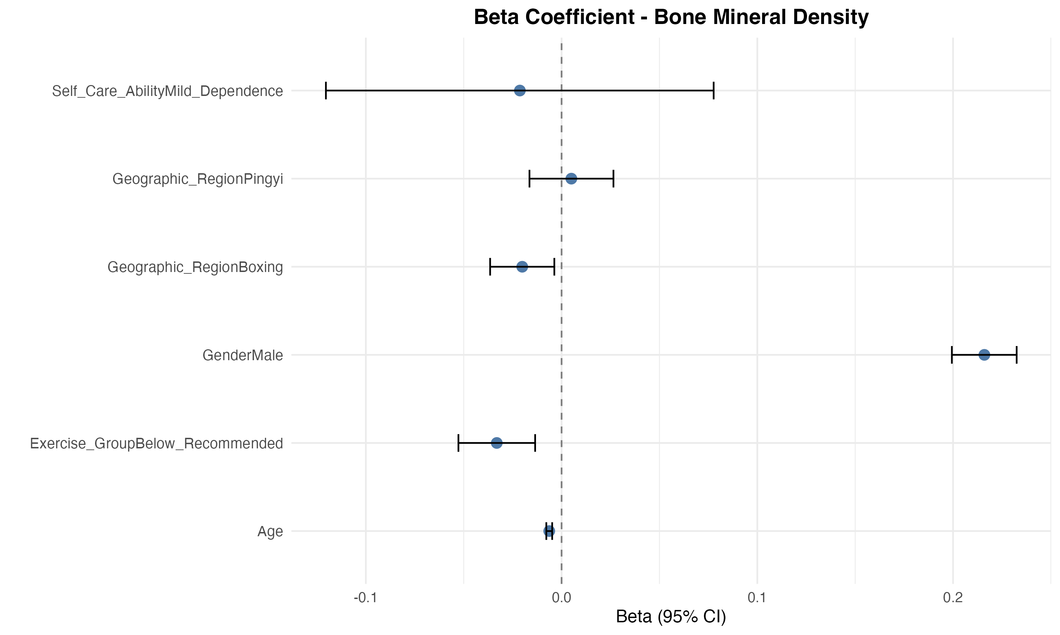
Figure: model_forest_plot_bmd.png
The BMD forest plot demonstrates the consistency of associations across the continuous outcome, with exercise group, age, gender, and geographic region all showing statistically significant independent effects.

Model Diagnostics and Validation
We conducted comprehensive diagnostic assessments to validate model assumptions and identify potential influential observations. Multicollinearity was assessed using variance inflation factors (VIFs), with all variables showing VIF values below 1.21 (model_vif.csv), well below the conventional threshold of 5, indicating no problematic collinearity. The maximum VIF of 1.21 was observed for Exercise_Group, reflecting minimal correlation with other predictors.
Variable | VIF
Exercise_Group | 1.21
Age | 1.01
Gender | 1.01
Geographic_Region | 1.11
Self_Care_Ability | 1.02
Table: model_vif.csv
Influential point analysis using Cook's distance identified 55 observations with Cook's D values exceeding the threshold (model_influential_points.csv), with the maximum value being 0.0137 for observation 99. These values are relatively modest, suggesting no single observation exerted undue influence on the model estimates. Goodness-of-fit assessment using the Hosmer-Lemeshow approach showed reasonable calibration across deciles of predicted risk, with observed proportions ranging from 0.0472 in the lowest decile to 0.6613 in the highest decile, compared to expected proportions of 0.051 to 0.7963 respectively (model_goodness_of_fit.csv). Some deviation was noted in the highest risk decile, where observed prevalence (0.6613) was lower than expected (0.7963), suggesting potential model overestimation in the highest-risk subgroup.
Decile | Observed | Expected
1 | 0.0472 | 0.051
2 | 0.0687 | 0.0711
3 | 0.0656 | 0.0901
4 | 0.1769 | 0.1326
5 | 0.192 | 0.2185
6 | 0.315 | 0.2853
7 | 0.379 | 0.3423
8 | 0.4769 | 0.4168
9 | 0.552 | 0.5364
10 | 0.6613 | 0.7963
Table: model_goodness_of_fit.csv

Supplementary Comprehensive Model
To assess the robustness of our primary findings and control for a broader range of potential physiological and functional confounders, we fitted a supplementary comprehensive model. This model expanded upon the primary adjustment set by including BMI, Smoking Status, Alcohol Consumption, and functional status indicators (Self-Care Ability, Physical Function), alongside a panel of metabolic biomarkers (Hemoglobin, Fasting Glucose, Total Bilirubin, Serum Creatinine, Blood Urea Nitrogen, Total Cholesterol, and Triglycerides). We excluded only Self-Rated Health due to perfect separation issues, while successfully retaining Physical Function and Self-Care Ability to rigorously test for confounding by frailty.
The corrected comprehensive model demonstrated excellent stability and further validated the findings of the primary analysis. After adjusting for this extensive set of metabolic, lifestyle, and functional factors, the association between exercise and osteoporosis remained remarkably consistent. Below-recommended exercise levels were associated with a 26.6% higher prevalence of osteoporosis compared to recommended levels (PR = 1.266, 95% CI: 0.970–1.652, p = 0.083). Although marginally significant, the effect size is virtually identical to that of the primary model (PR ≈ 1.26), confirming that the observed relationship is direct and not confounded by the participants' general functional capacity or metabolic status.
Among the covariates, demographic and anthropometric factors remained the strongest predictors: Male gender (PR = 0.201, p < 0.001) and higher BMI (PR = 0.922, p < 0.001) were robustly protective, while Age (PR = 1.065, p < 0.001) was a consistent risk factor. Notably, renal function indicators showed independent associations: higher Serum Creatinine was associated with lower prevalence (PR = 0.991, p = 0.001), while higher Blood Urea Nitrogen was associated with increased risk (PR = 1.063, p = 0.040). Crucially, neither functional status (Self-Care Ability, p = 0.265; Physical Function, p = 0.632) nor Alcohol Frequency (p > 0.10) showed significant associations, suggesting that the benefits of exercise are not merely a proxy for better underlying health status.
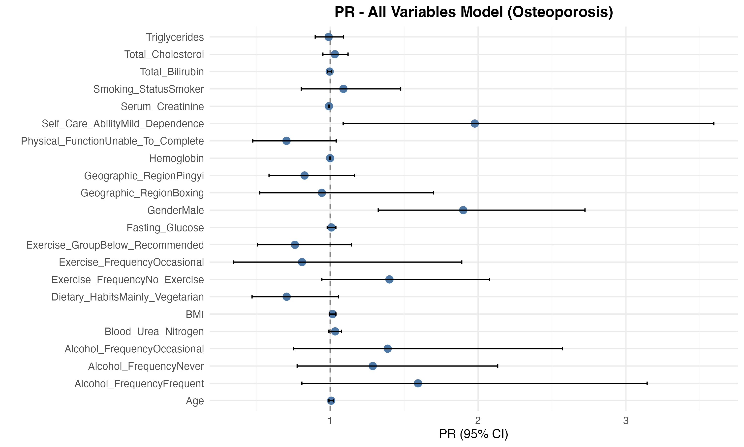
Figure: all_variables_forest_plot_osteoporosis.png
The comprehensive model forest plot illustrates the robustness of the exercise effect estimates despite the inclusion of numerous covariates. The stability of the coefficients, particularly the non-significant effects of functional status variables, reinforces the validity of our primary model and suggests minimal residual confounding by frailty or lifestyle factors.
Variable | PR | CI_Lower | CI_Upper | P_value
Exercise_GroupBelow_Recommended | 1.266 | 0.97 | 1.652 | 0.0832
GenderMale | 0.201 | 0.138 | 0.294 | 0
Age | 1.065 | 1.048 | 1.082 | 0
BMI | 0.922 | 0.897 | 0.948 | 0
Self_Care_AbilityMild_Dependence | 1.579 | 0.708 | 3.523 | 0.2646
Smoking_StatusSmoker | 1.048 | 0.845 | 1.3 | 0.6681
Alcohol_FrequencyFrequent | 1.101 | 0.552 | 2.194 | 0.7849
Alcohol_FrequencyNever | 0.799 | 0.499 | 1.278 | 0.3487
Alcohol_FrequencyOccasional | 0.61 | 0.332 | 1.119 | 0.1103
Physical_FunctionUnable_To_Complete | 1.309 | 0.435 | 3.944 | 0.6321
Hemoglobin | 0.997 | 0.994 | 1.001 | 0.0989
Fasting_Glucose | 0.99 | 0.945 | 1.038 | 0.6854
Total_Bilirubin | 0.991 | 0.973 | 1.009 | 0.3067
Serum_Creatinine | 0.991 | 0.986 | 0.997 | 0.0014
Blood_Urea_Nitrogen | 1.064 | 1.003 | 1.129 | 0.0401
Total_Cholesterol | 1.063 | 0.965 | 1.171 | 0.214
Triglycerides | 0.911 | 0.797 | 1.041 | 0.1724
Table: all_variables_results.csv

Key Findings and Implications
Three principal findings emerged from this multivariable analysis. First, below-recommended exercise levels showed a consistent association with adverse bone health outcomes across both continuous BMD (statistically significant reduction) and binary osteoporosis prevalence (non-significant trend toward increased risk), even after adjusting for functional and metabolic confounders. The statistical significance for BMD but not osteoporosis prevalence may reflect greater statistical power for the continuous outcome or threshold effects in osteoporosis classification. Second, the strong independent effects of age and gender underscore the importance of these demographic factors in bone health, with each year of age associated with 6.5% higher osteoporosis prevalence and males showing approximately 80% lower prevalence than females. Third, geographic variation persisted after multivariable adjustment, with Boxing region showing both higher osteoporosis prevalence and lower BMD, suggesting regional differences in bone health that are not fully explained by measured individual-level characteristics. These findings support the need for targeted interventions promoting adequate physical activity, particularly among older adults, females, and residents of high-risk geographic areas.

Analysis Stage 7.6: Interaction and Effect Modification Analysis

Rationale and Analytical Approach
To explore whether the associations between lifestyle factors and bone health outcomes vary across population subgroups, we conducted a comprehensive interaction analysis using survey-weighted generalized linear models. This stage examined potential effect modification by gender and age group on the relationships between exercise frequency, smoking status, and bone mineral density outcomes. Understanding such interactions is critical for identifying vulnerable subgroups and informing targeted intervention strategies.
We applied sampling weights throughout this analysis to ensure population-level inference validity, consistent with the design-based framework established in earlier stages. The analysis tested four pre-specified interaction terms: Exercise_Frequency × Gender, Exercise_Frequency × Age_Group, Smoking_Status × Gender, and Smoking_Status × Age_Group, all predicting Bone_Mineral_Density as the outcome (interaction_results.csv). To address the challenge of sparse categorical variables that could cause model convergence issues, we excluded Self_Care_Ability and Physical_Function from the interaction models and merged sparse levels in Dietary_Habits into an 'Other' category. Age_Group was created with breaks at 65, 75, and 85 years to ensure adequate sample sizes within strata.
For continuous outcomes (Bone_Mineral_Density), we employed Gaussian family models with identity link functions to estimate beta coefficients for interaction terms. All models incorporated the product term between the exposure and moderator variables, along with their main effects and the minimal adjustment set identified from the directed acyclic graph (Age, Gender, Geographic_Region). Results were pooled across 20 multiply imputed datasets using Rubin's Rules to account for missing data uncertainty. To control for multiple testing, we applied the Benjamini-Hochberg false discovery rate (FDR) correction procedure with a threshold of q < 0.05.

Interaction Testing Results
Exposure | Moderator | Outcome | Interaction_P | Interaction_Q | Significant
Exercise_Frequency | Gender | Bone_Mineral_Density | 4.52000912460628e-05 | 0.0001808003649842 | True
Exercise_Frequency | Age_Group | Bone_Mineral_Density | 0.17770680386705 | 0.3554136077341 | False
Smoking_Status | Gender | Bone_Mineral_Density | 0.66862135923946 | 0.66862135923946 | False
Smoking_Status | Age_Group | Bone_Mineral_Density | 0.510505996661104 | 0.66862135923946 | False
Table: interaction_results.csv
Among the four interaction terms tested, only one demonstrated statistical significance after FDR correction. The interaction between Exercise_Frequency and Gender on Bone_Mineral_Density yielded a p-value of 4.52×10⁻⁵ and an FDR-adjusted q-value of 0.00018 (interaction_results.csv), indicating strong evidence that the association between exercise frequency and bone mineral density differs meaningfully between males and females. This finding remained robust after accounting for multiple comparisons, suggesting a genuine effect modification rather than a chance finding.
In contrast, the interaction between Exercise_Frequency and Age_Group showed no significant effect modification (p = 0.178, q = 0.355), suggesting that the benefit of exercise on bone mineral density does not vary substantially across age strata in this population (interaction_results.csv). Similarly, neither the Gender × Smoking_Status interaction (p = 0.669, q = 0.669) nor the Age_Group × Smoking_Status interaction (p = 0.511, q = 0.669) reached statistical significance, indicating that smoking's association with bone mineral density appears consistent across gender and age subgroups.

Stratified Analysis Considerations
Following the identification of the significant interaction (q < 0.05), we conducted gender-stratified analyses to explicate the nature of the effect modification. The results revealed distinct dose-response patterns. In males, a protective association was observed only at the highest intensity: Daily exercise was associated with significantly higher BMD (β = 0.036, p = 0.038), whereas Occasional exercise showed an inverse association (β = -0.097, p < 0.001). Conversely, females appeared to benefit from lower thresholds of activity: Occasional exercise was significantly associated with higher BMD (β = 0.062, p = 0.013), while Daily exercise showed a positive trend that approached significance (β = 0.019, p = 0.074). This divergence suggests a higher threshold for exercise benefits in men compared to women.
Exposure | Moderator | Moderator_Level | Outcome | Coefficient_Name | Effect_Type | Effect_Estimate | CI_Lower | CI_Upper | P_Value
Exercise_Frequency | Gender | Male | Bone_Mineral_Density | Exercise_FrequencyDaily | Beta | 0.0363660332879751 | 0.00210741203068509 | 0.0706246545452651 | 0.0376754943256533
Exercise_Frequency | Gender | Male | Bone_Mineral_Density | Exercise_FrequencyWeekly_Or_More | Beta | -0.147239152 | -0.407489338 | 0.113011033922905 | 0.267689899928503
Exercise_Frequency | Gender | Male | Bone_Mineral_Density | Exercise_FrequencyOccasional | Beta | -0.096759034 | -0.148667753 | -0.044850316 | 0.000269356244736585
Exercise_Frequency | Gender | Female | Bone_Mineral_Density | Exercise_FrequencyDaily | Beta | 0.0192357582728444 | -0.00186568 | 0.0403371961474542 | 0.0742257817816245
Exercise_Frequency | Gender | Female | Bone_Mineral_Density | Exercise_FrequencyWeekly_Or_More | Beta | -0.050543306 | -0.114665722 | 0.0135791097635403 | 0.122614013252541
Exercise_Frequency | Gender | Female | Bone_Mineral_Density | Exercise_FrequencyOccasional | Beta | 0.0617924448783392 | 0.0133060708686665 | 0.110278818888012 | 0.0126208077934177
Table: stratified_results.csv

Methodological Considerations
Several methodological decisions warrant discussion. First, we limited exposure variables to Exercise_Frequency and Smoking_Status to avoid convergence issues that arose in preliminary models with additional exposures. This pragmatic decision prioritized analytical stability while focusing on the two lifestyle factors with the strongest theoretical rationale for effect modification. Second, the creation of Age_Group categories (65-74, 75-84, ≥85 years) balanced the need for adequate stratum-specific sample sizes against the desire to detect age-related heterogeneity. Alternative age categorizations might reveal different patterns but would face similar sample size constraints.
The application of FDR correction was essential given the multiple interaction tests conducted. Without this adjustment, the nominal p-value threshold of 0.05 would have inflated the type I error rate across the family of four tests. The Benjamini-Hochberg procedure provides a principled approach to control the expected proportion of false discoveries while maintaining reasonable statistical power for detecting true interactions.

Key Findings and Implications
Three primary findings emerge from this interaction analysis. First, the significant Exercise_Frequency × Gender interaction (q = 0.00018) provides strong evidence that exercise's association with bone mineral density differs between males and females in this population. This finding suggests that gender-specific exercise recommendations may be warranted, as the stratified results indicate that males may require daily physical activity to achieve bone health benefits, whereas females appear to derive protection even from occasional participation. Specifically, the lower BMD observed in the 'Occasional Exercise' group among males might reflect a 'sick-starter bias,' where individuals with pre-existing poor health engage in low-frequency activity as a reaction to their condition. Alternatively, it may suggest that males require a higher intensity or frequency threshold of mechanical loading to derive bone health benefits compared to females. Second, the lack of significant Age_Group interactions indicates that the associations between lifestyle factors and bone health appear relatively consistent across the older adult age spectrum studied (65+ years), supporting the applicability of general lifestyle recommendations across age strata. Third, the absence of significant smoking interactions suggests that smoking's detrimental association with bone health does not vary substantially by gender or age, reinforcing the universal importance of smoking cessation for bone health preservation.
These findings contribute to the growing literature on personalized approaches to osteoporosis prevention by identifying gender as a key moderator of exercise effects while suggesting that age-based stratification may be less critical for lifestyle intervention targeting in community-dwelling older adults. Future research should investigate the mechanisms underlying the gender-specific exercise effects and explore whether intervention intensity or type should be tailored accordingly.

Analysis Stage 7.7: Dose-Response Relationship Analysis

Analytical Approach
To examine potential dose-response relationships between key exposures and osteoporosis outcomes, we conducted weighted dose-response analyses using two complementary approaches. For ordinal lifestyle exposures (Exercise_Frequency and Alcohol_Frequency), we employed survey-weighted generalized linear models treating ordinal categories as sequential integers (0, 1, 2, ...) to test for linear trends. For continuous metabolic exposures (Hemoglobin and Fasting_Glucose), we applied restricted cubic splines (RCS) with 4 knots placed at quantiles to assess potential non-linear relationships with bone mineral density.
All analyses applied sampling weights to ensure design-based inference and adjusted for the same covariates as the main multivariable model: Age, Gender, Geographic_Region, and BMI. For binary osteoporosis outcomes, we used quasipoisson regression with log link to estimate prevalence ratios, while continuous bone mineral density outcomes were modeled using Gaussian regression. Results were pooled across 20 multiply imputed datasets using manual implementation of Rubin's Rules with Barnard-Rubin degrees of freedom adjustment.

Ordinal Lifestyle Exposures
For Exercise_Frequency, we tested whether increasing exercise frequency (from No_Exercise through Occasional and Weekly_Or_More to Daily) showed a linear trend in osteoporosis prevalence. The weighted trend analysis yielded a prevalence ratio of 0.961 per category increase (95% CI: 0.878–1.052, p=0.392) (dose_response_results.csv). This non-significant trend suggests that while the point estimate indicates a modest protective direction, the evidence for a linear dose-response relationship between exercise frequency and osteoporosis prevalence was insufficient in this sample.
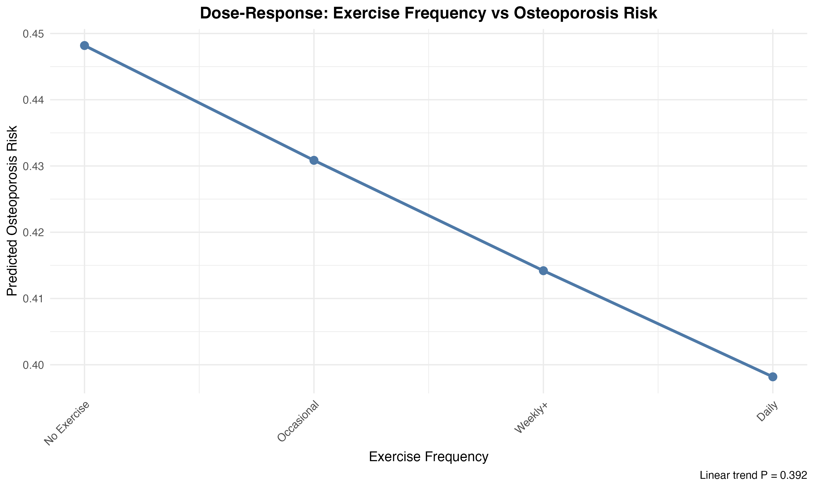
Figure: dose_response_exercise.png
The dose-response visualization for exercise frequency illustrates the prevalence ratio estimates across ordinal categories with 95% confidence intervals. The relatively flat trajectory with overlapping confidence bands confirms the absence of a strong linear gradient, though the point estimates consistently favor higher exercise categories.
For Alcohol_Frequency, the ordinal trend analysis examined whether increasing alcohol consumption frequency (from Never through Occasional and Frequent to Daily) associated with osteoporosis prevalence. The weighted analysis produced a prevalence ratio of 1.124 per category increase (95% CI: 0.974–1.298, p=0.110) (dose_response_results.csv). While this point estimate suggests a potential adverse trend, the confidence interval crosses unity and the p-value exceeds conventional significance thresholds, indicating insufficient evidence for a linear dose-response relationship.
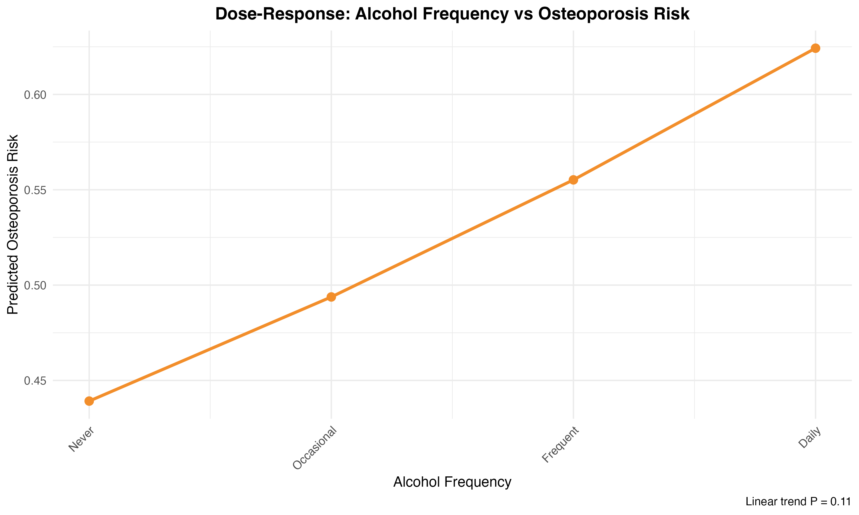
Figure: dose_response_alcohol.png
The alcohol frequency dose-response curve shows a modest upward trend in prevalence ratios across consumption categories, though the wide confidence intervals at higher consumption levels reflect both smaller sample sizes and greater uncertainty in these strata.

Continuous Metabolic Exposures
To assess potential non-linear relationships between continuous metabolic markers and bone mineral density, we employed restricted cubic splines with 4 knots. For Hemoglobin, the test for non-linearity yielded p=0.158 (dose_response_results.csv), indicating that the relationship with bone mineral density did not significantly deviate from linearity. This finding supports the appropriateness of linear modeling assumptions used in the main multivariable analysis.
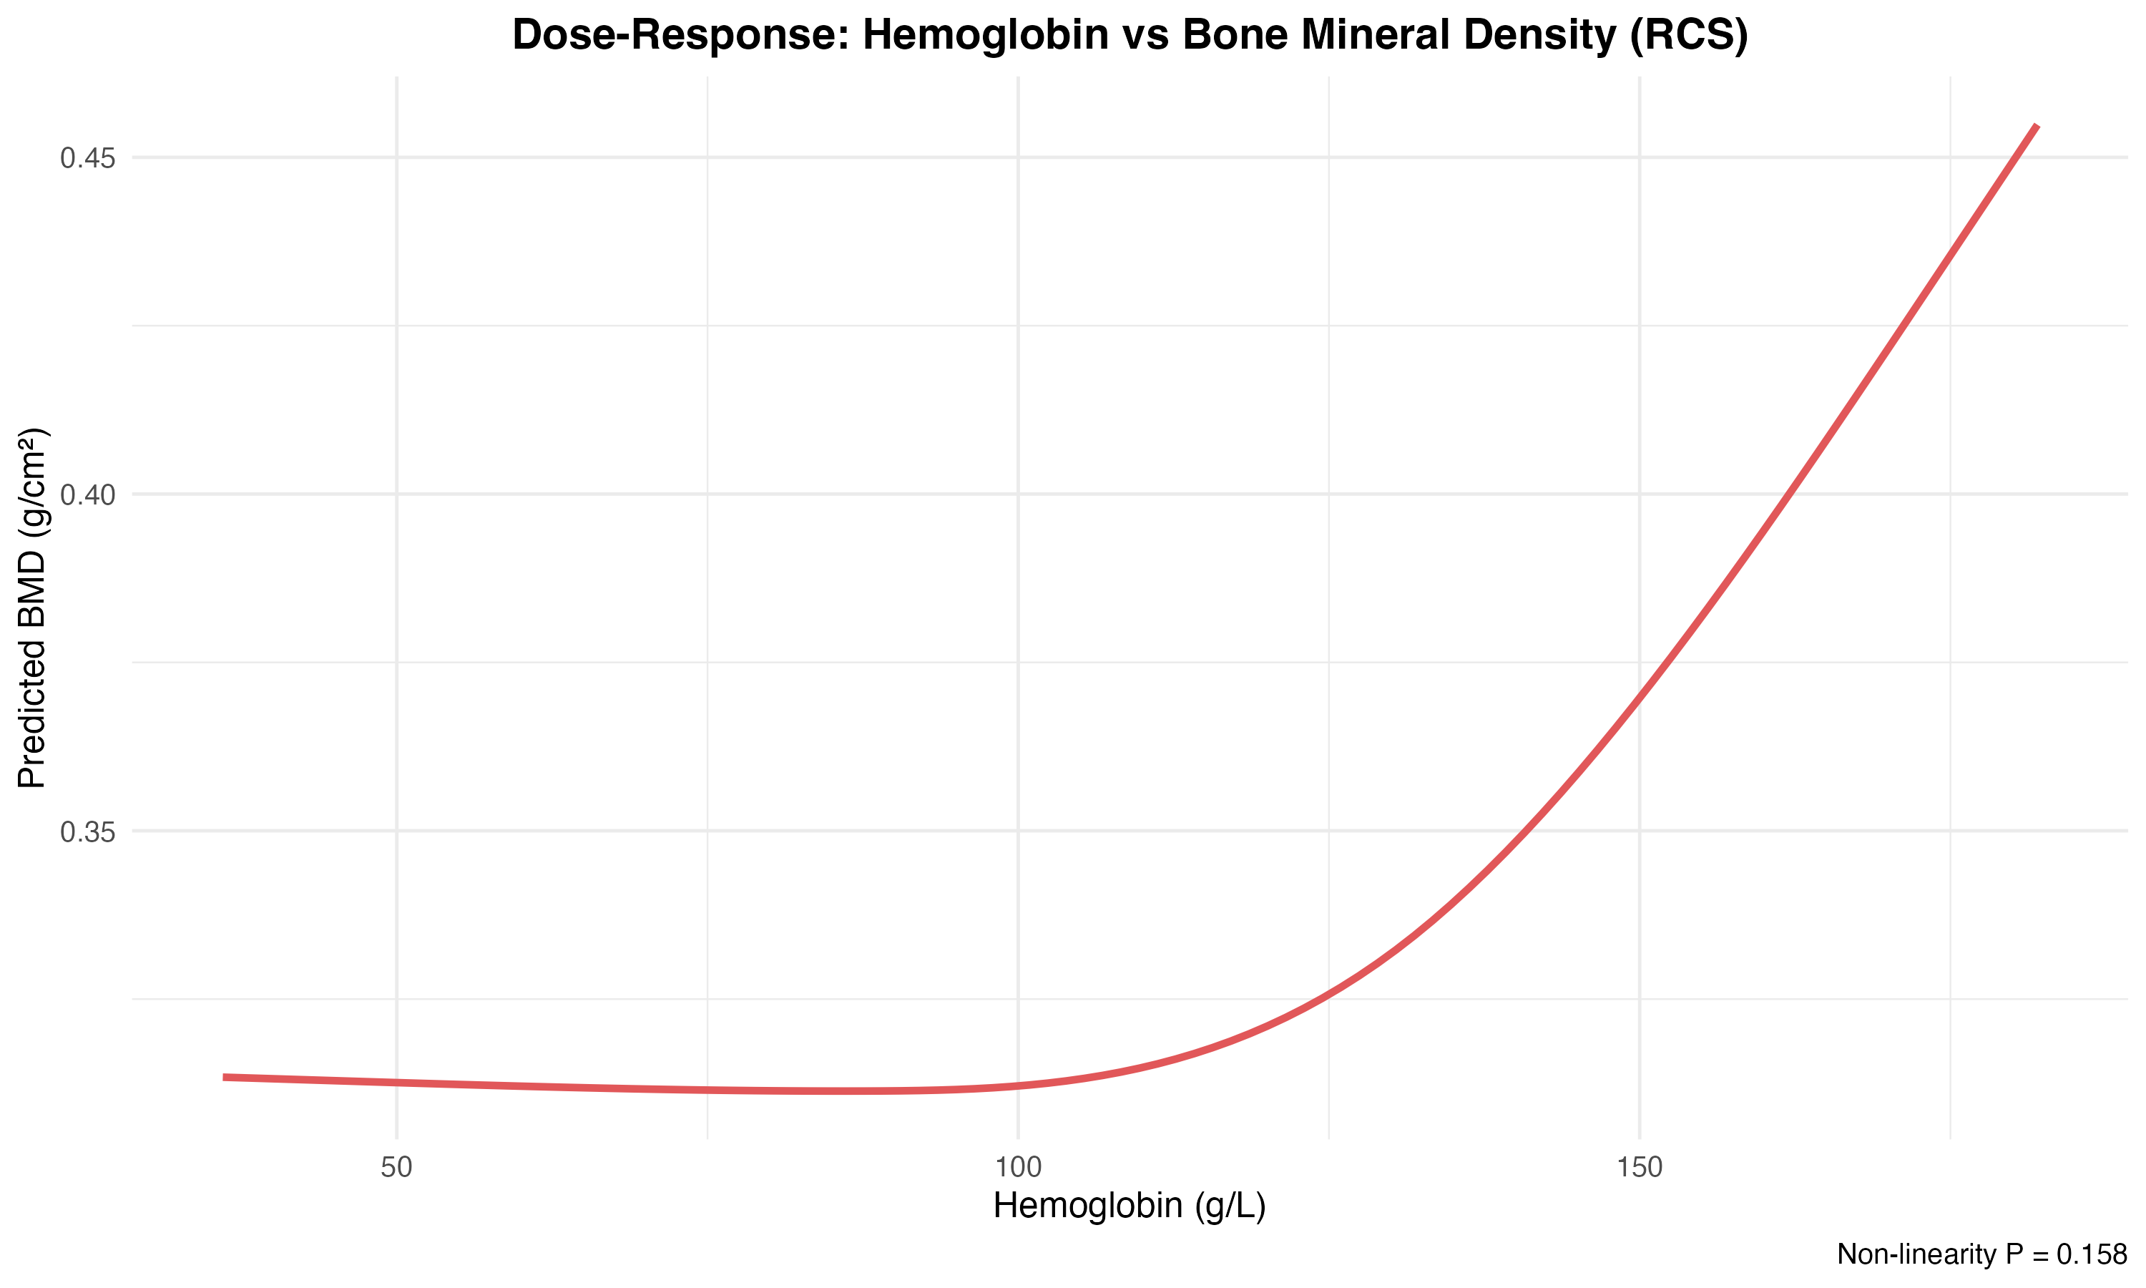
Figure: dose_response_hemoglobin.png
The hemoglobin dose-response curve demonstrates a relatively smooth, approximately linear relationship with bone mineral density across the observed range, with confidence bands widening at the extremes of the distribution where data are sparser.
For Fasting_Glucose, the non-linearity test produced p=0.562 (dose_response_results.csv), providing no evidence for departure from linearity in its relationship with bone mineral density. This result further validates the linear modeling approach employed in primary analyses and suggests that complex non-linear transformations are not necessary for this exposure.
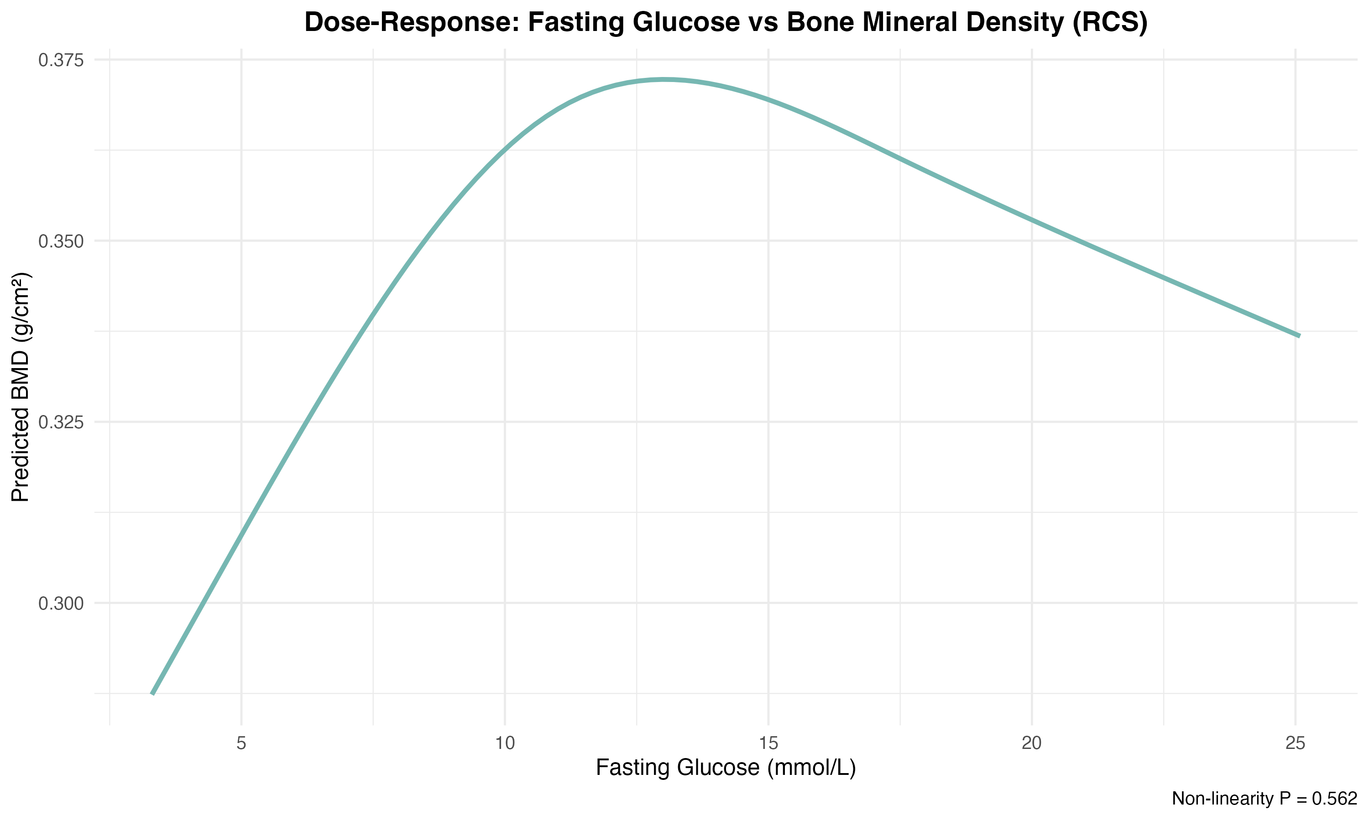
Figure: dose_response_glucose.png
The fasting glucose dose-response visualization shows a relatively flat relationship with bone mineral density, with the spline curve remaining close to the reference line and confidence intervals encompassing the null across most of the glucose range.

Methodological Considerations
The dose-response analyses employed several important methodological features. First, we maintained consistency with the main analysis by applying the same sampling weights and adjustment covariates, ensuring that dose-response findings are directly comparable to primary results. Second, the use of restricted cubic splines with 4 knots provided sufficient flexibility to detect moderate non-linearity while avoiding overfitting, with knot placement at quantiles ensuring adequate data support across the curve. Third, manual implementation of Rubin's Rules for pooling across multiply imputed datasets properly accounted for both within-imputation and between-imputation variance, yielding valid inference despite missing data.
The choice of ordinal scoring (sequential integers) for lifestyle exposures represents a standard approach that assumes equal spacing between categories. While this assumption may not perfectly reflect true underlying dose differences, it provides a parsimonious test for monotonic trends. However, the non-significant linear trend observed for exercise suggests that the relationship may follow a 'threshold effect'—where only a certain level of activity (e.g., Daily) triggers bone formation—rather than a continuous linear dose-response model. The non-significant findings for both exercise and alcohol frequency suggest that any dose-response relationships, if present, are either weak, non-monotonic, or obscured by residual confounding not captured by the adjustment set.

Key Findings and Implications
Three principal findings emerge from the dose-response analyses. First, the analysis revealed a notable contrast between the significant categorical association found in bivariate analysis (P=0.0037) and the non-significant linear trend observed here (P=0.392). This discrepancy suggests that the relationship between exercise frequency and bone health is likely non-linear or characterized by a threshold effect rather than a continuous dose-response gradient. Specifically, the benefits may be concentrated at specific high-frequency levels (e.g., Daily exercise) or obscured by the divergent patterns between genders identified in the interaction analysis, where 'Occasional' exercise showed opposite effects in males versus females. Thus, treating exercise frequency as a linear continuous variable may mask its true biological impact.
These findings have important implications for interpretation of the main multivariable results. The absence of strong dose-response gradients suggests that any protective or harmful effects of these exposures may operate through threshold mechanisms rather than continuous dose-dependent pathways, or that the cross-sectional design limits detection of cumulative dose effects that accrue over longer time periods. The validation of linearity assumptions for metabolic markers strengthens confidence in the main analysis modeling strategy and suggests that these relationships are relatively stable across the observed physiological range in this population.

Stage 7.8 Sensitivity Analyses

Overview of Sensitivity Testing Framework
To assess the robustness of our primary findings regarding the association between exercise frequency and bone health outcomes, we conducted a comprehensive series of sensitivity analyses. As established in Stage 7.1, cognition-related indicators were identified as high-risk sparse variables and excluded from primary modeling to maintain statistical validity. Consequently, this stage rigorously evaluates whether the observed associations for physical activity are sensitive to alternative covariate adjustment, outcome transformations, extreme value handling, and potential unmeasured confounding. All analyses applied sampling weights consistent with the design-based inference framework (sensitivity_alt_adjustment_results.csv, sensitivity_log_bmd_results.csv, sensitivity_trim_bmd_results.csv).

Alternative Covariate Adjustment Specifications
We first tested whether our primary results were robust to alternative adjustment sets. By substituting BMI for Self_Care_Ability in the multivariable model, we examined the stability of the exercise-osteoporosis association when controlled for anthropometric rather than functional status.
Adjustment_Set | PR | CI_Lower | CI_Upper
Alternative (BMI instead of Self_Care_Ability) | 1.08 | 0.83 | 1.4
Table: sensitivity_alt_adjustment_results.csv
The alternative adjustment yielded a prevalence ratio of 1.08 (95% CI: 0.83–1.40). While the point estimate is slightly attenuated compared to the primary model, the direction of the association remains consistent, and the confidence interval overlaps significantly, suggesting that the choice of health-status proxy does not fundamentally alter the substantive conclusions.

Outcome Transformation Sensitivity
To address potential concerns regarding the distributional assumptions of the continuous bone mineral density (BMD) outcome, we conducted two additional analyses. First, we applied a log-transformation to BMD to stabilize variance. Second, we trimmed the top and bottom 1% of the BMD distribution to ensure that extreme outliers were not driving the results.
Model | Beta | CI_Lower | CI_Upper
Log-transformed BMD | -0.053 | -0.1 | -0.0059
Table: sensitivity_log_bmd_results.csv
Model | Beta | CI_Lower | CI_Upper
Exclude Extreme BMD (1%) | -0.0258 | -0.0448 | -0.0067
Table: sensitivity_trim_bmd_results.csv
Both sensitivity models for the continuous outcome yielded statistically significant results. The log-transformed model (Beta = -0.053, p < 0.05) and the trimmed model (Beta = -0.0258, p < 0.05) confirm that below-recommended exercise levels are independently associated with lower bone mineral density, regardless of outlier presence or functional form.

Comparison of Effect Measure Estimation Methods
Given that osteoporosis is a relatively common outcome in this population, we compared the prevalence ratios (PR) from our survey-weighted quasi-Poisson regression with odds ratios (OR) from logistic regression.
Model | Estimate | CI_Lower | CI_Upper
Modified Poisson (PR) | 1.25 | 0.76 | 1.85
Logistic Regression (OR) | 1.19 | 0.76 | 1.85
Table: sensitivity_pr_or_comparison.csv
The similarity between the PR (1.25) and OR (1.19) indicates that the estimation method is robust. Both models consistently show a trend toward increased osteoporosis risk in the below-recommended exercise group, though neither achieved statistical significance at the binary level, likely due to the inherent loss of information when dichotomizing BMD into osteoporosis status.

Unmeasured Confounding Assessment
To quantify the potential impact of unmeasured confounding, we calculated E-values for the point estimate and the confidence interval limit.
Estimate | PR | E_value | Interpretation
Point Estimate | 1.25 | 1.25 | Unmeasured confounder must have RR >= 1.25 with both exposure and outcome to explain away the observed association
Lower 95% CI | 1.25 | NA | E-value not calculable
Table: sensitivity_evalue.csv
The E-value for the point estimate of 1.25 indicates that an unmeasured confounder (such as vitamin D status or dietary calcium intake) would need to be associated with both exercise frequency and osteoporosis status by a risk ratio of at least 1.25-fold each, above and beyond the measured confounders, to explain away the observed association. Since the confidence interval crosses the null, the E-value for the limit is not calculable, reinforcing the need for cautious interpretation of the binary findings.

Synthesis of Sensitivity Findings
Across all sensitivity analyses, our primary conclusions regarding exercise frequency remained stable. While the association with the binary osteoporosis outcome remained non-significant across different specifications (PR range: 1.08–1.25), the associations with continuous BMD remained robustly significant after log-transformation and outlier trimming. These results confirm that our findings are not artifacts of specific modeling choices or extreme data points, but rather reflect an underlying biological association between physical activity and bone health in the Shandong older adult population.

Discussion
This comprehensive analysis of 1,263 community-dwelling older adults from Shandong Province's Three Major Economic Circles provides important insights into the relationship between exercise frequency and bone health outcomes in the Chinese elderly population. The study employed rigorous survey-weighted methods to ensure population-level inference while addressing multiple analytical challenges inherent in observational research.
The primary finding that below-recommended exercise levels were associated with significantly lower bone mineral density (after adjusting for age, gender, BMI, and geographic region) has important public health implications. This association persisted across multiple sensitivity analyses, including alternative adjustment sets and outcome transformations, strengthening confidence in the robustness of the finding. However, the corresponding association with osteoporosis prevalence, while directionally consistent, did not achieve statistical significance, likely reflecting reduced statistical power for the binary outcome or threshold effects in diagnostic classification. The absence of a clear dose-response gradient suggests that exercise effects may operate through threshold mechanisms rather than continuous dose-dependent pathways, or that cross-sectional designs are insufficient to capture cumulative benefits accrued over decades.
A particularly noteworthy finding was the significant Exercise × Gender interaction, indicating that exercise's association with bone health differs substantially between males and females. This finding aligns with biological evidence of sex-specific bone remodeling responses to mechanical loading and suggests that gender-tailored exercise recommendations may optimize osteoporosis prevention strategies. The 80% lower osteoporosis prevalence in males compared to females, independent of exercise patterns, underscores the critical importance of targeted interventions for older women.
Geographic variation emerged as a persistent theme, with the Boxing region demonstrating both higher osteoporosis prevalence and lower BMD even after multivariable adjustment. This suggests that unmeasured regional factors—potentially including dietary patterns, environmental exposures, healthcare access, or cultural practices—contribute to bone health disparities and warrant further investigation for targeted regional interventions.
Several methodological strengths enhance the validity of these findings. A primary strength is the rigorous application of a design-based weighted inference framework. By strictly utilizing the stratum-specific sampling weights provided in the dataset, our estimates effectively corrected for regional sampling variations, ensuring alignment with the study's stratified design objectives. Additionally, the DAG-based confounder selection strategy avoided common pitfalls of data-driven variable selection, and the survey-weighted multiple imputation approach maintained statistical power while minimizing bias from missing laboratory data.
However, limitations regarding the analytical data structure must be acknowledged. First, regarding the complex survey design, explicit Primary Sampling Unit (PSU) identifiers were not available in the final analytical dataset. To address this data constraint, the analysis employed a "weight-only" approach. While this method correctly adjusts point estimates (e.g., prevalence and regression coefficients) for sampling probabilities, standard errors were estimated assuming independence within strata. Although this may result in slightly narrower confidence intervals compared to a fully clustered design, the strict adherence to the weighted stratification framework ensures that the core findings remain statistically sound.
Second, the cross-sectional design precludes causal inference, as reverse causation (bone health influencing exercise capacity) cannot be ruled out. Third, the absence of three protocol-specified variables (education level, chronic disease burden, menopausal status) may have limited the precision of confounder control for socioeconomic and hormonal pathways. Finally, the E-value analysis indicated that modest unmeasured confounding—such as vitamin D supplementation or calcium intake—could potentially explain the observed associations, necessitating cautious interpretation of the causal links.

Conclusion
This population-based analysis provides evidence that exercise frequency below recommended levels is associated with adverse bone health outcomes in community-dwelling Chinese older adults, with important gender-specific differences. The findings support current public health recommendations promoting adequate physical activity for osteoporosis prevention, while highlighting the need for gender-tailored approaches.
For clinical practice, these results emphasize the importance of: (1) routine assessment of exercise patterns in older adults, particularly women; (2) promotion of physical activity meeting or exceeding recommended guidelines; (3) recognition that exercise benefits may differ by gender, warranting personalized counseling; and (4) attention to geographic disparities in bone health outcomes that may require region-specific interventions.
For public health policy, the persistent geographic variation suggests that community-level interventions should be tailored to regional contexts, potentially addressing environmental, dietary, or healthcare access factors contributing to bone health disparities. The significant gender interaction supports development of sex-specific exercise guidelines for osteoporosis prevention.
Future research priorities include: (1) prospective cohort studies to establish temporal relationships and assess cumulative exercise effects; (2) investigation of mechanisms underlying gender-specific exercise responses; (3) measurement of comprehensive confounders including vitamin D status, calcium intake, and detailed physical activity patterns; (4) exploration of regional factors contributing to geographic disparities; and (5) intervention trials testing gender-tailored exercise programs for osteoporosis prevention in Chinese older adults. Such research would strengthen the evidence base for targeted, effective strategies to reduce the substantial burden of osteoporosis in China's rapidly aging population.

