inspection-reconcile User Guide
  - Inspection documentation readiness, with a read-only Quickbase adapter
Bo Chen
2026-10-09
Table of Contents

1 About this guide

1.1 Who it is for
This guide is for the person who runs an assessment and acts on what it finds: a documentation coordinator preparing a package for review, a QA reviewer checking it, or a project manager who needs to know what still blocks it. It assumes no programming knowledge beyond typing a command in a terminal.
The Administrator Guide covers installation on a server, the input formats, requirement packs, the Quickbase connection, security and operations.

1.2 What you need
- A computer running Windows, macOS or Linux, with Python 3.12 or later and uv, a fast Python package manager.
- A copy of the repository.
- For your own projects: a captured snapshot or a Quickbase-shaped export, and the requirement pack that applies (your administrator provides both). For learning, the repository ships 24 ready-made scenarios.

1.3 Conventions
Commands are shown as you type them from the repository's top folder. A line ending in \ continues on the next line; in PowerShell, either type the command on one line or end the line with a backtick instead.
uv run inspection-reconcile --version # prints: inspection-reconcile 0.1.0
uv run runs the tool inside the project's own environment, so nothing is installed system-wide. Names in CAPITALS_WITH_UNDERSCORES, such as NO_CURRENT_INSPECTION, are reason codes: each one has a fixed meaning, explained in The eight checks.
Note. Every example uses the fictional North Creek project (NC-001), with 40 obligations. The data is synthetic; no real organization's data appears in this guide or in the repository.

2 What the tool does

2.1 The question it answers
inspection-reconcile answers one question about a project's inspection documentation: is this package ready to be reviewed? It compares the work a project requires with the inspection records, documents and approvals that were actually captured, and it explains every gap with the source rows that show it.
It is deterministic: the same inputs always give the same verdict, byte for byte, on every operating system. It is also read-only: it never changes a source system.

2.2 Three facts behind the design
- Valid rows are not complete work. Thirty-nine valid inspection records cannot satisfy forty obligations. The expected work therefore comes from an independently accepted scope, never from the records being checked.
- Absence from a partial view is not absence. A missing record proves nothing unless the capture is known to be complete. The tool keeps an established failure separate from could not determine.
- Approvals go stale. An approval covers a specific inspection revision and specific evidence bytes. A later change to either is detected.

2.3 What READY_FOR_REVIEW means, and what it never means
READY_FOR_REVIEW means that every required check passed, for the accepted scope and the captured snapshot. The documentation package is complete, consistent and approved as captured, so a reviewer can start.
Important. READY_FOR_REVIEW is not approval. It is not a judgment of physical inspection quality, of regulatory compliance, or of whether the work in the field was done well. A hash proves which bytes were reviewed; it does not prove authorship or truthfulness.

2.4 What goes in, what comes out
goes in | comes out
the accepted scope: the obligations, with a revision and an acceptance record | assessment.json: the verdict and every finding, machine-readable
the inspection records, the artifact inventory (documents, photos) and the evidence files | report.html: a self-contained report for people
the approval decisions, each bound to an inspection revision and to evidence | run-manifest.json: which input files were read, and their digests
a requirement pack: which documents each kind of inspection needs | comparison.json (from compare): what changed between two runs
a snapshot manifest: what was captured, and how complete each part is

3 Quick start

3.1 Install
git clone https://github.com/bochen2029-pixel/inspection-reconcile.git
cd inspection-reconcile
uv sync
uv sync creates the project environment and installs the two runtime dependencies. It takes a few seconds.

3.2 Run the demonstration
uv run inspection-reconcile demo --all --out out/demo
The demonstration assesses all 24 fixture scenarios, checks each result against a hand-written expected answer (the oracle), and prints one line per scenario:
S01-clean READY_FOR_REVIEW matches oracle
S02-missing-inspection BLOCKED matches oracle
S03-wrong-project-evidence BLOCKED matches oracle
...
S24-scope-not-accepted UNKNOWN matches oracle
It exits with code 0 when every scenario matches its oracle.

3.3 Open the results
Open out/demo/index.html in a browser. Each scenario links to its own report.
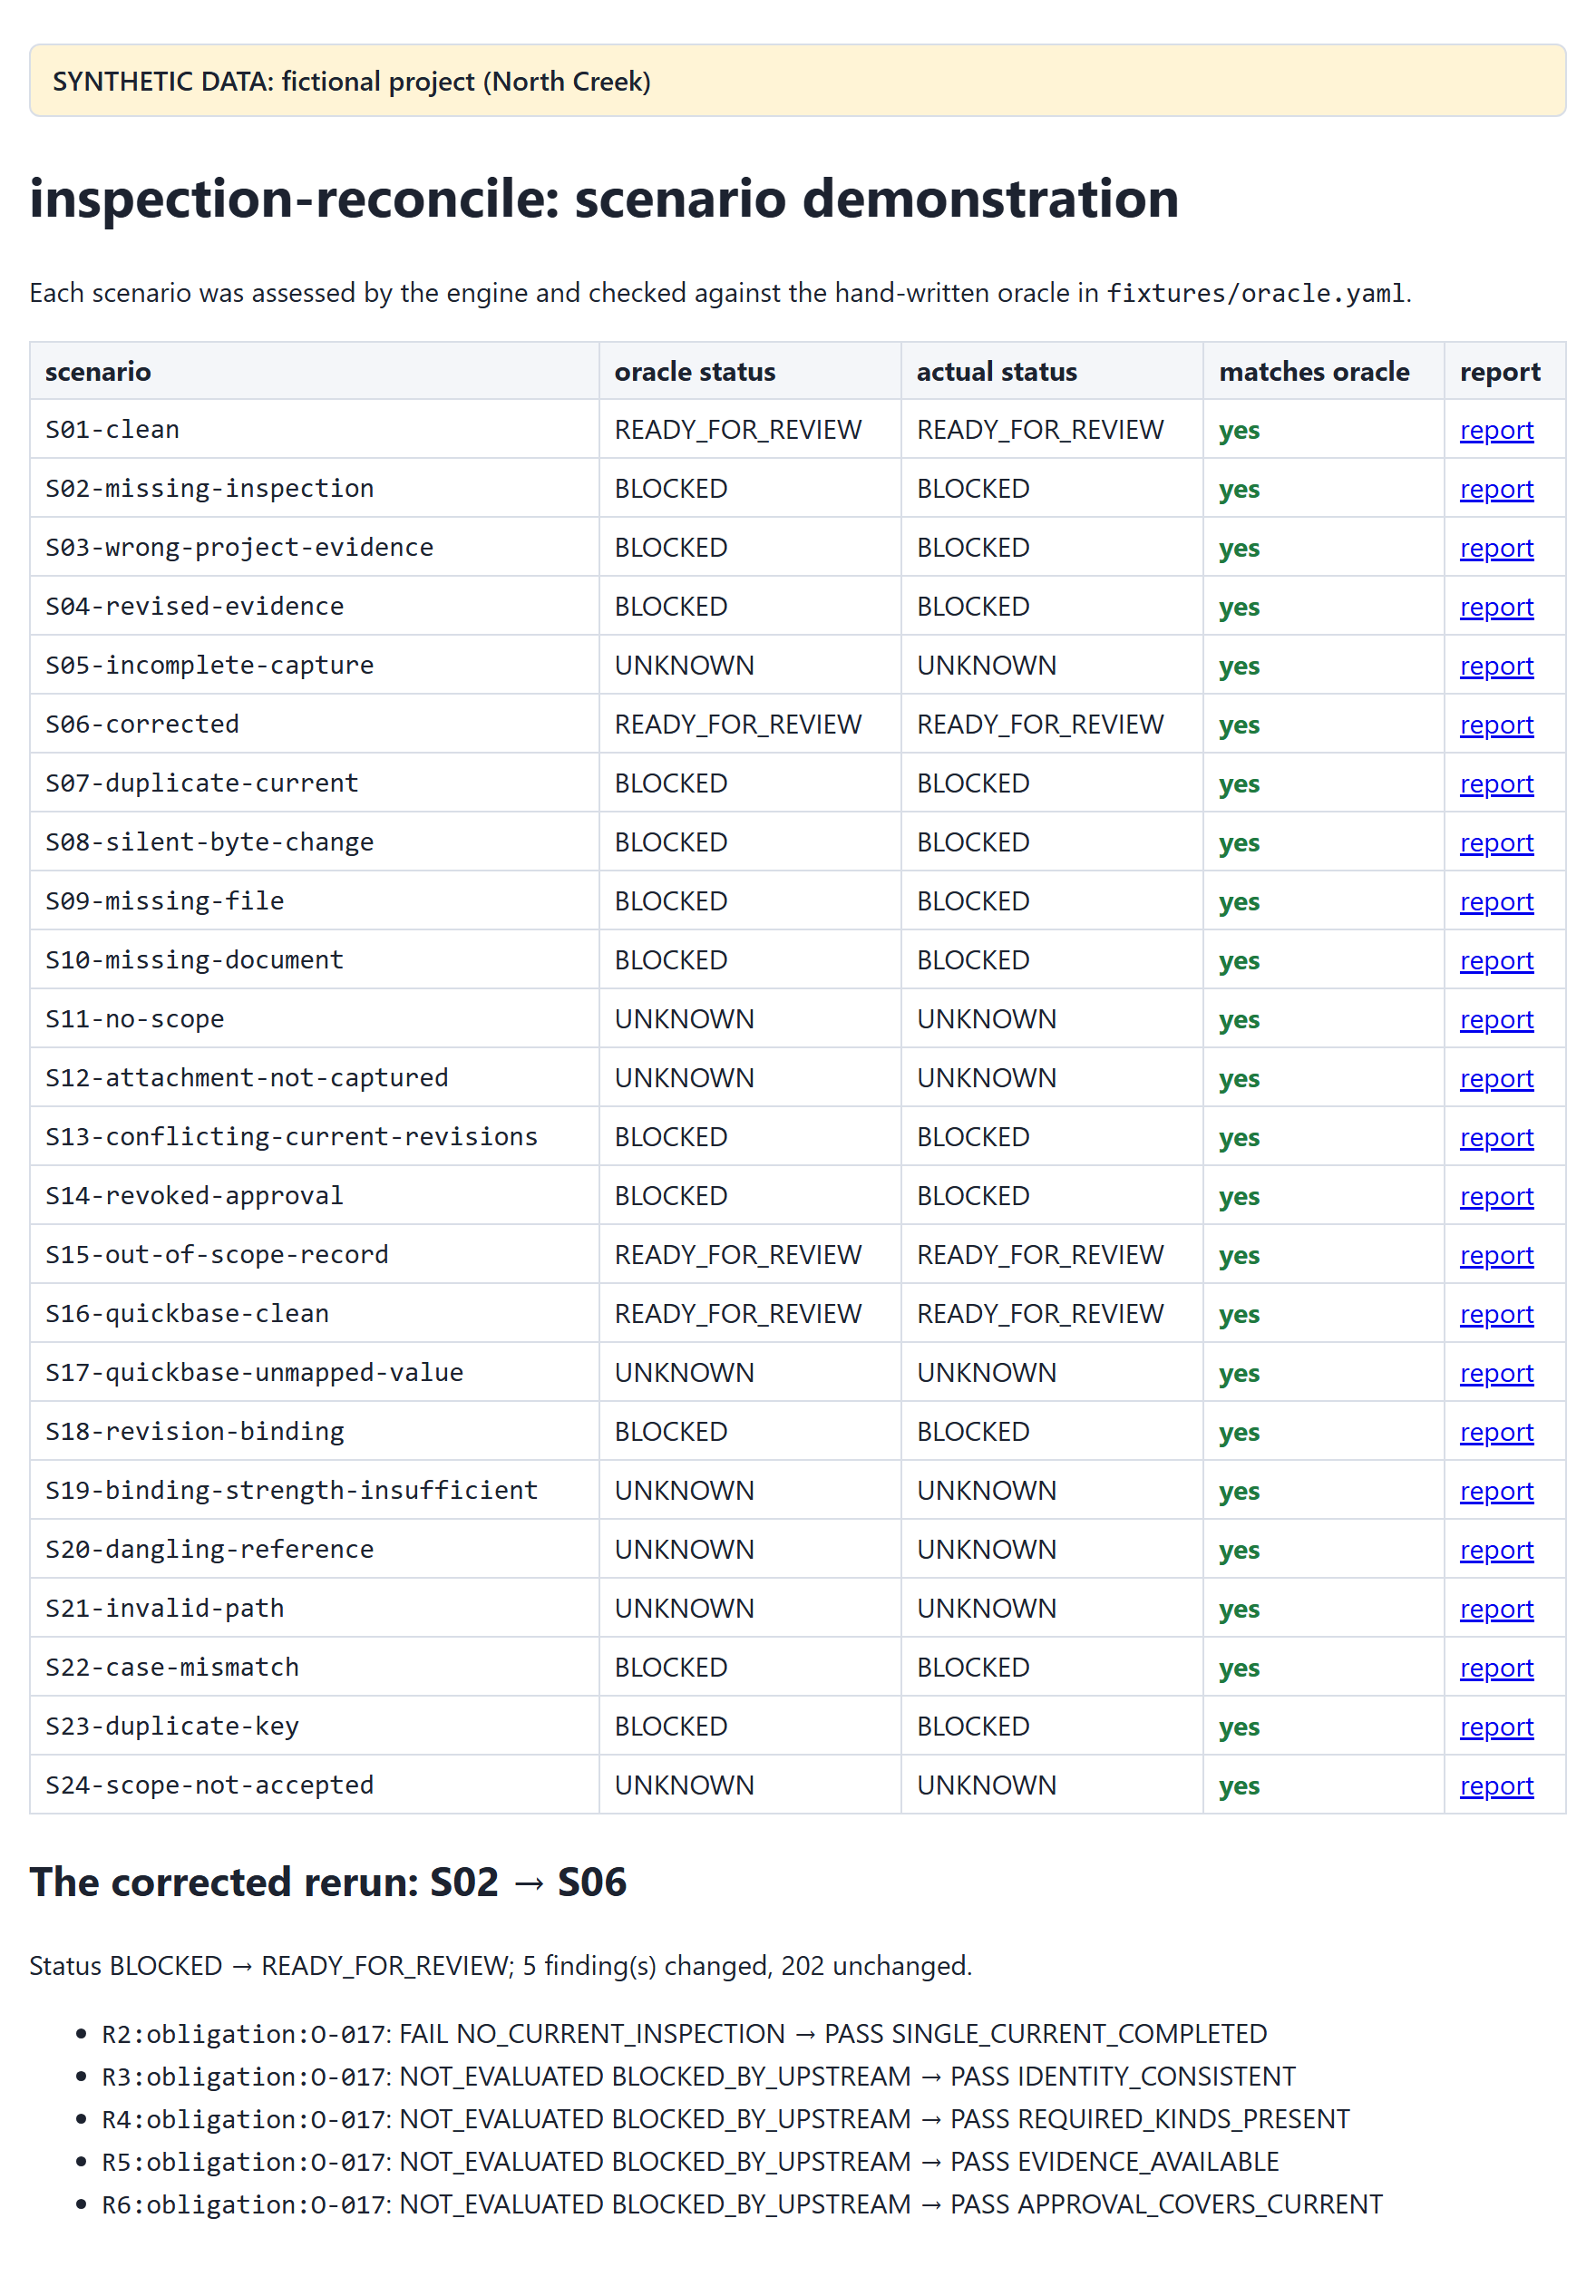
Start with S02, the classic case: one inspection was never recorded.
Tip. The same reports are published online at bochen2029-pixel.github.io/inspection-reconcile, rebuilt from the main branch after every successful test run, so you can browse them before installing anything.

4 Key ideas

4.1 Obligations, records and evidence
- An obligation is one piece of required work: an activity (for example visual_inspection) on an asset, in a project. The accepted scope lists them; North Creek has 40, O-001 to O-040.
- An inspection record says the work was done. It links to its obligation, has a revision, and is either the current revision or a superseded one.
- An artifact is a document or photo attached to an inspection. Its file lives in the snapshot's evidence folder and is identified by its content digest (SHA-256).
- An approval is a reviewer's decision (approved, rejected or revoked) on an inspection revision. It records which evidence it covers, either as one evidence digest or as the list of artifact revisions it saw.

4.2 Outcomes: PASS, FAIL, UNKNOWN, NOT_EVALUATED
Every check produces a finding with one of four outcomes:
outcome | meaning
PASS | the requirement holds, whatever records might still be missing from the capture
FAIL | the requirement fails, whatever records might still be missing: an established defect
UNKNOWN | the captured data cannot decide; the finding says what would resolve it
NOT_EVALUATED | not run, because a prerequisite did not pass; blocked_by names the prerequisite

4.3 Why UNKNOWN is not PASS
Suppose a capture stopped halfway, and obligation O-037 has no inspection in it. The inspection may simply be among the records that were not captured. Calling that FAIL would be an accusation the data cannot support; calling it PASS would hide a real gap. The honest answer is UNKNOWN, with the reason ABSENCE_UNCONFIRMED and the coverage problem that caused it.
The same logic works the other way. One captured, complete inspection proves the work was recorded, but under a partial capture a second, conflicting current inspection could still exist. So "exactly one" stays UNKNOWN (CARDINALITY_UNCONFIRMED) until the capture is known to be complete.

4.4 Project status
The project status is computed from the required findings only:
status | when
BLOCKED | any required finding is FAIL
UNKNOWN | no FAIL, but some required finding is UNKNOWN or NOT_EVALUATED
READY_FOR_REVIEW | every required finding is PASS
One check, R7 (records outside the scope), is advisory: it is reported but never changes the status.

4.5 Roots, dependencies and blocked_by
The checks build on each other. If an obligation has no inspection (R2 fails), there is nothing to check the identity, the documents or the approval of, so R3 to R6 are NOT_EVALUATED, and each names its prerequisite in blocked_by.
A root is a required FAIL or UNKNOWN that no other finding caused. Roots are what you fix; everything else follows. The report lists roots first, and shows for each one how many findings it blocks.
Tip. Work through the roots, re-capture, and re-run. A dependent finding usually resolves by itself once its root is fixed. The tool shows one problem at a time per obligation: a second, independent problem appears only after the first is fixed.

4.6 Coverage: how complete is the capture?
Every captured dataset (inspections, artifacts, approvals, evidence files) carries a coverage claim: complete_for_declared_scope, partial or unverified, together with the basis for the claim, for example query_total_matched, two_pass_stable and operator_attestation for a verified Quickbase read. The requirement pack lists which bases it accepts. A dataset counts as complete only when its claim is complete and its basis is accepted and nothing in the data contradicts it.
Incomplete coverage turns absences into UNKNOWN rather than FAIL. That is exactly fact 2 above.

4.7 Requirement packs
A requirement pack is a small, versioned YAML file. It says which document kinds each activity needs (North Creek's visual inspections need an inspection_report and a photo), which coverage bases are acceptable, and how approvals must bind to evidence: digest (the content of the files) or revisions (their revision labels). The demonstration ships two packs, policies/north-creek-demo.yml (digest binding) and policies/north-creek-revisions.yml.

5 Running an assessment

5.1 From a canonical snapshot
uv run inspection-reconcile assess \
--snapshot fixtures/scenarios/S02-missing-inspection/snapshot \
--policy policies/north-creek-demo.yml \
--out out/s02
The command prints one summary line and exits with a code that states the result:
BLOCKED roots: FAIL=1 UNKNOWN=0 not_evaluated=4 evaluation_id=sha256:bf6a33fe8f6f…
part | meaning
BLOCKED | the project status
roots: FAIL=1 UNKNOWN=0 | one root failure, no root unknowns
not_evaluated=4 | four required findings were not evaluated, because a prerequisite did not pass
evaluation_id=sha256:bf6a… | the identity of this evaluation: same inputs, same pack, same time, same id

5.2 From a Quickbase-shaped export
An export captured from Quickbase is read through a field mapping that says which Quickbase field holds which value. The tool normalizes it into a temporary snapshot, assesses it, and removes the temporary folder:
uv run inspection-reconcile assess \
--export fixtures/scenarios/S16-quickbase-clean/export \
--mapping mappings/quickbase-demo.yml \
--policy policies/north-creek-demo.yml \
--out out/s16
READY_FOR_REVIEW roots: FAIL=0 UNKNOWN=0 not_evaluated=0 evaluation_id=sha256:4b0013671cdc…
S16 holds the same data as the canonical scenario S01, so it receives the same evaluation_id.

5.3 The summary line and the exit code
Scripts and schedulers can act on the exit code alone:
exit code | meaning
0 | READY_FOR_REVIEW (assess), no difference (compare), every scenario matched (demo), or success
10 | BLOCKED
11 | UNKNOWN
2 | run error: a usage, configuration or input problem; nothing is written
20 | compare found semantic differences
30 | demo: at least one scenario did not match its oracle
assess always writes its outputs before it exits with 10 or 11. Exit code 1 is never used on purpose.

5.4 What gets written
--out names a folder. After a successful run it contains:
file | for | contents
report.html | people | the report described in the next chapter; one self-contained file that opens offline
assessment.json | systems | the status, the coverage table, the counts and every finding, in a fixed order
run-manifest.json | audit | the input files that were read, with their sizes and SHA-256 digests, the tool version and the time of the run
assessment.json and report.html are byte-identical for the same inputs, on every operating system. Only run-manifest.json records when and where the run happened.

5.5 Output folders and --force
The --out folder must be absent or empty. To re-run into the same folder, add --force: the tool then replaces its own output files and leaves anything else there untouched.
uv run inspection-reconcile assess --snapshot fixtures/scenarios/S02-missing-inspection/snapshot \
--policy policies/north-creek-demo.yml --out out/s02 --force
Note. --force never deletes anything outside --out, and never deletes a file it did not write itself.

5.6 Checking inputs before a run: validate
validate loads every file, checks the configuration, and lists the record-level defects that assess would report under R0, without writing anything:
uv run inspection-reconcile validate \
--snapshot fixtures/scenarios/S23-duplicate-key/snapshot \
--policy policies/north-creek-demo.yml
R0:inspection:INS-004@1#DUPLICATE_KEY FAIL DUPLICATE_KEY required
assessable: 1 record-level defect(s) would be reported under R0
It exits 0 when the inputs can be assessed and 2 when a configuration problem must be fixed first.

6 Reading the report
report.html is a single file with no scripts and no external resources: it opens offline, prints cleanly, and can be attached to an email or a ticket as it is. Status colors always come with text labels. The sections appear in the order below.

6.1 The header
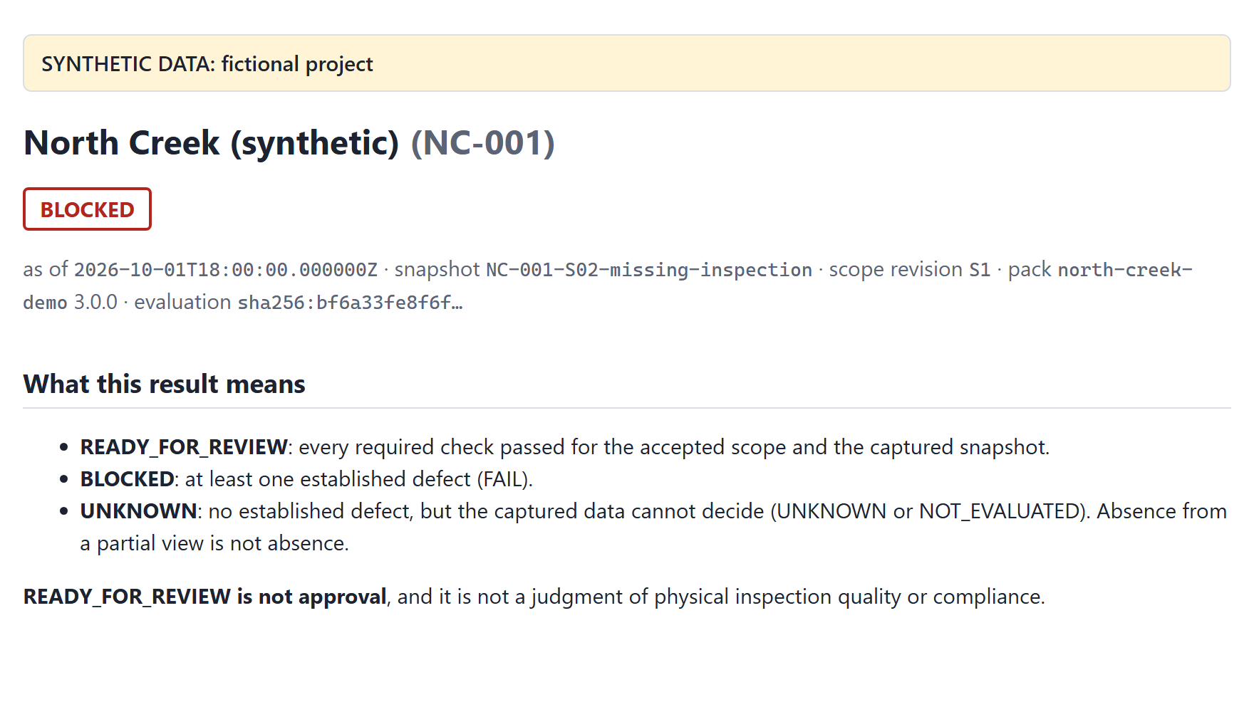
A yellow banner marks synthetic data. Below the project name come the status, then one line of context:
- as of: the evaluation time. By default it is the end of the capture; --as-of sets another.
- snapshot: the identifier of the captured snapshot.
- scope revision: the accepted scope that defines the expected work.
- pack: the requirement pack and its version.
- evaluation: the shortened evaluation_id. Hover over it for the full value.

6.2 What this result means
This section restates the three statuses in plain language, and that READY_FOR_REVIEW is not approval. It is the same on every report, so a reader who receives only the report has the definitions at hand.

6.3 Coverage
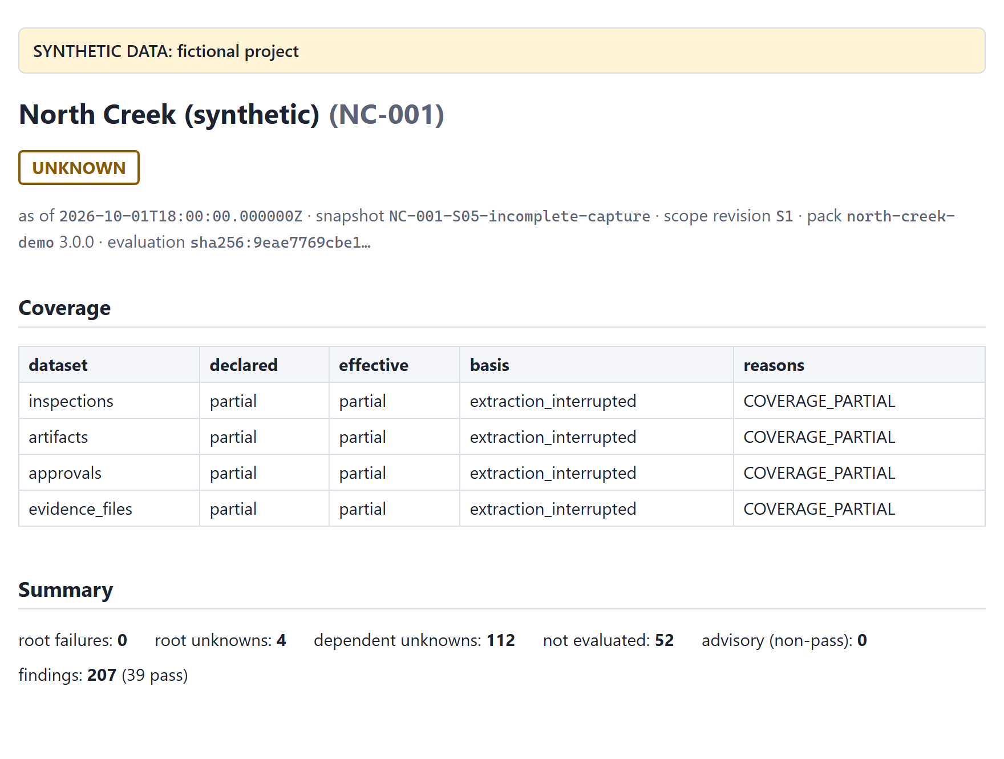
One row per dataset:
column | meaning
declared | what the snapshot manifest claims: complete_for_declared_scope, partial or unverified
effective | what the tool accepts after checking the basis and the data; this is the value the checks use
basis | the evidence behind the claim, for example synthetic_universe or query_total_matched
reasons | why the effective value is weaker than claimed, if it is
When effective is not complete_for_declared_scope, absences in that dataset become UNKNOWN instead of FAIL.

6.4 Summary counts
count | meaning
root failures | required FAILs that nothing else caused: established defects to fix
root unknowns | required UNKNOWNs that nothing else caused: usually a coverage gap or an unreadable value
dependent unknowns | UNKNOWNs that follow from a coverage root; they resolve when the root does
not evaluated | required checks skipped because a prerequisite did not pass
advisory (non-pass) | findings that never change the status, such as R7
findings | the total, with the number that passed

6.5 Root findings
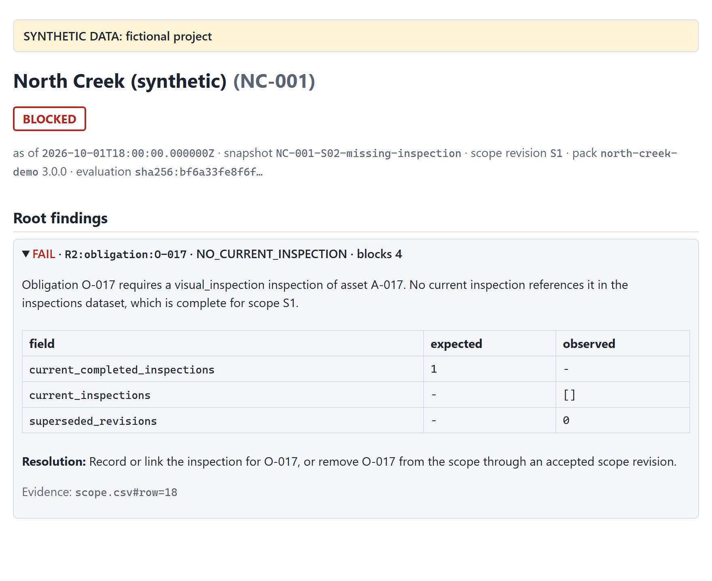
Each root is a collapsible panel, FAIL first, then UNKNOWN. The first three are open. Each one shows:
- the explanation, built from the actual values;
- an expected versus observed table, with the canonical values the check compared;
- the resolution: what would fix the finding, or what information would resolve it;
- the evidence: locators of the source rows, such as scope.csv#row=18, or table=bsyn00002;rid=117 for a Quickbase record;
- blocks N: how many findings depend on this one, directly or through others.

6.6 The obligation grid
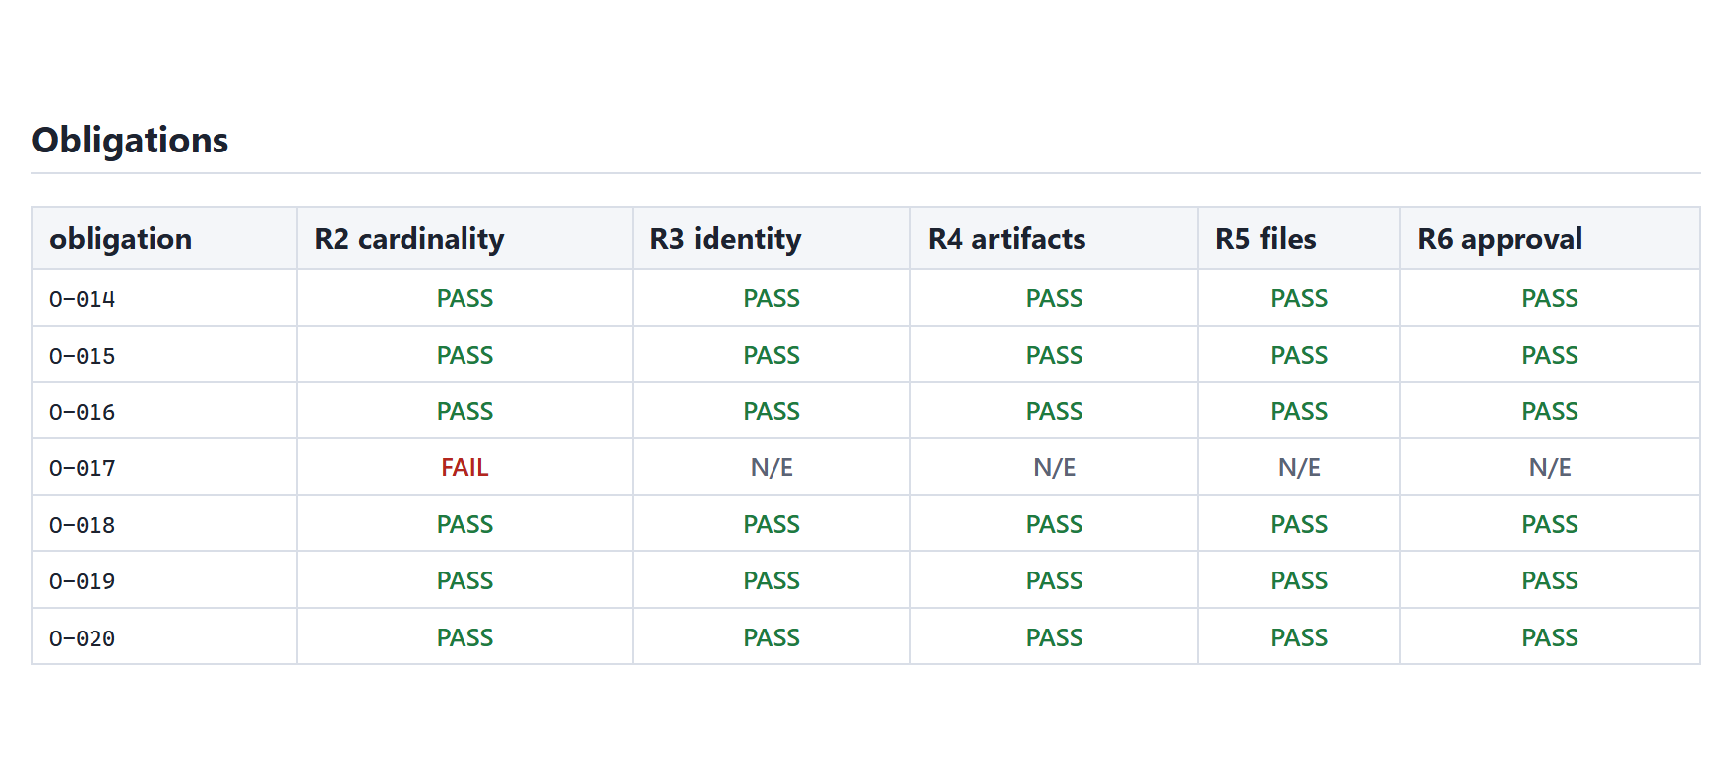
One row per obligation, one column per check from R2 to R6. Cells read PASS, FAIL, UNK or N/E (not evaluated). Hover over a cell to see the reason code. The grid is the quickest way to see whether a problem is isolated or widespread.

6.7 All findings
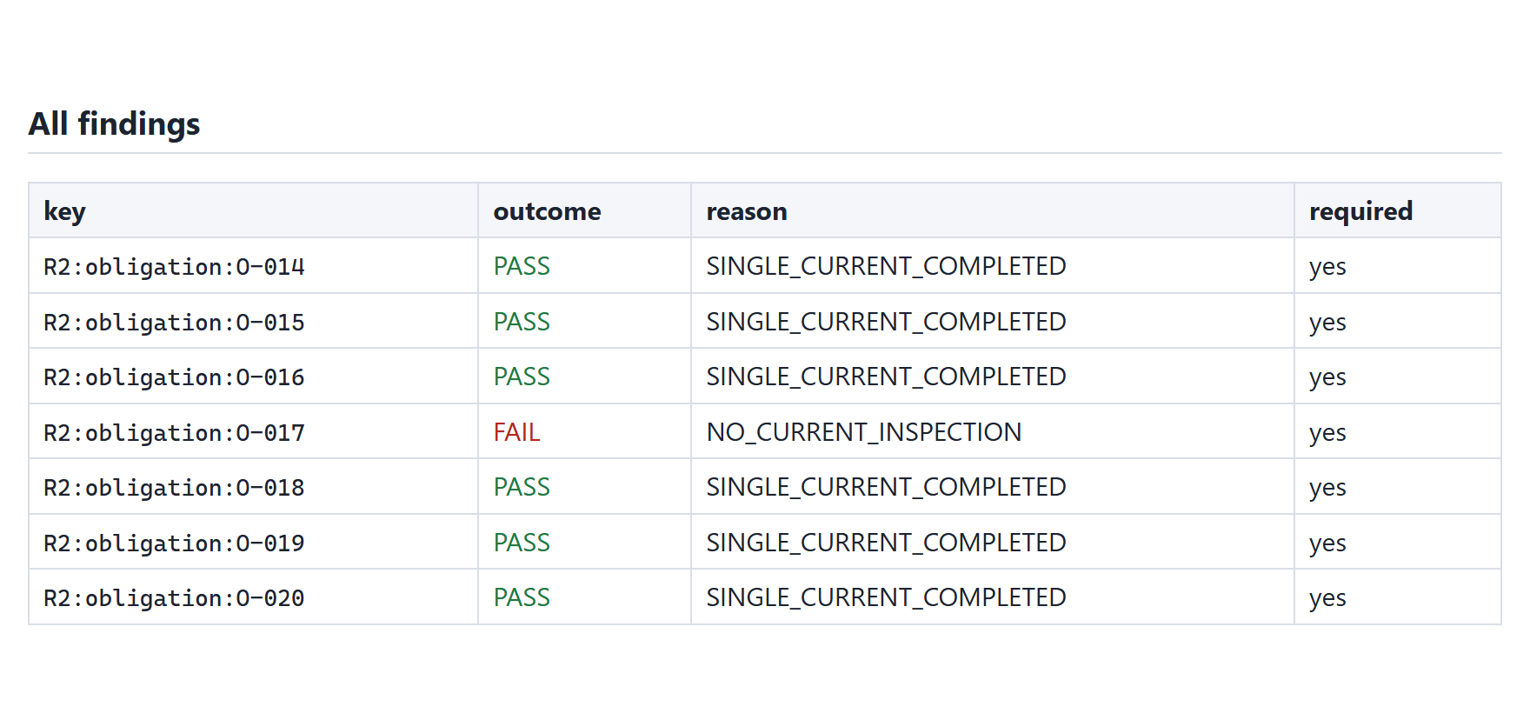
Every finding, in a fixed order: by check (R0 to R7), then by subject. Each row shows the finding's key, its outcome, its reason and whether it is required. A key such as R2:obligation:O-017 reads "check R2, for the obligation O-017". It is stable between runs, which is how compare matches findings.

6.8 Provenance
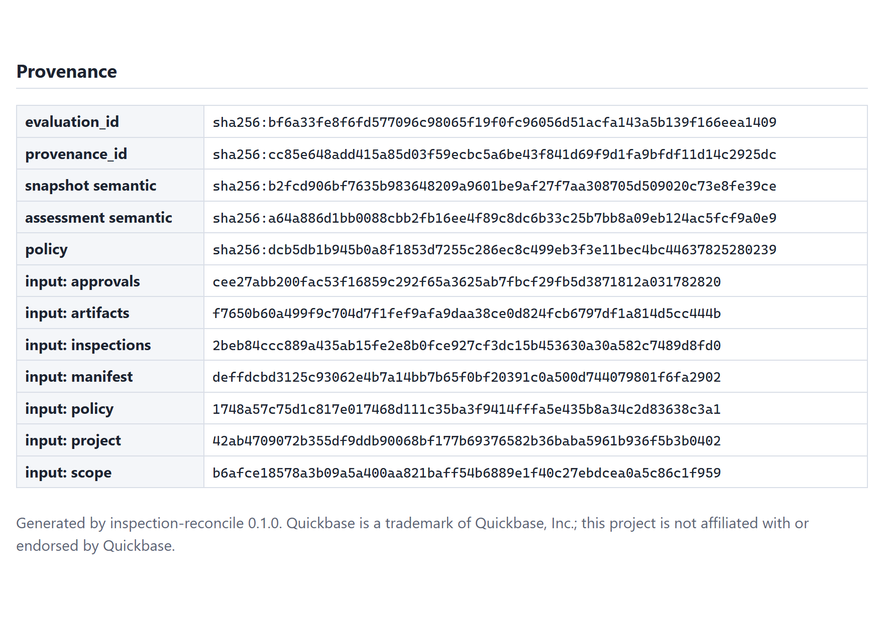
The digests that identify exactly what was assessed:
value | identifies
evaluation_id | the meaning of the run: the engine version, the pack, the snapshot's content and the evaluation time. Equal inputs always give an equal id, even if the rows are shuffled or come from an export
provenance_id | the exact input bytes that were read, as listed in run-manifest.json
snapshot semantic | the snapshot's content alone
assessment semantic | the findings alone; two runs with the same value have the same findings
policy | the requirement pack's content
input: … | each input file's SHA-256 digest

6.9 The assessment file
assessment.json holds everything the report shows, for other systems to consume. Each finding has the same fields in the same order: key, check_id, check_type, required, subject, outcome, reason, expected, observed, explanation, resolution, blocked_by, caused_by and evidence.

7 The eight checks
Each check is described below with the findings it can produce and what to do about each. The resolution text is the same one the report prints.

7.1 R0 · Input integrity
Are the captured records themselves sound? R0 looks for duplicate keys, conflicting current revisions, invalid values, unsafe file paths and references to records that do not exist. A defective row is quarantined: it is reported and kept out of the other checks, never guessed at.
code | outcome | meaning | what to do
INTEGRITY_OK | PASS | no record-level defect anywhere | nothing
DUPLICATE_KEY | FAIL | the same key appears more than once | remove or correct the duplicate records in the source
MULTIPLE_CURRENT_REVISIONS | FAIL | two revisions of one inspection or artifact are both marked current | mark exactly one revision current
COMPLETED_WITHOUT_TIMESTAMP | FAIL | a current, completed inspection has no completion time | record the completion time
INVALID_VALUE | UNKNOWN | a value does not match its type, for example an ID with a trailing space | correct the value in the source, or the mapping
UNMAPPED_VALUE | UNKNOWN | a Quickbase choice the field mapping does not know | confirm the value's meaning and extend the mapping's value map
INVALID_PATH | UNKNOWN | a file path that is unsafe or malformed; the file is never opened | correct the inventory path
MALFORMED_ROW | UNKNOWN | a CSV row with the wrong number of fields | repair the row in the source export
TIMESTAMP_AFTER_AS_OF | UNKNOWN | a completion or decision time later than the evaluation time | check the time zone, the source value or the capture time
DANGLING_REFERENCE | UNKNOWN | a record refers to one that is absent from a dataset declared complete | capture the referenced record, or correct the reference
An R0 finding is required when it concerns a record of an in-scope obligation, or a record that cannot be attributed to any obligation. A finding about a record outside the scope is advisory.

7.2 R1 · Scope and coverage
Is there an accepted scope, and how complete is each dataset? R1 produces one finding for the project and one per dataset.
code | outcome | meaning | what to do
SCOPE_ESTABLISHED | PASS | an accepted scope lists the obligations | nothing
SCOPE_MISSING | UNKNOWN | no scope was supplied; nothing can be assessed | supply the accepted scope
SCOPE_NOT_ACCEPTED | UNKNOWN | the scope has no acceptance record | record who accepted the scope, and when
SCOPE_INVALID, SCOPE_EMPTY, SCOPE_REVISION_MISMATCH, SCOPE_PROJECT_MISMATCH | UNKNOWN | the scope rows cannot be identified, are empty, or disagree with the pack or the project | correct the scope, or align its revision with the pack
COVERAGE_COMPLETE | PASS | the dataset is complete for the declared scope, on an accepted basis | nothing
DATASET_MISSING | UNKNOWN | the dataset was not supplied | capture it
COVERAGE_PARTIAL, COVERAGE_UNVERIFIED | UNKNOWN | the capture is declared partial or unverified | capture the dataset completely, with a basis the pack accepts
COVERAGE_BASIS_NOT_ACCEPTED | UNKNOWN | declared complete, on a basis the pack does not accept | re-capture with an accepted basis, or amend the pack deliberately
CHANGED_DURING_CAPTURE | UNKNOWN | records changed while the capture ran | re-capture when the source is stable
COVERAGE_CONTRADICTED, UNATTRIBUTABLE_RECORDS | UNKNOWN | the data contradicts the completeness claim | capture the missing records, or correct the rows
When the project finding is not PASS, every per-obligation check is NOT_EVALUATED: without a scope there is no expected work to compare against.

7.3 R2 · Inspection cardinality
Does each obligation have exactly one current, completed inspection?
code | outcome | meaning | what to do
SINGLE_CURRENT_COMPLETED | PASS | exactly one current inspection, and it is completed | nothing
NO_CURRENT_INSPECTION | FAIL | no current inspection references the obligation, and the inspections are complete | record or link the inspection, or remove the obligation through an accepted scope revision
MULTIPLE_CURRENT | FAIL | two or more current inspections reference it | mark superseded inspections not current, or correct their links
NOT_COMPLETED | FAIL | the current inspection is not completed | complete the inspection, or correct its status
ABSENCE_UNCONFIRMED | UNKNOWN | none captured, but the inspections are not complete | capture the complete inspections dataset
CARDINALITY_UNCONFIRMED | UNKNOWN | one captured, but another could exist uncaptured | capture the complete inspections dataset

7.4 R3 · Identity consistency
Do the inspection and its documents name the obligation's project, asset and activity? A report filed against the wrong asset is caught here.
code | outcome | meaning | what to do
IDENTITY_CONSISTENT | PASS | the inspection and its current documents all match | nothing
INSPECTION_PROJECT_MISMATCH, INSPECTION_ASSET_MISMATCH, INSPECTION_ACTIVITY_MISMATCH | FAIL | the inspection names another project, asset or activity | correct the inspection, or link it to the correct obligation
ARTIFACT_PROJECT_MISMATCH, ARTIFACT_ASSET_MISMATCH | FAIL | an attached document names another project or asset | attach the correct document, or correct the artifact
IDENTITY_UNCONFIRMED | UNKNOWN | no conflict found, but the artifacts are not complete | capture the complete artifacts dataset

7.5 R4 · Required artifacts
Is there a current document of every kind the pack requires?
code | outcome | meaning | what to do
REQUIRED_KINDS_PRESENT | PASS | every required kind is present | nothing
KIND_MISSING | FAIL | a required kind is missing, and the artifacts are complete | attach the missing document, or correct its kind or current flag
KIND_ABSENCE_UNCONFIRMED | UNKNOWN | a required kind was not captured, but the artifacts are not complete | capture the complete artifacts dataset
REQUIREMENT_UNDEFINED | UNKNOWN | the pack defines no documents for this activity | add requirements for the activity to the pack

7.6 R5 · Artifact availability
Can every required file be read and hashed? File names are matched exactly, including letter case, on every operating system, so a result never depends on where the tool runs.
code | outcome | meaning | what to do
EVIDENCE_AVAILABLE | PASS | every required file was read and hashed | nothing
FILE_ABSENT | FAIL | a required file is not in the evidence, which is complete | restore the file, or correct the inventory path
NOT_CAPTURED | UNKNOWN | a required file was not captured; the evidence is partial | capture the file, or confirm its absence in the source
FILE_UNREADABLE | UNKNOWN | the file exists but could not be read | fix the file's permissions or format, then re-run
FILE_TOO_LARGE | UNKNOWN | the file exceeds the pack's size limit | raise the limit deliberately, or review the file separately
AVAILABILITY_UNCONFIRMED | UNKNOWN | every captured file was available, but other required artifacts could exist | capture the complete artifacts dataset
When a file is absent only because of letter case (Photo.png against photo.png), the explanation says so: "A file differing only in letter case exists".

7.7 R6 · Approval binding
Does the latest approval cover the current inspection revision and the current evidence?
code | outcome | meaning | what to do
APPROVAL_COVERS_CURRENT | PASS | the latest decision approves the current revision and evidence | nothing
NO_APPROVAL | FAIL | there is no decision at all, and the approvals are complete | obtain a review decision
REVISION_NOT_APPROVED | FAIL | approvals exist, but only for older revisions | obtain approval for the current revision
EVIDENCE_CHANGED_SINCE_APPROVAL | FAIL | the decisions bind different evidence: it changed after approval | re-review the current evidence, or restore the approved version
APPROVAL_REJECTED, APPROVAL_REVOKED | FAIL | the latest decision on the current evidence is a rejection or a revocation | resolve the reviewer's decision
APPROVAL_UNCONFIRMED | UNKNOWN | the approvals are not complete; a later decision could exist | capture the complete approvals dataset
BINDING_UNAVAILABLE | UNKNOWN | the approval does not record which evidence it covers | record the evidence digest, or the approved artifact revisions
BINDING_STRENGTH_INSUFFICIENT | UNKNOWN | the approval binds revisions only, but the pack requires a digest | record the evidence digest, or use a pack that accepts revision binding
CONFLICTING_DECISIONS | UNKNOWN | decisions with the same timestamp disagree | correct the decision records
Digest binding and revision binding. With digest binding, the default, an approval stores one evidence digest: a SHA-256 over the content of every required file. Change one byte of one photo and the digest no longer matches. With revision binding, an approval lists the artifact revisions it saw. That is weaker: a file replaced under an unchanged revision label goes unnoticed. Scenarios S08 and S18 show the difference.
The digest an approval should store. evidence-digest prints it, together with the files it covers:
uv run inspection-reconcile evidence-digest \
--snapshot fixtures/scenarios/S01-clean/snapshot \
--policy policies/north-creek-demo.yml --inspection INS-001
sha256:4d97b90411ac5ee1c2e0f1564a147d0b3d84c3fe16d4c9bed7ccbb8c983e63d6
[
{
"artifact_id": "ART-001-P",
"document_kind": "photo",
"revision": "1",
"sha256": "14e2f9ba2bf3bfecf24618d6be0387d667f7a3ed932ddaceefb0f5a1f6d90c99"
},
...
]
A review process that stores this value with its decision gets byte-level protection: any later change to the evidence is detected as EVIDENCE_CHANGED_SINCE_APPROVAL.

7.8 R7 · Unmatched records (advisory)
Are there current inspections outside the accepted scope? An inspection that points at no in-scope obligation often means the scope is stale. R7 reports it as UNMATCHED_INSPECTION, which is advisory: it never changes the status. NO_UNMATCHED_RECORDS means every captured current inspection references an in-scope obligation.

8 Comparing runs

8.1 Running compare
compare matches the findings of two assessments by key and reports what changed. Each argument is an assessment.json or a folder that contains one:
uv run inspection-reconcile compare --before out/s02 --after out/s06
BLOCKED -> READY_FOR_REVIEW changed=5 added=0 removed=0 unchanged=202
It exits 0 when nothing changed and 20 when something did, so a script can tell a fixed package from an unchanged one. A finding counts as changed when its outcome, reason, expected or observed values, blocked_by, caused_by or requiredness differ. Explanation texts and evidence locators are not compared.

8.2 Reading comparison.json
--out FILE writes the comparison as JSON:
uv run inspection-reconcile compare --before out/s02 --after out/s06 --out out/compare.json
{
"schema": "inspection-reconcile/comparison/v1",
"before": {"evaluation_id": "sha256:bf6a…", "status": "BLOCKED"},
"after": {"evaluation_id": "sha256:eda9…", "status": "READY_FOR_REVIEW"},
"added": [],
"removed": [],
"changed": [
{"key": "R2:obligation:O-017",
"before": {"outcome": "FAIL", "reason": "NO_CURRENT_INSPECTION"},
"after": {"outcome": "PASS", "reason": "SINGLE_CURRENT_COMPLETED"}},
...
],
"unchanged_count": 202
}
- added and removed list keys present in only one of the two assessments.
- changed lists each changed finding's outcome and reason, before and after.
- unchanged_count counts the rest.
An existing --out file is replaced only with --force, and compare refuses to write over either of its inputs.

9 A guided tour
Five scenarios show the tool's behavior from start to finish. Each command below was run as printed.

9.1 S02 → S06: a missing inspection, found and fixed
In S02, obligation O-017 (a visual inspection of asset A-017) has no inspection record at all. The inspections dataset is complete, so the absence is an established defect.
uv run inspection-reconcile assess --snapshot fixtures/scenarios/S02-missing-inspection/snapshot \
--policy policies/north-creek-demo.yml --out out/s02 # exit 10: BLOCKED
The report has a single root failure, R2:obligation:O-017 · NO_CURRENT_INSPECTION · blocks 4. Its R3 to R6 are NOT_EVALUATED, because there is no inspection to check. S06 is the same project after the inspection was recorded:
uv run inspection-reconcile assess --snapshot fixtures/scenarios/S06-corrected/snapshot \
--policy policies/north-creek-demo.yml --out out/s06 # exit 0: READY_FOR_REVIEW
uv run inspection-reconcile compare --before out/s02 --after out/s06 # exit 20
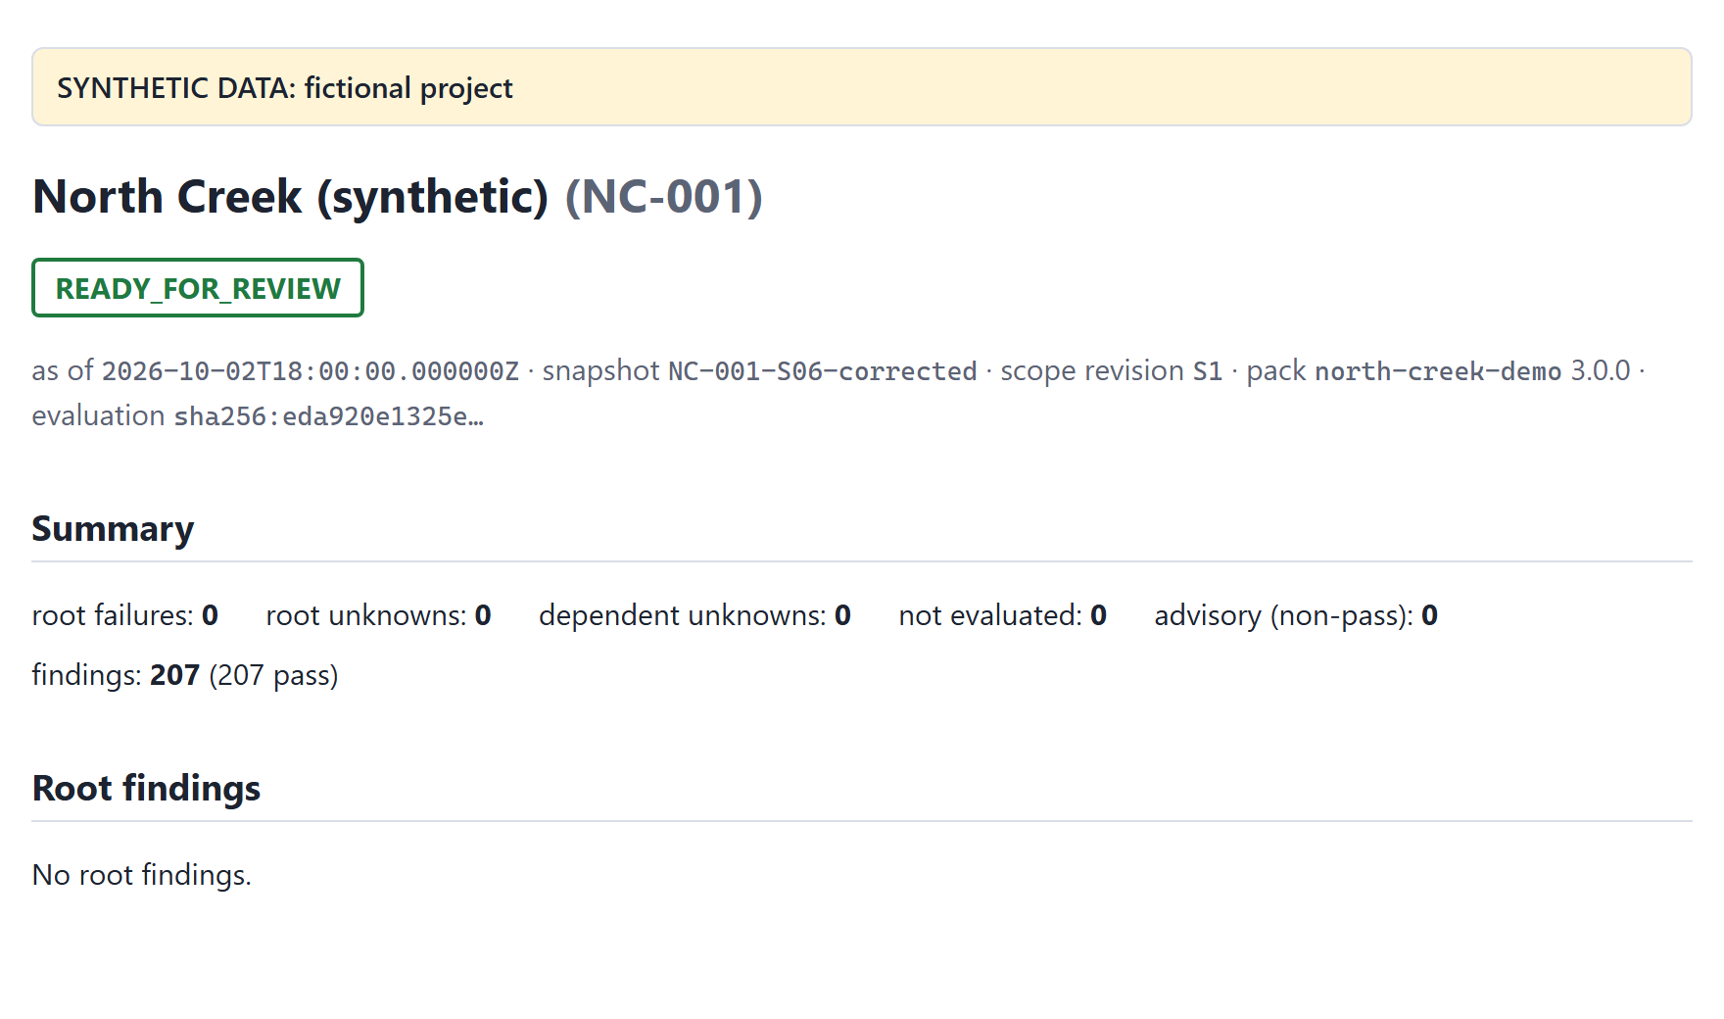
compare shows exactly five changed findings, R2 to R6 for O-017, and 202 unchanged. Fixing the root resolved everything that depended on it.

9.2 S05: an incomplete capture
S05's capture was interrupted: every dataset is declared partial on the basis extraction_interrupted.
uv run inspection-reconcile assess --snapshot fixtures/scenarios/S05-incomplete-capture/snapshot \
--policy policies/north-creek-demo.yml --out out/s05 # exit 11: UNKNOWN
UNKNOWN roots: FAIL=0 UNKNOWN=4 not_evaluated=52 evaluation_id=sha256:9eae7769cbe1…
The four roots are the coverage findings, one per dataset. Obligations whose inspections were not captured get ABSENCE_UNCONFIRMED, not FAIL: they may well be among the records the capture missed. The other 112 unknowns are dependent; they resolve once a complete capture replaces this one.

9.3 S08: an approval that no longer covers the evidence
In S08, the photo for O-009 was replaced after approval, under the same revision label. The approval's evidence digest no longer matches the current bytes.
uv run inspection-reconcile assess --snapshot fixtures/scenarios/S08-silent-byte-change/snapshot \
--policy policies/north-creek-demo.yml --out out/s08 # exit 10: BLOCKED
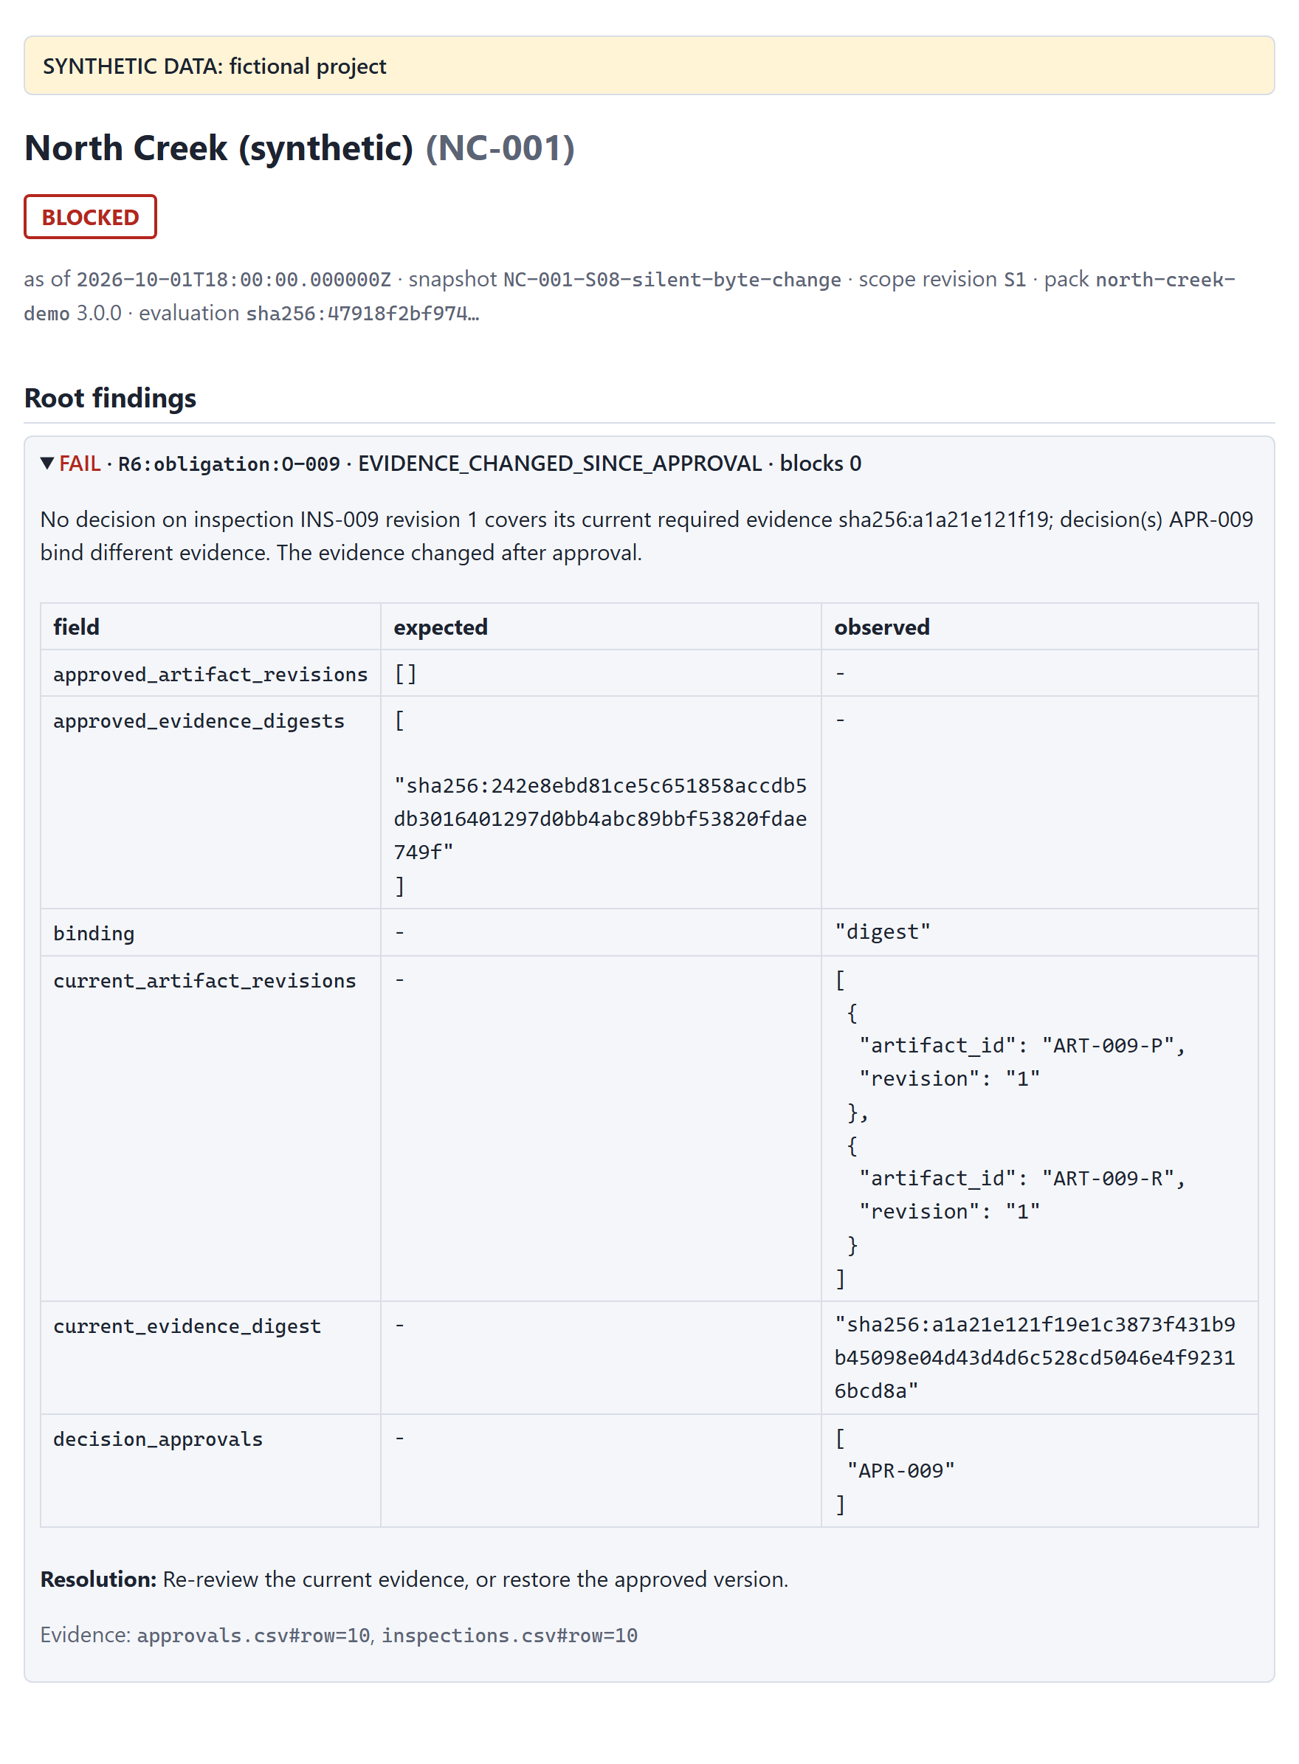
The root is R6:obligation:O-009 · EVIDENCE_CHANGED_SINCE_APPROVAL. The expected-versus-observed table shows the digest the approval stored next to the digest of the current files. Under revision binding (scenario S18) the same change cannot be seen, which is why digest binding is the default.

9.4 S12: attachments that were not captured
In S12, the capture skipped one attachment on purpose, and the manifest says so: the evidence files are partial, on the basis attachment_capture_skipped.
uv run inspection-reconcile assess --snapshot fixtures/scenarios/S12-attachment-not-captured/snapshot \
--policy policies/north-creek-demo.yml --out out/s12 # exit 11: UNKNOWN
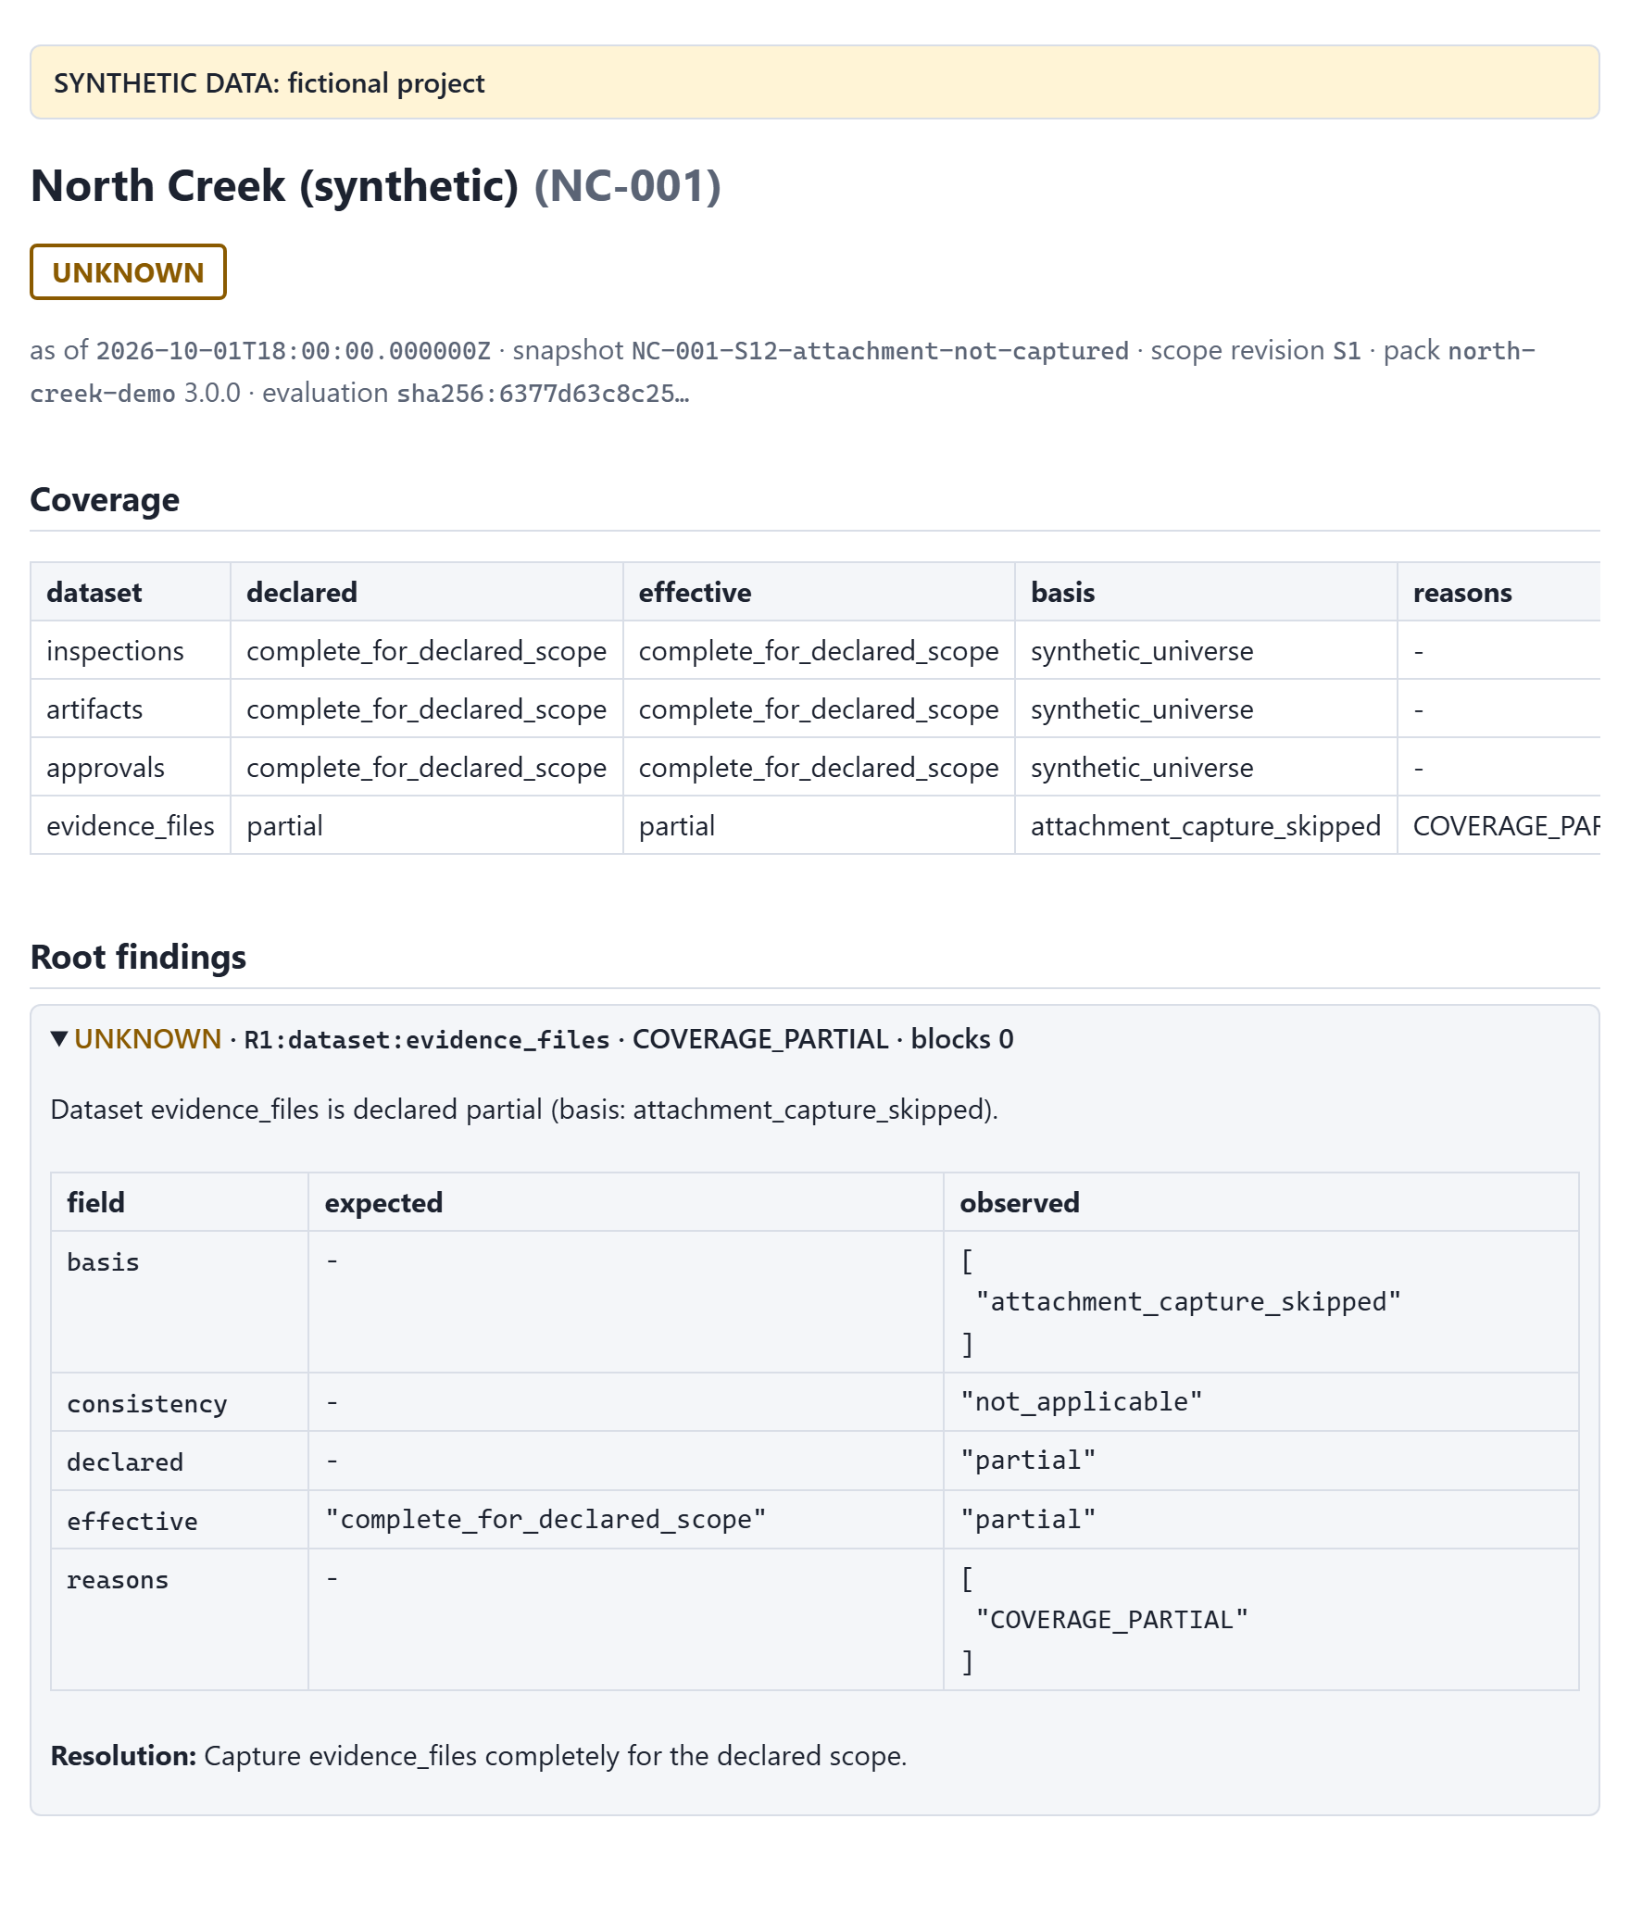
The root is the coverage finding for evidence_files. The missing file gives R5 NOT_CAPTURED for O-019, an UNKNOWN caused by that root, rather than FILE_ABSENT, a FAIL. The tool does not accuse a file it was never shown.

9.5 S17: a Quickbase value the mapping does not know
S17 is a Quickbase-shaped export in which one inspection's status reads Completed - pending QA. That choice is not in the mapping's value map. The tool does not guess what it means:
uv run inspection-reconcile assess --export fixtures/scenarios/S17-quickbase-unmapped-value/export \
--mapping mappings/quickbase-demo.yml --policy policies/north-creek-demo.yml --out out/s17 # exit 11
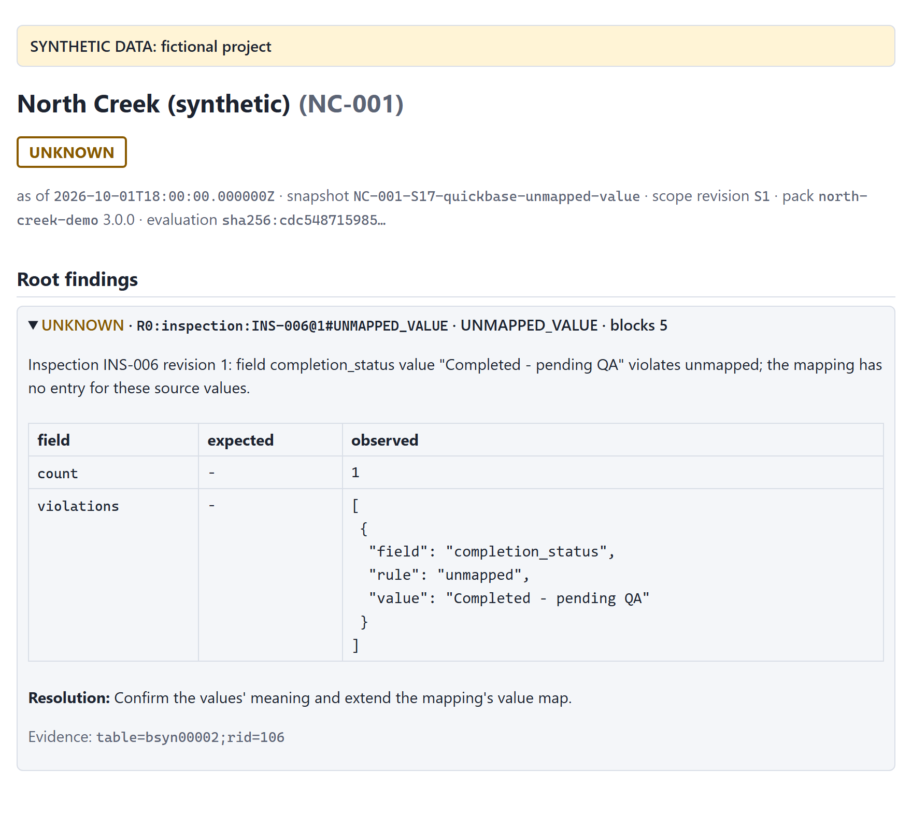
The root is R0:inspection:INS-006@1#UNMAPPED_VALUE. The fix belongs to whoever owns the mapping: confirm what the new choice means, then extend the value map. Until then, O-006's checks are NOT_EVALUATED.

10 Troubleshooting

10.1 The command stopped with exit code 2
Exit code 2 is a run error: the tool wrote nothing and printed one diagnostic line, error: CODE: message. The most common ones:
code | cause | what to do
OUT_NOT_EMPTY | the --out folder already holds files | use a new folder, or add --force to replace the tool's own outputs
OUT_EXISTS | compare --out or export-sqlite --out names an existing file | choose another file name, or add --force
USAGE | a missing or conflicting option, for example --export without --mapping | correct the command; --help lists the options
POLICY_NOT_EFFECTIVE | the evaluation time is before the pack's effective_from date | use the pack that was in force, or a later --as-of
PROJECT_MISMATCH | the snapshot's project is not the pack's project | use the pack for this project
CONFIG_INVALID, CONFIG_UNREADABLE | a pack, mapping or manifest has an unknown member or a wrong value, or cannot be read | read the message: it names the file and the member
CSV_HEADER_INVALID, CSV_UNREADABLE | a CSV file has the wrong columns, or is not UTF-8 | fix the export, then capture again
COMPARE_INPUT_INVALID | a compare argument is not an assessment | point it at an assessment.json or at an output folder
The Administrator Guide lists every code.

10.2 Common questions
Nothing failed, so why is the status UNKNOWN? Some required finding could not be decided, usually because a dataset is not complete. Look at the coverage table and the root unknowns: each one says what information would resolve it.
Why are so many checks NOT_EVALUATED? They depend on a root that did not pass. Fix the root and re-run; most of them resolve by themselves.
The file is there, but the report says FILE_ABSENT. Compare the letter case of the inventory path with the actual file name. The tool matches names exactly on every operating system, and the explanation adds a hint when only the case differs.
The approval exists, but R6 fails. Look at the expected-versus-observed table. Either the approval covers an older revision (REVISION_NOT_APPROVED), or the evidence changed after it was approved (EVIDENCE_CHANGED_SINCE_APPROVAL).
The report says READY_FOR_REVIEW. Is the project approved? No. The documentation is complete and consistent for the captured snapshot, so the review can start. Approval is a person's decision.
Can I feed the output to another system? Yes: use assessment.json and the exit code. Use --log-json to get diagnostics on standard error as JSON lines.

11 Glossary
term | meaning
accepted scope | the list of obligations, with a revision and a record of who accepted it, and when
advisory | a finding that is reported but never changes the status (R7, and R0 findings outside the scope)
artifact | a document or photo attached to an inspection, identified by its content digest
basis | the evidence behind a coverage claim, such as query_total_matched
blocked_by | the prerequisite findings that kept a check from running
caused_by | the coverage finding behind an UNKNOWN
coverage | how complete a captured dataset is, as declared and as effectively accepted
evidence digest | a SHA-256 over the content of an inspection's required files; what an approval should store
evaluation_id | the identity of an evaluation: the engine, the pack, the snapshot's content and the evaluation time
finding | the result of one check for one subject: an outcome, a reason, values, an explanation and a resolution
obligation | one piece of required work: an activity on an asset in a project
oracle | the hand-written expected result of each fixture scenario
requirement pack | the versioned YAML file that says what each activity requires
root | a required FAIL or UNKNOWN that no other finding caused
snapshot | a captured set of scope, records and evidence files, described by a manifest

