Taveau Project : Edge detection

Edge :
“An edge can generally be defined as a boundary or contour that separates adjacent image regions having relatively distinct characteristics according to some features of interest. Most often this feature is gray level or luminance […].” According to this definition, the pixels of an image belonging to an edge are the pixels located in regions of abrupt gray level changes. Moreover, to avoid counting noise pixels as edges, the pixels have to be part of a contour-like structure.
Edge detection is the process of finding the pixels belonging to the edges in an image, and producing a binary image showing the locations of the edge pixels. The derivative or the gradient of the greylevel intensity can be used to detect edges, as abrupt intensity changes translates to local extrema in the 1st derivative, and to a zero-crossing in the 2nd derivative (Laplacian approach).
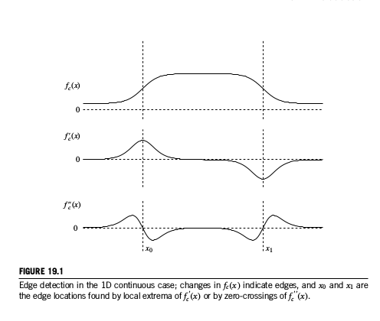
Edge detectors based on the derivative are sensitive to noise, which lead to the development of several algorithms. Most of them use a filter to reduce noise before actually detecting edges in the image.
Errors in edge detection can be either false positives (classification of non edge pixels as edge pixels) or false negatives (classification of edge pixels as non-edge pixels). There is also a conflict between the correct detection of edges and the precise localization of their position.

Edge detection algorithms follow three points :
- smoothing : filtering to suppress noise
- differentiation : amplify the edges
- decision : detection of edges using 1st or 2nd derivative, and thresholding

Linear edge operators :
- Convolution with edge templates (Prewit, Sobel, Kirsh)
- Zero-crossings of LoG convolution
- Zero-crossings of directional derivatives of smoothed images (Canny)

Laplacian based methods (Laplacian of Gaussian, Marr Filter):
The Laplacian is a 2D isotropic measure of the 2nd spatial derivative. It is used in image processing to detect regions of rapid intensity change in an image :
- In the regions of constant intensity (intensity gradient equal to zero), the Laplacian is equal to zero.
- In regions where there is a change in intensity, the Laplacian is positive on the darker side, and negative on the lighter side.
This has the effect of highlighting the edges in the image, and can be used as an enhancement technique, by adding the filtered image to the original image.

Formula : …
The Laplacian operator is usually used on greylevel images, previously smoothed with a Gaussian filter to reduce noise.

Laplacian of Gaussian:
It is possible to convolve the Gaussian smoothing filter with the Laplacian filter, before convolving this Laplacian of Gaussian (LoG) with the image. The Gaussian and Laplacian kernels are both small so it requires fewer operations than using both filters on the image. Another advantage of the LoG is that it can be calculated in advance as it is independent of the image to process.
Formula : …

Zero-crossing detector:
It is not possible to extract directly the edge orientation information from the Laplacian output. To extract the edges, we need to detect the zero-crossings in the output of the Laplacian, i.e. the regions of the image where the Laplacian passes through zero. However this can also happen in regions that are features other than edges in the image.
The input of the zero-crossing detector is the LoG filtered image, and the output is a binary image with lines representing the positions of all the zero-crossing points. All of the contour lines are closed lines because the strength of the edge is not considered so even gradual intensity transitions result in a zero-crossing. Local minima of the gradient magnitude can cause phantom edges, that can be eliminated by using a threshold for edge strength (this causes breaks in the closed contours).
This detector is highly influenced by the standard deviation used for the Gaussian filter applied to the image.

In ImageJ :
- FeatureJ > Laplacian
Parameter : laplacian smoothing scale (= stdev for the Gaussian kernel)
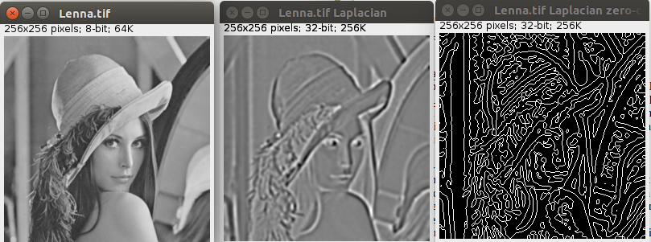

- LoG Filter
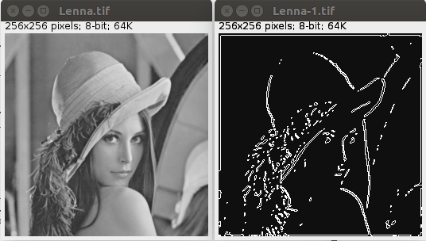
Parameters : sigma (standard deviation for the Gaussian filter), filter width (size of the LoG kernel), threshold for 1D DoG filtering, delta (level for adjusting zero-crossings)
limited to 8-bit images

refs :19, 15, 13, 4
19 : Theory of edge detection (1980) : accessible
15 : On the discrete representation of the Laplacian of Gaussian (1999)
13 : Comparison of edge detectors, a methodology and initial study (1998) : payant
4 : Edge detector evaluation using empirical ROC curves (2001) : payant

math equations in “The essential guide to image processing , chap 19”

Canny approach :
…..

Approaches for color and multispectral images

Comparison of edge detectors :
The quality of the results given by different algorithms is dependent of the image.

Edge detection approaches involving diffusion partial differential equations.

Simple algorithms using Java : http://homepages.inf.ed.ac.uk/rbf/HIPR2/flatjavasrc/ZeroCrossing.java (LoG)
http://homepages.inf.ed.ac.uk/rbf/HIPR2/flatjavasrc/Canny.java
http://homepages.inf.ed.ac.uk/rbf/HIPR2/flatjavasrc/Sobel.java

Equations :
Gradient :
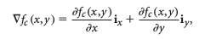

ix and iy : unit vectors in x and y directions
Thresholding :
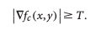

T: gradient magnitude threshold to classify edge points

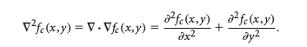
Laplacian (continuous) :

fc(x,y) : grey level intensity function for a continuous-space image

Discrete laplacian :
The Laplacian estimate for an image f(n1,n2) ? Can be estimated by designing a pair of 1D 2nd derivative filters and combining them into a 2D filter :

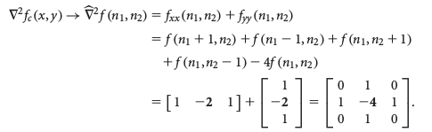

fxx : 2nd partial derivative in x , fyy : 2nd partial derivative in y
Other 3x3 kernels are :
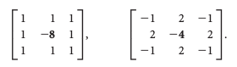

The kernels depend on the choice of the derivative approximator, the kernel size, and the noise-reduction filtering applied.

Zero-crossings :
Each pixel is compared to its eight immediate neighbors. If a pixel p differs in sign with its neighbor q there is an edge between them. The pixel p is classified as a zero-crossing if
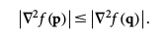

Laplacian of Gaussian :
The LoG function hc(x,y) can be desribed by this equation :
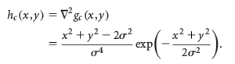

gc : Gaussian function, sigma : stdev of Gaussian function
To implement a discrete form, a filter can be constructed by sampling this equation after choosing a value for sigma.

Function | Canny Edge Detector | FeatureJ Edges | FeatureJ  Laplacian | Find Edges | Log Filter
Avg time  (ms) | 205.8 | 41.8 | 35.4 | 0.88 | 17.6
Avg memory  (MB) | 50.6 | 50.0 | 55.0 | 27.4 | 51.6

Canny : page 307, page 508 : see annotatitions
complexité des algos ?

Ajouter prewitt and kirch filter

Color images :

Unlike greyscale, images encoded in a color space are composed of three channels, which makes the computation trickier. Algorithms for color images usually only take the luminance component into account. This is a cost effective method because according to the color space either the luminance is one of the channels or it can be computed directly, for example with an RGB image. However, all edges are not necessarily best described by the luminance component, which results in a number of false negative edge pixels candidates. Another approach is to construct a cumulative edge map from each component of the image (for example after calculating the sum of the gradient magnitude of the three channels of an RGB image), but the results will be biased depending of the chosen color space. [^BOV2009]

Some algorithms developed for edge detection in color images based on vector approaches are described in papers by Trahanias and Venetsanopoulos [^TRA1993] and Scharcanski and Venetsanopoulos [^SCH1997].

Fixé freq du processeur avec le module acpi-cpufreq (pour éviter que le processeur ne change de freq durant le benchmark) et fixé le processeur qui réalise le benchmark avec la commande taskset (pour éviter le load balancing : partage de la charge processeur entre les différents coeurs), fixé process (JVM) avec une forte priorité pour éviter qu’il ne se fasse préempter)

Canny :
sigma: 1.0 , 2.0 ,3.0 ;
thr : 2.5 7.5 , 0.1 7.5 , 2.5 10

FeatureJ edges :
voir image dans discussion

Log Filter :
sigma : 3 , 5, 9

![Fig.2](images/filters.png)

Comparing the outputs of the two Canny implementations when using the same parameters we found that the results are similar. [Fig.?].

![Fig.?](images/Canny2.jpg)

Knowing this, we decided to test the influence of each parameter only for the Canny Edge Detector plugin, assuming that the results given by FeatureJ Edge would be the same. A variation of the standard deviation of the Gaussian function [Fig.?] has an influence of the number of pixels classified as edges by the function : with a standard deviation of 1.0 the contours of the eyes, nose, mouth and feathers are well defined, but some contours are created which have no physical sense like the line below the right eye. Raising this value to 2.0 and then 3.0 makes weaker edges disappear from the results, until only the outlines remain.

![Fig.?](images/CannySigma.jpg)

We then changed the value of either the low or the high threshold values [Fig.?]. A reduction of the low threshold does not seem to have an impact on the result, but an augmentation of the high threshold reduces the number of edges detected and creates gaps in continuous edges.

![Fig.?](images/CannyThr.jpg)

!!!! Add FeatureJ Laplacian sigma comparison !!!!!
!!!!!!!!!!! Log_Filter uses DoG filtering so the final output is the edges of the contour zones detected by the LoG !!!!!!!!!!!!

While the result is different from the one given by FeatureJ, we can see that the influence of the standard deviation is similar : a higher value for the smoothing step leads to imprecise contours and the loss of the objects’ shapes [Fig.?] . Here the thresholding step prevents us from seeing the impact of the noise removal on the number of false positive edge pixels.

![Fig.?](images/Log_FilterSigma.jpg)

