^{on} Sermon 13 August 2017 ‘Jealousy’
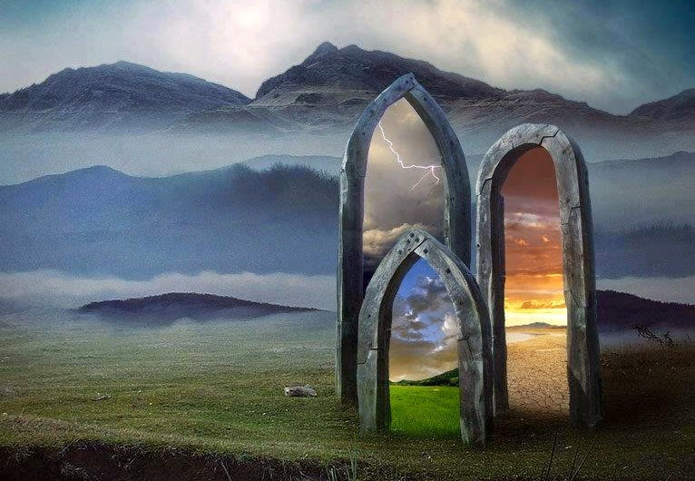

Genesis 37:1-4, 12-28 Matthew 14:22-33

Prayer: May the words of my mouth and the meditations of our hearts… amen. ^{off}

Today our main person illustrating our theme changes. ^{on}We have been looking at Jacob/ Israel and for the next two weeks we look at his son, Joseph. BUT –but J/Israel is still influencing today’s reflections. The background for J/Israel’s story is the same, YHWH-God, but today it is as if we are shown another picture – challenged to look through a window called ‘jealousy’. It’s a powerful – very powerful human emotion that impacts our lives and today a teaching today is how with Jesus in our life-boat we can overcome, this ‘storm’, not let it destroy our life and keep living. ^{off}

Over the past few weeks, we have seen how God has honoured his promises: 1 to be Abraham’s God, with Abraham and his descendants forever; 2 to give Abraham as many descendants as the stars in the sky; 3 to make Abraham the father of many nations…. We have listened how God stayed with Abraham and his family, despite them and circumstances they both got and found themselves in!

It is part of my wonder about the character of our God – that our holy scriptures are so detailed about humanity’s flaws, how we cheat, lie, steal, scheme, hurt and kill…. To get what we have decided is ‘ours’ and Abraham’s family illustrate most if not all human traits both good and flawed! And through all the sad / destructive human traits, the light of the beauty, purity, right-ness of God and God’s way shines for us to come into, walk with, live in. YHWH God honours his word to be with us, honours his creating promise to be the best friend we will ever know, and honours his side of the covenant.
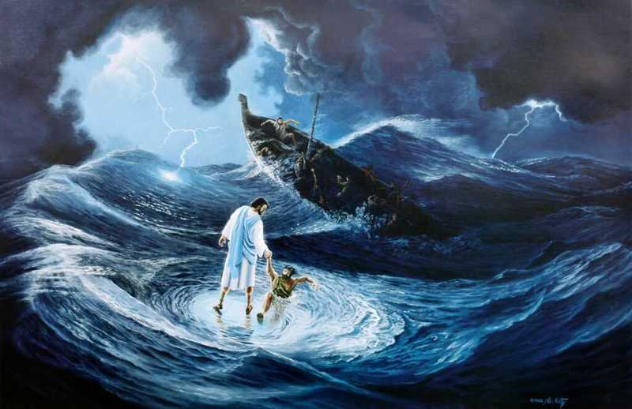

And for us of the Christian following, we see all these promises come to life in Jesus. ^{on} And a glimpse of what the Gospel reading is about today is that in Jesus, God’s power flows, overcoming all that would destroy, be-little, diminish, and sink us in despair… Jesus stopped the storm and as soon as he was in the ‘boat’ life continued. ^{off}
Please recognise there is no promise that we stop being human: feeling or avoiding feeling, trusting – or struggling to trust, speaking with truth – or not… etc. In fact we’re never asked to stop being human – we are asked to follow Jesus and walk in his light, his way with him.

I think one of the most difficult things we can ever do is trust that what Jesus wants from us is to be fully human! But in our humanity we take our eyes from him, we see the wind and sink! We all know the difficulty of faith-following, but when I reflect on the ancient people of our faith, on Joseph’s silent-God, we have Jesus and he/ they didn’t, we are blessed – even in the middle of our life storms!

One of the facts for Joseph and his people was that God had stopped talking to them directly.^{3*} There were no more direct addresses from God, even in response to brotherly violence. So that "when Joseph wanted to hear the voice of God, he had to listen to his life--to his dreams, to the people he met along the way, to the things that happened to him each day…" Even though we have Jesus and the Holy Spirit, I think we are still called to listen like this, as it opens more ways the Spirit of Jesus can reach to teach!

But back for a moment to develop young Joseph‘s story. ^{on} Today we are introduced to Joseph, he is we are told the favoured son of Rachel - his father’s favourite wife. Ohhh 2x ‘favourite’ is used… Jealousy’s shadow comes into view, along with family divisions and dissention. It’s not far into the story that we hear of how Joseph tells tales – stories to his father about his brother’s ‘bad’ behaviour. ^{off} The brother’s aren’t happy… not with Jacob’s tale-telling or his ‘dreams’ of prominence, they murmur and plot!!!!


Then we are told Joseph’s father loves him more. 2x Ohh not only a favourite but loved more – and spoilt with the gift of a coat. ^{on} A few words here about this famous ‘coat’. The style of the coat was that it had long ^{1*}sleeves; was for ^{2*}‘royalty’, it may have had many colours – but far more significantly it was for a non (manual) worker.

The ‘coat’ says Joseph did not have to work – unlike his older brothers…. ^{off} More seeds planted for the growth of the jealous- murderous hatred that is flowering… We can hear the echoes of the brotherly divisions among Joseph’s ancestors: ^{1*}Isaac and Ishmael; Esau and Jacob all traced back to parental favouritism. Families and family relationships are a powerful force for us being able to grow – or not, into our full humanity – and be like Jesus.

Joseph gets sent to find his brothers – Jacob is a little worried about them being around Shechem – I challenge you to go and find out why – those boys may have thought they were protecting their sister and family honour etc –but revenge is the Lord’s and there is no excuse for what they did. Anyway the flocks have moved on and Joseph eventually finds them. Note they are now a long way from home – and Ruben (not the best of the brothers but the eldest, if the iceberg theory holds then we have only been told of 1/11th of what they all got up to… these boys were bad! And God still honoured his word. Maybe God / God’s way is winning because Ruben tried to act responsibly and does prevent Joseph’s death.
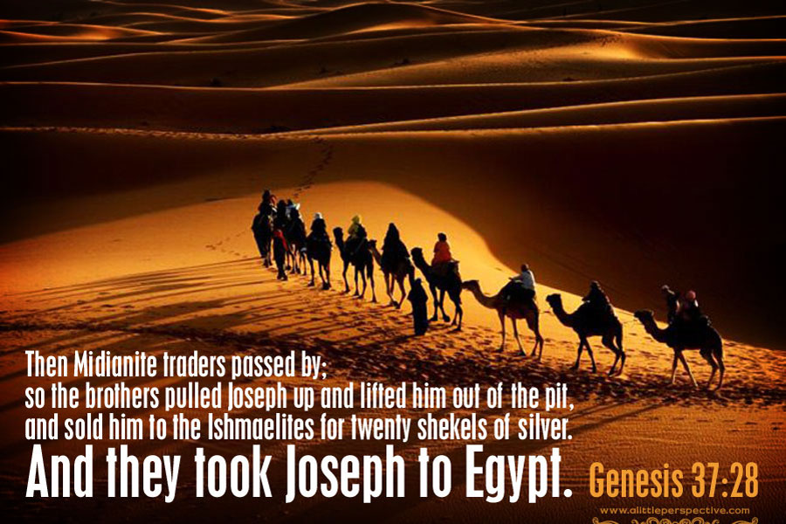

^{on}Joseph is carried away by tribal cousins and we have to wait to see what happens. That’s part of our faith-frustration isn’t it? We can’t see how making this decision will work out… It is hard to keep trusting the light of Jesus when we can’t see ahead very far especially when our emotions are all stirred up! So in the case of Joseph’s family – that wanted revenge – and if you do pick up my challenge and read around chapter 37 of Genesis for other parts of the story – you can see the brothers are very used to getting full revenge… They had killed before and if it wasn’t for Ruben, that’s where jealousy was driving the brothers with Joseph. ^{off}

So how do we balance our humanity with our ability for emotions and their ability to over-power logic / reason / sense / love / commitment…. How can we balance what we are with what we want to be as followers of Jesus? I believe we are gifted our emotions, and then spend a lifetime learning how to live with them! We can’t change that we are human’s with a full range of emotions – great, good, pathetic and bad… We can change how much we let them drive us out of the healing, loving, teaching, challenging light of Jesus.
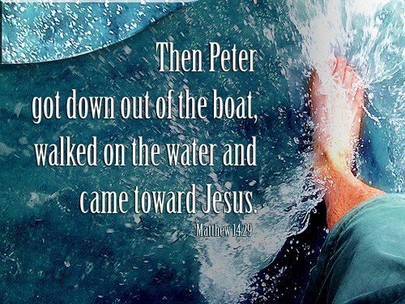

But each one of us has to want to follow Jesus – and take the risk of change. Reading through the NT, we know Peter is one spontaneously emotional guy, but that doesn’t stop him or God from using him in Jesus Church! ^{on}Today in the middle of the storm, remember he is a fisherman from the Sea of Galilee he’s on home ground so to speak! Peter and the rest in the boat are terrified their boat is being ‘battered’ – bas ani zominon- ‘tortured’ by the waves… ^{off}today he gets out of the boat and walks toward Jesus – on the water.
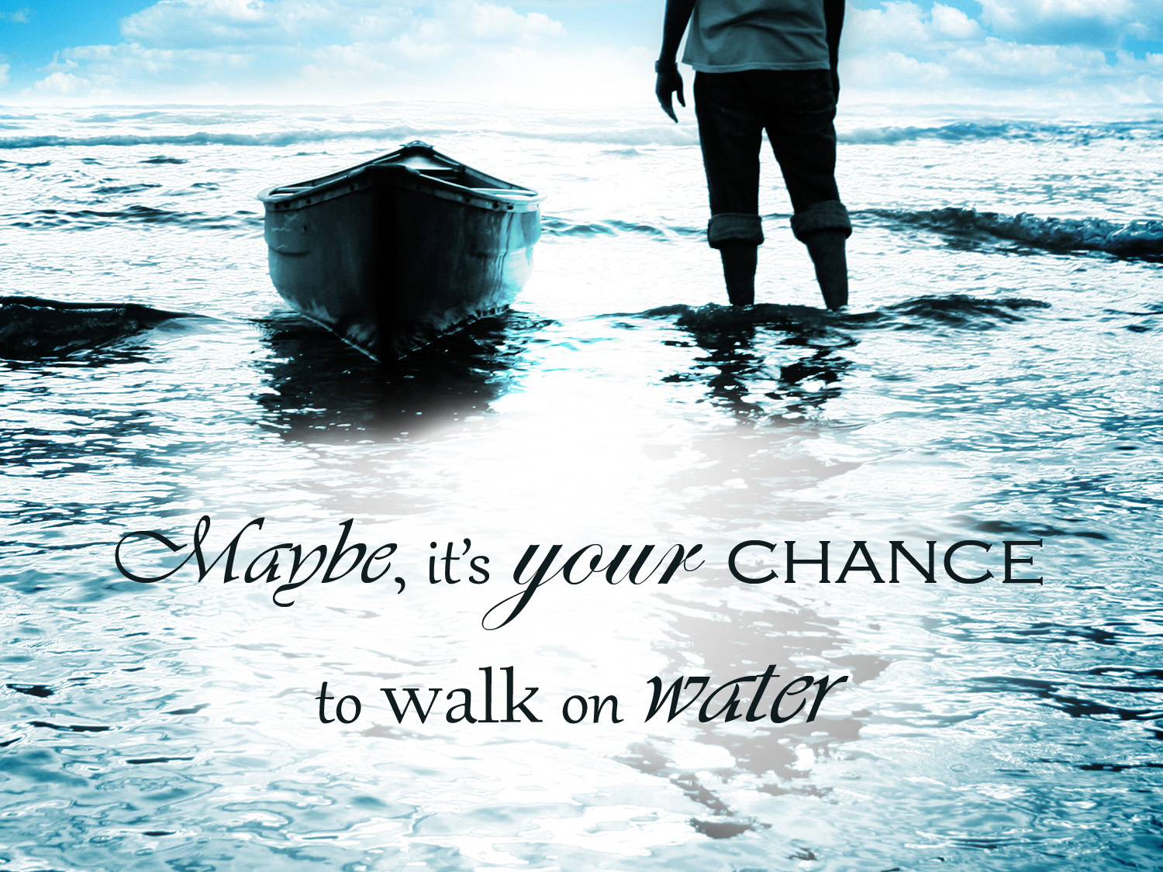

Jesus has what we need, truly want but to get to him is to risk, everything including your life^{on} – all of it the good and the bad, the love, loyalty, commitment as well as the doubts, fears, jealousy, revenge, even hate, all that stock piles within us from our life encounters. And when we look at Jesus even with all that, we can walk on water! ^{off} But the minute we stop looking at Jesus, see the wind, that sinking feeling happens.
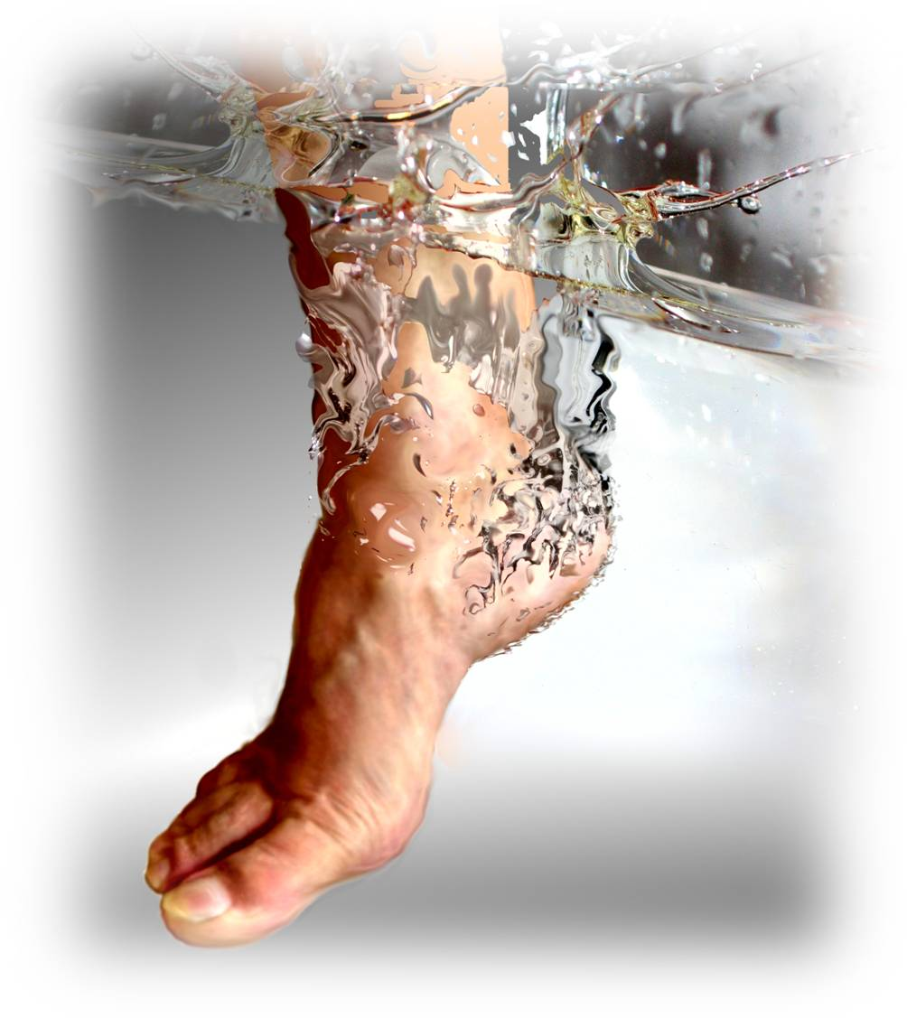
We have a choice^{on} – sink – or let Jesus help us back into the boat as he climbs in with us. Climbing back into the boat is never a backward step, you’ve taken a risk; got soaking wet; listened to both what’s happened to you (life experience) and Jesus voice. Don’t waste the lesson, use it, let the power Jesus shown in meeting you, in others insights, through life moments, and through who you are let his power hold you in the storm, until the wind dies down and the shore found. And before you climb on shore – make sure you stop long enough to give thanks, praise and offer worship for the gift of your life, storms included, because life will take you back out – faster than you know! Amen ^{off}

