^{on} Sermon 20 August 2017 ‘Reconcile’ Genesis 45:1-15 Mt 15:21-28
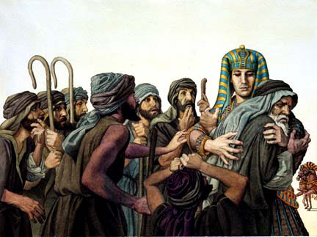

Prayer: Like the psalmist, O God we know how good it is, when your reconciling grace finds embodiment in community. How very good it will be, Lord, when we act with greater love and experience deeper unity than we have yet known. Lead us to where, and to whom, you would have us go. Amen. ^{off}

Reconcile is our word for today. To reconcile is not the same as to forgive and yet I think we often do ‘lump’ them together – assuming they are the same thing… and so today I feel we are being given a chance to reflect on the difference between them. We give a lot of exposure, words, time and energy in church to the ‘forgive’ word. Yes, in one way it is as important as we make it. Important, because we know the impact the ‘forgive’ process has on our health – spiritual, emotional and physical… on us. But if the emphasis comes at the expense of other important teachings then we are out of balance – and we are given the equivalent of a spiritual “shake-up”.

Reconciliation, and a spiritual discipline of reconciliation – is important for us to have as we mature into being fully like Jesus. To reconcile is to “restore friendly relations between” and to forgive is “to stop feeling angry or resentful towards (someone) for an offence, flaw or mistake. They are not the same, but can both be called a spiritual discipline. So when a colleague said their children’s talk today was on Joseph forgiving his brothers – I chose to say – that’s not what the text is about.

Joseph restored friendly relations with his brothers – he reconciled their relationship and family unity was restored. So, was forgiveness necessary before this could happen? Could Joseph have restored friendly relations with his brothers while still feeling angry, hateful, resentful???? Well, – I have to say yes, it is possible because of the things / games Joseph played over hostages, silver cups… but given the emotional strength recording his final confession, I don’t think so.

Let’s back up a bit. ^{on} Last week we had Joseph sold into slavery by his brothers and his dad told he’s been killed by wild dogs, that lovely long-sleeved coat ruined by blood…. Joseph’s life is one of the better known OT patriarch stories because of A-Loyd Webber’s and all the versions of ‘Joseph’s “Technicolour Dream Coat”. You can read the real story in the chapters before our one (c45) today. Those chapters will tell you that Joseph had good reasons to be angry and hate his brothers.


He was: the favourite son; spoilt with gifts of clothing; he didn’t have to ‘work’; he was given an education; we didn’t hear about the bits with Joseph’s dreams which made him a ruler and all others (his bro’s) bowing before him and don’t forget Joseph told tales to his father of how bad his older brother’s behaviour was… We know he was sold into slavery but we haven’t heard his story of being a slave, or being put into prison or his gradual rise in power until the fascinating line today in verse 8 “He made me father to Pharaoh, lord of his entire household and ruler of all Egypt.” ^{off} The ‘He’ is YHWH-God.

There is no record of God talking directly to Joseph, only of God’s ‘hiddenness’^{1a*} where God is at work in our lives but is the "something hidden, inscrutable, playful, and unresolved" that requires us to trust in God's purposes even when we can't "see" or understand them. In this way Joseph trusted, knew God was still with him – and shows for us God's ability to "see before (pro-video)" and provide, or act, in ways that are mysterious, wondrous, and good.”
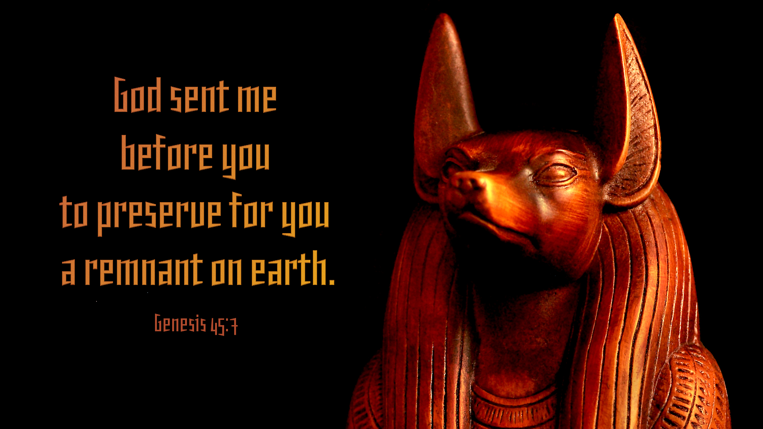

How does Joseph do this? ^{on} Because in the text today, Joseph has a flash of insight – of sunburst of faith – glimpse of revelation as suddenly he ‘see’s’ how God has been with him- all the time – in fact may even have been part of the whole ‘sold into slavery’ thing… ^{1b*} Professor Barbara Brown Taylor puts it like this: “Joseph saw a pattern in what was happening in that palace, that is, "he could see God's fingerprints all over the place." God isn't a puppeteer, making things happen. God, Taylor says, is more like an artist, for whom "[n]othing is too bent to be used--not even tragedies, not even bad decisions, not even plain human meanness." Joseph, she says, is "a living work of art".” ^{off}
This story helps us explore an important point of faith ^{2*} and that is the issue of the relation of the sovereignty of God and freedom of God to the freedom of humans in determining the course of events in this world. As Joseph’s story unfolds the family of Jacob – like Abraham and Issac’s were, is in the balance. ^{on} The future of the promise of heirs to Abraham, Isaac and Jacob is cast in doubt ^{(Gen 12:1-3 etc.}). The working out of the divine promise depends on a passing camel train of Midianites (or Ishmaelites) ^{(Genesis 37)}; it also depends on a butler’s memory (^{40:23 and 41:9ff} after a two year lapse of memory). But through it all the story, affirms that God is still at work – it lets us, just like Joseph see God’s fingerprints! ^{off}
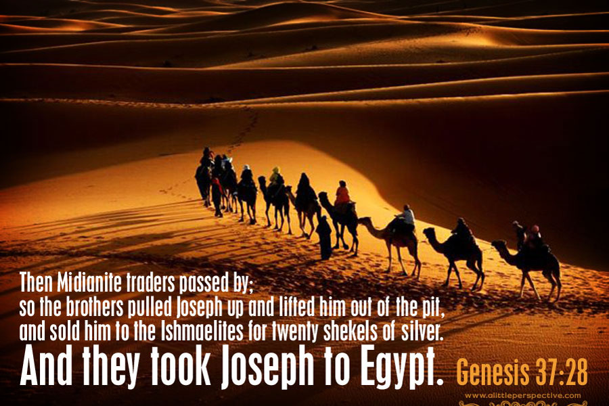

This story might hold some challenges depending on your faith explorations / development or learning’s, ^{2*}It does not support a superficial faith which makes God into a puppet master who is behind all human events pulling strings to make us ‘dance’. Nor does it support a version of God whose will must be found / sought before any human activity starts. Nor will it support a view that wants faith to ^{2*}‘ultimately see history in the control of unpredictable human activities and encounters.’

Joseph’s story ^{2*} ‘presupposes a faith in which the sovereignty and activity of God is seen as tightly bound to human agendas, yet at the same time possessing a freedom within certain bounds. It acts with, against, for, and in spite of those creaturely agendas. Once again we see the way in which God’s purposes are worked out with his creation, but in a way which exhibits both vulnerability and compassion. In that commitment is hope of the divine promise for all creation.’

For all creation – that’s a really important bit. Joseph’s story reminds us that God’s salvation through Joseph was not only for his family but it was based in / out of Egypt for all people who came driven by the disastrous seven year famine. One of our human traits is to want to be ‘special’/ ‘unique’ the ’only-one’ especially when it comes to love and often when it comes to “God-things”.
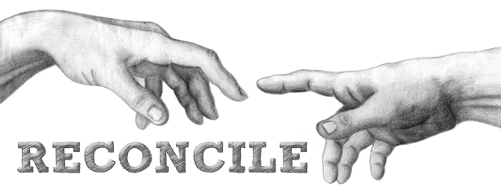

When allowed too much ‘room’ or given too much status this trait isolates, excludes, brakes relationships – fractures families… and the compassionate gift of reconciliation is needed to restore and heal…. St Paul used the gift of reconciliation as one way of describing what God did in Jesus. Col 1:20 “…and through him (Jesus) to reconcile to himself (God) all things, whether things on earth or things in heaven, by making peace through his blood, shed on the cross”.

Through Jesus, God is reconciling us to him, Paul says... All of us … all of creation; and that lesson was what we heard Jesus having a refresher course in –today! ^{off} Jesus wants to be only for the Israelites – Jacob’s family, not for the Canaanites. ^{3*} Who were the people living in the land when Joshua led the Hebrews on their return from Egypt, and settle in their ‘Promised Land’, some 1000 years before Jesus! The ‘settlers’ and the ‘locals’ had been in hostile and bitter dispute for that long – and so for Jesus and his disciples (people), Canaanites were still hated ‘out-siders’. ^{on} The ‘woman’ did not belong to those for whom Jesus was sent to reconcile with God… was where He started his interaction with her.
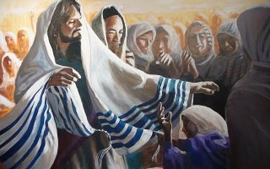

^{3*} This is the only time in scripture Jesus loses an argument, and the woman is a triple looser herself: a woman, a foreigner, and ancient enemy. A woman who will do anything, say anything, face down anyone because her daughter is dying… Telling us this story about Jesus was risky for Matthew – Jesus changed his mind, Jesus listened to her words, and responded as only God can – the Man who is God, who is having his own spiritual ‘shake-up’, acts to reconcile, this is who Matthew shares with us today. ^{off}


Jesus reconciles an ancient international break in relationships as he acknowledges the woman’s faith. This is the only time in Matthew’s Gospel where anyone’s faith is great! Jesus says ^{Mt 14:28} Woman you have great faith! Your request is granted – your daughter is healed. ^{on} God’s fingerprints can be found in the most surprising places! Don’t just leave them to Joseph or “the woman” – or even Jesus! Where in your life are you going to go and have a look? Where in another’s life can you point them out? And remember ^{4*} “Truth can be told in an instant, forgiveness can be offered spontaneously, but reconciliation is the work of lifetimes and generations." The work of ? for? reconciliation is Jesus gift to us! Amen ^{off}

