^{on} Sermon 12 Nov 2017 ‘Be ready’ Joshua 24:1-3a, 14-25 Matthew 25:1-13
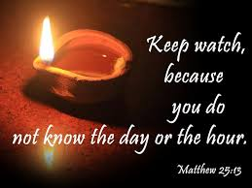

Prayer: God, kindle a flame within my heart to keep me alert and watching, ready always to seek and follow the ways of wisdom. Amen. ^{off}

What does it mean to ^{1*}choose God and be ready for God’s arrival in our lives? The passage from Joshua for us this morning is brutally honest about our usual patterns of behaviour. Yes, it is about ancient peoples- but the warning in vs 19 is just as applicable to us: “19 Joshua said to the people, “You are not able to serve the LORD. He is a holy God; he is a jealous God. He will not forgive your rebellion and your sins.”
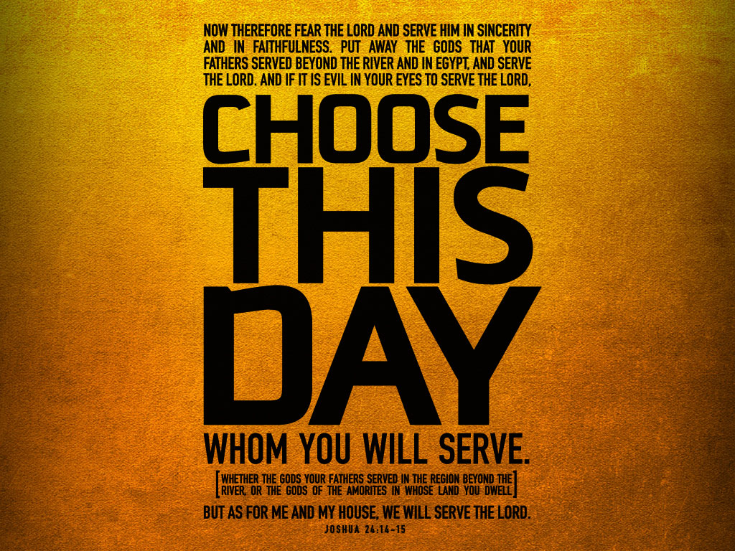

The people are called to choose 3 times!! ^{on} 3 times Joshua asks the people if they will choose to follow YHWH-God. And 3 times they say ‘YES, we will’. This ‘discussion’ is not a random event in their life. It is at a cross-over point. We have been following their story from Abraham leaving his homeland travelling into the promises of YHWH-God; through his descendants travelling into and out of Egypt with Moses and last week we had the transition from Moses to his successor Joshua, and the arrival into the Promised Land. ^{off}

In one of our weeks, they have crossed into the promised land and taken it ‘completely’! The ^{2*}land has been has been divided up among the twelve tribes of Israel^{(Joshua 12-21)}, because the promise of YHWH has been fulfilled. ‘They’ve arrived. But on that journey they have been rebellious, unfaithful, doubt-filled and afraid to trust… remember all those stories especially from their 40 years in the wilderness?? While they have been totally ‘human’, God has shown love, faithfulness, truth, trust, and fulfilled all his promises.

So what happens now?? What’s next? What about the future? And it is at this cross-over moment Joshua calls them together and in an echo of Israel^{(Exodus 19-24)} making the covenant with YHWH-God, they make a ?new? they re-new? They covenant with God under Joshua. The heart of this covenant is loyalty to Yahweh^{(cf. Deut 5:7)} and only YHWH-God. To move into the future they have to choose to stay with YHWH.

Joshua it seems, wants to make sure the people really know what they are doing: Have his people really grasped what loyalty to Yahweh is about and requires of them? It is ^{1*}as if our verses today are to act like a strong reminder ‘that at each stage of the journey with the Lord, there will be forces, strong forces, which will lure even those who have seen ‘those great signs’ ^{(v. 17)} to’ follow less than faithful paths; those that wander from God’s ways and serve other gods. There will always be temptations to unfaithfulness.

The Australian Old Testament scholar, H Wallace says: “Even at that point when we perceive our faith to be strongest, most assured, and vindicated, there is the very present danger of unfaithfulness and the need to hear again the call to obedience and discipleship. ^{on} Temptations to unfaithfulness can also be extremely subtle. In this case Joshua cites ‘the gods that your ancestors served beyond the River and in Egypt’. Deep traditions within the community’s history, even if no longer held, can be persuasive still, pulling at almost invisible cords of family and community loyalty. Alternatively, even those ‘gods’ who have been oppressive in the past (the gods of Egypt) can be a strange source of comfort and security in an unknown place, as the people discovered in the wilderness.” ^{off}


It would not be just to leave this Joshua passage without recognising that in the fulfilment of YHWH’s promise to his people and their gaining the ‘Promised Land’ – it involved cruel treatment of other peoples. In particular ^{2*} ‘the former inhabitants of the land, the Amorites and others^{(v. 18)}. If we read this text literally, this raises a major problem... At this point at least, the biblical story is especially to be read as a story about faith, not about history. It wants to stress unfailing loyalty to a God whose promises are unfailing.’

It wants to stand as a reminder to the people that they have choice; who will they follow? Whom do they serve? They know who they have followed – in their ‘living memories’ under Moses and Joshua – but what happens now? What does the future look like? Joshua is challenging them to be deliberate – to actively decide, be pro-active, to give their hearts to YHWH and live in his ways.
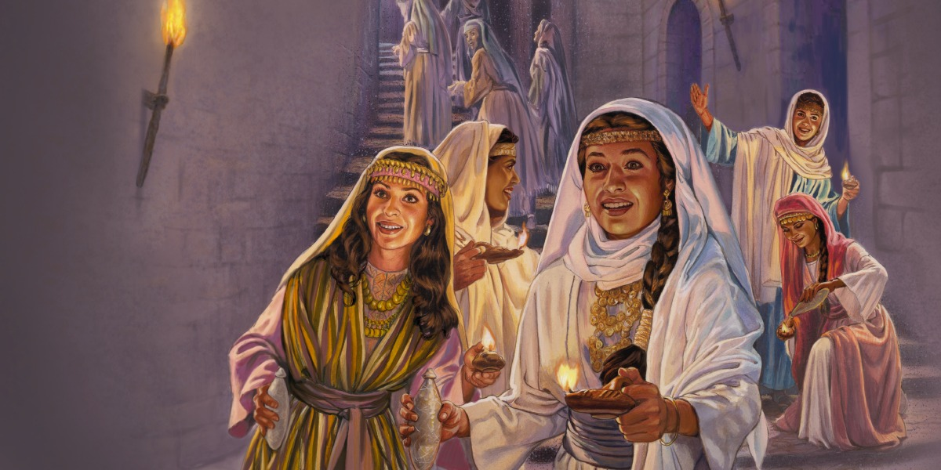
Thousands of years later Jesus would tell a parable that echo’s this challenge. The setting for our verses today is that Jesus and the disciples have been discussing “the end times”. ^{3*}We have a number of these parables and sayings of Jesus which provide challenges for us today! It is possible to see that throughout these stories one theme dominates – ‘timing’. ^{3*}“Jesus' disciples have started it all off by asking him, at the beginning of Chapter 24, for some insider information: When are all these things you're talking about going to happen, and how will we know they're about to happen, so we can be ready?”

And Jesus tells a parable….. ^{on} using a local setting because they would all know the customs around marriage and how a marriage basically had 2 parts, ^{3*}We’re not completely sure of the details but scholars believe that getting married took both time and effort. The first part was an “agreement not between bride and groom but between their families, and second, the fetching of the bride by the groom for the wedding ceremony, followed by a celebration that went on for days.” ^{off}


So Jesus builds the tension, the bridegroom in in no hurry: he is delayed. The Geek word for ‘delayed’ is ^{4*”}chronizontos…The word is based on chronos,1 of 2 Greek words for "time."^{on}Chronos refers to regular, every day time--chronological time. Kairos, on the other hand, means "special" time, "God's time." According to chronos--according to business as usual--the bridegroom is delayed. They all fall asleep.”

^{4*}"But midnight a cry happened!" It's a bit awkward in English, but its closer in meaning to "it came into existence," i.e. "it happened." The Greek word is often used to underline the significance of the event. In the middle of the night of chronological time, an in-breaking--"a cry"--and "behold! the bridegroom!"”
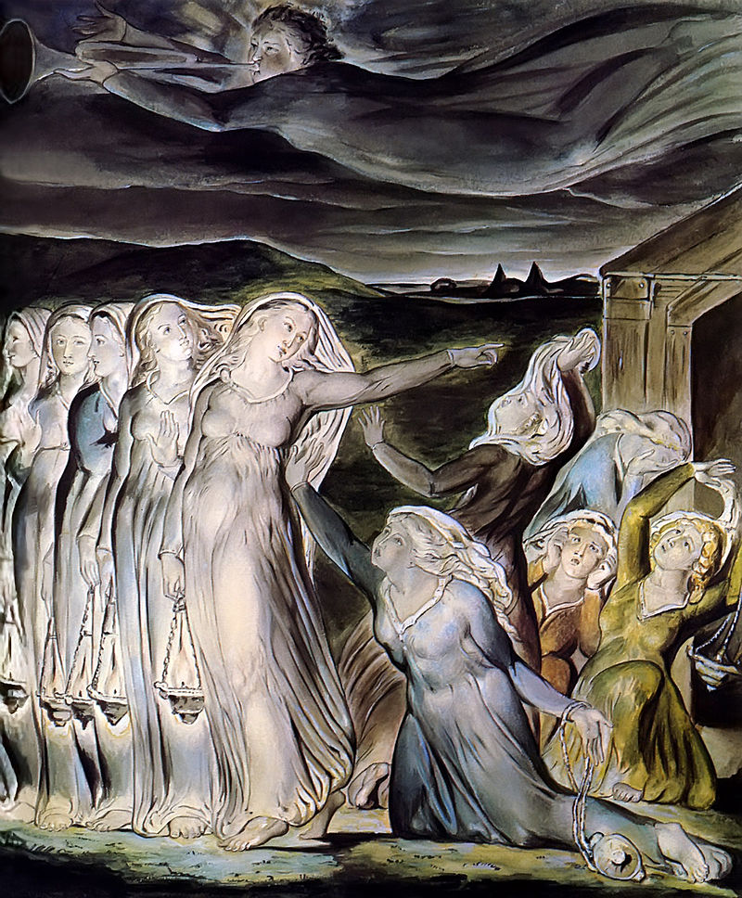

^{4a*} It can be argued “that the five foolish represent the "wisdom of this world--the live-by-what-you-see wisdom" that God has turned upside down. ^{on} The five wise virgins represent the "wisdom of faith," the wisdom of trusting in God's crazy redemption of the world. The five wise virgins anticipate the problem of delay by taking "vessels" of oil in addition to the oil in their lamps. Jesus and listeners would know in their Hebrew scriptures, oil was often a metaphor for good deeds. (Ps 119:105, Prov 6:23, Job 18:5)
Parable of the wise and foolish virgins, William Blake (1822)

As a sign of how the five foolish virgins live by the ways of this world, they wind up going to the marketplace to try to buy some more oil. ^{off} While they were participating in the established market system--the status quo of the world--the bridegroom interrupted chronological business-as-usual time by breaking in (a Kairos moment of God’s timing) and making a dramatic arrival.

After hanging around at the marketplace for a while, the foolish virgins manage to make it back to the wedding celebration only to find the door to the wedding feast shut in their face. They holler, "Lord, Lord," reminding us of 7: 21 where Jesus had said, "Not everyone who says to me, 'Lord, Lord', will enter the kingdom of heaven, but only one who does the will of my Father in heaven."”

‘The one who does the will of my Father’, the ones who live in the wisdom of the faith, the ones who anticipate a ‘wait’ and are ready for it –prepared to rest in God’s timing of their lives. Prepared to trust Jesus teachings and live in his ways – which is not in the status-quo, the foolish, business-as-usual of the world. We do living among the subtle temptations of life and it’s multitude of gods who tempt us to choose to follow and serve them instead of choosing to serve and worship only YHWH / Jesus.


The ones who do the work themselves have the ‘oil’ of good deeds and right ways of living already sorted. This is what it is to be ready. Entry with the ‘bridegroom’ is a life-long commitment making and remaking our choice to serve the Lord.^{on}Because as Jesus points out, we live in Chronos time waiting for the Kairos moment of God’s gathering us up. The gathering up is not so much a ‘new’ life, but a stepping into the future because of how we live today. Therefore be ready – we do not know ‘when’. Amen. ^{off}

