^{on} What Child Is This? ‘Shepherd’s’
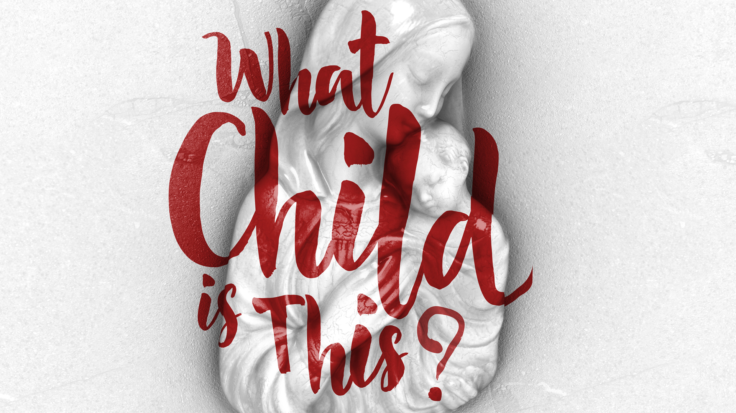

Prayer: May the words of my mouth and the meditations of our hearts… Amen

I am following a series called ‘What Child Is This?’, when I preach this advent. It comes with short videos, slides, ‘sermon-help’s’ plus… So things are a little different…Today we are called to look, listen, watch, think about both Shepherds and their role in the Christmas story and to think about ‘This’ child of Christmas – who was – who is - who is to be our Shepherd-King. ^{off}

In 1865, an Englishman named William Chatterton Dix wrote the words to a poem called "The Manger Throne.” A few years later the first three stanzas of that poem were set to the music of an English traditional folk song called "Greensleeves" that soon became known as the Christmas carol "WCIT?" It first published in the United Kingdom in 1871. It is now an annual reminder that something significant happened on that night in Bethlehem as ‘someone’ significant lay wrapped in swaddling clothes in a manger. ‘This’ child would change the world forever; but what CIT?
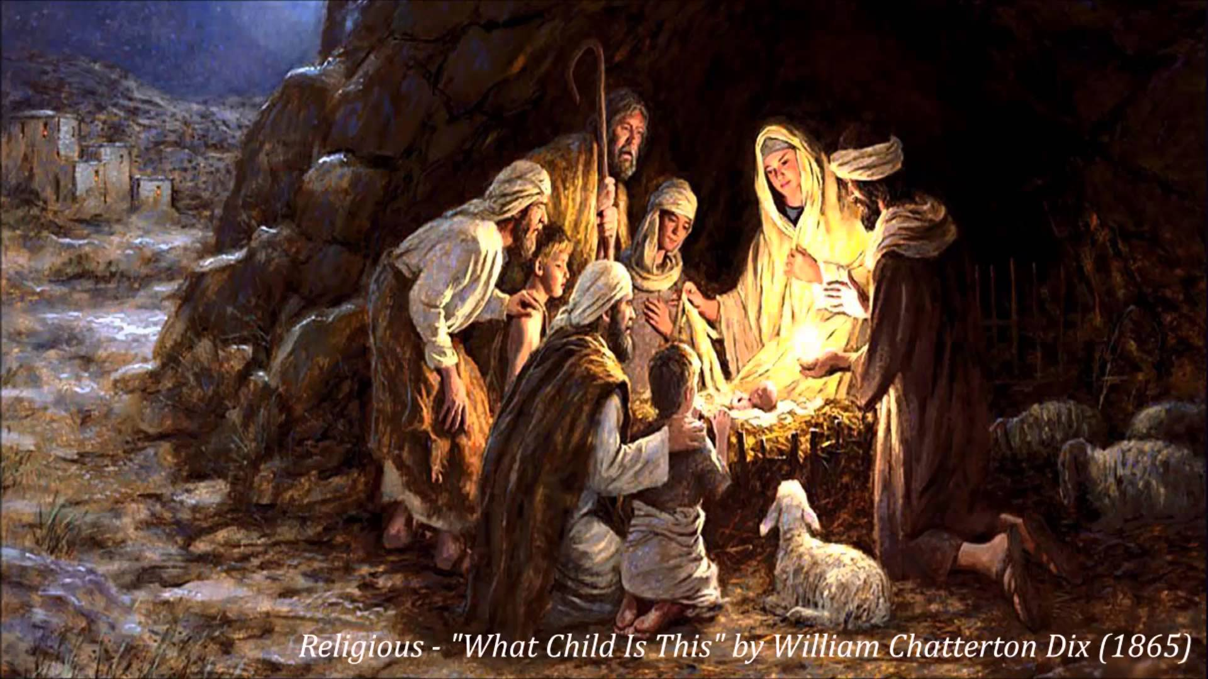

It is easy to imagine the question "What Child Is This?" as the 1st question the shepherds asked that night when they visited baby Jesus. ^{on} Right after their angelic encounter and their receiving the startling news while they looked after their sheep outside Bethlehem. Their heads must have been spinning, as they tried to understand all they’d just experienced. We heard the story as Michelle read Luke’s Gospel.

Every Christmas nativity scene has the ‘shepherds’, so they should always be a part of our Christmas thinking – but on their own they are not the whole of the biblical ‘shepherd’ picture. One of the common job descriptions for “the” child that arrived ‘that night’ is as Shepherd-King. Jesus used this job description himself, ^{Jn 10:11} "I am the good shepherd. The good shepherd lays down his life for the sheep."

“This child” would give his life for his ‘sheep’, his people, actually all people! Jesus had no problem identifying with shepherds. But in general and especially in his time, Shepherds were pretty close to being the ‘lowest class’ of society. But Jesus described himself as a Shepherd and one with great responsibility. He held life, all life in his hands and isn’t that exactly what a shepherd does for those under its care? ^{off}

A little ancient Near East history as background might help us see the context of Jesus claim/ Jesus understanding when he called himself a Shepherd. The Shepherd’s role and associated imagery was a dominant model for leadership in human affairs. Shepherds were equated with righteous government and often appear in contexts where the subject of justice is prominent. Shepherds were expected to be the ones who showed kindness in counselling, protecting, and guiding those whom they were responsible for, through every difficulty.

The shepherd was often meant to signify ruler-ship that was / is good, just, wise and beneficial for the people so it is particularly used as a metaphor of kings and God. Even the shepherd's crook has been viewed throughout the ages as a symbol of power, authority, and strength. Throughout the Bible, shepherds are mentioned over one hundred times. So when we increase our understanding of who shepherds were in terms of how they are defined and described historically in the Bible, it contributes to a better and more complete understanding of the question: What Child Is This?

Did you know that one of the first careers found in the pages of the Bible is that of the shepherd? After Adam and Eve had begun their life together outside of Eden, we learn that their son, Abel, was a shepherd. "Now Abel was a keeper of sheep …" ^{Genesis 4:2}

In biblical days, those who possessed flocks of sheep and other animals that needed shepherding such as goats, cows, oxen, horses, donkeys, and camels were viewed as wealthy and powerful. Great flocks and herds were deemed as blessings from the hand of God. Abraham is an example of such a blessing of this type when he is described in Genesis 24. "The Lord has greatly blessed my master, and he has become great. He has given him flocks and herds …camels and donkeys." ^{Genesis24:35}
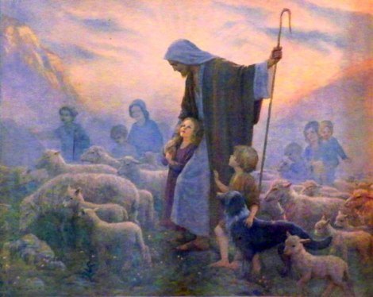
Jesus himself speaks about having many sheep ^{on} in John 10: "I am the good shepherd. I know my own and my own know me, just as the Father knows me and I know the Father; and I lay down my life for the sheep. And I have other sheep that are not of this fold. I must bring them also, and they will listen to my voice. So there will be one flock, one shepherd." ^{John10:14 -16}

Often the owner of the flocks was the one who was also the shepherd such as Abel in Genesis 4 and Jacob in Genesis 30. Other times the work of a shepherd was delegated to both the daughters and sons of the owner. Jesse's son, David, was given the responsibility to take care of his father's sheep before he would be called to care for and lead the people of Israel as their king. In fact, the place David was found before he was anointed as king by the prophet Samuel was out in the fields tending his father's sheep.

The child that would be born in the manger in Bethlehem would be near the pastures that David grazed his father's sheep centuries beforehand. The Saviour of the world, the good shepherd, would be born in the City of David and a direct descendent of the King who also was a good shepherd in by gone days. WCIT? He is a shepherd and king just as his ancestor David. ^{off}

The principal duty ^{on} of the shepherd was to make sure the animals that were under his or her care had enough food and water. David's most famous poem speaks to these priorities in Ps 23 that begins with a truth that echoes the answer to the question of the carol: What Child Is This? "The Lord is my shepherd; I shall not want. He makes me lie down in green pastures. He leads me beside still waters." ^{Psalm23:1 -2}
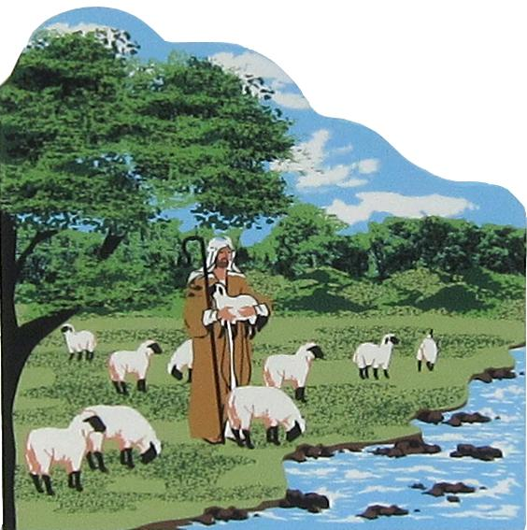

Just as the shepherd was responsible for the food and water provisions of the sheep, protecting the flock also was a priority that had to be continually provided. Sheep were easy prey for wild animals as seen in various places of the Bible. So Ps 23 continues to speak of the protection the writer felt from the Lord as his shepherd. "Even though I walk through the valley of the shadow of death, I will fear no evil, for you are with me; your rod and your staff, they comfort me." ^{Psalm23:4}

David describes attributes of the Lord who not only provides for his nourishment, but also protects him wherever he might find himself in life. These characteristics of the good shepherd contribute to the answer for the shepherd’s question: WCIT? He is the one who will provide for and protect all who are under His care. ^{off}

This good shepherd would not only protect his sheep from wild animals, but also from thieves who might try to snatch them away from their home and the life that was intended for them by the one who watched over and owned them. The good shepherd went to great lengths to take look after those under their care. He would make sure they were kept intact and would go the extra mile to make sure one that was lost was looked for until it was found as Jesus taught in His parable of the lost sheep. ^{Mt 18:10 -14.}

What child is this? He is the one who left all the riches and comfort of heaven to look for the ones who went astray. ^{on} All we like sheep have gone astray; we have turned every one of us — to our own way. The mission of the shepherd is to look for and rescue the ones who are lost. This is what a good shepherd naturally does. This is who this child in the manger would grow to become. He is the one who came to seek and to save those who were lost, alone, exposed, and astray.
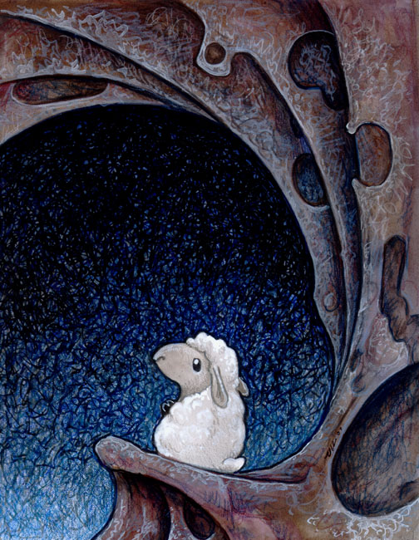

When Jesus completed the rescue mission on the cross outside of Jerusalem three decades after being born in the Bethlehem manger, He restored, empowered and entrusted the shepherding responsibilities to Peter on the shores of Galilee where they first met three years earlier. The whole conversation revolved around the on-going role and responsibility of being and training others to be shepherds of the ones Jesus came to rescue and call His own. ^{off}

"When they had finished breakfast, Jesus said to Simon Peter, "Simon, son of John, do you love me more than these?" …. Jesus said to him, "Feed my sheep." ^{John21:15 -17}

What child is this?
He is the one who came to lay down His life.
He is the one who came to provide for and protect His flock.
He is the one who is the good shepherd.

His name is Jesus, the baby wrapped in swaddling cloths and lying in the manger, just as the angel
said he would be.

Now go and tell everyone what has been heard,
seen and experienced concerning who this child is,
just as the shepherds did on that first Christmas in Bethlehem.

What child is this? He is a shepherd …the good shepherd.

Play video…

