^{on} Sermon 8 October 2017 ‘A Rule of Love’
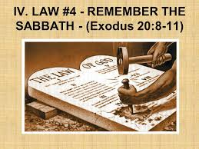
Exodus 20:1-4, 7-9, 12-20 Matthew 21:33-46

Prayer: Draw closer to us, our God, Rock, and Redeemer, for our travels have made us thirsty, our trials have made us weary, our tribulations have pushed us apart; leaving us longing for the guidance and instruction that only you can provide. Amen. ^{off}
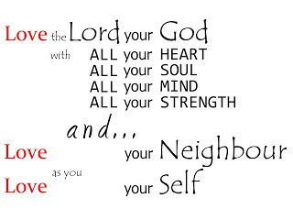

^{on}A rule of love is how Jesus would summarise the 10 ‘Words’ from God that Moses handed over in the Exodus reading today, when he said the greatest Commandment was to love God and love your neighbour as yourself. Under a rule of love is how the ‘Lord of the Vineyard’ expects the vineyard to be managed so that the fruit yield is maximised in the best way possible. Both texts allude to what happens when the rule of love fails as the operating model for relationships between God / people, and people / people. ^{off}
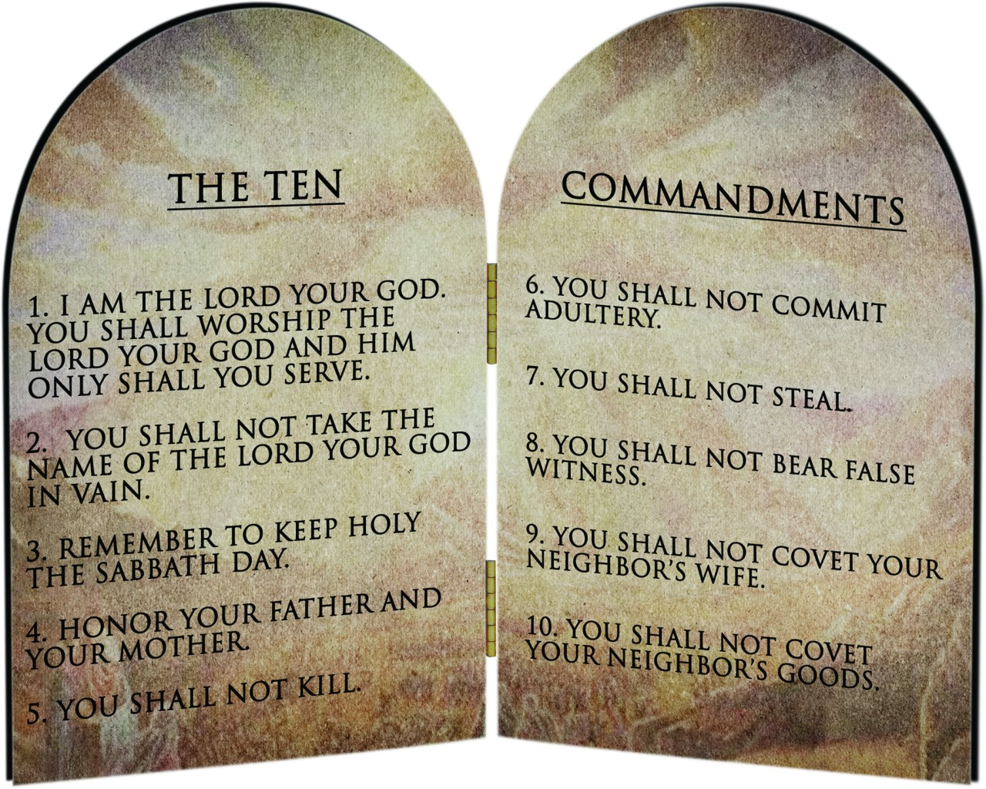

In ^{1*}Hebrew this chapter is known as the ‘Ten Words’, remember it began: ^{on} ‘Then God spoke all these words’. Wallace tells us that “the phrase ‘these words’ includes all of the laws which are to follow in Exodus-Deuteronomy. The ‘Ten Words’ are, like other lists of laws in the Old Testament (e.g. Ex 34:10-26; Deut 27:14-26 etc.), representative of a wider body of legislation. These representative lists often contained the 10-12 laws. But the ‘Ten Words’ in Ex 20, and the parallel (slightly different version in Deut 5) were given more significance because they were seen to represent the totality of the law. ^{off}

Now, before we get too caught up and depressed by ‘rules’, I want to remind us all of the ^{1*}purpose of law given by a god in the ancient world. And Wallace says in this regard Israelite law was no different to other law in its day. Law was more than just limiting and directing human behaviours so that equity and justice may be experienced by all and peace prevail. Law was always thought of as being of divine origin and was intended to order human society so that it functioned in a way consistent with the divine will and ordering of the whole cosmos. In other words, law was seen as part of creation itself. So for the Israelite people their ‘law’ has always belonged to the Creator’s plan for the whole world.

^{1*}Just as there were ‘natural’ limits and behaviours set within the cosmos itself, so law set these limits within human society. And just as creation was intended to offer life to all, so law was given that people may prosper in a long life (see Deut 6:1-3; 30:19 etc). The law or torah (also ‘teaching’) is an instrument of mutual relationship where the faith of the people responds to the love and grace of God. This is the understanding behind the torah that gives life to its keeping / its observance. When we hear Christians claiming the law is purely ‘legalistic’, and does not reveal a God of grace (as known by Christians) this could not be further from the truth. Their attitude shows a complete lack of understanding of torah.
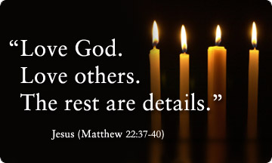

The 10 words, the ‘LAW’ given here begin with God introducing the “divine-self” as One who was worried about his people and so rescued them from Egypt / oppression / abuse / slavery... Then it is as if God realises the need for the people to have some way of living together and with Him – in their ‘liberated’ post Egypt state. ^{on} So the ‘10 Words’ are given – to keep relationships right; society healthy; community thriving and the promise of God to Abraham being fully realised. The relationship rules are to love God (1,2,3); love others (5,6,7,8,9,10) and self (4). When these ‘Words’ are followed they enable God’s people to live fully together, with God and the right way in the Kingdom. ^{off}

They are not about making God’s people ^{1*”}‘worthy to come into God’s presence… Law or torah in the Old Testament is always a way to live in the presence of the gracious God who first comes to us in our despair and need. They are also a reminder that living in the presence of this God brings responsibility toward God and toward all God’s creation. Law or torah was a way of’ enabling God’s people to live this God-centred life, God’s way, under if you like, God’s management, in God’s Kingdom.

God’s management is one way to describe the link to Jesus parable about the vineyard today. A common picture from the Old Testament is one where the people – Israel are compared / called a Vineyard, (Eg Isaiah 5: 1-7,) God’s vineyard managed under the Law was the way for the Vineyard (Israel) to flourish. This very common picture is what Jesus used that day when he was facing the Chief Priests and Scribes. He was completely within the traditions of Israel and YHWH-God when he described a vineyard – of God’s people. But then Jesus throws out his challenge as he describes how its managers were rejecting the owner-Lord’s methods and attempts to check on his vines / his fruit / his people!!!

I find the strength of this parable almost too much. Jesus is so strong in his condemnation of the people managing God’s people because of their rejection of God’s ways, eg. with their use of violence and murder… I don’t think it is too hard to see how in the rejection of the ‘owner’ (God), the ‘managers’ have claimed that position for themselves. They are deciding who can live, who dies, and who inherits. They decide the rules for living… setting themselves as the ‘owner’ making the rules and not the ‘owner-Lord’.
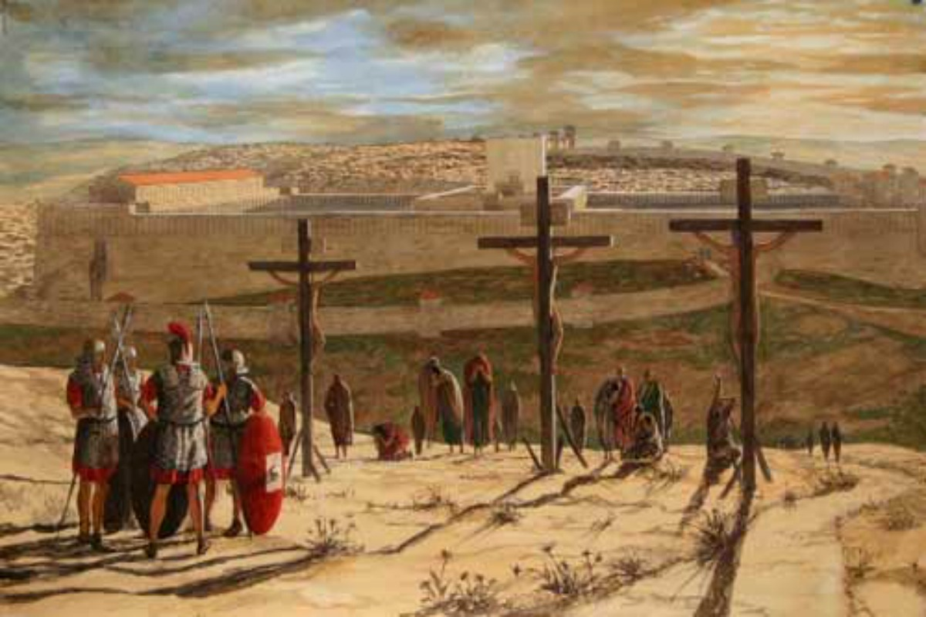

They are certainly – in Jesus parable breaking ‘some’ of the 10 ‘Words’ – but even more is that they are breaking the Owner-God’s heart. They fail to live in love with God, neighbour and self, they (will) kill ^{on} the beloved Son – and throw him out of the vineyard. ^{2*} ‘Being thrown out of the vineyard is a metaphor for being thrown out of Israel. Remember Jesus was crucified on a cross outside the walls of Jerusalem? He was literally ‘thrown outside’, and this is another way of saying that the religious leadership of Judaism rejected (was rejecting) Jesus and his teachings. ^{off}


You see, this parable is not really about the fruit, the glorious vines doing what they are supposed to do: bearing fruit. ^{on} This is about the people in charge not living God’s way – in God’s rule of love, and who fail to recognise God’s appointed envoys / servants / Son. ^{off} And Jesus listeners – all of them knew it.

Like last week, Jesus invites his listeners into the story, asking them: “what will the owner do?” 41 “He will bring those wretches to a wretched end,” they replied, “and he will rent the vineyard to other tenants, who will give him his share of the crop at harvest time.” Because of the way Jesus has told the story, it is the chief priests and scribes who pronounce their own judgment. He asks what the "lord" would do to the wicked tenants? They say: "He will put those wretches to a miserable death."

^{2*}Petty tells us that “the response of the chief priests and scribes is incriminating on yet another level as well. "He will put those wretches to a miserable death" is a statement that reveals the chief priests and scribes to be people of violence.”
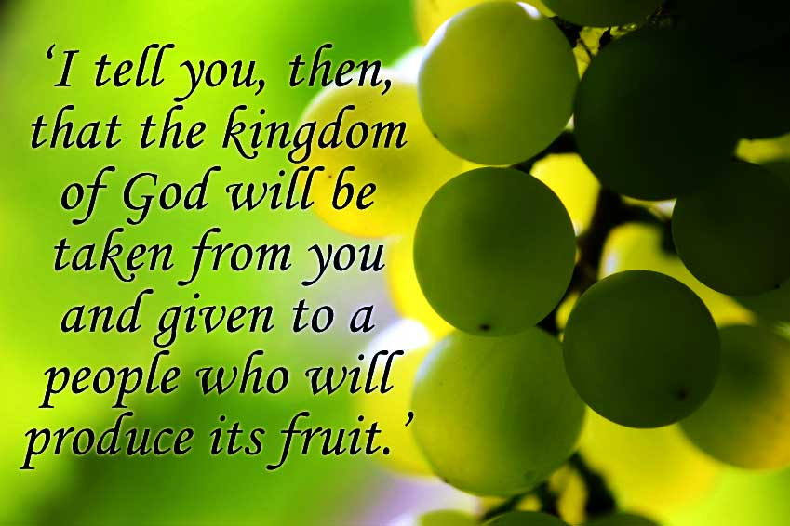

But now the teaching from parable begins to shift – because the violence suggested is not of ‘God’. It is the human ‘managers’, the chief Priests and scribes answer and judgement. God doesn’t kill – ^{on} he removes and ^{2*}replaces them with those who can produce the fruits of the kingdom. By the end of the parable, the concept of vineyard has shifted even more. Did you pick it up? The vineyard is no longer Israel or Jerusalem, but rather has become "the kingdom". It is no longer governed by a corrupt elite, but by an egalitarian people who live out the precepts of that kingdom and produce good fruit. ^{off}

Remember this is Matthew’s Gospel and for Matthew ‘fruits’ is his favourite way of describing ^{2*}walking in the way of Jesus; doing as Jesus did; following the program of Jesus; which can be summarised as being about the absolute equality of all, and an affirmation of the dignity of every human being.

Jesus finishes by quoting from Psalm 118: 22-23--"the stone which the builders rejected"--to say that God has indeed vindicated him-Jesus and placed him at the "head of the corner." This description is one way we can understand his resurrection: ^{2*} The way which is rejected (Jesus’s) of non-violence, equality, human dignity--turns out to be the true way. Resurrection is God's vindication of the person and ministry of Jesus of Nazareth. ^{on} It is God's stamp of approval--God's emphatic "yes!" Yes, to the way of the rule of love as lived and taught by Jesus in his life and his death for his people – of the Kingdom’s vineyard. Amen ^{off}


