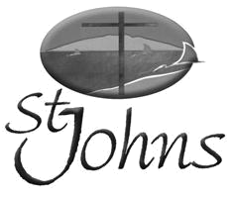
Weekly Newsletter

Sunday 15 October 2017

“Being the Gospel to all

People”

A very warm welcome is extended

to all visitors to St Johns

Morning tea is offered after the service today, so please stay and enjoy.

This week’s theme: ‘Soothing Our Souls’
Focus Scripture: Exodus 32:1-14
Other Readings: Psalms 106:1-6; Phil 4:1-9; Matthew 22:1-14
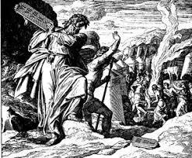


Exodus 32:1-14

32 When the people saw that Moses was so long in coming down from the mountain, they gathered around Aaron and said, “Come, make us gods who will go before us. As for this fellow Moses who brought us up out of

Egypt, we don’t know what has happened to him.” ² Aaron answered them, “Take off the gold earrings that your wives, your sons and your daughters are wearing, and bring them to me.” ³ So all the people took off
their earrings and brought them to Aaron. ⁴ He took what they handed him and made it into an idol cast in the shape of a calf, fashioning it with a tool. Then they said, “These are your gods, Israel, who brought you up out

of Egypt.” ⁵ When Aaron saw this, he built an altar in front of the calf and announced, “Tomorrow there will
be a festival to the LORD.” ⁶ So the next day the people rose early and sacrificed burnt offerings and presented
fellowship offerings. Afterward they sat down to eat and drink and got up to indulge in revelry. ⁷ Then
the LORD said to Moses, “Go down, because your people, whom you brought up out of Egypt, have become
Next Sunday: Sunday 6 August 2017
corrupt. 8 They have been quick to turn away from what I commanded them and have made themselves an
Next week’s theme: ‘Struggle’
idol_{Focus}castin _{Scripture:}theshapeofa _{Genesis}calf.Theyhave_{32:22}bowed₋₃₁down to it and sacrificed to it and have said, ‘These are your
^{gods,}Other^{Israel,}Readings:^{whobrought} Psalm^{youupout}17:1^{ofEgypt}-7,.’ 15; Romans 9:1-5; Matthew 14:13-21

Next Sunday: 22 October 2017
Next week’s theme: Our Whole Selves
Focus Scripture: Exodus 33:12-23
Other Readings: Psalm 99; 1 Thessalonians 1:1-10; Matthew 22:15-22

Prayer points for: Families, Children and Leaders for Mainly Music Ministry please; The Handscamp family (Nigel, Rebecca, Letitia and Jacinta) with the sudden death of Nigel’s mum a few weeks ago and now his dad has passed away.

Steve Logan says thank you all (and God) for the strength and grace he found to live through his Leukaemia treatment, (a bone marrow transplant (successful)) and while all that was happening, for being able to cope with his wife’s death. Please pray for the Logan family as they mourn Lynette’s death.

*** LEPROSY MISSION BOXES due this month. Please hand in to Joan Jones ***
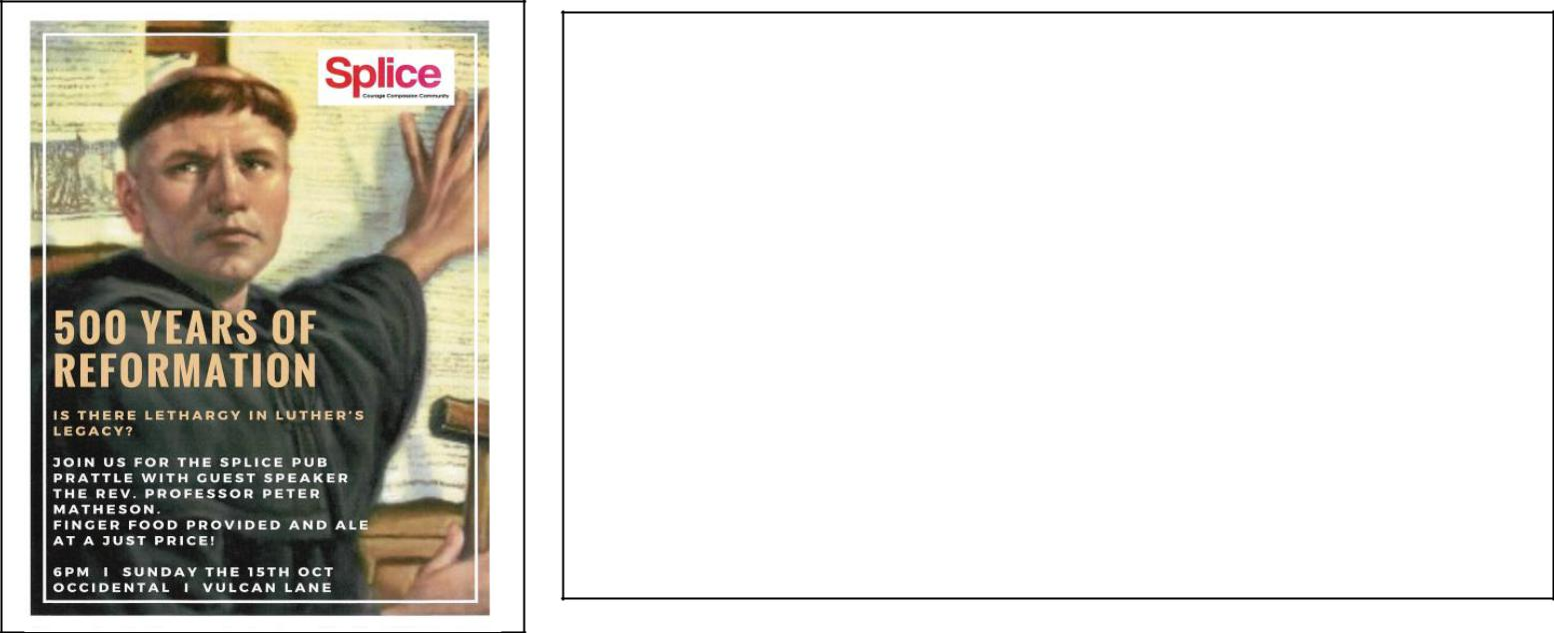

500 YEARS OF REFORMATION

Is There Lethargy in Luther’s Legacy?

6pm Sunday 15 October

Occidental, Vulcan Lane

Join the Splice Pub Prattle with Guest Speaker The Rev. Professor Peter Matheson.

Finger food provided and ale at a just price!

The Five Hundredth Anniversary of the Reformation 1517-2017 The community of St Luke and St Heliers Presbyterian Church invite you to a public marking this anniversary. “How do we speak about God? Authenticity for Martin Luther and for us” by Professor Peter Matheson, St Lukes Church 130 Remuera Road, 17 October at 7.30 pm.

Real Life with John Cowan 7.30pm Sunday nights on Newstalk ZB John Cowan’s guest this Sunday night (15 October) will be TV presenter and producer, Jude Dobson. Jude became a familiar television presence in the 1990’s presenting a run of lifestyle shows, and then her own ‘five nights a week’ series. After beginning on quiz show Sale of the Century, she went on to helm almost 1000 episodes of 5.30 with Jude and its follow up. In 2002, she set up production companies Homegrown Television and Raising Children Media to accessible, useful video content for parents. Dobson’s ‘Family Matters’ column has appeared in The NZ Herald; she has also written an advice column in The New Zealand Woman’s Weekly and takes on varied contract writing gigs.
One More at the Table: Uniting Congregations of Aotearoa New Zealand (UCANZ) Forum ‘One More at the Table’ takes place from 26-29 October at the Onehunga Co-operating Parish, Corner of Grey Street and Onehunga Mall. This year’s UCANZ Forum goal is to enlarge vision and equip those attending with greater understanding of the diversities encountered in the life of Cooperative Ventures. Full programme at www.ucan.org.nz

Afternoon tea contributions and servers needed-
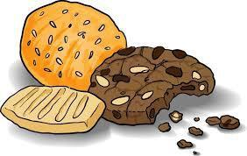
Saturday 28 October

St Johns is responsible for preparing and serving afternoon tea at the forum mentioned above. Contributions of slices or biscuits for this event will be appreciated. Please bring them to church on Friday 27 October. Helpers on the day would also be welcome, contact Lorraine or Alison.


Auckland Prayer Breakfast

Thursday, 26 October at 6.30 am Eden Park Function Centre

This event is for anyone who desires to pray for the different communities that come together in the Auckland area such as business (the professions), politics, the arts and those in need.

THANKSGIVING SUNDAY, 29 October

In 2017 we are appealing for funds to refurbish and freshen-up the upstairs hall. If you venture up there you will see that this is badly needed. The kitchen upgrade is going to make the rest of the upstairs look even more shabby. This is the environment in which our Mandarin language services are held. So, if you can please give generously.

As always we will be giving 10% of the money raised to a cause outside of St Johns. This year the Leadership Team decided to support the Chinese Churches Support Mission. (CCSM). This is close to the hearts of our Mandarin Brethren. Murray Cameron who is often here to speak at services upstairs works for CCSM.

Sunday Services: English / Mandarin & Children’s Ministry 9:30a.m.
Office Hours: 9:30am – 3:00pm, Tuesday – Friday
Phone: 534 2305, Fax: 534 6355, Email: office@stjohnsbb.org.nz
PO Box 39 278, Howick Website: www.stjohnsbb.org.nz
Lorraine: minister@stjohnsbb.org.nz CYL: cyl@stjohnsbb.org.nz
Minister | Rev. Lorraine Francis | 534 1380
Administrator | Alison Stanton | 534 2305
Child /Youth |  | 534 2305
Session Clerk | Alan Vickers | 533 3790
People’s Warden | Julie Dickey | 535 5814
Minister’s | Felicity Vincer | 535 5883
Pastoral Care | Judy McDonald | 274 8534
Prayer Chain | Judy McDonald | 274 8534
Justice of Peace | Margaret Wernham | 534 9921

Ministry Groups:
Bucklands Beach Rest Home: 3rd Thursday’s of the month, 11:00am
Children’s Church (Preschool, Primary & Intermediate): Sundays, 9:30am

Girls’ Brigade: In recess for 2017 CTC Julie 535 5814
Home Groups: No home group at this time please contact Rev Lorraine Francis
Men’s Group: Thursday nights 7:30pm in the Chapel; contact Alan Vickers ph: 533 3790
Mainly Music: Wednesdays, 10:00am (Term Time)
Music Ministry: Thursdays, 7.30pm; Wednesdays 7:30pm
Young Adults / Youth on Sundays: at least on Youth-band Sunday after Church till 12:30 pm

 | This Week’s Helpers (15 Oct) | Next Week’s Helpers (22 Oct)
Minister | Rev Lorraine Francis | Rev Lorraine Francis
Keyboard | Joshua Wong | Rahil
Projector | Alison Stanton | Alison Stanton
Sound Desk | Erika Lim | Alan Vickers
Reader | Trevor Haigh | Dick McDonald
Intercessor | Mavis Haigh | Judy McDonald
HC set up | Christine Lewis | N/A
 | Dick and Judy McDonald; Christine | N/A
HC Serving team | Lewis; Alison Stanton
Prayer ministry | Loas Toung | Alan Vickers
Welcome Desk | Loas Toung | Joan Rutherford
Ushers | Trevor and Mavis Haigh | Dick and Judy McDonald
Counters | Trevor Haigh, Grace Li | Dick McDonald, Li Ying Zhang
Morning Tea | Uraiwan Jolly, Nessie Crawford | Sue Chang and Friend
Flowers | St Johns | Sue Chang and Friend

