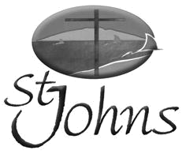
Weekly Newsletter

Sunday 22 October 2017

“Being the Gospel to all

People”

A very warm welcome is extended

to all visitors to St Johns

Morning tea is offered after the service today, so please stay and enjoy.

This week’s theme: ‘Our Whole Selves
Focus Scripture: Exodus 33:12-23
Other Readings: Psalms 19; 1 Thessalonians 1:1-10; Matthew 22:15-22
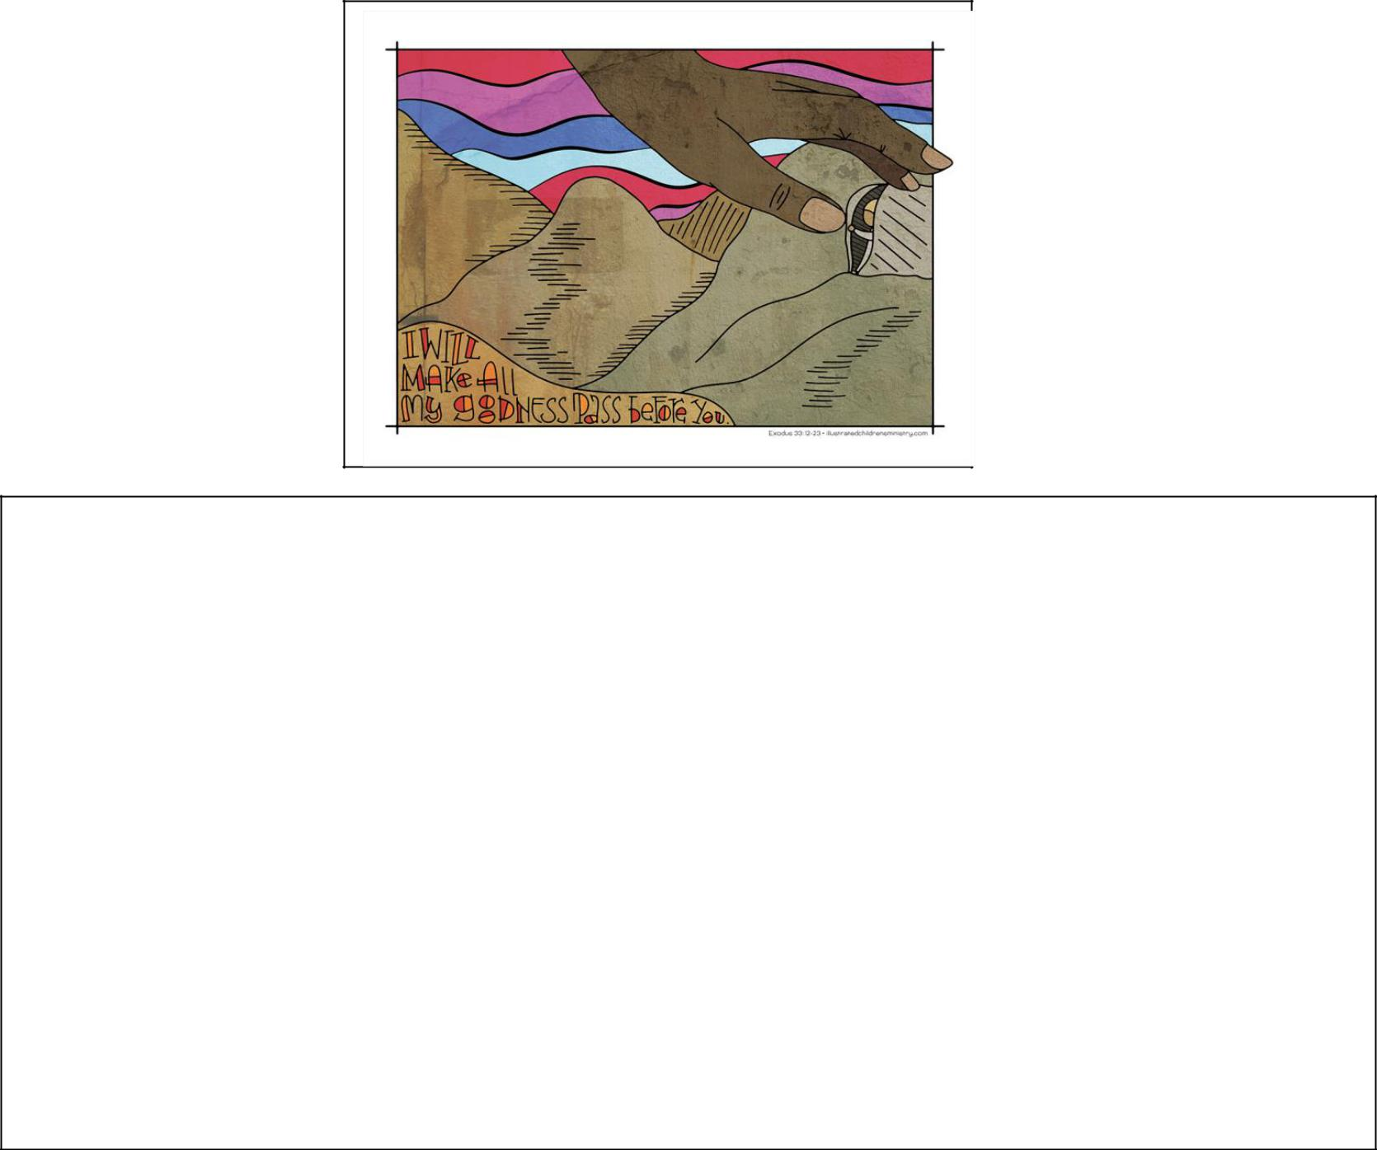

Exodus 33: 12-23

- Moses said to the LORD, “You have been telling me, ‘Lead these people,’ but you have not let me know whom you will send with me. You have said, ‘I know you by name and you have

found favour with me.’ ¹³ If you are pleased with me, teach me your ways so I may know you and continue to find favour with you. Remember that this nation is your people.”

- The LORD replied, “My Presence will go with you, and I will give you rest.”

- Then Moses said to him, “If your Presence does not go with us, do not send us up from here. ¹⁶ How will anyone know that you are pleased with me and with your people unless you
goNextwith us?Sunday:WhatelseSundaywilldistinguish6Augustme2017andyour people from all the other people on the

faceNextof theweek’searth?”theme: ‘Struggle’
17Focus Scripture: Genesis 32:22-31
And the LORD said to Moses, “I will do the very thing you have asked, because I am pleased
Other Readings: Psalm 17:1-7, 15; Romans 9:1-5; Matthew 14:13-21 with you and I know you by name.”

Next Sunday: 29 October 2017
Next week’s theme: A Problem and a Solution
Focus Scripture: Isaiah 6:1-8
Other Readings: 1 John 1:8-10; John 1:19-21, 29-34

Prayer points for: Brenda Ryan for good health; Families, Children and Leaders for Mainly Music Ministry please; George Morrison and family with the sudden death of his daughter, Fiona. The Handscamp family (Nigel, Rebecca, Letitia and Jacinta) with the sudden death of Nigel’s mum a few weeks ago and now his dad is in a hospice, dying of cancer.

Steve Logan says thank you all (and God) for the strength and grace he found to live through his Leukaemia treatment, (a bone marrow transplant (successful)) and while all that was happening, for being able to cope with his wife’s death. Please pray for the Logan family as they mourn Lynette’s death.

- LEPROSY MISSION BOXES due this month. Please hand in to Joan Jones ***

Real Life with John Cowan 7.30pm Sunday nights on Newstalk ZB John Cowan’s guest this Sunday night (22 October) will be celebrity chef, food writer and publisher, Annabel Langbein.

Age Concern have two local events coming up. You can register for either of these by phoning the Age Concern Office 09 279-4331 Ext 800 or email reception@accm.org.nz

Nutrition in a Nutshell – 10 am – noon, Thursday 26 October, East City Wesleyan Church, 219 Burswood Drive, Botany.

Staying Safe – 9.30am-2.30pm, Friday 27 October, St Andrews Presbyterian Church, 11 Vincent Street, Howick.

One More at the Table: Uniting Congregations of Aotearoa New Zealand (UCANZ) Forum ‘One More at the Table’ takes place from 26-29 October at the Onehunga Co-operating Parish, Corner of Grey Street and Onehunga Mall. This year’s UCANZ Forum goal is to enlarge vision and equip those attending with greater understanding of the diversities encountered in the life of Cooperative Ventures. Full programme at www.ucan.org.nz

Afternoon tea contributions and servers

needed- Saturday 28 October

St Johns is responsible for preparing and serving afternoon tea at the forum mentioned above. Contributions of slices or biscuits for this event will be appreciated. Please bring them to church on Friday 27 October. Helpers on the day would also be welcome, contact Lorraine or Alison.

Auckland Prayer Breakfast Thursday, 26 October at 6.30 am Eden Park Function Centre

This event is for anyone who desires to pray for the different communities that come together in the Auckland area such as business (the professions), politics, the arts and those in need.

THANKSGIVING SUNDAY, 29 October: In 2017 we are appealing for funds to refurbish and freshen-up the upstairs hall. If you venture up there you will see that this is badly needed. The kitchen upgrade is going to make the rest of the upstairs look even more shabby. This is the environment in which our Mandarin language services are held. So, if you can please give generously.

In particular we wish to:
Install blinds |  | quote to come
Improve the sound system |  |  | “
Install heat pumps |  |  | “
Paint |  |  | “
Replace the vinyl flooring
- | Hall | $11,684.00
- | Stairwell | $ | 5,715.00

As always we will be giving 10% of the money raised to a cause outside of St Johns. This year the Leadership Team decided to support the Chinese Churches Support Mission. (CCSM). This is close to the hearts of our Mandarin Brethren. Murray Cameron who is often here to speak at services upstairs works for CCSM.

INSPIRE/PREACH – Ecumenical Lay Preachers Meeting – Saturday 25th November 9.30am – Noon. The Methodist Church Offices, 409 Great South Road, Auckland. This is the beginning of a new venture for Lay Preachers in our area. The Lay Preachers License requires that Lay Preachers are involved in continuing education and the organisers intend to make it a practical and memorable offacions for all Lay Preachers whatever their experience. RSVP 18th November marilynw@methodist.org.nz

Sunday Services: English / Mandarin & Children’s Ministry 9:30a.m.
Office Hours: 9:30am – 3:00pm, Tuesday – Friday
Phone: 534 2305, Fax: 534 6355, Email: office@stjohnsbb.org.nz
PO Box 39 278, Howick Website: www.stjohnsbb.org.nz
Lorraine: minister@stjohnsbb.org.nz CYL: cyl@stjohnsbb.org.nz
Minister | Rev. Lorraine Francis | 534 1380
Administrator | Alison Stanton | 534 2305
Child /Youth |  | 534 2305
Session Clerk | Alan Vickers | 533 3790
People’s Warden | Julie Dickey | 535 5814
Minister’s | Felicity Vincer | 535 5883
Pastoral Care | Judy McDonald | 274 8534
Prayer Chain | Judy McDonald | 274 8534
Justice of Peace | Margaret Wernham | 534 9921

Ministry Groups:
Bucklands Beach Rest Home: 3rd Thursday’s of the month, 11:00am
Children’s Church (Preschool, Primary & Intermediate): Sundays, 9:30am
Girls’ Brigade: In recess for 2017 CTC Julie 535 5814
Home Groups: No home group at this time please contact Rev Lorraine Francis
Men’s Group: Thursday nights 7:30pm in the Chapel; contact Alan Vickers ph: 533 3790
Mainly Music: Wednesdays, 10:00am (Term Time)
Music Ministry: Thursdays, 7.30pm; Wednesdays 7:30pm
Young Adults / Youth on Sundays: at least on Youth-band Sunday after Church till 12:30 pm

 | This Week’s Helpers (22 Oct) | Next Week’s Helpers (29 Oct)
Minister | Rev Lorraine Francis | Rev Grahame Drummond
Keyboard | Rahil | Rahil John
Projector | Alison Stanton | Alison Stanton
Sound Desk | Alan Vickers | Bob Corbett
Reader | Dick McDonald | John Pybus
Intercessor | Judy McDonald | Alan Vickers
HC set up | N/A | Joan Jones
 | N/A | Joan Jones; David Hall; John
HC Serving team |  | Copping; John Pybus; Alan Vickers
Prayer ministry | Alan Vickers | Joan Rutherford
Welcome Desk | Joan Rutherford | Joan Rutherford
Ushers | Dick and Judy McDonald | Trevor Haigh and Mavis Haigh
Counters | Dick McDonald and Li Ying Zhang | Trevor Haigh and Grace Li
Morning Tea | Sue Chang and Friend | Sue Chang and Friend
Flowers | St Johns | St Johns

