Numerical Expressions ⸱ Practice

Example 1
Write a numerical expression for each verbal expression.
1. two plus twelve divided by four 2. eighteen more than five

3. seven more than three times eleven 4. twenty-five less than one hundred

5. six minus three minus one 6. fourteen decreased by three times four

7. twenty-four divided by six plus seven 8. eight times six divided by two minus nine

9. one hundred sixteen divided by four plus twenty-eight minus thirty-three

10. two hundred fifty-nine minus eighty-five plus sixty-two divided by two

Example 2
Write a numerical expression for each verbal expression.
11. the sum of three and seven divided by two 12. the difference of six and two divided by four

13. the sum of four and nine times three 14. eighteen divided by the sum of two and seven

15. ten divided by the product of four and five 16. the difference of eleven and four times five

17. the sum of one and two divided by twenty 18. the sum of two and four and six times eight

19. the sum of twelve and sixteen divided by the sum of three and four

20. the difference of twenty-two and six divided by the sum of five and three

21. the sum of thirty-six and fourteen divided by the product of two and five

22. the quotient of thirty-two and four divided by the sum of one and three

23. the sum of six and fifteen divided by the difference of thirteen and three

24. the difference of thirty-one and seventeen divided by the product of ten and four

Example 3
25. SOLAR SYSTEM It takes Earth about 365 days to orbit the Sun. It takes Uranus about 85 times
as long. Write a numerical expression to describe the number of days it takes Uranus to orbit the Sun.

26. TEST SCORES To find the average of a student’s test scores, add the scores and divide by the number of tests. Suppose Ryan scored 85, 92, 88, and 98 on four tests. Write a numerical expression to describe Ryan’s average test score.

27. HOMEWORK It took Carrie five less minutes than twice the amount of time as Hua to complete her homework. It took Hua thirty-five minutes to complete her homework. Write a numerical expression to describe the amount of time it took Carrie to complete her homework.

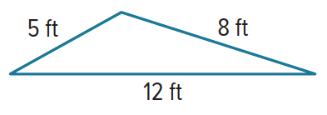
28. PERIMETER The perimeter of Stephanie’s triangle is half the perimeter of Juan’s triangle. Juan’s triangle is shown. Write a numerical expression to describe the perimeter of Stephanie’s triangle.

29. BEDROOM Shenandoah’s rectangular bedroom is 12 feet long and 7 feet wide. Write a numerical expression to describe the area of Shenandoah’s bedroom.

Examples 4, 5, and 7
Evaluate each expression.
30. 7² 31. 14³ 32. 2⁶

33. 35 – 3 • 8 34. 18 ÷ 9 + 2 • 6 35. 10 + 8³ ÷ 16

36. [(6³ – 9) ÷ 23]4 37. $\frac{8 + 3^{3}}{12 - 7}$ 38. $\frac{\left(1 + 6\right)9}{5^{2} - 4}$

39. 4(16 ÷ 2 + 6) 40. 13 – $\frac{1}{3}$(11 – 5) 41. (5 • 2 – 9) + 2 • $\frac{1}{2}$

42. 62 – 3² • 8 + 11 43. 4³ ÷ 8 44. 20 + 3(8 – 5)

45. 3[4 – 8 + 4²(2 + 5)] 46. $\frac{2 • 8^{2} - 2^{2} • 8}{2 • 8}$

47. 25 +$\left[\left(16-3 • 5\right)+\frac{12 + 3}{5}\right]$ 48. 7³ – $\frac{2}{3}$(13 • 6 + 9)4

Example 6
49. BIOLOGY Lavania is studying the growth of a population of fruit flies in her laboratory. After
6 days, she had nine more than five times as many fruit flies as when she began the study. If she observes 20 fruit flies on the first day of the study, write and evaluate an expression to find the population of fruit flies Lavania observed after 6 days.
a. Write an expression for the population of fruit flies Lavania observed after 6 days.

b. Find the population of fruit flies Lavania observed after 6 days.

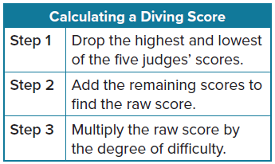
50. PRECISION The table shows how scores are calculated at diving competitions. Each of the five judges scores each dive from 1 to 10 in 0.5-point increments. Tyrell performs a dive with a degree of difficulty of 2.5. His scores from the judges are 8.0, 7.5, 6.5, 7.5, and 7.0.

a. Write an expression to find Tyrell’s score for the dive.

b. What was Tyrell’s score for the dive?

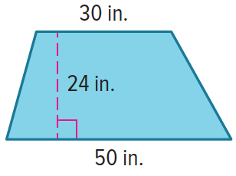
51. RAMP The side panel of a skateboard ramp is a trapezoid, as shown.
a. Write an expression to find the amount of wood needed to build the two side panels of a skateboard ramp.

b. How much wood is needed to build the two side panels of a skateboard ramp?

Example 8
52. SKIING The cost of a ski trip is shown. The Sanchez family wants to purchase lift
tickets for 2 adults and 3 children. They also need to rent 2 complete pairs of
skis. If they also buy a 16-ounce hot chocolate for each person, find the total cost
of the ski trip.
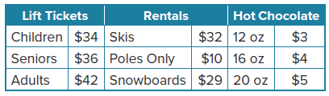

Mixed Exercises
Write a numerical expression for each verbal expression.
53. eight to the fourth power increased by six

54. the sum of three and five to the third power times five plus one

55. CONSTRUCT ARGUMENTS Isabel wrote the expression 6 + 3 × 5 – 6 + 8 ÷ 2 and asked Tamara to evaluate it. When Tamara evaluated it, she got a value of 19. Isabel told Tamara that her value was incorrect and said that the value should have been 38. Who is correct? Justify your argument.

56. REASONING Write an expression that includes the numbers 2, 4, and 5, has a value of 50, and includes one set of parentheses.
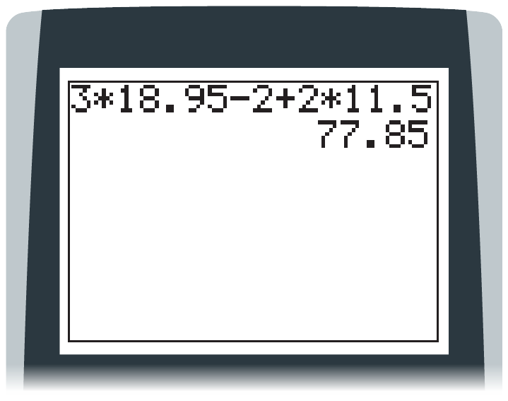

57. CONSTRUCT ARGUMENTS Kelly buys 3 video games that cost $18.96 each. She also buys 2 pairs of earbuds that cost $11.50 each. She has a coupon for $2 off the price of each video game. Kelly uses a calculator, as shown, to find that the total cost of the items is $77.85. The cashier tells her that the total cost is $73.85. Who is correct? Justify your argument.

58. REASONING The expression 13.25 × 5 + 6.5 gives the total cost in dollars of renting a bicycle and helmet for 5 days. The fee for the helmet does not depend upon the number of days.

a. What does 13.25 represent?

b. How would the expression be different if the cost of the helmet were doubled?

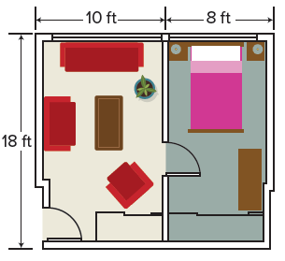
59. PERSEVERE The figure shows a floor plan for a two-room apartment. Write an expression for the area of the apartment, in square feet, by first finding the area of each room and then adding. Then describe how you can write the expression in a different way.

60. CREATE Describe a situation that could be represented by each expression.
a. 9.95 + 0.75 × 3

b. 15 × 6 – 5 × 6

c. 59 × 5 – 25 × 5 – 30

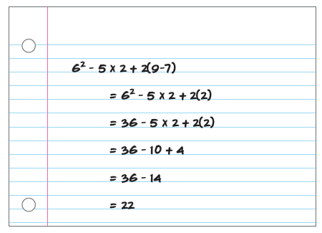
61. FIND THE ERROR A student was asked to evaluate an expression. The student’s work is shown. Describe any errors and find the correct value of the expression. Explain your reasoning.

62. PERSEVERE When is 4x < 4? Use a drawing to justify your reasoning.

