Solving Equations with the Variable on Each Side ⸱ Practice

Examples 1, 3, and 4
Solve each equation. Check your solution.
1. 7c + 12 = –4c + 78 2. 2m – 13 = –8m + 27

3. 9x – 4 = 2x + 3 4. 6 + 3t = 8t – 14

5. $\frac{b - 4}{6}$ = $\frac{b}{2}$ 6. $\frac{3v + 12}{6}=\frac{4v}{3}$

7. 2(r + 6) = 4(r + 4) 8. 6(n + 5) = 3(n + 16)

9. 5(g + 8) – 7 = 117 – g 10. 12 – $\frac{4}{5}$(x + 15) = $\frac{2}{5}x+6$

11. 3(3m – 2) = 2(3m + 3) 12. 6(3a + 1) – 30 = 3(2a – 4)

13. 7n + 6 = 4n – 9 14. –6(2r + 8) = –10(r – 3)

15. 5 – 3(w + 4) = w – 7 16. 2x – 5(x – 3) = 2(x – 10)

Example 2
17. OLYMPICS In the 2010 Winter Olympic Games, the United States won 1 more than 4 times the number of gold medals France won. The United States won 7 more gold metals than France. Write and solve an equation to find the number of gold medals each country won.

18. REASONING Diego’s sister is twice his age minus 9 years. She is also as old as half the sum of the ages of Diego and both of his 12-year-old twin brothers. Write and solve an equation to find the ages of Diego and his sister.

19. NATURE The table shows the current heights and average growth rates of two different species of trees. Write and solve an equation to find how long it will take for the two trees to be the same height.
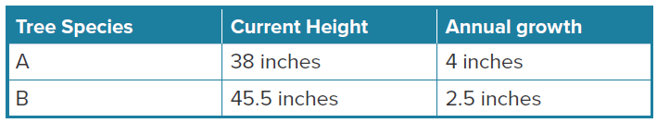

20. WEIGHT A dog weighs two pounds less than three times the weight of a cat. The dog also weighs twenty-two more pounds than the cat. Write and solve an equation to find the weights of the dog and the cat.

Example 5
21. GEOMETRY Supplementary angles are two angles with measures that have a sum of 180º. Complementary angles are two angles with measures that have a sum of 90º. The measure of the supplement of an angle is 10º more than twice the measure of the complement of the angle. Let 90 – x equal the degree measure of the complement angle and 180 – x equal the degree measure of the supplement angle. Write and solve an equation to find measure of the angle.

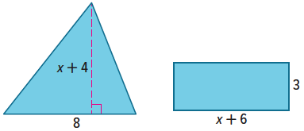
22. GEOMETRY Write and solve an equation to find the value of x so that the figures have the same area.

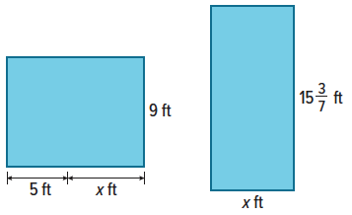
23. GEOMETRY Write and solve an equation to find the value of x so that the figures have the same area.

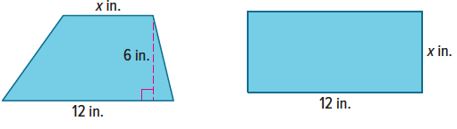
24. GEOMETRY Write and solve an equation to find the value of x so that the figures have the same area. The area of a trapezoid is $\frac{1}{2}h(b_{1}+b_{2})$.

Examples 6 and 7
Solve each equation and state whether the equation has one solution, no solution,
or is an identity.
25. –6y – 3 = 3 – 6y 26. $\frac{1}{2}$(x + 6) = $\frac{1}{2}$x – 9

27. 8q + 12 = 4(3 + 2q) 28. 21(x + 1) – 6x = 15x + 21

29. 12y + 48 – 4y = 8(y – 6) 30. 8(z + 6) = 4(2z + 12)

31. 2a + 2 = 3(a + 2) 32. $\frac{1}{4}$x + 5 = $\frac{1}{4}$x

33. 7(c + 9) = 7c + 63 34. 4k + 3 = $\frac{1}{4}$(8k + 16)

35. 3b – 13 + 4b = 7b + 1 36. $\frac{1}{2}$($\frac{1}{2}$m – 8) = $\frac{1}{4}$(m – 16)

Mixed Exercises
Solve each equation. Check your solution.
37. 2x = 2(x – 3) 38. $\frac{2}{5}$h – 7 = $\frac{12}{5}$h – 2h + 3

39. –5(3 – q) + 4 = 5q – 11 40. 2(4r + 6) = $\frac{2}{3}$(12r + 18)

41. $\frac{3}{5}$f + 24 = 4 – $\frac{1}{5}$f 42. $\frac{1}{12}$ + $\frac{3}{8}$y = $\frac{5}{12}$ + $\frac{5}{8}$y

43. 6.78j – 5.2 = 4.33j + 2.15 44. 14.2t – 25.2 = 3.8t + 26.8

45. 3.2k – 4.3 = 12.6k + 14.5 46. 5[2p – 4(p + 5)] = 25

47. m – 9 = $\frac{2m - 12}{3}$ 48. $\frac{3d - 2}{8}$ = –d + 16$\frac{1}{4}$

49. Twice the greater integer of two consecutive odd integers is 13 less than three times the lesser integer.
a. Write an equation to find the two consecutive odd integers.
b. What are the integers in ascending order?

50. Two times the quantity of eight times a number plus two is equal to three times the quantity of two times the same number minus seven.
a. Write an equation to find the number.

b. Solve the equation to find the number.

51. USE A MODEL The perimeter of Figure 1 is four times a number minus three. The perimeter of Figure 2 is two times the same number plus five. The perimeters of Figure 1 and Figure 2 are the same.
a. Write an equation to find the number.

b. Solve the equation to find the number.

c. What is the perimeter of Figure 2? Explain.

d. Find the perimeter of Figure 1. Compare the perimeter of Figure 1 to the perimeter you found for Figure 2 to justify the value of k is correct. Show your work.

52. STRUCTURE Find two consecutive even integers such that twice the lesser of two integers is 4 less than two times the greater integer.
a. Write and solve an equation to find the integers.

b. Does the equation have one solution, no solution, or is it an identity? Explain.

53. FIND THE ERROR Anthony and Patty are solving the equation y – m = m – y + 1 for y. Is either correct? Explain why or why not?
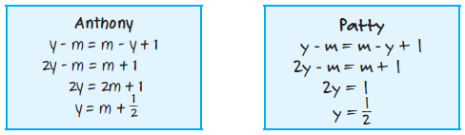

54. PERSEVERE Write an equation with variables on each side of the equal sign, at least one fractional coefficient, and a solution of –6. Discuss the steps you used.

55. CREATE Create an equation with at least two grouping symbols for which there is no solution.

56. WRITE Compare and contrast solving equations with variables on both sides of the equation to solving one-step or multi-step equations with a variable on one side of the equation.

57. ANALYZE Determine whether each solution is correct. If it is incorrect; find the correct solution. Justify your argument.

- 2(g + 5) = 22 b. 5d = 2d – 18 c. –6z + 13 = 7z
2g + 5 = 22 5d – 2d = 2d – 18 – 2d –6z + 13 – 6z = 7z – 6z
2g + 5 – 5 = 22 3d = –18 13 = z
2g = 17 d = –6
g = 8.5

58. PERSEVERE Find the value of k for which each equation is an identity.
a. k(3x – 2) = 4 – 6x b. 15y – 10 + k = 2(ky – 1) – y

59. CREATE Write an equivalent equation to x = 8 that has the variable x on both sides.

60. ANALYZE Solve 5x + 2 = ax – 1 for x. Assume a ≠ 5. Describe each step.

