Solving Equations Involving Absolute Value ⸱ Practice

Examples 1 and 2
Solve each equation. Then graph the solution set.
1. $\left|n –3\right|$ = 5 2. $\left|f+10\right|$ = 1

3. $\left|v –2\right|$ = –5 4. $\left|4t –8\right|$ = 20

5. $\left|8w+5\right|$ = 21 6. $\left|6y –7\right|$ = –1

7. $\left|x+5\right|$ = –3 8. $\left|-2y+6\right|$ = 6

9. $\left|\frac{3}{4}a –3\right|$ = 9 10. $\left|2x – 3\right|$ = 7

Solve each equation.
11. $\left|7 –2q\right|$ = 3

12. $\left|4x –2\right|$ = 26

13. $\left|w+1\right|$ = 5

14. $\left|n+2\right|$ = –1

15. $\left|m –2\right|$ = 2

16. $\left|5c –3\right|$ = 1

17. $\left|2t+6\right|$ = 4

18. $\left|8k –5\right|$ = –4

Example 3
19. ENGINEERING Tolerance is an allowance made for imperfections in a manufactured object. The manufacturer of an oven specifies a temperature tolerance of ±15ºF. This means that the temperature inside the oven will be within 15ºF of the temperature that to which it is set. Write and solve an absolute value equation to find the maximum and minimum temperatures inside the oven when the thermostat is set to 400ºF.

20. POLLS Candidate A and Candidate B are running for mayor. A poll was taken to determine which candidate would likely win the election. The poll is accurate within ±5%. Write and solve an absolute value equation to find the maximum and minimum percent of voters who will vote for Candidate A if 38% of the voters in the poll voted for Candidate A.

21. STATISTICS The most familiar statistical measure is the arithmetic mean, or average. A second important statistical measure is the standard deviation, which is a measure of how far the data are from the mean. For example, the mean score on the Wechsler IQ test is 100 and the standard deviation is 15. This means that people within one standard deviation of the mean have IQ scores that are 15 points higher or lower than the mean.
a. One year, the mean mathematics score on the ACT test was 20.9 with a standard deviation of 5.3. Write an absolute value equation to find the maximum and minimum scores within one standard deviation of the mean.

b. What is the range of ACT mathematics scores within one standard deviation of the mean? within two standard deviations of the mean?

22. AVIATION The graph shows the results of a survey that asked 4300 students ages 7 to 18 what they thought would be the most important benefit of air travel in the future. There are about 40 million students in the United States. If the margin of error is ±3%, what is the range of the number of students ages 7 to 18 who would likely say that “finding new resources for Earth” is the most important benefit of future flight?

23. MANUFACTURING A hardware store sells bags of rock salt that are labeled as weighing 35 pounds. The equipment used to package the salt produces bags with a weight that is within 8 ounces of the label weight. Write and solve and absolute value equation to determine the maximum and minimum weights for the bag of rock salt. Justify each step in the solution.

Example 4
Write an equation involving absolute value for each graph.
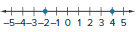
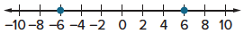
24. 25.

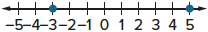
26. 27.

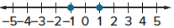
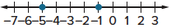
28. 29.

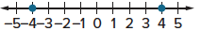
30. 31.

Mixed Exercises
Solve each equation. Then graph the solution set.
32. $\left|-\frac{1}{2}b –2\right|$ = 10 33. $\left|-4d+6\right|$ = 12

34. $\left|5f-3\right|$ = 12 35. 2|h| – 3 = 8

36. 4 – 3|q| = 10 37. $\frac{4}{\left|p\right|}$ + 12 = 14

Write an equation involving absolute value for each graph.
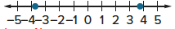
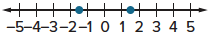
38. 39.

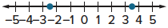
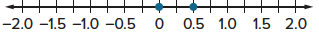
40. 41.

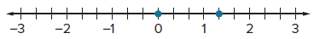
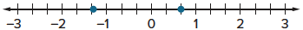
42. 43.

44. REGULARITY For tropical fish, aquarium water should be set to 76°F with an allowance of 4°.
a. Explain how to write an absolute value equation to represent this situation.

b. Explain the steps to solve the absolute value equation. What do the solutions represent?

45. REASONING The temperature of a refrigerator is 38°F give or take 2°.
a. Write an equation to find the maximum and minimum temperatures of the refrigerator.

b. Solve the equation to find the maximum and minimum temperatures of the refrigerator.

46. STRUCTURE A quality control inspector at a bolt factory examines random bolts that come off the assembly line. All bolts being made must be a tolerance of 0.04 mm. The inspector is examining bolts that are to have a diameter of 6.5 mm. Write and solve and absolute value equation to find the maximum and minimum diameters of bolts that will pass his inspection.

47. SWIMMING POOL Chlorine is added to a swimming pool to sanitize the water and make it safe for swimming. The chlorine should be in the range of 2–4 ppm (parts per million). Write an equation that represents the maximum and minimum chlorine concentration.

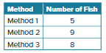
48. FISH TANK Tom has a 10 gallon fish tank that he wants to fill with neon tetra fish. Tom calculates the number of fish that will fit in the tank using three different methods. Write an equation to represent the maximum and minimum number of fish that will fit in the tank.

49. PERSEVERE If three points a, b, and c lie on the same line, then b is between a and c if and only if the distance from a to c is equal to the sum of the distances from a to b and from b to c. Write an absolute value equation to represent the definition of betweenness.

50. ANALYZE Translate the sentence x = 5 ± 2.3 into an equation involving absolute value. Explain.

51. FIND THE ERROR Chris and Cami and solving |x + 3| = –6. Is either of them correct? Explain
your reasoning.
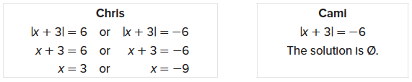

52. WRITE Explain why an absolute value can never be negative.

53. CREATE Describe a real-world situation that could be represented by the absolute value equation |x – 4| = 10.

