Representing Relations ⸱ Practice

Example 1
Express each relation as a table, a graph, and a mapping. Then determine the domain and range.
1. {(–1, –1), (1, 1), (2, 1), (3, 2)}

2. {(0, 4), (– 4, – 4), (–2, 3), (4, 0)}

3. {(3, –2), (1, 0), (–2, 4), (3, 1)}

Example 2
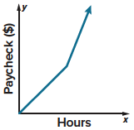
4. PAYCHECK The graph represents the amount of Seth’s paycheck for different numbers of hours he works.
a. Identify the independent and dependent variables of the relation.

b. Describe what happens in the graph.

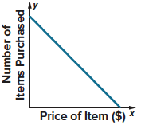
5. DEMAND The graph represents the price of an item and the number of items purchased.
a. Identify the independent and dependent variables of the relation.

b. Describe what happens in the graph.

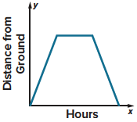
6. AIRPLANES The graph represents the number of hours of a flight and the distance an airplane is from the ground.
a. Identify the independent and dependent variables of the relation.

b. Describe what happens in the graph.

Examples 3 and 4
7. HEALTH The American Heart Association recommends that your target heart rate during exercise should be between 50% and 75% of your maximum heart rate. Use the data in the table below to graph the approximate maximum heart rates for people of given ages.
Source: American Heart Association
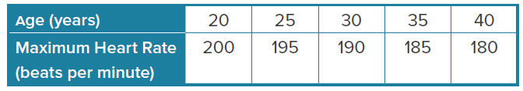

8. USE TOOLS The following ordered pairs give the length in feet and the width in pounds of five snakes at the reptile house at a zoo. Graph the data.
{(5.5, 4.5), (3, 0.5), (3, 2), (8, 4.5), (2, 0.5)}

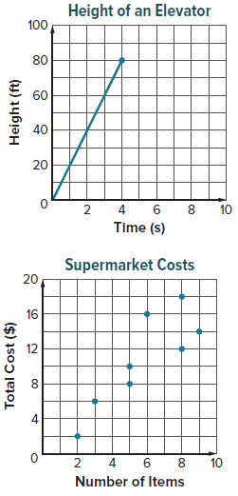
Example 5
9. ELEVATOR The height of an elevator above the ground is given in the table. Interpret the meaning of the axes, scale, and origin of the corresponding graph of the data.
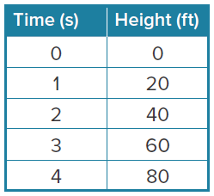


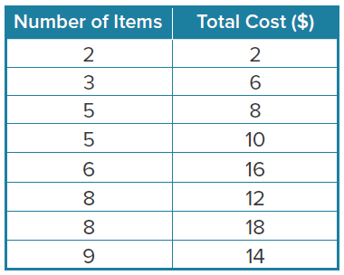
10. SUPERMARKET The number of items that eight customers bought at a supermarket and the total cost of the items is given in the table. Interpret the meaning of the axes, scale, and origin of the corresponding graph of the data.

Mixed Exercises
For Exercises 11-14, express the relation in each table, graph, or mapping as a set of ordered pairs.
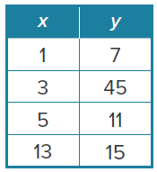
11. 12.
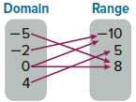

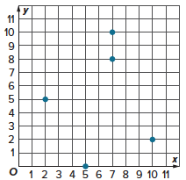
13. 14.
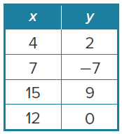

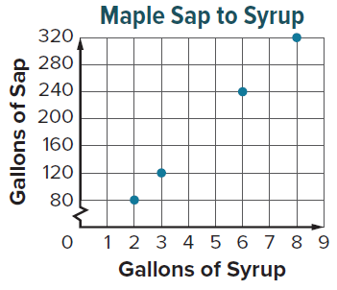
15. NATURE Maple syrup is made by collecting sap from sugar maple trees and boiling it down to remove excess water. The graph shows the number of gallons of tree sap required to make different quantities of maple syrup. Express the relation as a set of ordered pairs. Interpret the meaning of the axes, scale, and origin of the corresponding graph of the data.
Source: Vermont Maple Sugar Makers’ Association

16. TRAVEL Omari drives a car that gets 18 miles per gallon of gasoline. The car’s gasoline tank holds 15 gallons. The distance Omari drives before refueling is a function of the number of gallons of gasoline in the tank. Identify a reasonable domain for this situation.
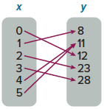
17. DATA COLLECTION Rafaella collected data to determine the number of books her schoolmates were bringing home each evening. Her data is shown in the mapping. She let x be the number of textbooks brought home after school and y be the number of students with x textbooks.
a. Express the relation as a set of ordered pairs.
b. What is the domain of the relation?

c. What is the range of the relation?

18. COOKIES Identify the graph that best represents the relationship between the number of cookies and the equivalent number of dozens.

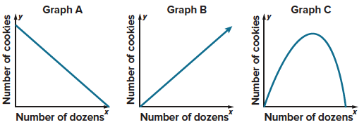

19. MOWING Cordell is mowing his front lawn. His mailbox is on the edge of the lawn. Draw a reasonable graph that shows the distance Cordell is from the mailbox as he mows. Let the horizontal axis show the time and the vertical axis show the distance from the mailbox.
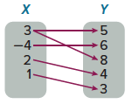

20. STRUCTURE Express the relation in the mapping as a set of ordered pairs.

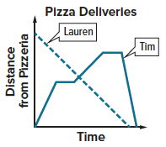
Tim and Lauren use their cars to deliver pizzas. The graph represents their distance from the pizzeria starting at 6 P.M. Use the graph for Exercises 21-24.
21. Describe what happens in Tim’s graph.

22. Describe what happens in Lauren’s graph.

23. A student said that Tim’s and Lauren’s graphs intersect, so their cars must have crashed at some time after 6 P.M. Do you agree or disagree? Explain.

24. After 6 P.M., which delivery person was the first to return to the pizzeria? How do you know?

25. ANALYZE Cameron said that for any relation, the number of elements in the domain must be greater than or equal to the number of elements in the range. Do you agree? If so, explain why. If not, give a counterexample.

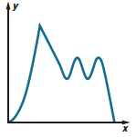
26. CREATE Think of a situation that could be modeled by this graph. Then label the axes of the graph and write several sentences describing the situation.

27. CREATE Use the set {–1, 0, 1, 2} as a domain and the set {–3, –1, 4, 5} as a range.
a. Create a relation. Express the relation as a set of ordered pairs.
b. Express the relation you created in part a as a table, a graph, and a mapping.

28. ANALYZE Describe a real-life situation where it is reasonable to have a negative number included in the domain or range.

29. WRITE Compare and contrast dependent and independent variables.

