Functions ⸱ Practice

Examples 1 and 3
Determine whether each relation is a function. Explain.
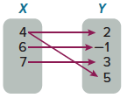
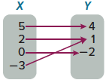
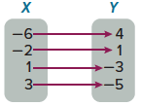
1. 2. 3.

4. 5. 6.
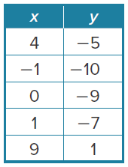
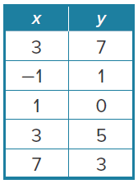
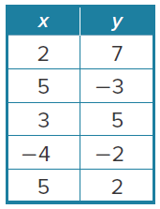

7. {(2, 5), (4, –2), (3, 3), (5, 4), (–2, 5)} 8. {(6, –1), (–4, 2), (5, 2), (4, 6), (6, 5)}

9. y = 2x – 5 10. y = 11

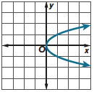
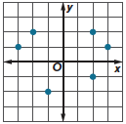
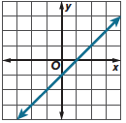
11. 12. 13.

Example 2
14. TURNPIKE The total cost for cars entering President George Bush Turnpike at Beltline Road is related to the number of cars entering the turnpike at Beltline Road. The cost of different numbers of cars entering the turnpike at Beltline Road are as follows: 1 car, $0.75; 2 cars, $1.50; 3 cars, $2.25; 4 cars, $3.00; 5 cars, $3.75.
a. Make a table.

b. Determine the domain and range of the relation.
c. Determine whether the relation is a function.

15. HOUSE VALUE The average value of a house changes over time. The average value of a house in January in Denver, Colorado, for different years are as follows: 2014, $254,000; 2015, $293,000; 2016, $338,000; 2017, $372,000.
a. Make a table.

b. Determine the domain and range of the relation.
c. Determine whether the relation is a function.

Examples 4 and 5
If f(x) = 3x + 2 and g(x) = x² – x, find each value.
16. f(4) 17. f(8) 18. f(–2)

19. g(2) 20. g(–3) 21. g(–6)

22. f(2) + 1 23. f(1) – 1 24. g(2) – 2

25. g(–1) + 4 26. f(x) + 1 27. g(3b)

Example 6
28. CELL PHONES Many cell phone plans have an option to include more than one phone. The function for the monthly cost of cell phone service from a wireless company is f(x) = 25x + 200, where x is the number of phones on the plan. Find and interpret f(3) and f(5).

29. GEOMETRY The area for any square is given by the function f(x) = x², where x is the length of a side of the square. Find and interpret f(3.5).

30. TRANSPORTATION The cost of riding in a cab is $3.00 plus $0.75 per mile. The equation that represents this relation is y = 0.75x + 3, where x is the number of miles traveled and y is the cost of the trip. Find an interpret f(17).

31. GYM MEMBERSHIP The cost of a gym membership is $75 plus $30 per month. The equation that represents this relation is y = 30x + 75, where x is the number of months and y is the cost. Find and interpret f(12).

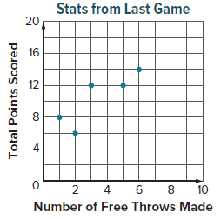
Mixed Exercises
32. USE A MODEL Mario collected data about some of the players on a women’s basketball team. The data are shown in the table, mapping, and graph. Is each relation a function? Why or why not?
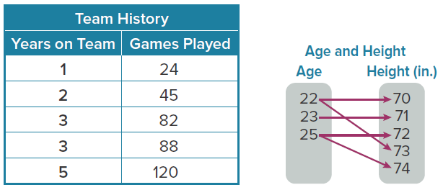

If f(x) = –2x – 3 and g(x) = x² + 5x, find each value.
33. f(–1) 34. f(6) 35. g(2)

36. g(–3) 37. g(–2) + 2 38. f(0) – 7

39. f(4y) 40. g(–6m) 41. f(c) – 5

42. f(r) + 2 43. 5[f(d)] 44. 3[g(n)]

45. FINANCIAL LITERACY Aisha has $40 to spend for her ornithology club. She spends some of it buying birdseed and saves the rest. Her savings is given by f(x) = 40 – 1.25x, where x is number of pounds of birdseed she buys at $1.25 per pound.

a. Graph the equation.

b. Is the relation a function? Explain.

c. Find f(3), f(18), and f(36). What do these values represent?

d. How many pounds of birdseed can Aisha buy if she wants to save $30?

46. USE A MODEL A recipe for homemade pasta dough says that the number of eggs you need is always one more than the number of servings you are making.

a. Make a graph that shows the relationship between the number of servings and the number of eggs.

b. Is the relation a function? Explain.

c. What is the domain of the function? Describe its meaning in the context of the situation.

47. REASONING The height h of a balloon, in feet, t seconds after it is released is given by the function h(t) = 2t + 6.
a. What is the value of h(20), and what does it mean in the context of the situation?

b. Explain how to use the function to find the height of the balloon 2 minutes after it is released.

c. What is the height of the balloon just before it is released? How do you know?

d. Are there any restrictions on the values of t that can be used as inputs for the function? If so, how would this affect the graph of the function? Explain.

48. CONSTRUCT ARGUMENTS The following set of ordered pairs represents a function, but one of the values is missing: {(–4, –1), (–3, –1), (3, 2), (5, 2), (?, 2)}. What conclusions can you make about the missing value? Justify your arguments.

49. WRITE How can you determine whether a relation represents a function?

50. ANALYZE Feng says that the set of ordered pairs {(0, 1), (3, 2), (3, –5), (5, 4)} represents a function. Determine whether his statement is true or false. Justify your argument.

51. PERSEVERE Consider f(x) = –4.3x – 2. Write f(g + 3.5) and simplify by combining like terms.

52. REASONING For the function $y=15x-4$, assume the domain is only values of x from 0 to 5. What is the range of the function?

53. PERSEVERE If f(3b – 1) = 9b – 1, find one possible expression for f(x).

