Linearity and Continuity of Graphs ⸱ Practice

Examples 1 and 2
Determine whether the function is discrete, continuous, or neither. Explain.
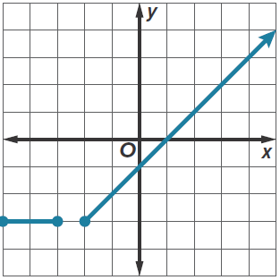
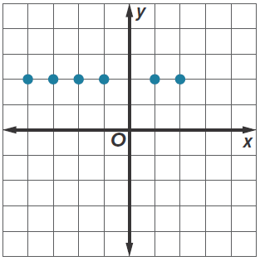
1. 2.

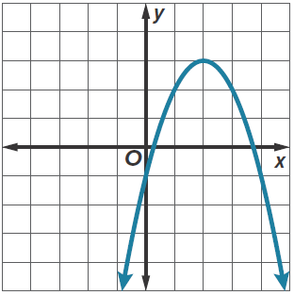
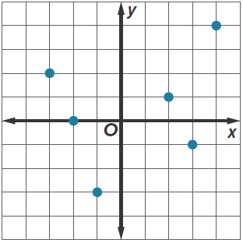
3. 4.

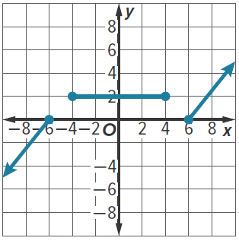
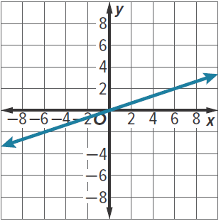
5. 6.

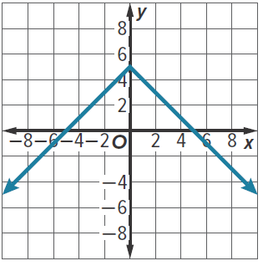
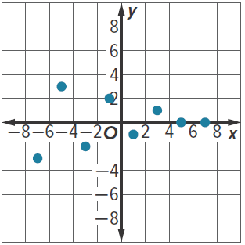
7. 8.

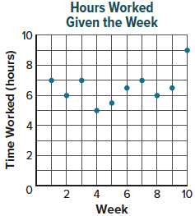
Example 3
9. EMPLOYMENT Kylie records the number of hours she works in her after-school job each week and then graphs the function that models the situation. Use the graph to determine if the function that models this situation is discrete, continuous, or neither.

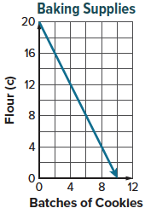
10. BAKING Kalynda keeps track of the number of cups of flour she has after baking batches of cookies and then graphs the function that models the situation. Use the graph to determine if the function that models this situation is discrete, continuous, or neither.

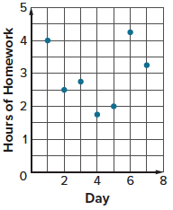
11. HOMEWORK Nayati records the number of hours of homework he has each day and then graphs the function that models the situation. Use the graph to determine if the function that models this situation is discrete, continuous, or neither.

Examples 4, 5, and 6
Determine whether each function is linear or nonlinear.
12. y – $\frac{1}{x}$ = 11 13. x + ($\sqrt{2}$x)² + y – 2x² = 11

14. y = 2x + 5 15. y = 3x² – x + 5

16. 2y + $\frac{x}{3}$ = –6 17. 9x – (9x)² = 19 – y

18. –9x + ($\sqrt{4}$x)² + y = –4 + 7x² 19. y = –x³ + 2x

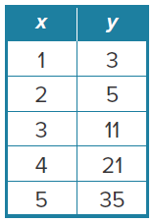
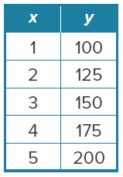
20. 21.

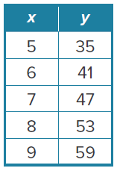
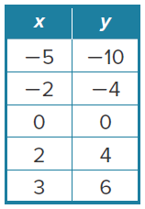
22. 23.

Example 7
24. ENDURANCE Tamika wants to improve her running endurance and thus tries to run for longer periods of time each day. The distance she runs, given the day, is provided in the table.
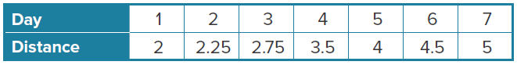

- Determine linearity.
- Graph.

25. SCUBA DIVING Marco wants to know his elevation compared to sea level for periods of time each minute while scuba diving. His elevation is provided in the table.
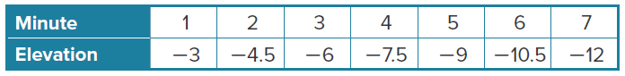

- Determine linearity.
- Graph.

Mixed Exercises
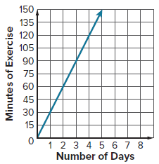
26. EXERCISE Rashona keeps track of the total number of minutes she exercises and then graphs the function that models the situation. Use the graph to determine if the function that models this situation is discrete, continuous, or neither.

27. HOT AIR BALLOON The elevation of a hot air balloon, in feet, compared to sea level for periods of time each minute is provided in the table.
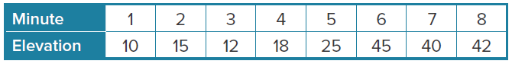

- Determine linearity.
- Graph.

Determine whether the function is discrete, continuous, or neither. Then determine whether each function is linear or nonlinear.
28. y – 14x = 3 29. (2x)² – 4y = 2

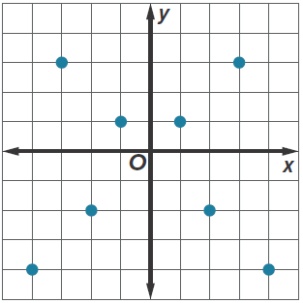
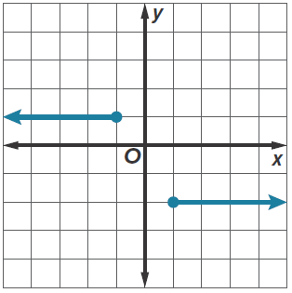
30. 31.

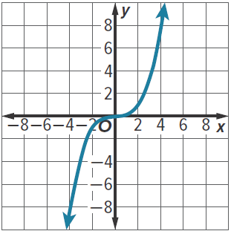
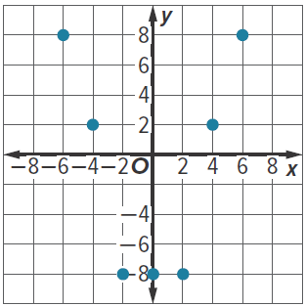
32. 33.

34. ANALYZE If f(x) is a linear function, then is f(x + a), where a is a real number, sometimes, always, or never a continuous function? Justify your argument.

35. WRITE Describe a real-world situation where the function that models the situation is neither discrete nor continuous.

36. ANALYZE A function that consists of a finite set of ordered pairs is sometimes, always, or never continuous? Justify your argument.

