Intercepts of Graphs ⸱ Practice

Examples 1 and 2
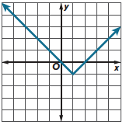
Use the graph to estimate the x- and y-intercepts of the function and describe where the function is positive and negative.
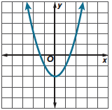
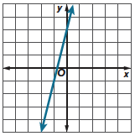
1. 2. 3.

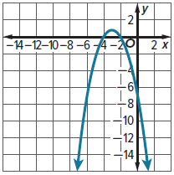
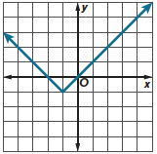
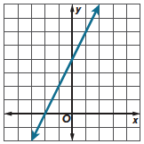
4. 5. 6.

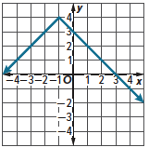
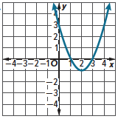
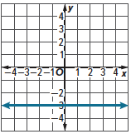
7. 8. 9.

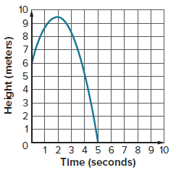
Example 3
10. FOOTBALL The graph shows the height of a football after being kicked. Use the graph to estimate the x- and y-intercepts of the function, where the function is positive and negative, and interpret the meanings in the context of the situation.

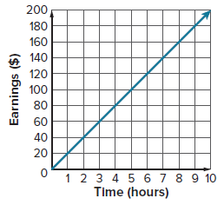
11. EARNINGS The graph shows the amount of money Ryan earns. Use the graph to estimate the x- and y-intercepts of the function, where the function is positive and negative, and interpret the meanings in the context of the situation.

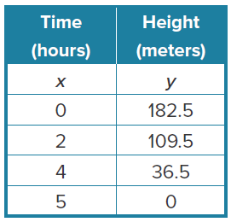
Example 4
12. CLIMBING Indira is mountain climbing and starts the day at 182.5 meters above sea level. Each hour she descends 36.5 meters. The table shows
the function relating Indira’s height to the number of hours she is
mountain climbing.

- Find the intercepts.

- Describe what the intercepts mean in the context of the situation.

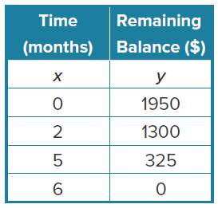
13. MONEY Javier borrowed $1950 from his parents. Each month he repaid his parents $325. The table shows the function relating Javier’s remaining balance to the number of months.

- Find the intercepts.

- Describe what the intercepts mean in the context of the situation.

Examples 5, 6, and 7
Solve each equation by graphing. Check your solution.
14. 2x – 3 = 3 15. –4x + 2 = –4x + 1
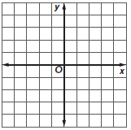

16. 4 = $\frac{1}{2}$x + 5 17. x² = 6x – 8


18. 3x – 5 = 3x – 3 19. x² + x = 6


Example 8
20. INVITATIONS Moesha and Keyon are mailing invitations for their wedding. They have $50 to spend and each invitation costs $1.25 to mail. The function m = 50 – 1.25w represents the amount of money m Shelby and Dylan have left after mailing w wedding invitations. Find the zero of the function. Describe what this value means in the context of this situation.

21. GIFT BAGS Juanita is tying ribbon on gift bags. She has 24 feet of ribbon and each gift bag uses 0.75 foot of ribbon. The function r = 24 – 0.75g represents the amount of ribbon r Juanita has left after tying ribbon on g gift bags. Find the zero of the function. Describe what this value means in the context of this situation.

Mixed Exercises
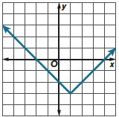
Use the graph to estimate the x- and y-intercepts of the function and describe where the function is positive and negative.
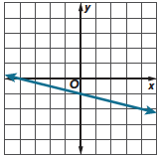
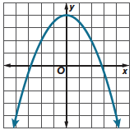
22. 23. 24.

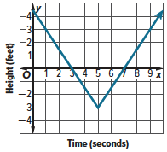
25. REASONING The graph shows the height of a bird compared to sea level over time. Use the graph to estimate the x- and y-intercepts of the function, where the function is positive and negative, and interpret the meanings in the context of the situation.

Solve each equation by graphing. Then find the x- and y- intercepts.
26. 3x + 1 = –5 27. 9x – 7 = –6x + 8

28. ANALYZE Do linear equations sometimes, always, or never have x- and y-intercepts? Justify your argument.

29. WRITE Describe how to find x- and y-intercepts by graphing and by using tables.

30. CREATE Write a word problem for the function y = 60 – 2.5x. Find the zero of the function. Describe what this value means in the context of your situation.

31. PERSEVERE Describe the steps you use to solve the equation 16 = x + 4 + (2⁴ – 6) by graphing. Then explain how you can check your solution.

