Shapes of Graphs ⸱ Practice

Example 1
Determine whether each function has line symmetry. Explain.
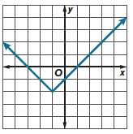
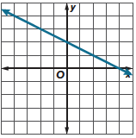
1. 2.

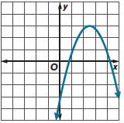
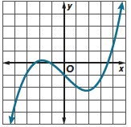
3. 4.

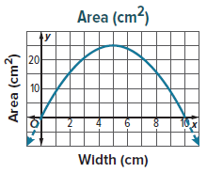
Example 2
5. GEOMETRY The solid portion of the graph represents the relationship between the width of a rectangle in centimeters x and the area of the rectangle in centimeters squared y. Find and interpret any symmetry in the graph of the function.

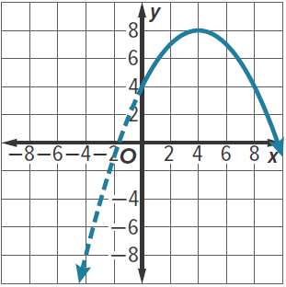
6. SPRINKERS A sprinkler is spraying a stream of water into the air. The solid portion of the graph represents the path of the water, where x represents the distance in feet from the sprinkler and y represents the height in feet of the water. Find and interpret any symmetry in the graph of the function.

Example 3
Determine where f(x) is increasing and/or decreasing.
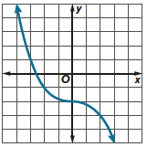
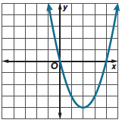
7. 8.

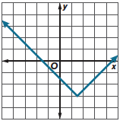
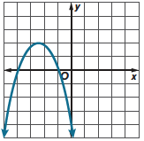
9. 10.

Example 4
Determine the extrema of f(x). Then identify each point as a relative maximum or
relative minimum.
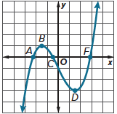
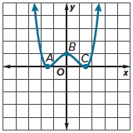
11. 12.

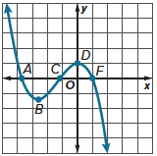
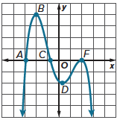
13. 14.

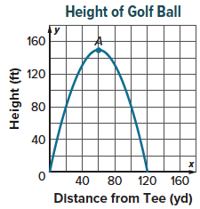
Example 5
15. GOLF The height of a golf ball compared to the distance the golf ball is from the tee is shown in the graph. Determine whether point A is a relative minimum, relative maximum, or neither. Describe what this value means in the context of this situation.

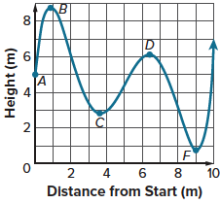
16. ROLLERCOASTER The height of a rollercoaster compared to the distance from start is shown in the graph. Determine whether points B, C, D, and F are a relative minimum, relative maximum, or neither. Describe what each value means in the context of this situation.

Examples 6 and 7
Determine the end behavior of f(x).
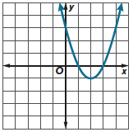
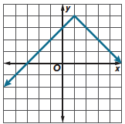
17. 18.

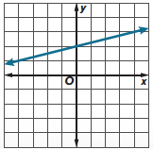
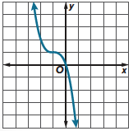
19. 20.

Mixed Exercises
Determine whether each function has line symmetry and where the function is increasing and/or decreasing. Determine the extrema. Then identify each point as a relative maximum or relative minimum. Determine the end behavior.
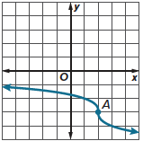
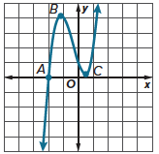
21. 22.

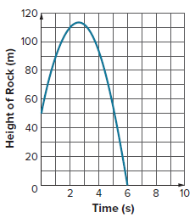
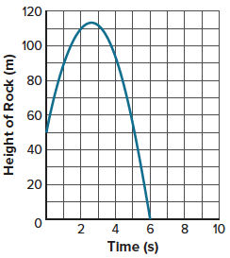
23. ROCKS The graph shows the height of a rock after it is thrown into the air over time. Determine the extrema. Then identify each point as a relative minimum, relative maximum, or neither. Describe what each value means in the context of this situation.

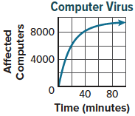
24. WRITE The graph shows the number of computers that are affected by a virus over time. Determine and interpret the end behavior.

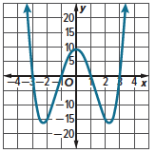
25. WHICH ONE DOESN’T BELONG Which statement about the graph is not true? Justify your conclusion.

The graph is symmetric in the line x = 0.
The graph has one relative minimum at about (–2.25, –16).
The graph has one relative maximum at about (0, 9).
As x decreases, y increases. As x increases, y increases.

