Sketching Graphs and Comparing Functions ⸱ Practice

Example 1
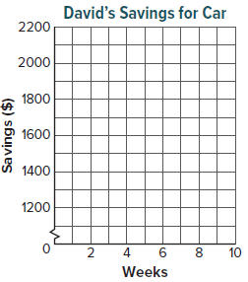
1. SAVINGS David is saving money to buy a new car. The amount he saves can be represented by a function. Sketch a graph that shows the amount in savings y, in dollars, as a function of time x, in weeks.
x-Intercept: none
y-Intercept: $1400
Linear or Nonlinear: The graph of the function is linear.
Positive: for time greater than 0
Increasing: for time greater than 0
End Behavior: As the number of weeks he has saved increases, the amount saved increases.

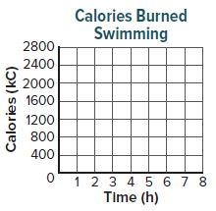
2. SWIMMING Yukio is keeping track of the number of calories she burns while swimming freestyle laps. The number of calories she burns can be represented by a function. Sketch a graph that shows the number of calories burned y as a function of time x, in hours.
y-Intercept: No calories burned when she has swum for 0 hours.
Linear or Nonlinear: The graph of the function is linear.
Positive: for time greater than 0
Increasing: for time greater than 0
End Behavior: As the number of hours she has swum increases, the number of calories burned increases.

Example 2
3. FOOTBALL The flight of a football thrown by a quarterback can be modeled by an interval of a function. Sketch a nonlinear graph that shows the height of a football y, in feet, as a function of time x, in seconds.
Positive: between 0 seconds and 5 seconds
Negative: for time greater than 5 seconds (represents the time after the ball hits the ground)
Increasing: for time less than 2 seconds
Decreasing: for time greater 2 seconds
Relative Maximum: at 2 seconds, when the height of the football
is 9 feet
End Behavior: As time increases, the height of the football decreases.
Symmetry: The height of the football for time between 0 seconds and 2 seconds is the same as the height for time between 2 seconds and 4 seconds.

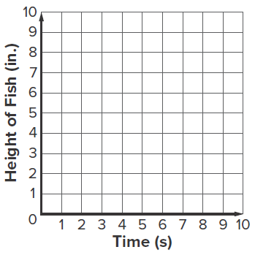
4. FISH The height of a fish compared to sea level as it jumps out of the ocean water can be represented by a function. Sketch a nonlinear graph that shows the height of a fish y, in inches, as a function of time x, in seconds. Interpret the key features.
Positive: between 2 seconds and 8 seconds
Negative: for time less than 2 seconds and greater than 8 seconds
Increasing: for time less than 5 seconds
Decreasing: for time greater 5 seconds
Relative Maximum: at 5 seconds, when the height of the fish is
9 inches
End Behavior: As time increases or decreases, the height of the
fish decreases.
Symmetry: The height of the fish for time less than 5 seconds is the same as the height for time greater than 5 seconds.

Example 3
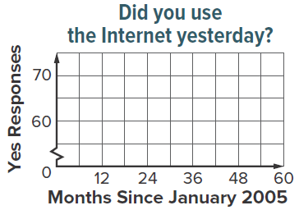
5. TECHNOLOGY The results of a poll that asks Americans whether they used the Internet yesterday can be modeled as a function. Sketch a graph that shows the number of people polled that responded yes to the survey y as a function of time x, months since January 2005.
Positive: for time greater than 0 months
Negative: none
Increasing: for all time greater than 0 months
Decreasing: none
Intercepts: The graph intersects the y-axis at about (0, 60).
Extrema: none
End Behavior: As x increases, y increases. The data represent people, so the maximum it could ever reach is the maximum number of people surveyed.

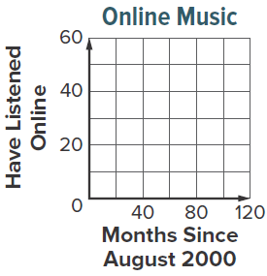
6. MUSIC The results of a poll that asks Americans whether they have listened to online music can be modeled as a function. Sketch a graph that shows the number of people polled that have listened online y as a function of time x, months since August 2000. Interpret the key features.
Positive: for time greater than 0 months
Negative: none
Increasing: between 0 months and 10 months, for time greater than about 65 months
Decreasing: between 10 months and about 65 months
Intercepts: The graph intersects the y-axis at about (0, 37).
Relative Minimum: at about (65, 31)
Relative Maximum: at about (10, 39)
End Behavior: As x decreases, y decreases. As x increases, y increases. The data represent people, so the maximum it could ever reach is the maximum number of people surveyed.

Example 4
7. INTERNET Use the description and graph to compare the Internet use at home and Internet use away from home, where y is the number of people polled, in thousands, that use the Internet several times a day and x is the number of months since March 2004. Use the description and graph to compare Internet use at home and Internet use away from home since March 2004.

Internet Use at Home  About 10,000 of those polled used the  Internet at home in March 2004. The  number of users decreased to 7000 at  36 months since March 2004. The  number of users continued to increase  after 36 months since March 2004. | 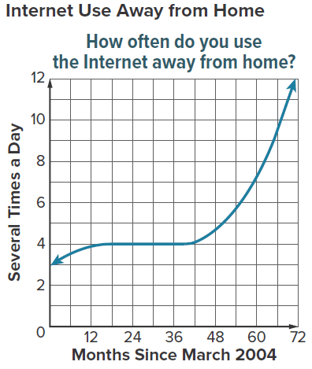

8. SPENDING Use the description and graph to compare the amount of U.S. spending on electronics and education, where y is the amount spent in billions and x is the number of years since 1949. Write statements to compare U.S. spending on electronics and education since 1949.

US Electronic Spending  In 1949, the U.S. spent $0 on electronics.  Twenty years after 1949, the U.S. spent  about $4 billion on electronics. Thirty  years after 1949, the U.S. spent about  $3 billion on electronics. Seventy years  after 1949, the U.S. spent about $7.5  billion on electronics and spending continues  to increase. | 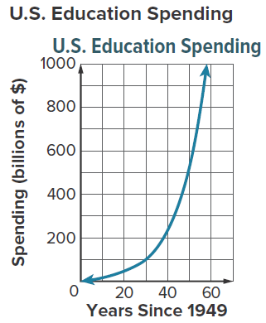

Mixed Exercises
The costume department of a theatre company is making cone-shaped hats for a play set in medieval times. Each hat will be covered with satin over its entire lateral surface area inside and out. The slant height of each hat will remain constant at 20 inches but the radius of the base will vary to accommodate different head sizes. Using 3.14 for $π$, the lateral area of the hat can be expressed as a function. Use this information for Exercises 9–11.
9. MODELING Sketch a graph that shows the lateral area of the hat y, in square inches, as a function of the radius of its base x, in inches.
y-Intercept: No lateral area when the radius of its base is 0 inches.
Linear or Nonlinear: The graph of the function is linear.
Positive: for radius of a base greater than 0
Increasing: for radius of a base greater than 0
End Behavior: As the radius of the base increases, the lateral
area increases.

10. REASONING Write a function y for the lateral area of the hat as a function of the radius of its base, x. (Hint: The formula for the lateral area of a cone is y = $π$xs, where s is the slant height)

11. USE TOOLS Enter the function into your graphing calculator. Press WINDOW and enter the following settings: Xmin: –10; Xmax: 10; Ymin: –1000; Ymax: 1000. Then press GRAPH. Compare the graph on the calculator to the graph you sketched in Exercise 9.

Aidan buys used bicycles, fixes them up, and sells them. His average cost to buy and fix each bicycle is $47. He also incurred a one-time cost of $840 to purchase tools and a small shed to use as his workshop. He sells bikes for $75 each. Use this information for Exercises 12–15.
12. WRITE Write revenue and cost functions R(x) and C(x) for Aidan’s situation, where x is the number of bicycles. How do you include the one-time cost in C(x)?

13. WRITE Write a profit function P(x) such that P(x) = R(x) – C(x). In words, what does
P(x) represent?

14. PERSEVERE List key features for the profit function P(x). Then use the key features to sketch a graph that shows the profit P(x) as a function of x bicycles.

15. ANALYZE Which key feature of the graph represents Aidan’s break-even point (profit = 0)? Explain how to use your graph to find the most accurate value for this feature.

16. CREATE Research the population in your state over a 10-year period. Sketch a graph to model the data. Then list the key feature of the graph.

