Graphing Linear Functions ⸱ Practice

Examples 1 through 4
Graph each equation by making a table.
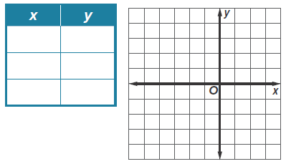
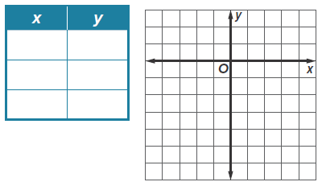
1. x = –2 2. y = –4

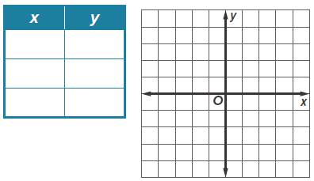
3. y = –8x 4. 3x = y
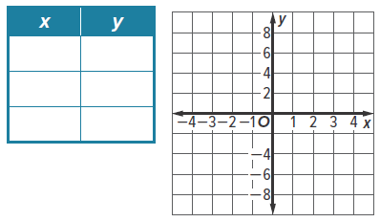
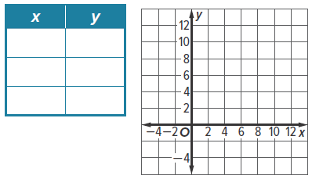
5. y – 8 = –x 6. x = 10 – y
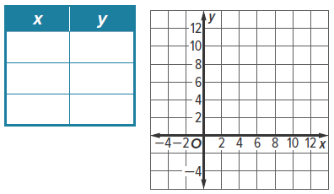
7. y = $\frac{1}{2}$x + 1 8. y + 2 = $\frac{1}{4}$x
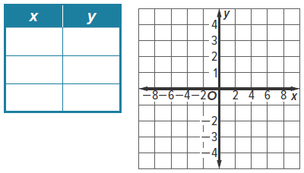
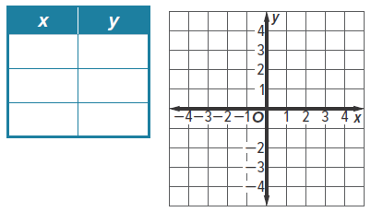

Example 5
Graph each equation by using the x-and y-intercepts.
9. y = 4 + 2x 10. 5 – y = –3x 11. x = 5y + 5
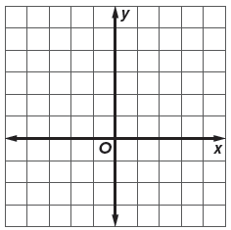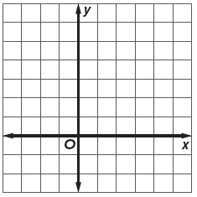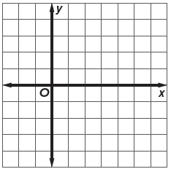

12. x + y = 4 13. x – y = –3 14. y = 8 – 6x
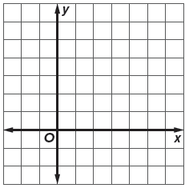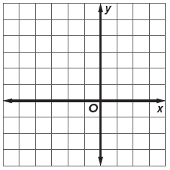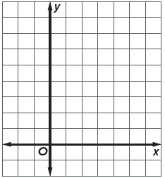

Example 6
15. SCHOOL LUNCH Amanda has $210 in her school lunch account. She spends $35 each week on school lunches. The equation y = 210 – 35x represents the total amount in Amanda’s school lunch account y for x weeks of purchasing lunches.
a. Find the x- and y-intercepts and interpret their meaning in the context of the situation.

b. Graph the equation by using the intercepts.

16. SHIPPING The OOCL Shenzhen, one of the world’s largest container ships, carries 8063 TEUs (1280-cubic-feet containers). Workers can unload a ship at a rate of 1 TEU every minute. The equation y = 8063 – 60x represents the number of TEUs on the ship y after x hours of the workers unloading the containers from the Shenzhen.
a. Find the x- and y-intercepts and interpret their meaning in the context of the situation.

b. Graph the equation by using the intercepts.

Mixed Exercises
Graph each equation.
17. 1.25x + 7.5 = y 18. 2x – 3 = 4y + 6 19. 3y – 7 = 4x + 1
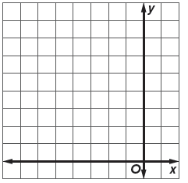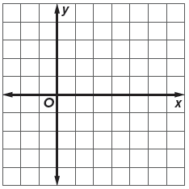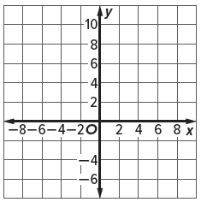

Find the x-intercept and y-intercept of the graph of each equation.
20. 5x + 3y = 15 21. 2x – 7y = 14

22. 2x – 3y = 5 23. 6x + 2y = 8

24. y = $\frac{1}{4}$x – 3 25. y = $\frac{2}{3}$x + 1

26. HEIGHT The height of a woman can be predicted by the equation h = 81.2 + 3.34r, where h is her height in centimeters and r is the length of her radius bone in centimeters.
a. What are the r- and h-intercepts of the equation? Do they make sense in the situation? Explain.

b. Graph the equation by using the intercepts.

c. Use the graph to find the approximate height of a woman whose radius bone is
25 centimeters long.

27. TOWING Pick-M-Up Towing Company charges $40 to hook a car and $1.70 for each mile that it is towed. Write an equation that represents the total cost y for x miles towed. Graph the equation. Find the y-intercept, and interpret its meaning in the context of the situation.

28. USE A MODEL Elias has $18 to spend on peanuts and pretzels for a party. Peanuts cost $3 per pound and pretzels cost $2 per pound. Write an equation that relates the number of pounds of pretzels y and the number of pounds of peanuts x. Graph the equation. Find the x- and y-intercepts. What does each intercept represent in terms of context?

29. REASONING One football season, a football team won 4 more games than they lost. The function y = x + 4 represents the number of games won y and the number of games lost x. Find the x- and y-intercepts. Are the x- and y-intercepts reasonable in this situation? Explain.

30. WRITE Consider real-world situations that can be modeled by linear functions.

a. Write a real-world situation that can be modeled by a linear function.

b. Write an equation to model your real-world situation. Be sure to define variables. Then find the x- and y-intercepts. What does each intercept represent in your context?

c. Graph your equation by making a table. Include a title for the graph as well as labels and titles for each axis. Explain how you labeled the x- and y-axes. State a reasonable domain for this situation. What does the domain represent?

31. FIND THE ERROR Geroy claims that every line has both an x- and a y-intercept. Is he correct? Explain your reasoning.

32. WHICH ONE DOESN’T BELONG? Which equation does not belong with the other equations? Justify your conclusion.

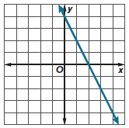
33. ANALYZE Robert sketched a graph of a linear equation 2x + y = 4. What are the x- and y-intercepts of the graph? Explain how Robert could have graphed this equation using the x- and y-intercepts.

34. ANALYZE Compare and contrast the graph of y = 2x + 1 with the domain {1, 2, 3, 4} and y = 2x + 1 with the domain all real numbers.

CREATE Give an example of a linear equation in the form Ax + By = C for each condition. Then describe the graph of the equation.
35. A = 0 36. B = 0 37. C = 0

