Rate of Change and Slope ⸱ Practice

Example 1
Find the rate of change of the function by using two points from the table.
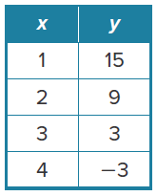
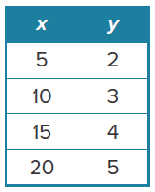
1. 2.

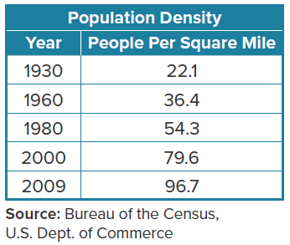
3. POPULATION DENSITY The table shows the population density for the state of Texas in various years. Find the average annual rate of change in the population density from 2000 to 2009.

4. BAND In 2012, there were approximately 275 students in the Delaware High School band. In 2018, that number increased to 305. Find the annual rate of change in the number of students in the band.

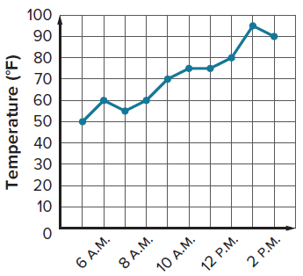
Example 2
5. TEMPERATURE The graph shows the temperature in a city during different hours of one day.
a. Find the rate of change in temperature between 6 A.M. and
7 A.M. and describe its meaning in the context of the situation.
b. Find the rate of change in temperature from 1 P.M. and 2 P.M. and describe its meaning in the context of the situation.

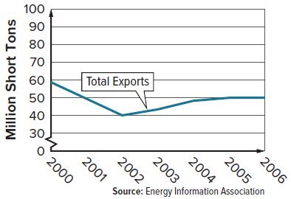
6. COAL EXPORTS The graph shows the annual coal exports from U.S. mines in millions of short tons.
a. Find the rate of change in coal exports between 2000 and 2002 and describe its meaning in the context of the situation.

b. Find the rate of change in coal exports between 2005 and 2006 and describe its meaning in the context of the situation.

Examples 3 and 4
Determine whether the function is linear. If it is, state the rate of change.
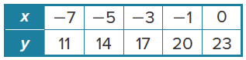
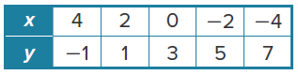
7. 8.

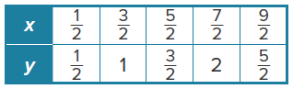
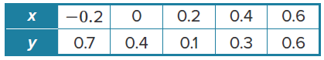
9. 10.

Examples 5 through 8
Find the slope of the line that passes through each pair of points.
11. (4, 3), (–1, 6) 12. (8, –2), (1, 1) 13. (2, 2), (–2, –2)

14. (6, –10), (6, 14) 15. (5, –4), (9, –4) 16. (11, 7), (–6, 2)

17. (–3, 5), (3, 6) 18. (–3, 2), (7, 2) 19. (8, 10), (–4, –6)

20. (–12, 15), (18, –13) 21. (–8, 6), (–8, 4) 22. (–8, –15), (–2, 5)

23. (2, 5), (3, 6) 24. (6, 1), (–6, 1) 25. (4, 6), (4, 8)

26. (–5, –8), (–8, 1) 27. (2, 5), (–3, –5) 28. (9, 8), (7, –8)

29. (5, 2), (5, –2) 30. (10, 0), (–2, 4) 31. (17, 18), (18, 17)

32. (–6, –4), (4, 1) 33. (–3, 10), (–3, 7) 34. (2, –1), (–8, –2)

35. (5, –9), (3, –2) 36. (12, 6), (3, –5) 37. (–4, 5), (–8, –5)

Example 9
Find the value of r so that the line passes through each pair of points has the given slope.
38. (12, 10), (–2, r), m = –4 39. (r, –5), (3, 13), m = 8

40. (3, 5), (–3, r), m = $\frac{3}{4}$ 41. (–2, 8), (r, 4), m = $-\frac{1}{2}$

42. (r, 3), (5, 9), m = 2 43. (5, 9), (r, –3), m = –4

44. (r, 2), (6, 3), m = $\frac{1}{2}$ 45. (r, 4), (7, 1), m = $\frac{3}{4}$


Example 10
46. ROAD SIGNS Roadway signs such as the one shown are used to warn drivers of an upcoming steep down grade. What is the grade, or slope, of the hill described on the sign?

47. HOME MAINTENANCE Grading the soil around the foundation of a house can reduce interior home damage from water runoff. For every 6 inches in height, the soil should extend 10 feet from the foundation. What is the slope of the soil grade?

48. USE A SOURCE Research the Americans with Disabilities Act (ADA) regulation for the slope of a wheelchair ramp. What is the maximum slope of an ADA regulation ramp? Use the slope to determine the length and height of an ADA regulation ramp.

49. DIVERS A boat is located at sea level. A scuba diver is 80 feet along the surface of the water from the boat and 30 feet below the water surface. A fish is 20 feet along the horizontal plane from the scuba diver and 10 feet below the scuba diver. What is the slope between the scuba diver and fish?
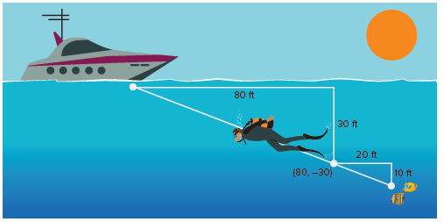

Mixed Exercises
STRUCTURE Find the slope of the line that passes through each pair of points.
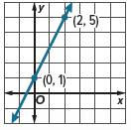
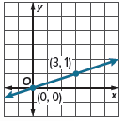
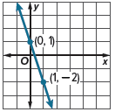
50. 51. 52.

53. (6, –7), (4, –8) 54. (0, 5), (5, 5) 55. (–2, 6), (–5, 9)

56. (5, 8), (–4, 6) 57. (9, 4), (5, –3) 58. (1, 4), (3, –1)

59. REASONING Find the value of r that gives the line passing through (3, 2) and (r, –4) a slope that
is undefined.

60. REASONING Find the value of r that gives the line passing through (–5, 2) and (3, r) a slope of 0.

61. CREATE Draw a line on a coordinate plane so that you can determine at least two points
on the graph. Describe how you would determine the slope of the graph and justify the slope you found.

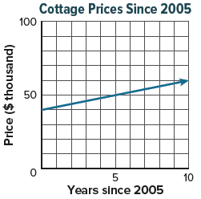
62. ARGUMENTS The graph shows median prices for small cottages on a lake since 2005. A real estate agent says that since 2005, the rate of change for house prices is $10,000 each year. Do you agree? Use the graph to justify your answer.

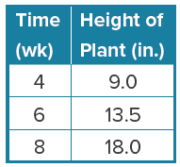
63. CREATE Use what you know about rate of change to describe the function represented by the table.

64. WRITE Explain how the rate of change and slope are related and how to find the slope of a line.

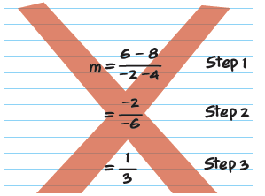
65. FIND THE ERROR Fern is finding the slope of the line that passes through (–2, 8) and (4, 6). Determine in which step she made an error. Explain your reasoning.

66. PERSEVERE Find the value of d so that the line that passes through (a, b) and (c, d) has a slope of $\frac{1}{2}$.

67. ANALYZE Why is the slope undefined for vertical lines? Explain.

68. WRITE Tarak wants to find the value of a so that the line that passes through (10, a) and (–2, 8) has a slope of $\frac{1}{4}$. Explain how Tarak can find the value of a.

