Transformations of Linear Functions ⸱ Practice

Examples 1 through 3
Describe the translation in each function as it relates to the graph of the parent function.
1. g(x) = x + 11 2. g(x) = x – 8 3. g(x) = (x – 7)
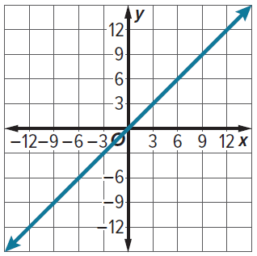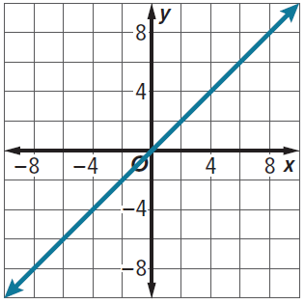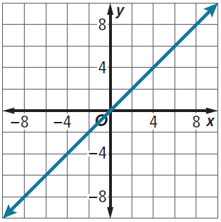

4. g(x) = (x + 12) 5. g(x) = (x + 10) – 1 6. g(x) = (x – 9) + 5
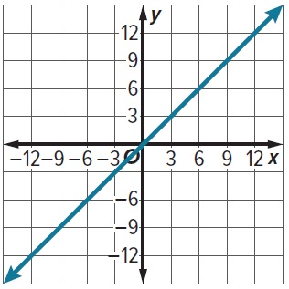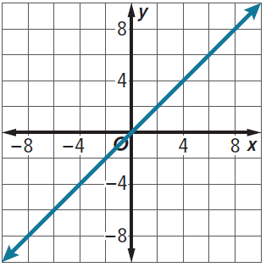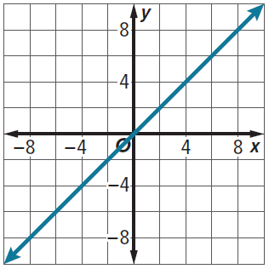

Example 4
7. BOWLING The cost for Nobu to go bowling is $4 per game plus an additional flat fee of $3.50 for the rental of bowling shoes. The cost can be modeled by the function f(x) = 4x + 3.5, where x represents the number of games bowled. Describe the graph of g(x) as it relates to f(x) if Nobu does not rent bowling shoes.

8. SAVINGS Natalie has $250 in her savings account, into which she deposits $10 of her allowance each week. The balance of her savings account can be modeled by the function
f(w) = 250 + 10w, where w represents the number of weeks. Write a function g(w) to represent the balance of Natalie’s savings account if she withdraws $40 to purchase a new pair of shoes. Describe the translation of f(w) that results in g(w).

9. BOAT RENTAL The cost to rent a paddle boat at the county park is $8 per hour plus a nonrefundable deposit of $10. The cost can be modeled by the function f(h) = 8h + 10, where
h represents the number of hours the boat is rented. Describe the graph of g(h) as it relates
to f(h) if the nonrefundable deposit increases to $15.

Examples 5 and 6
Describe the dilation in each function as it relates to the graph of the parent function.
10. g(x) = 5(x) 11. g(x) = $\frac{1}{3}$(x) 12. g(x) = 1.5(x)
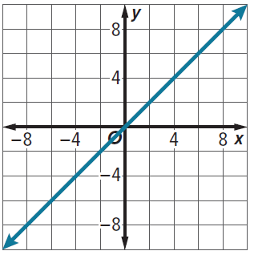

13. g(x) = (3x) 14. g(x) = $\left(\frac{3}{4}x\right)$ 15. g(x) = (0.4x)


Example 7
Describe how the graph of each function is related to the graph of the parent function.
16. g(x) = −4(x) 17. g(x) = −8(x) 18. g(x) = $-\frac{2}{3}$(x)


Example 8
Describe how the graph of each function is related to the graph of the parent function.
19. g(x) = $\left(-\frac{4}{5}x\right)$ 20. g(x) = (−6x) 21. g(x) = (−1.5x)


Mixed Exercises
Describe the transformation in each function as it relates to the graph of the parent function.
22. g(x) = x + 4 23. g(x) = (x – 2) – 8 24. g(x) = $\left(-\frac{5}{8}x\right)$


25. g(x) = $\frac{1}{5}$(x) 26. g(x) = −3(x) 27. g(x) = (2.5x)


REASONING Write a function g(x) to represent the translated graph.
28. f(x) = 3x + 7 translated 4 units up. 29. f(x) = x – 5 translated 2 unit down.

30. PERIMETER The function f(s) = 4s represents the perimeter of a square with side length s. Write a function g(s) to represent the perimeter of a square with side lengths that are twice as great. Describe the graph of g(s) compared to f(s).

31. GAMES The function f(x) = 0.50x gives the average cost in dollars for x cell phone game downloads that cost an average of $0.50 each. Write a function g(x) to represent the cost in dollars for x cell phone game downloads that cost $1.50 each. Describe the graph of g(x) compared to f(x).

32. TRAINER The function f(x) = 90x gives the cost of working out with a personal trainer, where $90 is the trainer’s hourly rate, and x represents the number of hours spent working out with the trainer. Describe the dilation, g(x) of the function f(x), if the trainer increases her hourly rate to $100.

33. DOWNLOADS Hannah wants to download songs. She researches the price to download songs from Site F. Hannah wrote the function f(x) = x, which represents the cost in dollars for x songs downloaded that cost $1.00 each.
a. Hannah researches the price to download songs from Site G. Write a function g(x) to represent the cost in dollars for x songs downloaded that cost $1.29 each.

b. Describe the graph of g(x) compared to the graph of f(x).

34. PERSEVERE For any linear function, replacing f(x) with f(x + k) results in the graph of f(x) being shifted k units to the right for k < 0 and shifted k units to the left for k > 0. Does shifting the graph horizontally k units have the same effect as shifting the graph vertically −k units? Justify your answer. Include graphs in your response.

35. CREATE Write an equation that is a vertical compression by a factor of a of the parent function
y = x. What can you say about the horizontal dilation of the function?

36. WHICH ONE DOESN’T BELONG Consider the four functions. Which one does not belong in this group? Justify your conclusion.

