Arithmetic Sequences ⸱ Practice

Example 1
ARGUMENTS Determine whether each sequence is an arithmetic sequence. Justify your reasoning.
1. –3, 1, 5, 9, … 2. $\frac{1}{2}$, $\frac{3}{4}$, $\frac{5}{8}$, $\frac{7}{16}$, …

3. –10, –7, –4, 1, … 4. –12.3, –9.7, –7.1, –4.5, …

5. 4, 7, 9, 12, ... 6. 15, 13, 11, 9, ...

7. 7, 10, 13, 16, ... 8. –6, –5, –3, –1, ...

Example 2
Find the common difference of each arithmetic sequence. Then find the next three terms.
9. 0.02, 1.08, 2.14, 3.2, ... 10. 6, 12, 18, 24, ...

11. 21, 19, 17, 15, ... 12. $-\frac{1}{2}$, 0, $\frac{1}{2}$, 1, ...

13. 2$\frac{1}{3}$, 2$\frac{2}{3}$, 3, 3$\frac{1}{3}$, ... 14. $\frac{7}{12}$, 1$\frac{1}{3}$, 2$\frac{1}{12}$, 2$\frac{5}{6}$, ...

15. 3, 7, 11, 15, ... 16. 22, 19.5, 17, 14.5, ...

17. –13, –11, –9, –7, ... 18. –2, –5, –8, –11, ...

Example 3
Use the given arithmetic sequence to write an equation and then find the 7th term of the sequence.
19. –3, –8, –13, –18, … 20. –2, 3, 8, 13, …

21. –11, –15, –19, –23, … 22. –0.75, –0.5, –0.25, 0, …

Example 4
23. SPORTS Wanda is the manager for the soccer team. One of her duties is to hand out cups of water at practice. Each cup of water is 4 ounces. She begins practice with a 128-ounce cooler of water.
a. Create a function to represent the arithmetic sequence.

b. Graph the function.

c. How much water is remaining after Wanda hands out the 14th cup?

24. THEATER A theater has 20 seats in the first row, 22 in the second row, 24 in the third row, and so on for 25 rows.
a. Create a function to represent the arithmetic sequence.

b. Graph the function.

c. How many seats are in the last row?

25. POSTAGE The price to send a large envelope first class mail is 88 cents for the first ounce and 17 cents for each additional ounce. The table shows the cost for weights up to 5 ounces.
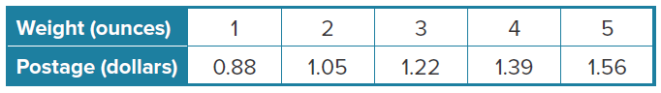

- Create a function to represent the arithmetic sequence.

- Graph the function.

- How much did a large envelope weigh that cost $2.07 to send?

26. VIDEO DOWNLOADING Brian is downloading episodes of his favorite
TV show to play on his personal media device. The cost to download
1 episode is $1.99. The cost to download 2 episodes is $3.98. The cost
to download 3 episodes is $5.97.
a. Create a function to represent the arithmetic sequence.

b. Graph the function.

c. What is the cost to download 9 episodes?

27. USE A MODEL Chapa is beginning an exercise program that calls for 30 push-ups each day for the first week. Each week thereafter, she has to increase her push-ups by 2.
a. Write a function to represent the arithmetic sequence.

b. Graph the function.

c. Which week of her program will be the first one in which she will do at least 50 push-ups a day?

Mixed Exercises
CONSTRUCT ARGUMENTS Determine whether each sequence is an arithmetic sequence. Justify your argument.
28. –9, –12, –15, –18, ... 29. 10, 15, 25, 40, ...

30. –10, –5, 0, 5, ... 31. –5, –3, –1, 1, ...

Write an equation for the nth term of each arithmetic sequence. Then graph the first five terms of the sequence.
32. 7, 13, 19, 25, … 33. 30, 26, 22, 18, … 34. –7, –4, –1, 2, …

35. SAVINGS Fabiana decides to save the money she’s earning from her after-school job for college. She makes an initial contribution of $3000 and each month deposits an additional $500. After one month, she will have contributed $3500.
a. Write an equation for the nth term of the sequence.

b. How much money will Fabiana have contributed after 24 months?

36. NUMBER THEORY One of the most famous sequences in mathematics is the Fibonacci sequence. It is named after Leonardo de Pisa (1170-1250) or Filius Bonacci, alias Leonardo Fibonacci. The first several numbers in the Fibonacci sequence are shown.
1, 1, 2, 3, 5, 8, 13, 21, 34, 55, 89, . . .
Does this represent an arithmetic sequence? Why or why not?

37. STRUCTURE Use the arithmetic sequence 2, 5, 8, 11, ...
a. Write an equation for the nth term of the sequence.

b. What is the 20th term in the sequence?

38. CREATE Write a sequence that is an arithmetic sequence. State the common difference, and find $a_{6}$.

39. CREATE Write a sequence that is not an arithmetic sequence. Determine whether the sequence has a pattern, and if so describe the pattern.

40. REASONING Determine if the sequence 1, 1, 1, 1, . . . is an arithmetic sequence.
Explain your reasoning.

41. CREATE Create an arithmetic sequence with a common difference of –10.

42. PERSEVERE Find the value of x that makes x + 8, 4x + 6, and 3x the first three terms of an arithmetic sequence.

43. CREATE For each arithmetic sequence described, write a formula for the nth term of a sequence that satisfies the description.
a. first term is negative, common difference is negative
b. second term is –5, common difference is 7
c. a₂ = 8, a₃ = 6

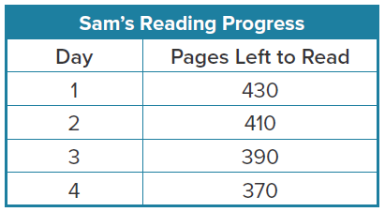
Andre and Sam are both reading the same novel. Andre reads 30 pages each day. Sam created the table at the right. Refer to this information for Exercises 44–46.
44. ANALYZE Write arithmetic sequences to represent each boy’s daily progress. Then write the function for the nth term of each sequence.

45. PERSEVERE Enter both functions from Exercise 44 into your calculator. Use the table to determine if there is a day when the number of pages Andre has read is equal to the number of pages Sam has left to read. If so, which day is it? Explain how you used the table feature to help you solve the problem.

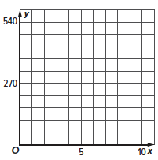
46. ANALYZE Graph both functions on your calculator, then sketch the graph in the coordinate plane at the right. How can you use the graph to answer the question from Exercise 45?

