Piecewise and Step Functions ⸱ Practice

Example 1
Graph each function. State the domain and range.
1. f(x) = $\left\{\begin{matrix}\frac{1}{2}x-1 & if x>3 \\ -2x+ 3 & if x≤3\end{matrix}\right.$ 2. f(x) = $\left\{\begin{matrix}2x-5 & if x>1 \\ 4x-3 & if x≤1\end{matrix}\right.$ 3. f(x) = $\left\{\begin{matrix}2x+3 & if x≥-3 \\ -\frac{1}{3}x+1 & if x<-3\end{matrix}\right.$
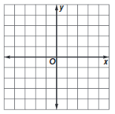



4. f(x) = $\left\{\begin{matrix}3x+4 & if x≥1 \\ x+3 & if x<1\end{matrix}\right.$ 5. f(x) = $\left\{\begin{matrix}3x+2 & if x>-1 \\ -\frac{1}{2}x-3 & if x≤-1\end{matrix}\right.$ 6. f(x) = $\left\{\begin{matrix}2x+1 & if x<-2 \\ -3x-1 & if x≥-2\end{matrix}\right.$





Example 2
Graph each function. State the domain and range.
7. f(x) = $3⟦x⟧$ 8. f(x) = $⟦-x⟧$ 9. g(x) = $-2⟦x⟧$




10. g(x) = $⟦x⟧+3$ 11. h(x) = $⟦x⟧-1$ 12. h(x) = $\frac{1}{2}⟦x⟧+1$




Example 3

13. BABYSITTING Ariel charges $8 per hour as a babysitter. She rounds every fraction of an hour up to the next half-hour. Draw a graph to represent Ariel’s total earnings y after x hours.
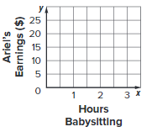
14. FUNDRAISING Students are selling boxes of cookies at a fund-raiser. The boxes of cookies can only be ordered by the case, with 12 boxes per case. Draw a graph to represent the number of cases needed y when x boxes of cookies are sold.
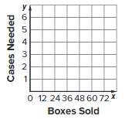

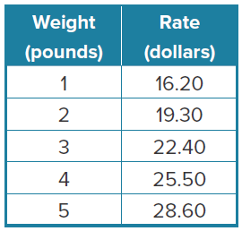
Mixed Exercises
15. PRECISION A package delivery service determines rates for express shipping by the weight of a package, with every fraction of a pound rounded up to the next pound. The table shows the cost of express shipping packages that weigh no more than 5 pounds. Write a piecewise-linear function representing the cost to ship a package that weighs no more than 5 pounds. State the domain and range.

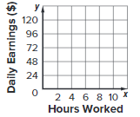
16. EARNINGS Kelly works in a hospital as a medical assistant. She earns $8 per hour the first 8 hours she works in a day and $11.50 per hour each hour thereafter.
a. Organize the information into a table. Include a row for hours worked x, and a row for daily earnings f(x).

b. Write the piecewise equation describing Kelly’s daily earnings f(x) for x hours.

c. Draw a graph to represent Kelly’s daily earnings.

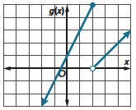
17. REASONING Write a step function that the graph represents.

18. STRUCTURE Suppose f(x) = 2$⟦x - 1⟧$.
a. Find f(1.5). b. Find f(2.2).

c. Find f(9.7). d. Find f(–1.25).

19. RENTAL CARS Mr. Aronsohn wants to rent a car on vacation. The rate the car rental company charges is $19 per day. If any fraction of a day is counted as a whole day, how much would it cost for Mr. Aronsohn to rent a car for 6.4 days?

20. USE A MODEL A roadside fruit and vegetable stand determines rates for selling produce, with every fraction of a pound rounded up to the next pound. The table shows the cost of tomatoes by weight in pounds.
a. Write a piecewise-linear function representing the cost of purchasing 0 to 5 pounds of tomatoes, where C is the cost in dollars and p is the number of pounds.
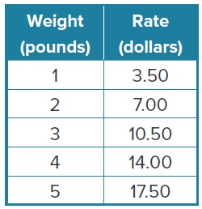
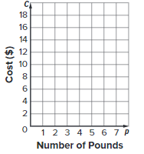

b. Graph the function.

c. State the domain and range.

d. What would be the cost of purchasing 4.3 pounds of tomatoes at the roadside stand?

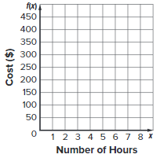
21. ELECTRONIC REPAIRS Tech Repairs charges $25 for an electronic device repair that takes up to one hour. For each additional hour of labor, there is a charge of $50. The repair shop charges for the next full hour for any part of an hour.
a. Complete the table to organize the information. Include a row for hours of repair x, and a row for total cost f(x).
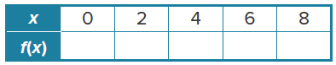

b. Write a step function to represent the total cost for every hour x of repair.

c. Graph the function.

d. Devesh was charged $125 to repair her tablet. How long did the repair take to complete?

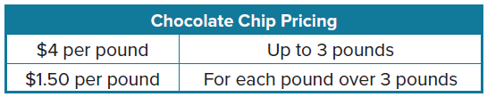
22. INVENTORY Malik owns a bakery. Every week he orders chocolate chips from a supplier. The supplier’s pricing is shown in the table.

a. Write a function to represent the cost of chocolate chips.

b. Malik’s budget for chocolate chips for the week is $25. How many whole pounds of chocolate chips can he order?

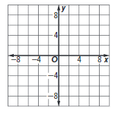
23. CREATE Write a piecewise-defined function with three linear pieces. Then graph the function.

24. FIND THE ERROR Amy graphed a function that gives the height of a car on a roller coaster as a function of time. She said her graph is the graph of a step function. Is this possible? Explain your reasoning.

25. WRITE What is the difference between a step function and a piecewise-defined function?

26. ANALYZE Does the piecewise relation y = f(x) = $\left\{\begin{matrix}-2x+4 & if x≥2 \\ -\frac{1}{2}x-1 & if x≤4\end{matrix}\right.$ represent a function?
Justify your argument.

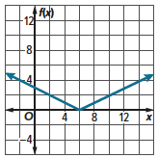
ANALYZE Refer to the graph for Exercises 27-31.
27. Write a piecewise function to represent the graph.

28. What is the domain?

29. What is the range?

30. Find f(8.5).

31. Find f(1.2).

