Absolute Value Functions ⸱ Practice

Examples 1 through 3
Describe the translation in g(x) as it relates to the graph of the parent function.
1. g(x) = |x| – 5 2. g(x) = |x + 6| 3. g(x) = |x – 2| + 7

4. g(x) = |x + 1| – 3 5. g(x) = |x| + 1 6. g(x) = |x – 8|

Examples 4 and 5
Use the graph of the function to write its equation.
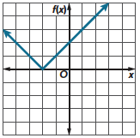
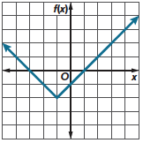
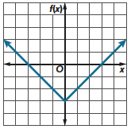
7. 8. 9.

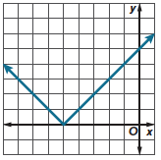
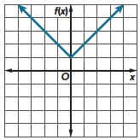
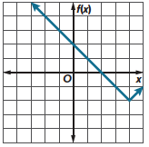
10. 11. 12.

Examples 6 through 8
Describe the dilation in g(x) as it relates to the graph of the parent function.
13. g(x) = $\frac{2}{5}$|x| 14. g(x) = |0.7x| 15. g(x) = 1.3|x|

16. g(x) = |3x| 17. g(x) = $\left|\frac{1}{6}x\right|$ 18. g(x) = $\frac{5}{4}$|x|

Examples 9 through 11
Describe how the graph of g(x) is related to the graph of the parent function.
19. g(x) = –3|x| 20. g(x) = –|x| – 2 21. g(x) = $\left|-\frac{1}{4}x\right|$

22. g(x) = –|x – 7|+ 3 23. g(x) = |–2x| 24. g(x) = – $\frac{2}{3}$|x|

Examples 12 through 14
USE TOOLS Graph each function. State the domain and range.
25. g(x) = |x + 2| + 3 26. g(x) = |2x – 2| + 1 27. f(x) = $\left|\frac{1}{2}x-2\right|$

28. f(x) = |2x – 1| 29. f(x) = $\frac{1}{2}\left|x\right|+2$ 30. h(x) = –2|x – 3| + 2

31. f(x) = –4|x + 2| – 3 32. g(x) = $-\frac{2}{3}\left|x+6\right|-1$ 33. h(x) = $-\frac{3}{4}\left|x-8\right|$ + 1

Example 15
Determine an absolute value function that models each situation.
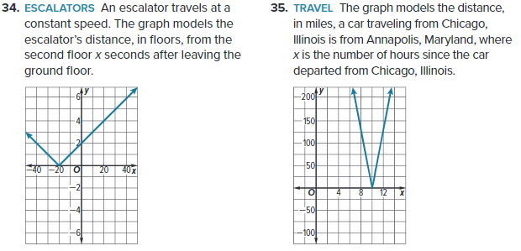

Mixed Exercises
MODELING Graph each function. State the domain and range. Describe how each graph is related to its parent graph.
36. f(x) = $-4\left|x- 2\right|+3$ 37. f(x) = $\left|2x\right|$ 38. f(x) = $\left|2x + 5\right|$

Use the graph of the function to write its equation.
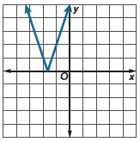
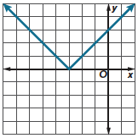
39. 40.

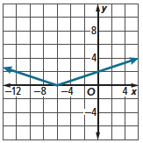
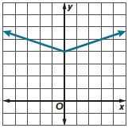
41. 42.

43. SUNFLOWER SEEDS A company that produces and sells bags of sunflower seeds. A medium-sized bag of sunflower seeds must contain 16 ounces of seeds. If the amount of sunflower seeds s in the medium-sized bag differs from the desired 16 ounces by more than x, the bag cannot be delivered to companies to be sold. Write an equation that can be used to find the highest and lowest amounts of sunflower seeds in a medium-sized bag.

44. REASONING The function $y=\frac{5}{4}|x-5|$ models a car’s distance in miles from a parking lot after x minutes. Graph the function. After how many minutes will the car reach the parking lot?

45. STATE YOUR ASSUMPTION A track coach set up an agility drill for members of the track team. According to the coach, 21.7 seconds is the target time to complete the agility drill. If the time differs from the desired 21.7 seconds by more than x, the track coach may require members of the track team to change their training. Write an equation that can be used to find the fastest and slowest times members of the track team can complete the agility drill so that their training does not have to change. If $x=3.2,$ what can you assume about the range of times the coach wants the members of the track team to complete the agility drill? Solve your equation for $x=3.2$ and use the results to justify your assumption.

46. SCUBA DIVING The function y = $3\left|x-12\right|-36$ models a scuba diver’s elevation in feet compared to sea level after x minutes. Graph the function. How far below sea level is the scuba diver at the deepest point in their dive?

47. MANUFACTURING A manufacturing company produces boxes of cereal. A small box of cereal must have 12 ounces. If the amount of cereal b in a small box differs from the desired 12 ounces by more than x, the box cannot be shipped for selling. Write an equation that can be used to find the highest and lowest amounts of cereal in a small box.

48. STRUCTURE Amelia is competing in a bicycle race. The race is along a circular path. She is 6 miles from the start line. She is approaching the start line at a speed of 0.2 mile per minute. After Amelia reaches the start line, she continues at the same speed, taking another lap around the track.

a. Organize the information into a table. Include a row for time in minutes x, and a row for distance from start line f(x).

b. Draw a graph to represent Amelia’s distance from the start line.

49. WRITE Use transformations to describe how the graph of $h\left(x\right)= - \left|x+2\right| –3$ is related to the graph of the parent absolute value function.

50. ANALYZE On a straight highway, the town of Garvey is located at mile marker 200. A car is located at mile marker x and is traveling at an average speed of 50 miles per hour.
a. Write a function T(x) that gives the time, in hours, it will take the car to reach Garvey. Then graph the function on the coordinate plane.

b. Does the graph have a maximum or minimum? If so, name it and describe what it represents in the context of the problem.

51. PERSEVERE Write the equation y = |x – 3| + 2 as a piecewise-defined function. Then graph the piecewise function.

52. CREATE Write an absolute value function, f(x), that has a domain of all real numbers and a range that is greater than or equal to 4. Be sure your function also includes a dilation of the parent function. Describe how your function relates to the parent absolute value graph. Then graph your function.

