Writing Equations in Slope-Intercept Form ⸱ Practice

Example 1
Write an equation of the line that passes through the given point and has the given slope.
1. (4, 2); slope $\frac{1}{2}$ 2. (3, –2); slope $\frac{1}{3}$ 3. (6, 4); slope $-\frac{3}{4}$

4. (–5, 4); slope –3 5. (4, 3); slope $\frac{1}{2}$ 6. (1, –5); slope $-\frac{3}{2}$

Example 2
7. EXERCISE Carlos is jogging at a constant speed. He starts a timer when he is
12 feet from his starting position. After 3 seconds, Carlos is 21 feet from his starting position. Write a linear equation to represent the distance d of Carlos from his starting position after t seconds.

8. JOBS Mr. Kimball sells computer software. He earns a base salary of $41,250 and 8% commission on his sales. Write an equation to represent Mr. Kimball’s total pay p after selling d dollars of software.

9. USE A MODEL In 2006, the average ticket price for a National Football League game was $62.38. Since then the cost has increased an average of $2.54 per
year. Write a linear equation to represent the cost C of an NFL ticket y years
after 2006.

10. TYPING Nebi has already typed 250 words. He then starts a timer and finds that he types 150 words in 3 minutes. If Nebi types at a constant rate, write a linear equation to represent the number of words w Nebi types m minutes after starting the timer.

Example 3
Write an equation of the line that passes through each pair of points.
11. (0, –4), (5, –4) 12. (–4, –2), (4, 0) 13. (–2, –3), (4, 5)

14. (0, 1), (5, 3) 15. (–3, 0), (1, –6) 16. (1, 0), (5, –1)

17. (9, 2), (–2, 6) 18. (–6, 5), (–6, –4) 19. (5, –2), (7, –1)

20. (5, –3), (2, 5) 21. $\left(\frac{5}{4}, 1\right)$, $\left(-\frac{1}{4}, \frac{3}{4}\right)$ 22. $\left(\frac{5}{12}, -1\right)$, $\left(-\frac{3}{4}, \frac{1}{6}\right)$

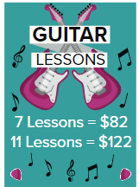
Example 4
23. GUITAR Lydia wants to purchase guitar lessons. She sees a sign that gives the prices for 7 guitar lessons and 11 guitar lessons. Write a linear equation to find the total cost C for d lessons.

24. CENSUS The population of Laredo, Texas, was about 215,500 in 2007. It was about 123,000 in 1990. If we assume that the population growth is constant, write a linear equation with an integer slope to represent p, Laredo’s population t years after 1990.

25. WEATHER A meteorologist finds that the temperature at the 6000-foot level of a mountain is 76°F and the temperature at the 12,000-foot level of the mountain is 49°F. Write a linear equation to represent the temperature T at an elevation of x, where x is in thousands of feet.

26. FUNDRAISING Natalia and her friends held a bake sale to benefit a local charity. The friends sold 15 cakes on the first day and 22 cakes on the second day of the bake sale. They collected $60 on the first day and $88 on the second day. Write an equation to represent the amount R Natalia and her friends raised after selling c cakes.

Mixed Exercises
Write an equation of each line.
27. 28. 29.

30. 31. 32.
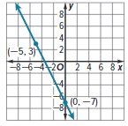
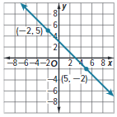
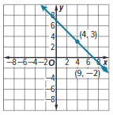

Determine whether the given point is on the line. Explain your reasoning.
33. (3, –1); y = $\frac{1}{3}$x + 5 34. (6, –2); y = $\frac{1}{2}$x – 5

35. (15, –13); y = $-\frac{1}{5}$x – 10 36. (3, 3); y = $-\frac{2}{3}$x + 1

Determine another point on a line given two points on the line.
37. (2, –4), (4, –2) 38. (0, 5), (4, 1) 39. (–3, 1), (–1, –3)

40. (0, 4), (2, 5) 41. (–2, 9), (2, –1) 42. (3, 0), (12, 3)

For Exercises 43–45, determine which equation best represents each situation.
Explain the meaning of each variable.
A. y = $\frac{1}{25}$x + 300 B. y = 25x + 300 C. y = 300x + 25

43. PLANES Plane tickets cost $300 each plus a fee of $25 to select seats per order.

44. SAVINGS Larry has $300. He saves $25 each week.

45. OIL The current oil level in a tank is 25 feet. The rate that oil is being poured into the tank is $\frac{1}{25}$ inch per hour.

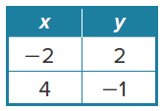
46. USE A MODEL The table of ordered pairs shows the coordinates of the two points on the graph of a function. Write an equation that describes the function.

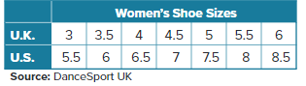
47. USE A SOURCE The table shows how women’s shoe sizes in the United Kingdom compare to women’s shoe sizes in the United States.
a. Write a linear equation to determine the U.S. size y if you are given the U.K. size x.

b. What would be the U.S. shoe size for a woman who wears a U.K. size 7.5?

c. Research women’s shoe sizes in Australia compared to women’s shoe sizes in the United States. Write a linear equation to determine the U.S. size y if you are given the Australia size x.

48. REASONING Shikita borrowed money from her brother and paid back a set amount each week. The table shows how much she owed in a given week.
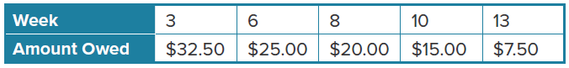

a. Let x represent the number of weeks and y represent the amount owed.
Write an equation in slope-intercept form to model the amount Shikita owed each week.
b. Describe the graph of the equation you found in part a. What does its shape tell you about the problem?

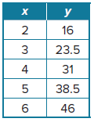
49. REASONING Koby tracked the weight of his puppy for 6 months. Her growth is shown in the table where x = age in months and y = weight in pounds.
a. Write an equation in slope-intercept form to model the growth of
Koby’s puppy.
b. What is the y-intercept? What does the y-intercept mean in the context of
the problem?
c. What is the slope? What does the slope mean in the context of the problem?

50. PERSEVERE Write the equation of each line in slope-intercept form.
a. slope $\frac{4}{5}$, y-intercept: –8
b. (–3, 0), (3, –16)
c. What point do the graph of both equations have in common, and what does this tell you about their graph?

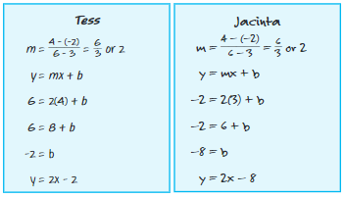
51. FIND THE ERROR Tess and Jacinta are writing an equation of the line through (3, –2) and (6, 4). Is either of them correct? Explain your reasoning.

52. WRITE Linear equations are useful in predicting future events. Describe some factors in real-world situations that might affect the reliability of the graph in making any predictions.

53. CREATE Create a real-world situation that fits the graph at the right. Define the two quantities and describe the functional relationship between them. Write an equation to represent this relationship, and describe what the slope and y-intercept mean.

