Scatter Plots and Lines of Fit ⸱ Practice
Example 1
Determine whether each scatter plot shows a positive, negative, or no correlation. If the correlation is positive or negative, describe its meaning in the situation.
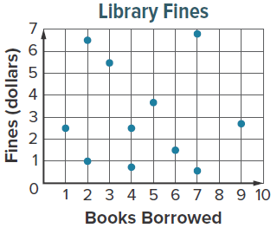
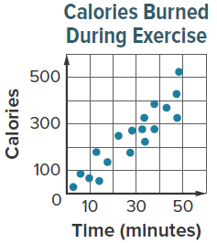
1. 2.

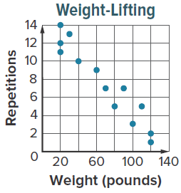
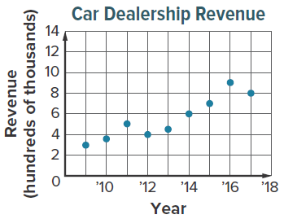
3. 4.

Example 2
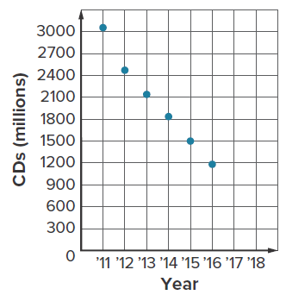
5. MUSIC The scatter plot shows the number of CDs in millions that were sold from 2011 to 2016.
a. Use the points (2, 2485.6) and (6, 1172.5) to write an equation of the line of fit in slope-intercept form. Let x be the years since 2010.
b. If the trend continued, about how many CDs were sold in 2019?

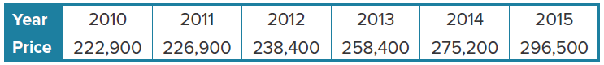
6. HOUSING The data show the median price of an existing home from 2010 to 2015.

- Use the points (1, 226.9) and (4, 275.2) to write an equation for the line of fit in slope-intercept form, where x is the number of years since 2010 and y is the median price in thousands of dollars.
- If the trend continues, what would be the approximate median price of an existing home in 2025?

Mixed Exercises
7. FAMILY The table shows the predicted annual cost for a middle-income family to raise a child from birth until adulthood.
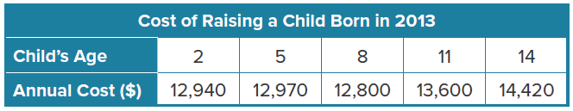
- Make a scatter plot and describe what relationship exists within the data.

- Use the points (8, 12,800) and (14, 14,420) to write the equation of the line of fit in slope-intercept form.
- If the trend continued, what will be the approximate annual cost of raising a child born in 2013 at age 17?

Determine whether each scatter plot shows a positive, negative, or no correlation. If the correlation is positive or negative, describe its meaning in the situation.
8. 9. 10.
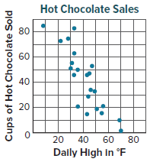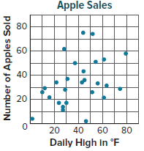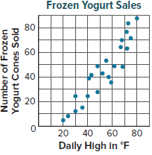

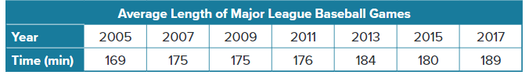
11. BASEBALL The table shows the average length in minutes of professional baseball games in selected years.
a. Make a scatter plot and draw a line of fit.
b. Write the equation of the line of fit in slope-intercept form where x is the number of years since 2005. Explain your process.
c. If the trend continued, what will be the approximate length of a major league baseball game in 2021?
d. How reliable is the predicted length of a major league baseball game in 2021? Justify your argument.

12. INCOME The table shows the average median income for selected ages.
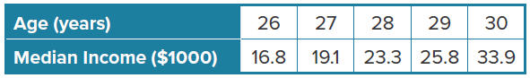

- Make a scatter plot relating age to median income. Then draw a line of fit for the scatter plot.

b. Determine whether the graph shows a positive, negative, or no correlation. If the correlation is positive or negative, describe its meaning in the situation.

c. Use the table to write an equation of the line of fit.
d. Use the line of fit to predict the median income for 32-year olds.
13. FOOTBALL The scatter plot shows the average price of a National Football League ticket from 2007 to 2016.
a. Determine what relationship, if any, exists in the data. Explain.

- Use the points (2007, 67.11) and (2016, 92.98) to write the slope-intercept form of an equation for the line of fit shown, where x is the number of years since 2006. Round to the nearest hundredth.

c. Predict the price of a ticket in 2030.

14. STRUCTURE Refer to the scatter plot at the right.
a. Describe the trend in the data shown in the scatter plot and the relationship between x and y.
b. Describe a real-life situation that could be modeled by the given scatter plot. Explain your reasoning.

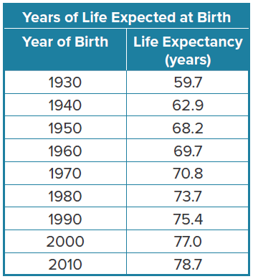
15. USE A MODEL The table gives the life expectancy of a child born in the United States in a given year.
a. Make a scatter plot of the data. Then draw a line of fit.

b. Use the data to predict the life expectancy of a baby born in 2023. Round to the nearest tenth. Does your answer follow the trend of the data? Explain.

c. Explain any assumptions you made when using the line of fit to extrapolate and find the life expectancy of a baby born in 2023.

16. USE TOOLS Several groups volunteered to clean up litter along a mile of the highway near their town. The table shows how many people were in each group and how long it took each group to finish the job.
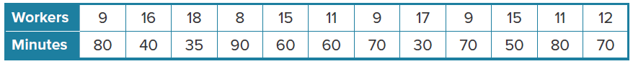
a. Graph the data on a scatter plot.

b. Draw a line of fit to show the trend of the data.

c. Choose two points on the line of fit. Then find the equation of the line in slope-intercept form.

d. Another group wants to get done in 45 minutes. About how many workers should they have? Explain your reasoning.

e. Find the y-intercept of the line of fit. Does the y-intercept make sense in the context of the situation? Justify your argument.

17. CREATE Describe a real-life situation that can be modeled using a scatter plot. Describe whether there is positive, negative, or no correlation.

18. WHICH ONE DOESN’T BELONG Analyze the following situations and determine which one does not belong. Justify your conclusion.


19. ANALYZE Determine which line of fit shown is a better fit for the data in the scatter plot. Justify your argument.

20. WRITE Does an accurate line of fit always predict what will happen in the future? Explain your reasoning.

21. CREATE Make a scatter plot that shows the height of a person and age. Explain how you could use the scatter plot to predict the age of a person given his or her height. How can the information from a scatter plot be used to identify trends and make decision?

