Correlation and Causation ⸱ Practice

Example 1
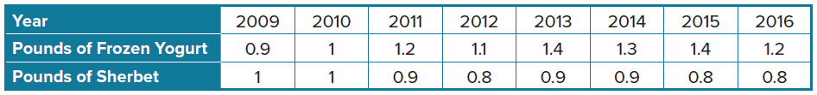
1. FROZEN DESSERTS The table shows the number of pounds of frozen yogurt and the number of pounds of sherbet consumed per capita in the United States from 2009 to 2016.
a. Graph the ordered pairs (pounds of frozen yogurt, pounds of sherbet) to create a scatter plot.

b. Does the scatter plot show a positive, negative, or no correlation. Explain.

c. Determine whether the data illustrate a correlation or causation. What other factors may influence the data?

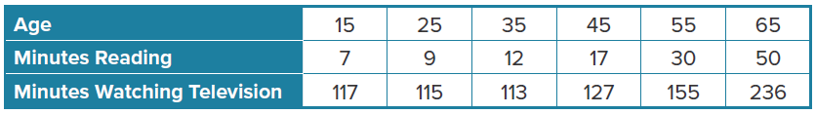
2. LEISURE ACTIVITIES The table shows the average number of minutes a person reads per weekday and the average number of minutes a person watches television per weekday.
a. Graph the ordered pairs as a scatter plot (minutes reading, minutes watching television).
b. Does the scatter plot show a positive, negative, or no correlation. Explain.
c. Determine whether the data illustrate a correlation or causation. What other factors may influence the data.

Example 2
Determine whether each situation illustrates a correlation, but not causation or causation. Explain your reasoning.
3. A class experiment shows a negative correlation between the width of a person’s palm and the amount of time they spend watching television each day.

4. The larger a person’s shoe size, the higher a person’s reading level.

5. At a grocery store, there is a negative correlation between the price of cereal and the number of boxes of cereal sold.

6. Hae notices that the lower the daily temperature is, the less time she spends outside.

Mixed Exercises
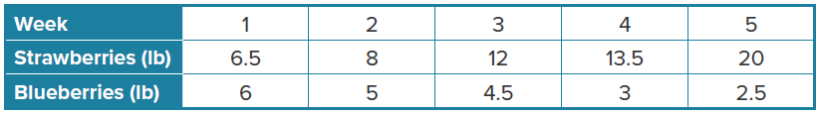
7. GARDENING Jalen weighs each type of fruit his garden produces each week.
a. Graph the ordered pairs (pounds of strawberries, pounds of blueberries) to create a
scatter plot.
b. Does the scatter plot show a positive, negative, or no correlation. Explain.
c. Determine whether the data illustrate a correlation or causation. What other factors may influence the data?

8. SHOES The table shows the number of pairs of sandals and snow boots sold at a certain store during various months of the year.
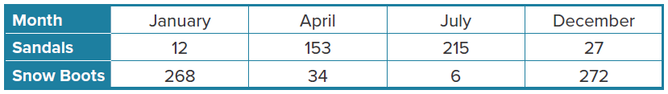
a. Graph the ordered pairs (sandals sold, show boots sold) to create a scatter plot.
b. Does the scatter plot show a positive, negative, or no correlation. Explain.

c. Determine whether the data illustrate a correlation or causation. What other factors may influence the data?

Determine whether each situation illustrates a correlation or causation. If there is a correlation, describe the trend. Explain your reasoning.
9. PIZZA The more pizzas a restaurant sells, the more cheese it uses.
10. BOOKS Sam notices that as the number of words in a book increases, the number of pages in the book increases.

11. CONSTRUCT ARGUMENTS What is meant by this statement: Correlation does not imply causation? Justify your argument.
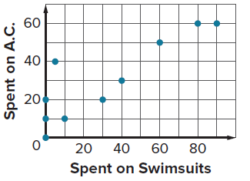
A study compared the average monthly amount spent on swimsuits with the average monthly amount spent on air conditioning for several months in Sunnyside. The data is shown in the scatter plot. Use this information for Exercises 12 and 13.
12. ANALYZE Explain what the scatter plot shows and describe any correlation.

13. WRITE Explain whether this statement is accurate. “There is a strong positive correlation between spending money on swimsuits and spending money on air conditioning. Therefore, to cut down the amount of electricity used in Sunnyside, people should buy fewer swimsuits.”

