Linear Regression ⸱ Practice

Example 1
1. SOCCER The table shows the number of goals a soccer team scored each season since 2010. Let x be the number of years since 2010.
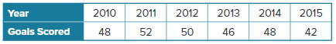
a. Write the equation for the best-fit line for the data.

b. Find and interpret the correlation coefficient.

2. REVENUE The table shows the estimated revenue earned for ringtone and ringback purchases, in millions of dollars, each year since 2010.
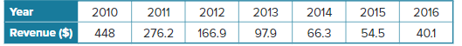
a. Write the equation for the best-fit line for the data.

b. Find and interpret the correlation coefficient.

3. SALES The table shows the sales of major health and beauty supply company, in millions of dollars, for several years. Let x be the number of years since 2010.
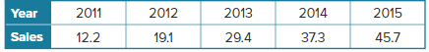
a. Write the equation for the best-fit line for the data.

b. Find and interpret the correlation coefficient.

Example 2
4. PURCHASING A supermarket chain closely monitors how many bottles of sunscreen it sells each year so that it can reasonably predict how many bottles to stock in the following year. Let x be the number of years since 2010.
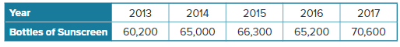
a. Find the equation for the best-fit line for the data.

b. How many bottles of sunscreen should the supermarket expect to sell in 2025?

5. GOLD Ounces of gold are traded by large investment banks in commodity exchanges much the same way that shares of stock are traded. The table below shows the cost of a single ounce of gold on the last day of trading in given years. Let x be the number of years since 2000.
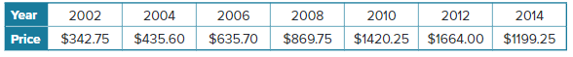
a. Find the equation for the best-fit line for the data.

b. According to the equation, what would be the price of an ounce of gold on the last day of trading in 2030?

6. GOLF SCORES Emmanuel is practicing golf as part of his school’s golf team. Each week he plays a full round of golf and records his total score. His scores for the first five weeks are shown.
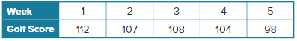
a. Find the equation for the best-fit line for the data.

b. What score can Emmanuel expect to get after 10 weeks?

Example 3
7. MODELING For a science project, Noah measured the effect of light on plant growth. At the
end of 3 weeks, he recorded the height of each plant and how many hours of light it received each day.
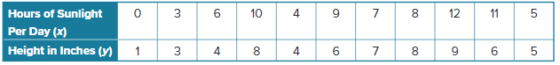
a. Find the equation for the best-fit line for the data.

b. Graph and analyze the residual plot.

8. STRUCTURE For her project, Darius measured the effect of fertilizer on plant growth. At the end of 3 weeks, he recorded the height of each plant and how many drops of fertilizer it received each day.
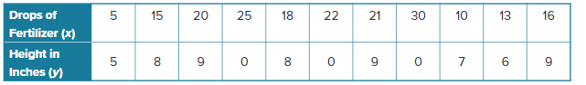
a. Find the equation of the best-fit line for the data.

b. Graph and analyze the residual plot.

Mixed Exercises
9. PHYSICAL FITNESS The table shows the percentage of students in public school who have met all six of California’s physical fitness standards each year since the 2011-2012 school year.
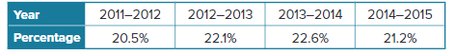
a. Write the equation for the best-fit line for the data.

b. Find and interpret the correlation coefficient.

c. What constraints are there in the situation? Explain.

10. FARMING Some crops, such as barley, are very sensitive to the acidity of the soil. Barley grows best in soil with a pH range of 6 to 7.5. To determine the ideal level of acidity, a farmer measures how many bushels of barley he harvests in different fields with varying acidity levels.
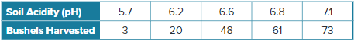
a. Find the equation for the best-fit line for the data and the correlation coefficient.
b. Use the equation of the best-fit line to estimate how many bushels the farmer would harvest if the soil had a pH of 10.

c. Could the equation of the best-fit line be used to extrapolate the data for extremely high levels of soil acidity? Explain.

11. FOOTBALL A college running back ran for 1732 total yards in the regular season. The table shows his cumulative total number of yards gained after select games.
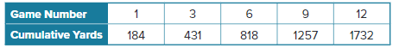
a. Find the equation for the best-fit line for the total yards y gained after x games.
b. Find and interpret the correlation coefficient.

c. Use the trend of the data and the table to estimate when the running back will have run for 950 yards. Explain your reasoning.

d. During which game would you expect the running back to reach a total of
1000 yards?

12. REGULARITY Consider the linear regression equation that models a set of data very well to be y = 1.43x – 4.2. Would there be any restrictions on what the correlation coefficient value could be? Justify your reasoning.

13. STRUCTURE The table shows the number of student athletes participating in college athletics since the 2010-2011 school year.
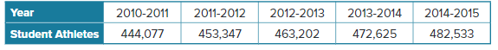
a. Find the equation for the best-fit line for the data.

b. Find and interpret the correlation coefficient.

c. Graph and analyze the residual plot. Does this support your conclusion
from part b?

d. Predict the number of college athletes in 2035.

14. WRITE How are lines of fit and linear regression similar? different?

15. CREATE For a class project, the scores that 10 randomly selected students earned on the first 8 tests of the school year are given. Explain how to find a line of best fit. Could it be used to predict the scores of the other students? Explain your reasoning.

16. ANALYZE Determine whether the following statement is sometimes, always, or never true: If the correlation coefficient in a given situation is 0.946, the change in the independent variable causes change in the dependent variable. Justify your argument.

17. PERSEVERE The table shows the number of participants in high school athletics.
a. Find an equation for the regression line.

b. According to the equation, how many participated in 2008?

