Inverses of Linear Functions ⸱ Practice

Examples 1 and 2
Find the inverse of each relation.
1. 2. 3.
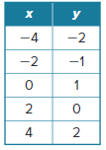
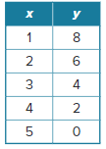
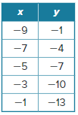

4. {(–3, 2), (–1, 8), (1, 14), (3, 20)} 5. {(5, –3), (2, –9), (–1, –15), (–4, –21)}

6. {(4, 6), (3, 1), (2, –4), (1, –9)} 7. {(–1, 16), (–2, 12), (–3, 8), (–4, 4)}

8. {(–5, 13), (6, 10.8), (3, 11.4), (–10, 14)} 9. {(–4, –49), (8, 35), (–1, –28), (4, 7)}

Example 3
Graph the inverse of each function.
10. 11. 12.
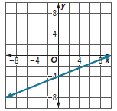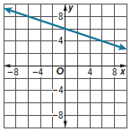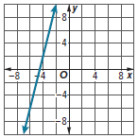

13. 14. 15.
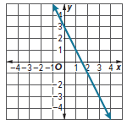

Examples 4 and 5
Find the inverse of each function.

16. f(x) = 8x – 5 17. f(x) = 6(x + 7) 18. f(x) = $\frac{3}{4}$x + 9

19. f(x) = –16 + $\frac{2}{5}$x 20. f(x) = $\frac{3x + 5}{4}$ 21. f(x) = $\frac{-4x + 1}{5}$

Example 6
22. LEMONADE Bernardo spent $15 on supplies for his lemonade stand. He charges $1.25 per glass. The function $P\left(x\right)=1.25x-15$ represents his profit, where $x$ is the number of glasses of lemonade sold.
a. Find the inverse function, P^{–1}(x).

b. What do x and P^{–1}(x) represent in the context of the inverse function?

c. How many glasses must Bernardo sell in order to make $10 in profit?

23. BUSINESS Alisha started a baking business. She spent $36 initially on supplies and can make 5 dozen brownies for $12. She charges her customers $10 per dozen brownies. The function $P\left(x\right)=7.6x-36$ represents her profit, where $x$ is the number of dozens of brownies sold.
a. Find the inverse function, P^{–1}(x).

b. What do x and P^{–1}(x) represent in the context of the inverse function?

c. How many dozens of brownies does Alisha need to sell in order to make a profit?

24. SEASON PASS A season pass to an amusement park cost $70 per family member plus a $50 fee for parking. The function $C\left(x\right)=70x+50$ represents the total cost of the season pass for a family, where $x$ is the number of family members on the season pass.
a. Find the inverse function, C^{–1}(x).

b. What do x and C^{–1}(x) represent in the context of the inverse function?

c. How many family members purchased a season pass to the amusement park if the total charge was $470?

25. GARDENING Kara is building raised garden beds for her backyard. The total cost C(x) in dollars is given by C(x) = 125 + 16x, where x is the number of pieces of wood required for the boxes.
a. Find the inverse function C^{–1}(x).

b. If the total cost was $269 and each piece of wood was 12 feet long, how many total feet of wood were used?

26. GEOMETRY The area of the base of a cylindrical water tank is 12$π$ square feet. The volume
of water in the tank is dependent on the height of the water h and is represented by the
function V(h) = 12$π$h.
a. Find V^{–1}(h).

b. What will the height of the water be when the volume reaches 420$π$ cubic feet?

Mixed Exercises
Write the inverse of each function in f^{–1}(x) notation.
27. 3y – 12x = –72 28. x + 3y = 10

29. –42 + 6y = x 30. 3y + 24 = 2x

31. –7y + 2x = –28 32. 12y – x = 7

Write an equation for the inverse function f^{–1}(x) that satisfies the given conditions.
33. slope of f(x) is 7; graph of f^{–1}(x) contains the point (13, 1)

34. graph of f(x) contains the points (–3, 6) and (6, 12)

35. graph of f(x) contains the point (10, 16); graph of f^{–1}(x) contains the point (3, –16)

36. slope of f(x) is 4; f^{–1}(5) = 2

Match each function with the graph of its inverse.

37. $f\left(x\right)=\frac{1}{2}x+2$ 38. $f\left(x\right)=\frac{1}{2}x-2$ 39. $f\left(x\right)=x+2$
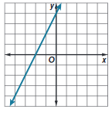
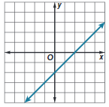
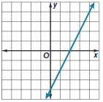
A. B. C.

40. STRUCTURE Write the inverse of each function.
a. f(x) = $\frac{x - 10}{3}$

b. g(x) = $\frac{3}{4}x+6$

c. h(x) = –5x – 7

d. Graph h(x) and h^{–1}(x) on the same coordinate plane to check your answer.

41. REASONING Suppose the inverse of a relation is {(b, –k), (–g, p), (–w, –m), (r, q)}. What is
the relation?

42. ANALYZE How can you use ordered pairs to check if the inverse of a function is correct?

43. WRITE What is the relationship between the slopes of two lines that are inverse functions of one another? Give an example.

44. WRITE What is the relationship between the x- and y-intercepts of two lines that are inverse functions of one another? Give an example.

45. FIND THE ERROR A student claims that there is a simple method to find the inverse of the function f(x). To find the inverse, f^{–1}(x), we need only remember that raising something to the power of –1 is the same as taking its reciprocal. Is this claim correct? Include an example or counterexample.

46. PERSEVERE If f(x) = 5x + a and f^{–1}(10) = –1, find a.

47. PERSEVERE If f(x) = $\frac{1}{a}$x + 7 and f^{–1}(x) = 2x – b, find a and b.

ANALYZE Determine whether the following statements are sometimes, always, or never true. Explain your reasoning.

48. If f(x) and g(x) are inverse functions, then f(a) = b and g(b) = a.

49. If f(a) = b and g(b) = a, then f(x) and g(x) are inverse functions.

50. CREATE Give an example of a function and its inverse. Verify that the two functions are inverses by graphing the functions and the line y = x on the same coordinate plane.

51. WRITE Explain why it may be helpful to find the inverse of a function.

