Solving One-Step Inequalities ⸱ Practice
Example 1
Graph the solution set of each inequality.
1. x ≤ –5 2. y ≥ –2

3. g > 5 4. h < –6

5. a < 7 6. b ≤ 6

Example 2
Write an inequality that represents each graph.
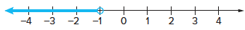
7.

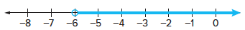
8.

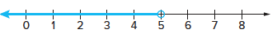
9.

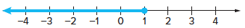
10.

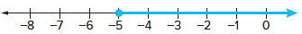
11.

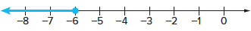
12.

Examples 3–5
Solve each inequality.
13. m – 4 < 3 14. p – 6 ≥ 3

15. r – 8 ≤ 7 16. t – 3 > –8

17. b + 2 ≥ 4 18. 13 > 18 + r

19. 5 + c ≤ 1 20. –23 ≥ q – 30

21. 11 + m ≥ 15 22. h – 26 < 4

23. 8 ≤ r – 14 24. –7 > 20 + c

25. 2a ≤ –4 + a 26. z + 4 ≥ 2z

27. w – 5 ≤ 2w 28. 3y ≤ 2y – 6

29. 6x + 5 ≥ 7z 30. –9 + 2a < 3a

Example 6
31. PIZZA Tara and friends order a pizza. Tara eats 3 of the 10 slices and pays $4.50 for her share. Assuming that Tara has paid at least her fair share, write and solve an inequality to represent the cost of the pizza.

32. WEATHER Theodore Fujita of the University of Chicago developed a classification of tornadoes according to wind speed and damage. The table shows the classification system.
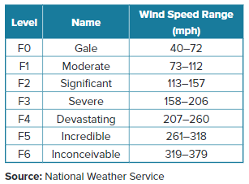

a. Suppose an F3 tornado has winds that are 162 miles per hour. Write and solve an inequality to determine how much the winds would have to increase before the F3 tornado becomes an F4 tornado.

b. A tornado has wind speeds that are at least 158 miles per hour. Write and solve an inequality that describes how much greater these wind speeds are than the slowest tornado.

Example 7
33. GARBAGE The amount of garbage that the average American adds to a landfill each day is
4.6 pounds. If at least 2.5 pounds of a person’s daily garbage could be recycled, how much would still go into a landfill?

34. SUPREME COURT The first Chief Justice of the U.S. Supreme Court, John Jay, served 2079 days as Chief Justice. He served 10,463 days fewer than John Marshall, who served as Supreme Court Chief Justice for the longest period of time. How many days must the current Supreme Court Chief Justice John Roberts serve to surpass John Marshall’s record of service?

35. AIRLINES On average, at least 25,000 pieces of luggage are lost or misdirected each day by United States airlines. Of these, 98% are located by the airlines within 5 days. From a given day’s lost luggage, at least how many pieces of luggage are still lost after 5 days?

36. SCHOOL Gilberto earned these scores on the first three tests in biology this term: 86, 88, and 78. What is the lowest score that Gilberto can earn on the fourth and final test of the term if he wants to have an average of at least 83?

Examples 8–10
Solve each inequality. Graph the solution on a number line.
37. $\frac{1}{4}$m ≤ –17 38. $\frac{1}{2}$a < 20

39. –11 > – $\frac{c}{11}$ 40. –2 ≥ – $\frac{d}{34}$

41. –10 ≤ $\frac{x}{-2}$ 42. –72 < $\frac{f}{-6}$

43. $\frac{2}{3}$h > 14 44. – $\frac{3}{4}$j ≥ 12

45. – $\frac{1}{6}$n ≤ –18 46. 6p ≤ 96

47. 4r < 64 48. 32 > –2y

49. –26 < 26t 50. –6v > –72

51. –33 ≥ –3z 52. 4b ≤ –3

53. –2d < 5 54. –7f > 5

Mixed Exercises
Match each inequality with its corresponding statement.
55. 3n < 9 a. Three times a number is at most nine.

56. $\frac{1}{3}$ n ≥ 9 b. One third of a number is no more than nine.

57. 3n ≤ 9 c. Negative three times a number is more than nine.

58. –3n > 9 d. Three times a number is less than nine.

59. $\frac{1}{3}$ n ≤ 9 e. Negative three times a number is at least nine.

60. –3n ≥ 9 f. One third of a number is greater than or equal to nine.

Define a variable, write an inequality, and solve each problem. Check your solution.
61. Seven more than a number is less than or equal to –18.

62. Twenty less than a number is at least 15.

63. A number plus 2 is at most 1.

64. One eighth of a number is less than or equal to 3.

65. Negative twelve times a number is no more than 84.

66. Eight times a number is at least 16.

STRUCTURE Solve each inequality. Check your solution, and then graph it on a number line.
67. 14c > 56 68. 20b ≥ –120

69. $\frac{x}{4}$ < 9 70. $\frac{x}{2.5}$ ≤ 8

71. m + 3.7 < 9.1 72. n – $\frac{1}{5}$ > $\frac{4}{5}$

73. c + (–1.4) ≥ 2.3 74. k + $\frac{3}{4}$ > $\frac{1}{3}$

75. EVENT PLANNING The Community Center does not charge a rental fee as long as a rentee orders a minimum of $5000 worth of food. Antonio is planning a banquet. If he is expecting 225 people to attend, what is the minimum he will have to spend on food per person to avoid paying a rental fee?

76. VITAMINS The minimum daily requirement of vitamin C for 14-year-olds is at least 50 milligrams per day. An average-sized apple contains 6 milligrams of vitamin C. How many apples would a person have to eat each day to satisfy this requirement? Define a variable and write and solve an inequality to represent this situation.

77. USE A SOURCE The loudest insect is the African cicada. It produces sounds as loud as 105 decibels. The blue whale is the loudest mammal. The call of the blue whale can reach levels up to 83 decibels louder than the African cicada. Write and solve an inequality to represent the situation. How loud are the calls of the blue whale? Use a source to verify your answer.
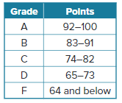
78. USE A MODEL In a mathematics exam with a maximum score of 100, Michelle loses less than 27 points. The table shows the grade that matches the exam score. Compare points to grades and identify which grade Michelle can get.
a. Define a variable. Then write and solve an inequality to represent the number of points Mary received on her exam.
b. Interpret the solution to your inequality. What do you know about Michelle’s grade on the exam?

79. WHICH ONE DOESN’T BELONG Which inequality does not have the solution {x | x < –2}?
A –3x > 6 B – $\frac{x}{2}$ < 1 C 7x < –14 D $\frac{4}{3}$ x < – $\frac{8}{3}$

80. FIND THE ERROR Marty and Heath solved the same exercise in different ways. Is either correct? Explain your reasoning.
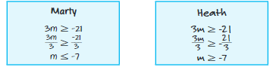

81. Solve each inequality in terms of x. Assume that a does not equal 0.
a. ax < 7 b. ax ≥ 12
c. ax > 3a d. ax ≥ $\frac{a}{4}$

82. ANALYZE Determine whether the statement is sometimes, always, or never true. If $a>b$, then $\frac{1}{a}>\frac{1}{b}$. Justify your argument.

