Solving Compound Inequalities ⸱ Practice

Examples 1, 3, and 4
Solve each compound inequality. Then graph the solution set.
1. f – 6 < 5 and f – 4 ≥ 2 2. n + 2 ≤ –5 and n + 6 ≥ –6

3. y – 1 ≥ 7 or y + 3 < –1 4. t + 14 ≥ 15 or t – 9 < –10

5. –5 < 3p + 7 ≤ 22 6. –3 ≤ 7c + 4 < 18

7. 5h – 4 ≥ 6 and 7h + 11 < 32 8. 22 ≥ 4m – 2 or 5 – 3m ≤ –13

9. –y + 5 ≥ 9 or 3y + 4 < –5 10. –4a + 13 ≥ 29 and 10 < 6a – 14

11. 3b + 2 < 5b – 6 ≤ 2b + 9 12. –2a + 3 ≥ 6a – 1 > 3a – 10

13. 10m – 7 < 17m or –6m > 36 14. 5n – 1 < –16 or –3n – 1 < 8

15. m + 3 ≥ 5 and m + 3 < 7 16. y – 5 < –4 or y – 5 ≥ 1

Example 2
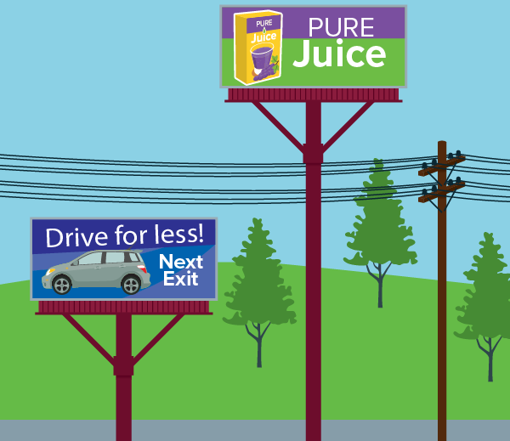
17. STORE SIGNS In Randy’s town, all stand-alone signs must be exactly 8 feet high. When mounted atop a pole, the combined height of the sign and pole must be less than 20 feet or greater than 35 feet so that they do not interfere with the power and phone lines.
a. Write a compound inequality to represent the possible above-ground height of the poles, x.

b. Solve the inequality. Explain any restrictions.
c. Graph the inequality.

18. HEALTH The human heart circulates from 770,000 to 1,600,000 gallons of blood through a person’s body every year.
a. Write a compound inequality to represent the number of gallons of blood that the heart circulates through the body in one day, x.

b. Solve the inequality. Round to the nearest whole gallon.

c. Graph the inequality.

Examples 5 and 6
Write a compound inequality that describes each graph.
19. 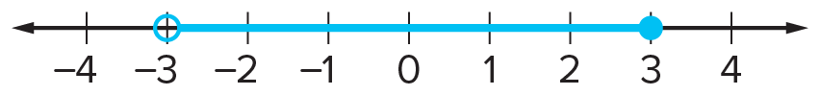 20. 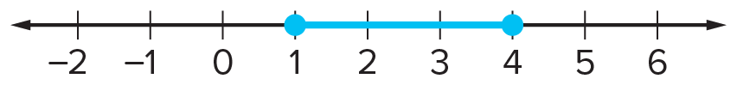

21. 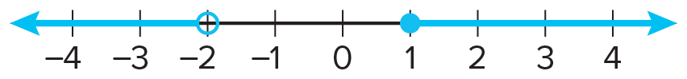 22. 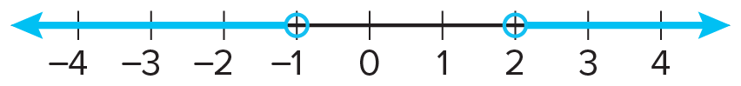

23. 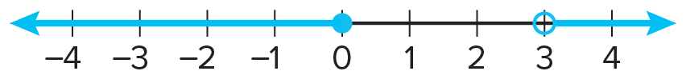 24. 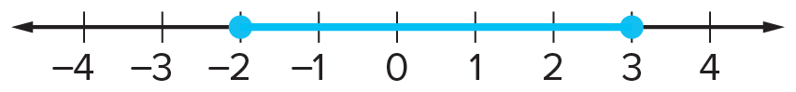

25. 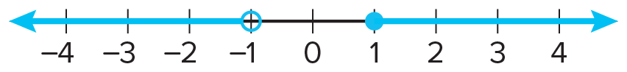 26. 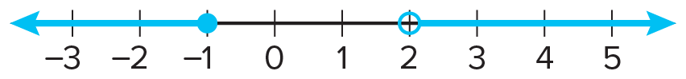

Mixed Exercises
Solve each compound inequality. Then graph the solution set.
27. 4 < f + 6 and f + 6 < 5 28. w + 3 ≤ 0 or w + 7 ≥ 9

29. –6 < b – 4 < 2 30. p – 2 ≤ –2 or p – 2 > 1

31. –5 ≤ 2a – 1 < 9 32. –1 < 2x – 1 ≤ 5

Define a variable, write an inequality, and solve each problem. Check your solution.
33. A number decreased by two is at most four or at least nine.

34. The sum of a number and three is no more than eight or is more than twelve.

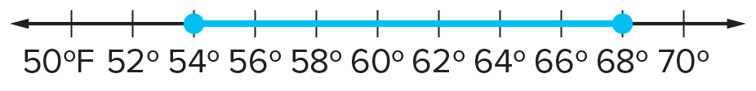
35. WEATHER Kenya saw this graph in the local weather forecast. It shows the predicted temperature range for the following day. Write an inequality to represent the number line.

36. REASONING The pH of a person’s eyes is 7.2. Therefore, the ideal pH for the water in a swimming pool is between 7.0 and 7.6. Write a compound inequality to represent pH levels that could cause physical discomfort to a person’s eyes.

37. FIELD TRIP It costs $1000 to rent a bus that holds 100 students. A school is planning to rent one of these buses for a field trip to an aquarium. The trip will also have a cost of $15 per student for the tickets to the aquarium. Given that the total expense for the trip must be between $2000 and $3000, find the minimum and maximum number of students who can go on the trip. Explain.

38. HEALTH Body mass index (BMI) is a measure of weight status. The BMI of a person over 20 years old is calculated using the following formula.

BMI = 703 × $\frac{weight in pounds}{{(height in inches)}^{2}}$

a. The recommended BMI for a person over 20 years old is 18.5-24.9. Write a compound inequality to represent the recommended BMI range.

b. Write a compound inequality to represent the weight of an adult who is 6 feet tall that is within the recommended BMI range. Round to the nearest tenth if necessary.

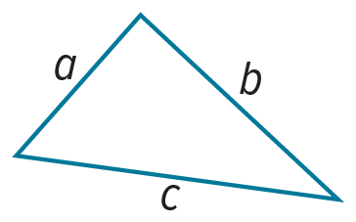
39. STATE YOUR ASSUMPTION The Triangle Inequality states that in any triangle, the sum of the lengths of any two sides is greater than the length of the third side. In the figure, this means a + b > c, a + c > b, and b + c > a.
a. Suppose a triangle has a side that is 5 meters long and a perimeter of 14 meters. Let one of the unknown sides be x. Write a compound inequality that you can use to determine the value of x. Explain.

b. What assumption about the two unknown side lengths of the triangle can you make? Explain.

40. CONSTRUCT ARGUMENTS Bianca said that if k is a real number, then the solution set of the compound inequality x < k or x > k is all real numbers. Do you agree? Justify your argument.

41. STRUCTURE Write the solution set of the following compound inequality. Then graph the solution set: –x + 1 < 8 and –x + 1 < 3 and –x + 1 > –4.

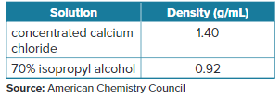
42. PHYSICS The table shows common chemical solutions and their densities. The density, in grams per milliliter, of a substance determines whether it will float or sink in a liquid. Any object with a greater density will sink and any object with a lesser density will float. Density is given by the formula d = $\frac{m}{v}$, where m is mass and v is volume. Here is a table of common chemical solutions and their densities. Plastics vary in density when they are manufactured; therefore, their volumes are variable for a given mass. A tablet of polystyrene (a manufactured plastic) sinks in 70% isopropyl alcohol solution and floats in calcium chloride solution. The tablet has a mass of 0.4 gram. Write an inequality to represent the range of values for v, the volume of the tablet.


43. COMPUTER SALE Marietta is shopping during a computer store’s sale. She is considering buying computers that range in cost from $500 to $1000.
a. How much are the computers after the 20% discount?

b. If sales tax is 7%, how much should Marietta expect to pay?

44. CREATE The figure shows the solution set of a compound inequality. Write a compound inequality that has the given solution set. Solving the inequality should require the Distributive Property, Addition Property of Inequalities, and the Division Property of Inequalities.

45. ANALYZE Which value of x is not a solution to 3x – 1 < 5 or 7 – x ≤ 3?
A 0 B 2 C 4 D 5

46. FIND THE ERROR Sierra solved the compound inequality –3x + 7x – 1 < –5 or –3x + 7x – 1 > 11 as shown. What error did she make in solving the inequality?
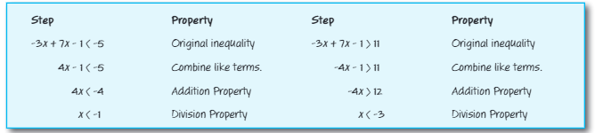

Refer to the graphs for Exercises 47-49.
47. WRITE Write a compound inequality whose solution is the union of the two graphs. Then explain how the compound inequality can be expressed as a single inequality.

48. WRITE Write a compound inequality whose solution is the intersection of the two graphs. Then explain how the compound inequality can be expressed as a single inequality.

49. ANALYZE How are the graphs of the solution sets for the inequalities in Exercise 47 and Exercise 48 related to the given graphs?
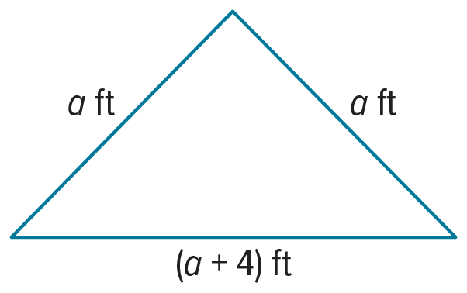
50. PERSEVERE Jocelyn is planning to place a fence around the triangular flower bed shown. The fence costs $1.50 per foot. Assuming that Jocelyn spends between $60 and $75 for the fence, what is the shortest possible length for a side of the flower bed? Use a compound inequality to explain your answer.

51. PERSEVERE Solve each inequality for x. Assume a is constant and a > 0.
a. –3 < ax + 1 ≤ 5 b. $-\frac{1}{a}$x + 6 < 1 or 2 – ax > 8

52. CREATE Create an example of a compound inequality containing or that has infinitely
many solutions.

53. ANALYZE Determine whether the following statement is always, sometimes, or never true. Justify your argument. The graph of a compound inequality that involves an or statement is bounded on the left and right by two values of x.

54. WRITE Give an example of a compound inequality you might encounter at an amusement park. Does the example represent an intersection or a union?

