Graphing Inequalities in Two Variables ⸱ Practice

Examples 1 and 2
Graph each inequality.
1. y < x – 3 2. y > x + 12 3. y ≥ 3x – 1

4. y ≤ –4x + 12 5. 6x + 3y > 12 6. 2x + 2y < 18

7. 5x + y > 10 8. 2x + y < –3 9. –2x + y ≥ –4

10. 8x + y ≤ 6 11. 10x + 2y ≤ 14 12. –24x + 8y ≥ –48

Example 3
13. INCOME In 2006 the median yearly family income was about $48,200 per year. Suppose the average annual rate of change since then is $1240 per year.
a. Write and graph an inequality for the annual family incomes y that are less than the median for x years after 2006.

b. Determine whether each of the following points is part of the solution set.
(2, 51,000) (8, 69,200) (5, 50,000) (10, 61,000)

14. FUNDRAISING Troop 200 sold cider and donuts to raise money for charity. They sold small boxes of donut holes for $1.25 and cider for $2.50 a gallon. In order to cover their expenses, they needed to raise at least $100. Write and graph an inequality that represents this situation.

Example 4
Graph each inequality.
15. $2y+6≥0$ 16. $\frac{1}{2}x+1<3$ 17. $\frac{2}{3}x-\frac{10}{3}>-4$

Mixed Exercises
Graph each inequality.
18. y < –1 19. y ≥ x – 5 20. y > 3x

21. y ≤ 2x + 4 22. y + x > 3 23. y – x ≥ 1

24. Kumiko has a $50 gift card for a Web site that sells apps and games. Games cost $2.50 each, and apps cost $1.25 each.
a. Write an inequality that represents the number of apps a and the number of games g that Kumiko can buy and describe any constraints.

b. Graph the solution of the inequality on a coordinate plane.

c. Use your graph to find three different combinations of apps and games that Kumiko can buy.

d. Kumiko decides to buy the same number of apps and games, and she decides to spend as much of the $50 as possible. How many apps and games does she buy? How much money does she have left on her gift card?

25. USE A MODEL A café sells peach smoothies and berry smoothies. The café makes a profit of $2.25 for each peach smoothie that is sold and a profit of $2 for each berry smoothie that is sold. The owner of the café wants to make a total profit of more than $90 per day from the sales of smoothies.
a. Write an inequality that represents the number of peach smoothies p and berry smoothies b that the café needs to sell. Describe the constraints on the variables.
b. Graph the solution of the inequality on a coordinate plane.
c. On Monday, the café sold 20 peach smoothies and made the daily profit goal. What can you say about the number of berry smoothies that were sold on Monday?
d. On Tuesday, the café made the daily profit goal by selling the minimum number of smoothies. How many smoothies did they sell? Explain.

26. REASONING Oleg is training for a triathlon. One day, he jogged for 2 hours at x miles per hour. Then he bicycled for 2 hours at y miles per hour. Finally he swam a distance of 2 miles. The total number of miles did not exceed 30 miles.
a. Write an inequality to represent the distance that he traveled that day. Describe the constraints on the variables.
b. Graph the solution of the inequality on the coordinate plane shown. Label the axes with a description of the quantity that each axis represents. Include the unit of measure.
c. What is the greatest possible speed that Oleg could have bicycled that day? How do you know?

27. CONSTRUCT ARGUMENTS The solution of the inequality ax + by < c is a half plane that includes the point (0, 0). What conclusion can you make about the value of c? Justify your argument.

28. FIND THE ERROR Reiko and Kristin are solving 4y ≤ $\frac{8}{3}$x by graphing. Is either of them correct? Explain your reasoning.

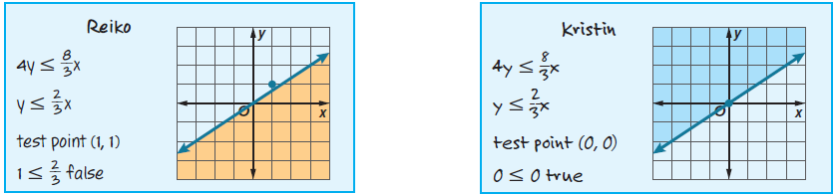

29. CREATE Write a linear inequality for which (–1, 2), (0, 1), and (3, –2) are solutions but (1, 1) is not.

30. ANALYZE Explain why a point on the boundary should not be used as a test point.

31. CREATE Write a two-variable inequality with a restricted domain and range to represent a real-world situation. Give the domain and range, and explain why they are restricted.

32. WRITE Summarize the steps to graph an inequality in two variables.

