Graphing Systems of Equations ⸱ Practice

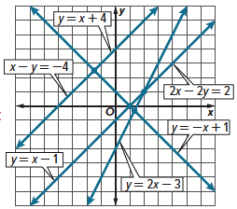
Examples 1 and 2
Use the graph to determine the number of solutions the system has. Then state whether the system of equations is consistent or inconsistent and if it is independent or dependent.
1. y = x – 1 2. x – y = –4
y = –x + 1 y = x + 4

3. y = x + 4 4. y = 2x – 3
2x – 2y = 2 2x – 2y = 2

Examples 3 and 4
Determine the number of solutions the system has. Then state whether the system of equations is consistent or inconsistent and if it is independent or dependent.
5. y = $\frac{1}{2}$x 6. 4x – 6y = 12
y = x + 2 –2x + 3y = –6

7. 8x – 4y = 16 8. 2x + 3y = 10
–5x – 5y = 5 4x + 6y = 12

9. y = $-\frac{3}{2}$x + 5 10. y = x – 3
y = $-\frac{2}{3}$x + 5 y = –4x + 3

Examples 5 and 6
Graph each system and determine the number of solutions it has. If it has one solution, determine its coordinates.
11. y = –3 12. y = 4x + 2
y = x – 3 y = –2x – 4

13. y = x – 6 14. x + y = 4
y = x + 2 3x + 3y = 12

15. x – y = –2 16. 2x + 3y = 12
–x + y = 2 2x – y = 4

Example 7
17. AVIATION An air traffic controller manages the flow of aircraft in and out of airport airspace by guiding pilots during takeoff and landing. An air traffic controller is monitoring two planes that are in flight near a local airport. The first plane is at an altitude of 1000 meters and is ascending at a rate of 400 meters per minute. The second plane is at an altitude of 5900 meters and is descending at a rate of 300 meters per minute.
a. Write and graph a system of equations that represents the altitude of each plane, where x is the amount of time, in minutes, and y is the altitude, in meters.
b. Predict when the planes will be at the same altitude.

18. STRUCTURE Gustavo sets up tables for a caterer on weekends. Each round table can seat 8 people. Each rectangular table can seat 10 people. One weekend, his boss asked him to set up tables for 124 people. He uses 2 more round tables than rectangular tables. Define variables and write a system of equations to find the number of round tables and rectangular tables Gustavo used. Then solve the system graphically.

Example 8
Write and graph a system of equations to solve each linear equation.
19. 3x + 6 = 6 20. 2x – 17 = x – 10

21. –12x + 90 = 30 22. 13x – 28 = 24

23. 2x + 5 = 2x + 5 24. x + 1 = x + 3

Example 9
Solve each system of equations. State the decimal solution to the nearest hundredth.
25. 2.5x + 3.75y = 10.5 26. 2.2x + 1.8y = –3.6 27. 1.12x – 2.24y = 4.96
1.25x – 8.5y = –5.25 –4.8x + 12.4y = 10.6 –3.56x – 2.48y = –7.32

Example 10
28. USE TOOLS An office building has two elevators. One elevator starts out on the 4th floor, 35 feet above the ground, and is descending at a rate of 2.2 feet per second. The other elevator starts out at ground level and is rising at a rate of 1.7 feet per second. Write and solve a system of equations to determine when both elevators will be at the same height. Interpret the solution.

29. USE TOOLS A bookstore makes a profit of $2.50 on each book they sell, and $0.75 on each magazine they sell. One week the store sold x books and y magazines, for a weekly profit of $450. The total number of publications sold that week was 260. Write and solve a system of equations to determine the number of books and magazines that the bookstore sold that week. Interpret the solution.

Mixed Exercises
Graph each system and determine the number of solutions it has. If it has one solution, determine its coordinates. Then state whether the system is consistent or inconsistent and if it is independent or dependent.
30. 2x – y = –3 31. 2x + y = 4
2x + y = –1 y = –2x – 2

32. 2y = 5 + x 33. 2x – y = 5
3x – 6y = –15 x + y = –2

34. 2y = 1.2x – 10 35. x = 6 – $\frac{3}{8}$y
4y = 2.4x 4 = $\frac{2}{3}$x + $\frac{1}{4}$y

36. x – y = 3 37. x + 2y = 4
x – 2y = 3 y = $-\frac{1}{2}$ x + 2

38. y = 2x + 3 39. y – x = –1
3y = 6x – 6 x + y = 3

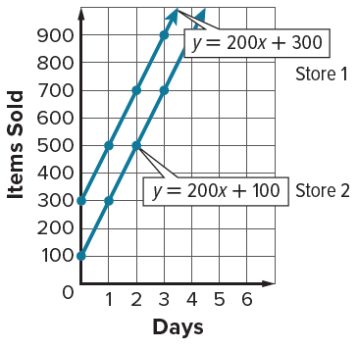
40. BUSINESS The number of items sold at Store 1 can be represented by
y = 200x + 300, where x represents the number of days and y represents the number of items sold. The number of items sold at Store 2 can be represented by y = 200x + 100, where x represents the number of days and y represents the number of items sold. Look at the graph of the system of equations and determine whether it has no solution, one solution, or infinitely many solutions.

41. USE A MODEL Olivia and her brother William had a bicycle race. Olivia rode at a speed of 20 feet per second while William rode at a speed of 15 feet per second. Olivia gave William a 150-foot head start, and the race ended in a tie.
a. Define variables and write a system of equations to represent this situation.
b. Graph the system of equations.
c. How far away was the finish line from where Olivia started?


42. CONSTRUCT ARGUMENTS Abhijit uses a calculator to graph the system
y = 1.21x – 3 and 5y – 5 = 6x. He concludes that the system has no solution. Do you agree or disagree? Explain your reasoning.

43. USE A MODEL Some days, Cayley walks to school. Other days, she rides her bicycle.
When she walks to school, she needs to leave home 15 minutes earlier than when she rides
her bicycle. Cayley walked 3 days last week and rode her bike on 2 days. Cayley spent a total
of 1 hour 10 minutes going to school last week.
a. Define variables and write a system of equations to represent this situation.
b. Graph the system of equations.
c. How long does it take Cayley to walk to school?

44. REGULARITY Maureen says that if a system of linear equations has three equations, then there could be exactly two solutions to the system. Is Maureen correct? Use a graph to justify your reasoning.

45. PERSEVERE Use graphing to find the solution of the system of equations 2x + 3y = 5, 3x + 4y = 6, and 4x + 5y = 7.

46. ANALYZE Determine whether a system of two linear equation with (0, 0) and (2, 2) as solutions sometimes, always, or never has other solutions. Justify your argument.

47. WHICH ONE DOESN’T BELONG Which one of the following systems of equations doesn’t belong with the other three? Justify your conclusion.
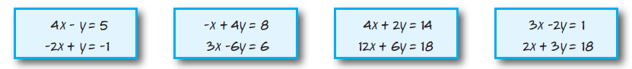

48. CREATE Write three equations such that they form three systems of equations with y = 5x – 3. The three systems should be inconsistent, consistent and independent, and consistent and dependent, respectively.

49. WRITE Describe the advantages and disadvantages of solving systems of equations by graphing.

50. CREATE Write and graph a system of equations that has the following number of solutions.
Then state whether the system of equations is consistent or inconsistent and if it is independent or dependent.
a. one solution b. Infinite solutions c. no solution

51. FIND THE ERROR Store A is offering a 10% discount on the purchase of all electronics in their store. Store B is offering $10 off all the electronics in their store. Francisca and Alan are deciding which offer will save them more money. Is either of them correct? Explain your reasoning.


