Substitution ⸱ Practice

Examples 1-3
Use substitution to solve each system of equations.
1. y = 5x + 1 2. y = 4x + 5 3. y = 3x – 34
4x + y = 10 2x + y = 17 y = 2x – 5

4. y = 3x – 2 5. 2x + y = 3 6. 3x + 4y = –3
y = 2x – 5 4x + 4y = 8 x + 2y = –1

7. y = –3x + 4 8. –1 = 2x – y 9. x = y – 1
–6x – 2y = –8 8x – 4y = –4 –x + y = –1

10. y = –4x + 11 11. y = –3x + 1 12. 3x + y = –5
3x + y = 9 2x + y = 1 6x + 2y = 10

13. 5x – y = 5 14. 2x + y = 4 15. –5x + 4y = 20
–x + 3y = 13 –2x + y = –4 10x – 8y = –40

Example 4
16. MONEY Harvey has some $1 bills and some $5 bills. In all, he has 6 bills worth $22. Let x be the number of $1 bills and let y be the number of $5 bills. Write a system of equations to represent the information, and use substitution to determine how many bills of each denomination Harvey has.

17. REASONING Shelby and Calvin are conducting an experiment in chemistry class. They need
5 milliliters of a solution that is 65% acid and 35% distilled water. There is no undiluted acid in the chemistry lab, but they do have two beakers of diluted acid. Beaker A contains 70% acid and 30% distilled water. Beaker B contains 20% acid and 80% distilled water.
a. Write a system of equations that Shelby and Calvin could use to determine how many milliliters they need to pour from each beaker to make their solution.
b. Solve your system of equations. How many milliliters from each beaker do Shelby and
Calvin need?

Mixed Exercises
Use substitution to solve each system of equations.
18. y = 3.2x + 1.9 19. y = $\frac{1}{4}$x – $\frac{1}{2}$ 20. y = –10x – 6.8
2.3x + 2y = 17.72 8x + 12y = $-\frac{1}{2}$ – 50x – 10.5y = 60.4

21. USE A SOURCE Research population trends in South America. Write and solve a system of equations to predict when the population of two countries will be equal.

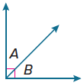
22. REGULARITY Angle A and angle B are complementary, and their measures have a difference of 20°. What are the measures of the angles? Generalize your method.

23. STRUCTURE A two-digit number is reduced by 45 when the digits are interchanged. The digit in the tens pace of the original number is 1 more than 3 times the digit in the units place. Define variables and write a system of equations to find the original number.

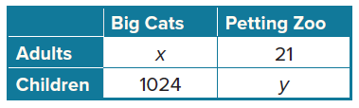
24. USE A MODEL A zoo keeps track of the number of visitors to each exhibit. The table shows the number of visitors for two exhibits on one day.
a. Three times the total number of adults was 17 less than the number of children who visited the petting zoo. Write an equation to model this relationship.
b. The total number of children who visited the zoo that day was 681 less than 10 times the number of adults who visited the big cats. Write an equation to model this relationship.
c. Solve the system of equations to find the total number of visitors to those two exhibits on that day.
d. Tickets to the zoo cost $25 for adults and $10 for children. The total ticket sales one day were $47,750. The number of children who visited the zoo was 270 more than 6 times the number of adults who visited. Write and solve a system of equations to find the total number of visitors to the zoo that day.

25. FIND THE ERROR In the system a + b = 7 and 1.29a + 0.49b = 6.63, a represents pounds of apples and b represents pounds of bananas. Guillermo and Cara are finding and interpreting the solution. Is either correct? Explain your reasoning.
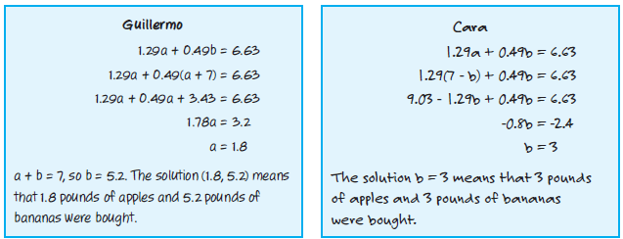

26. PERSEVERE A local charity has 60 volunteers. The ratio of boys to girls is 7:5. Find the number of volunteers who are boys and the number who are girls.

27. ANALYZE Compare and contrast the solution of a system found by graphing and the solution of the same system found by substitution.

28. CREATE Create a system of equations that has one solution. Illustrate how the system could represent a real-world situation and describe the significance of the solution in the context of the situation.

29. WRITE Explain how to determine what to substitute when using the substitution method of solving systems of equations.

