Elimination Using Multiplication ⸱ Practice

Examples 1 and 2
Use elimination to solve each system of equations.
1. x + y = 2 2. x – y = –8 3. x + 5y = 17
–3x + 4y = 15 7x + 5y = 16 –4x + 3y = 24

4. 6x + y = –39 5. 2x + 5y = 11 6. 3x – 3y = –6
3x + 2y = –15 4x + 3y = 1 –5x + 6y = 12

7. 3x + 4y = 29 8. 8x + 3y = 4 9. 8x + 3y = –7
6x + 5y = 43 –7x + 5y = –34 7x + 2y = –3

10. 4x + 7y = –80 11. 12x – 3y = –3 12. –4x + 2y = 0
3x + 5y = –58 6x + y = 1 10x + 3y = 8

Example 3
13. SPORTS The Fan Cost Index (FCI) tracks the average costs for attending sporting events, including tickets, drinks, food, parking, programs, and souvenirs. According to the FCI, a family of four would spend a total of $592.30 to attend two Major League Baseball (MLB) games and one National Basketball Association (NBA) game. The family would spend $691.31 to attend one MLB and two NBA games.

a. Write a system of equations to find the family’s costs for each kind of game according to the FCI.

b. Solve the system of equations to find the cost for a family of four to attend each kind of game according to the FCI.

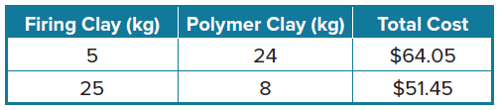
14. ART Mr. Santos, the curator of the children’s museum, recently made two purchases of firing clay and polymer clay for a visiting artist to sculpt. Use the table to find the cost of each product per kilogram.

a. Write a system of equations to find the cost of each product per kilogram.

b. Solve the system of equations to find the cost of each product per kilogram.

Mixed Exercises
15. Two times a number plus three times another number equals 13. The sum of the two numbers is 7. What are the numbers?

16. Four times a number minus twice another number is –16. The sum of the two numbers is –1. Find the numbers.

17. FUNDRAISING Trisha and Byron are washing and vacuuming cars to raise money for a class trip. Trisha raised $38 by washing 5 cars and vacuuming 4 cars. Byron raised $28 by washing 4 cars and vacuuming
2 cars. Find the amount they charged to wash a car and vacuum a car.

18. STRUCTURE Consider the system of equations –2x + 3y = –5 and 3x – 4y = 6.
a. Describe two different ways to solve the system by elimination.

b. Explain why multiplying the first equation by 6 and the second equation by 5 and then adding is not useful for solving the system.

c. Solve the system by elimination.

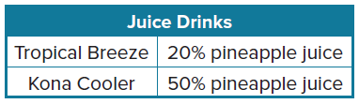
19. REASONING The owner of a juice stand wants to make a new juice drink. He would like to mix Tropical Breeze, t, and Kona Cooler, k, to make 10 quarts of a new drink that is 40% pineapple juice.
a. Make a table to help write a system of equations that the owner of the juice stand can solve to determine the amount of each drink he should use to make the new drink.
b. Solve the system and explain what your solution represents.

c. Explain how you know your answer is correct.

20. USE A MODEL Marlene works as a cashier at a grocery store. At the end of the day, she has a total of 125 five-dollar bills and ten-dollar bills. The total value of these bills is $990.
a. Write a system of equations that you can use to find the number of five-dollar
bills and the number of ten-dollars bills. Describe what each variable represents.

b. Solve the system and explain what your solution represents.

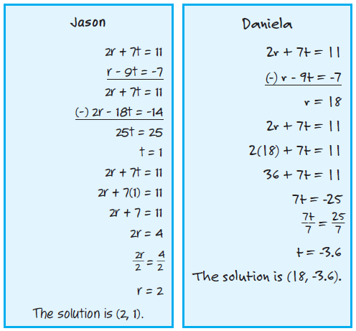
21. FIND THE ERROR Jason and Daniela are solving a system of equations. Is either of them correct? Explain your reasoning.

22. ANALYZE Determine whether the following statement is true or false: A system of linear equations will only have infinitely many solutions if the equations have the same coefficients. Justify your argument.

23. CREATE Write a system of equations that can be solved by multiplying one equation by –3 and then adding the two equations together.

24. PERSEVERE The solution of the system 4x + 5y = 2 and 6x – 2y = b is (3, a). Find the values of a and b. Discuss the steps you used.

25. WRITE Why is substitution sometimes more helpful than elimination, and vice versa?

