Exponential Functions ⸱ Practice

Example 1
Determine whether the set of data displays exponential behavior. Write yes or no. Explain why or why not.
1. 2.
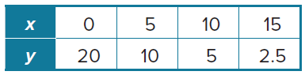
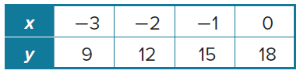

3. 4.
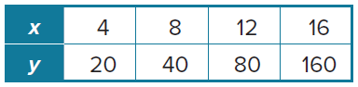
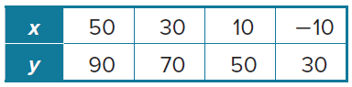

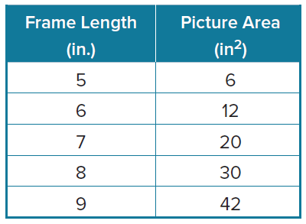
5. PICTURE FRAMES Since a picture frame includes a border, the picture must be smaller in area than the entire frame. The table shows the relationship between picture area and frame length for a particular line of frames. Is this an exponential relationship? Explain.

Examples 2 and 3

6. WASTE Suppose the waste generated by nonrecycled paper and cardboard products in tons y after x days can be approximated by the function
y = 1000(2)^{0.3x}.
a. Identify key features.

b. Graph the function.

c. Identify relevant domain and range.


7. IODINE Iodine 131 is a radioisotope that is related to nuclear energy, medical diagnostic and treatment procedures, and natural gas production. A scientist is testing 50 milligrams of Iodine 131. The scientist knows that the half-life of Iodine 131 is about 8.02 days. The function y = 50${\left(\frac{1}{2}\right)}^{\frac{x}{8.02}}$ represents the amount of Iodine 131 remaining in milligrams y after x days.
a. Identify key features.

b. Graph the function.

c. Identify relevant domain and range.

8. DEPRECIATION Suppose a company’s computer equipment is decreasing in value according to the function y = 4000(0.87)^{x}. In the equation, x represents the number of years that have elapsed since the equipment was purchased and y represents the value in dollars. What was the value 5 years after the computer equipment was purchased? Round your answer to the nearest dollar.

Mixed Exercises
Graph each function. Find the y-intercept and state the domain, range, and the equation of the asymptote.
9. y = ${2\left(\frac{1}{6}\right)}^{x}$ 10. y = ${\left(\frac{1}{12}\right)}^{x}$ 11. y = –3(9^{x})




12. y = –4(10^{x}) 13. y = 3(11^{x}) 14. y = 4^{x} + 3




15. METEOROLOGY The atmospheric pressure in millibars at altitude x meters above sea level can be approximated by the function f(x) = 1038(1.000134)^{–x} when x between 0 and 10,000.
a. What is the atmospheric pressure at sea level?
b. The McDonald Observatory in Texas is at an altitude of 2000 meters. What is the approximate atmospheric pressure there?
c. As altitude increases, what happens to atmospheric pressure?

16. PERSEVERE Use tables and graphs to compare and contrast an exponential function
f(x) = ab^{x} + c, where a ≠ 0, b > 0, and b ≠ 1, and a linear function g(x) = ax + c. Include intercepts, symmetry, end behavior, extrema, and intervals where the functions are increasing, decreasing, positive, or negative.

17. CREATE Write an exponential function for which the graph passes through (0, 3) and (1, 6).

18. ANALYZE Determine whether the graph of y = ab^{x}, where a ≠ 0, b > 0, and b ≠ 1, sometimes, always, or never has an x-intercept. Justify your argument.

19. WRITE Find an exponential function that represents a real-world situation, and graph the function. Analyze the graph, and explain why the situation is modeled by an exponential function rather than a linear function.

