Transformations of Exponential Functions ⸱ Practice

Examples 1–3, 6–7, 10–12
Describe the transformation of g(x) as it relates to the parent function f(x).
1. f(x) = 6^{x}; g(x) = 6^{x} + 8 2. f(x) = 5^{x}; g(x) = −5^{x}

3. f(x) = 3^{x} + 1; g(x) = 3^{2x} + 1 4. f(x) = 4^{x} – 3; g(x) = 4^{0.5x} – 3

5. f(x) = 2.3^{x}; g(x) = −2.3^{x − 1} 6. f(x) = 2^{x}; g(x) = 2^{−x} + 1

7. f(x) = 5^{x} + 2; g(x) = 5^{−x} + 6 8. f(x) = 1.4^{x} – 1; g(x) = −1.4^{x} + 6

9. f(x) = 3^{x} + 1; g(x) = 2(3^{x} + 1) 10. f(x) = −4^{x}; g(x) = $\frac{1}{3}$(–4^{x})

11. f(x) = 4^{x}; g(x) = 4^{x – 3} 12. f(x) = ${\left(\frac{1}{2}\right)}^{x}$+ 5; g(x) = ${\left(\frac{1}{2}\right)}^{x}$

Examples 4–5, 9
Each graph is a transformation of the parent function y = 2^{x}. Use the graph of the function to write its equation.
13. 14.
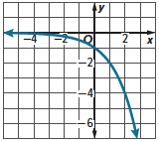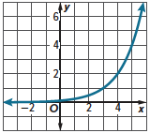

15. 16.
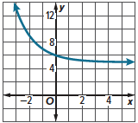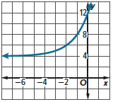

Example 8
17. SAVING Celia invests $2000 in a savings account that earns 1.25% interest per year compounded annually. The amount of money in her bank account after x years can be modeled by
g(x) = 2000(1.0125)^{x}. Describe the dilation in g(x) as it relates to the parent function
f(x) = 1.0125^{x}.

18. CAFFEINE Suppose an 8-ounce cup of coffee contains 100 milligrams of caffeine. The rate at which caffeine is eliminated from an adult’s body is 11% per hour. The function f(x) = 100(0.89)^{x} can be used to model the amount of caffeine left in a person’s bloodstream after x hours of consuming the cup of coffee. Suppose the function g(x) = 25(0.89)^{x} represents the amount of caffeine left in a person’s bloodstream after x hours of consuming an 8-ounce cup of green tea. Describe g(x) as a transformation of f(x).

19. VISITORS The number of visitors to a new skateboarding park can be modeled by the exponential function g(x) = 20(2^{x}), where x represents the number of months since the park’s grand opening. Explain how the number of visitors during that first month is a dilation of the parent function f(x) = 2^{x}.

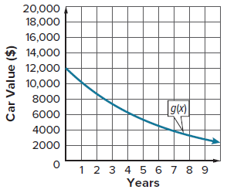
20. DEPRECIATION Depreciation is the decrease in the value of an item resulting from its age or wear. When an item loses about the same percent of its value each year, an exponential function can be used to model its decreasing value over time. The function g(x) = 12,000(0.85)^{x} can be used to model the value of a $12,000 car as it depreciates at an annual rate of 15% over x years. g(x) is a dilation of the parent function f(x) = 0.85^{x}. The graph shows the function g(x).
a. Write the equation of a function h(x) that represents the depreciation of a $20,000 car depreciating at the same rate over x years.

b. Describe h(x) as it relates to the parent function.

c. What is the difference between the values of the $12,000 car and the $20,000 car after
5 years?

Mixed Exercises
Describe the transformation of g(x) as it relates to the parent function f(x) = 2^{x}.
21. g(x) = 2^{x} + 6 22. g(x) = 3(2)^{x}

23. g(x) = $-\frac{1}{4}$(2)^{x} 24. g(x) = –3 + 2^{x}

25. g(x) = ${\left(2\right)}^{-x}$ 26. g(x) = –5(2)^{x}

Write a function g(x) to represent the transformation of the parent function f(x).
27. f(x) = 2^{x} translated 3 units up 28. f(x) = 8^{x} translated 1 unit down

29. f(x) = 5^{x} translated 2 units right 30. f(x) = 3^{x} translated 4 units left

31. f(x) = 6^{x} + 7 translated 2 units down 32. f(x) = −2^{x} + 3 translated 5 units right

33. f(x) = 4^{x} is compressed vertically by a 34. f(x) = 3^{x} is stretched vertically by a
factor of $\frac{1}{2}$ factor of 5

35. f(x) = 2^{x} is compressed horizontally by a 36. f(x) = 5^{x} is stretched horizontally by a
factor of $\frac{1}{3}$ factor of 4

Each graph is a transformation of the parent function f(x) = 5^{x}. Use the graph of the function to write its equation.
37. 38.
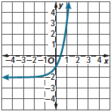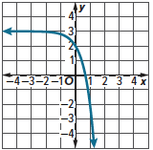

39. 40.
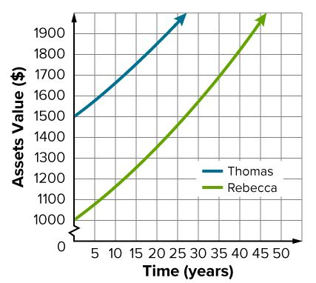
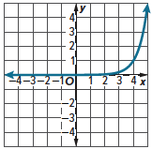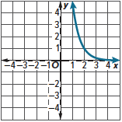

41. ASSETS Thomas and Rebecca each put $1000 into a bank account that earns 1.5% interest per year compounded annually. Thomas also has an antique toy automobile. The graph shows the amount of their assets over time.
a. Describe the graph of Thomas’ assets as a transformation of
Rebecca’s assets.
b. Use the graph to extrapolate the value of Thomas’ antique
toy automobile.

The graph of g(x) is a transformation of the parent function f(x). Graph g(x) and describe the transformation in each function as it relates to the parent function.
42. f(x) = 3^{x} 43. f(x) = 2^{x}
g(x) = 5 $∙$ 3^{x + 2} – 4 g(x) = –3 $∙$ 2^{–x} + 1

44. CONSTRUCT ARGUMENTS Name the coordinates of the point at which the graphs of
g(x) = 2^{x} + 3 and h(x) = 5^{x} + 3 intersect. Explain your reasoning.

45. STRUCTURE Describe the similarities between the graph of f(x) = 4^{x + 2} and the graph of
g(x) = 16 · 4^{x}. Use the properties of exponents to justify your answer.

46. ANALYZE What would happen to the shape of the graph of an exponential function if the function is multiplied by a number between 0 and –1? What would happen to its shape if the exponent is multiplied by a number between 0 and –1? Justify your argument.

47. FIND THE ERROR Jennifer claims that the graph of g(x) = 2(2^{x}) is a graph that rises more rapidly than its parent function f(x) = 2^{x}. James claims that it is actually the parent graph shifted to the left 2 units. Who is correct? Explain your reasoning.

48. WRITE A deficit is a negative amount of some quantity, such as money. A deficit that is growing exponentially can be modeled by y = ab^{c(x – h)} + k. Describe the constraints on a, b, and c.

49. WHICH ONE DOESN’T BELONG? Consider each pair of transformations of the function f(x) to g(x). Which one does not belong? Justify your conclusion.
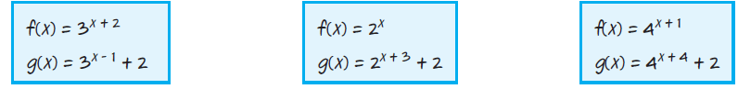

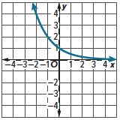
50. CREATE The graph shows a parent function f(x).
a. Write a function to represent the parent function f(x).

b. Write a function to represent a transformation of the parent function g(x).

c. Describe the transformation.

d. Graph the transformed function g(x).

