Transforming Exponential Expressions ⸱ Practice

Example 1
1. INVESTING Kimiyo is planning to invest money in a savings account. She is comparing the interest rates of savings accounts at two banks. Bank A offers a savings account with 2.1% interest compounded annually. Bank B offers a savings account with a quarterly compounded interest rate of 0.8%.
a. Write a function to represent the amount A that Kimiyo would earn after t years through Bank A, assuming an initial investment of $1. Then write an equivalent function that represents quarterly compounding.
b. Which is the better plan? Explain.
c. What is the approximate effective annual interest rate at Bank B? How does your result relate to your answer to part b?

2. COLLECTIONS Keandra is comparing the growth rates in the value of two items in a collection. The value of a necklace increases by 3.2% per year. The value of a ring increases by 0.33% per month.
a. Write a function to represent the value A of the necklace after t years, assuming an initial value of $1. Then write an equivalent function that represents monthly compounding.
b. Which item is increasing in value at a faster rate? Explain.
c. What is the approximate annual rate of growth of the ring? How does your result relate to your answer to part b?

3. SAVINGS Amir is trying to decide between two savings account plans at two different banks. He finds that Bank A offers a quarterly compounded interest rate of 0.95%, while Bank B offers 3.75% interest compounded annually. Which is the better plan? Explain.

4. BACTERIA A scientist found that Bacteria A has a growth rate of 0.99% per minute, while Bacteria B has a growth rate of 0.018% per second. Determine which bacterium has a faster growth rate. Explain.

5. POPULATION The population of Species A is decreasing at a rate of about 0.25% per quarter. The population of Species B is decreasing at a rate of about 1.34% per year. Determine which species has a population that is decreasing at a faster rate? Explain.

Mixed Exercises
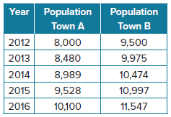
6. POPULATION The table shows the population of two small towns that experience increases in population.
a. Write a function that can be used to estimate the population P(t) of Town A t years after 2012.
b. Write a function that can be used to estimate the population P(t) of Town B t years after 2012.
c. Use your equations and properties of exponents to find the approximate effective monthly increase in the populations of Town A and Town B.

7. ACCOUNTS Dominic is trying to decide between two checking account plans. Plan A offers a monthly compounded interest rate of 0.05%, while Plan B offers 0.5% interest compounded annually. Which is the better plan?

8. CAR DEPRECIATION Juana is deciding between two cars to purchase. Car A depreciates annually at a rate of 3.5%, while Car B depreciates monthly at a rate of 0.32%. Which car has a better effective rate of depreciation?

9. INVESTMENT As a wedding gift, Dotty and Brad received $10,000 cash from Dotty’s grandparents. The couple is trying to decide where to invest the money. Account A offers 2.3% interest compounded semi-annually. Account B offers 4.2% interest compounded annually. Which account has the better rate? Explain.

10. SAVINGS Hernando is deciding between two certificate of deposit accounts. Account Y offers 4.5% interest compounded annually. Account Z offers 1.13% interest compounded quarterly. Which is the better deal? Explain.

11. FINANCE Gita is deciding between two retirement accounts. Account A offers 0.5% interest compounded monthly. Account B offers 2.5% interest compounded annually. Which is the better deal? Explain.

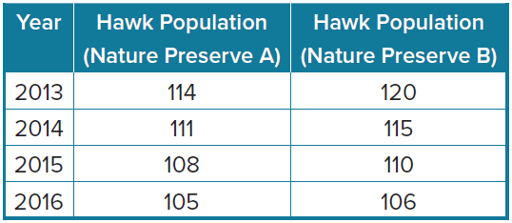
12. WILDLIFE The table shows that the population of hawks in two different nature preserves has been decreasing.
a. Write a function that can be used to estimate the population P(t) of the hawks in Nature Preserve A t years after 2013.
b. Write a function that can be used to estimate the population P(t) of the hawks in Nature Preserve B t years after 2013.
c. Use your equations and properties of exponents to find the approximate effective quarterly decrease in population of hawks in Nature Preserve A and Nature Preserve B.

13. PERSEVERE The rate at which an object cools is related to the temperature of the surrounding environment. At the time of an experiment, Mrs. Haubner’s lab temperature was 72$°$F. The approximate temperature of the water at time t in minutes in Mrs. Haubner’s lab is predicted by the function T(t) = 72 + (212 – 72)2.72^{–0.4t}, where –0.4$°$ per minute is defined as the rate of cooling. Rewrite this function so that the coefficient of t in the exponent is 1.

14. WRITE Explain why it is important for a consumer to compare rates in the same unit before making a purchase.

15. CREATE Write a scenario that compares two accounts with interest rates compounded at different rate units. Then determine which account has the better rate.

16. FIND THE ERROR Marsha is opening a savings account. Eagle Savings Bank is offering her an account with a 0.13% monthly interest rate, while Admiral Savings Bank is offering an account with a 1% annual interest rate. Marsha believes the account at Admiral Savings bank is better because 1% is a greater interest rate than 0.13%. Why is Marsha incorrect? Explain your reasoning.

