Geometric Sequences ⸱ Practice

Examples 1 and 2
Determine whether each sequence is geometric. Explain.
1. 4, 1, 2, … 2. 10, 20, 30, 40, …

3. 4, 20, 100, … 4. 212, 106, 53, …

5. –10, –8, –6, –4, … 6. 5, –10, 20, 40, …

7. –96, –48, –24, –12, … 8. 7, 13, 19, 25, …

9. 3, 9, 81, 6561, … 10. 108, 66, 141, 99, …

11. $\frac{3}{8}$, – $\frac{1}{8}$, – $\frac{5}{8}$, – $\frac{9}{8}$, … 12. $\frac{7}{3}$, 14, 84, 504, …

Example 3
Find the next three terms in each geometric sequence.
13. 2, –10, 50, … 14. 36, 12, 4, …

15. 4, 12, 36, … 16. 400, 100, 25, …

17. –6, –42, –294, … 18. 1024, –128, 16, …

19. 2, 6, 18, … 20. 2500, 500, 100, …

21. $\frac{4}{5}$, $\frac{2}{5}$, $\frac{1}{5}$, … 22. –4, 24, –144, …

23. 72, 12, 2, … 24. –3, –12, –48, …

Example 4
Use an explicit formula to find the 10th term of each geometric sequence.
25. 1, 9, 81, 729, … 26. 2, 8, 32, 128, …

27. –9, 27, –81, 243, … 28. 6, –24, 96, –384, …

Example 5
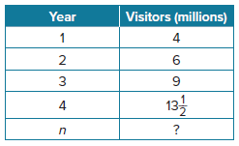
29. MUSEUMS The table shows the annual visitors to a museum in millions. Write an equation for the projected number of visitors after n years.

30. WORLD POPULATION The CIA estimates that the world population is growing at a rate of 1.167% each year. The world population in 2015 was about 7.3 billion.
a. Write an equation for the world population after n years.

b. Find the estimated world population in 2025.

31. DEPRECIATION Te’Andra has a computer system that she bought for $5000. Each year, the computer system loses one-fifth of its then-current value. How much money will the computer system be worth after 6 years?

Mixed Exercises
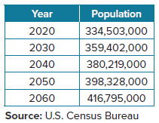
32. POPULATION The table shows the projected population of the United States through 2060. Does this table show an arithmetic sequence, a geometric sequence, or neither? Explain.

33. SAVINGS ACCOUNTS A bank offers a savings account that earns 0.5% interest each month.
a. Write an equation for the balance of the savings account after n months.

b. Given an initial deposit of $500, what will the account balance be after 15 months?

34. Write an equation for the nth term of the geometric sequence 3, – 24, 192, … .
Then find the 9th term of this sequence.

35. Write an equation for the nth term of the geometric sequence $\frac{9}{16}$, $\frac{3}{8}$, $\frac{1}{4}$ , … .
Then find the 7th term of this sequence.

36. Write an equation for the nth term of the geometric sequence 1000, 200, $40$, … .
Then find the 5th term of this sequence.

37. Write an equation for the nth term of the geometric sequence – 8, – 2, – $\frac{1}{2}$, … .
Find the 8th term of this sequence.

38. Write an equation for the nth term of the geometric sequence 32, 48, 72, … .
Find the 6th term of this sequence.

39. USE A SOURCE Research the average annual salary for a 25-year old and the average rate of increase in salary per year. Then write an equation for the nth year of employment. Find the 20th term of this sequence, and explain what it means.

40. STRUCTURE For each of the geometric sequences below, fill in the missing terms, write the corresponding exponential equation, and use the exponential equation to determine the 10th term in the sequence.

a. 0.5, 6, _______, _______, _______; f(x) = ____________; 10th term: __________

b. _______, 10, _______, 40, _______; g(x) = ____________; 10th term: __________

41. REASONING Find the previous three terms of the geometric sequence −192, −768, −3072, ... .

42. STATE YOUR ASSUMPTION Consider two different geometric sequences. Each starts with the same constant. The common ratio producing subsequent terms in the first is positive and is the reciprocal of the common ratio producing subsequent terms in the second. How would the graphs of the two sequences compare? Think about intercepts, asymptotes, and end behavior. Then graph an example of the situation.

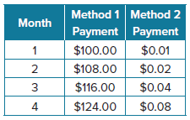
43. REASONING You have just been offered a part-time job. The employer offers two different methods of payment. They are shown in the table.
a. Describe the two different methods of payment being offered.

b. What kind of mathematical equations can you use to model each situation? How do you know? Write each equation.

c. You are planning to work at this job for two years. Your manager promises to raise your salary the way it is described in the table, as long as you meet the minimum performance rating each month. Which payment plan would you choose? Explain your reasoning.
44. CONSTRUCT ARGUMENTS The terms of a geometric sequence are defined by the equation
a_{n} = 512(0.5)^{x}. A second sequence contains the terms b₃ = 7168 and b₇ = 28.
a. Determine which sequence has the greater common ratio.

b. What is the initial term of each sequence? Explain your reasoning.

45. REGULARITY The sum of the interior angles of a triangle is 180°. The interior angles of a pentagon add to 540°. Is the relationship between the number of sides in a polygon and the sum of interior angles a geometric sequence? Use the sum of the measures of the interior angles of a square to justify your answer.
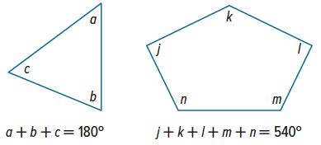

46. PERSEVERE Write a sequence that is both geometric and arithmetic. Explain your answer.

47. FIND THE ERROR Haro and Matthew are finding the ninth term of the geometric sequence
–5, 10, –20, … . Is either of them correct? Explain your reasoning.
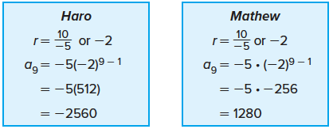

48. ANALYZE Write a sequence of numbers that form a pattern but are neither arithmetic nor geometric. Justify your argument.

49. WRITE How are graphs of geometric sequences and exponential functions similar? How are they different?

50. WRITE Summarize how to find a specific term of a geometric sequence.

51. CREATE Give a counterexample for the following statement:
As n increases in a geometric sequence, the value of a_{n} will move farther away from zero.

52. CREATE Write a geometric sequence. Then explain why your sequence is geometric.

