Recursive Formulas ⸱ Practice

Examples 1 and 2
Find the first five terms of each sequence.
1. a₁ = 23, a_{n} = a_{n – 1} + 7, n ≥ 2 2. a₁ = 48, a_{n} = –0.5a_{n – 1} + 8, n ≥ 2

3. a₁ = 8, a_{n} = 2.5a_{n – 1}, n ≥ 2 4. a₁ = 12, a_{n} = 3a_{n – 1} – 21, n ≥ 2

5. a₁ = 13, a_{n} = –2a_{n – 1} – 3, n ≥ 2 6. a₁ = $\frac{1}{2}$, a_{n} = a_{n – 1} + $\frac{3}{2}$, n ≥ 2

Example 3
Write a recursive formula for each sequence.
7. 12, –1, –14, –27, … 8. 27, 41, 55, 69, …

9. 2, 11, 20, 29, … 10. 100, 80, 64, 51.2, …

11. 40, –60, 90, –135, … 12. 81, 27, 9, 3, …

Example 4
Write a recursive formula for each graph.
13. 14.
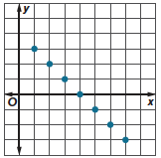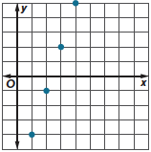

15. 16.
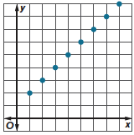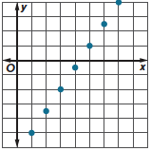

Write a recursive formula for each graph.
17. 18.
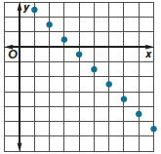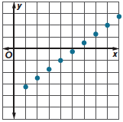

Example 5
19. VIRAL VIDEOS A viral video got 175 views in one hour, 350 views in two hours, 525 views in three hours, 700 views in four hours, and so on.
a. Find the next 5 terms in the sequence.

b. Write a recursive formula for the sequence.

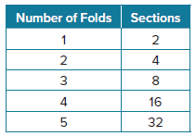
c. Write an explicit formula for the sequence.

20. PAPER A piece of paper is folded several times. The number of sections into which the piece of paper is divided after each fold is shown.
a. Write a recursive formula for the sequence.

b. Write an explicit formula for the sequence.

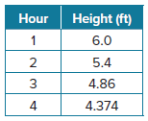
21. SNOW A snowman begins to melt as the temperature rises. The height of the snowman in feet after each hour is shown.
a. Write a recursive formula for the sequence.

b. Write an explicit formula for the sequence.

Example 6
For each recursive formula, write an explicit formula. For each explicit formula, write a recursive formula.
22. a_{n} = 3(4)^{n – 1} 23. a₁ = –2, a_{n} = a_{n – 1} – 12, n ≥ 2

24. a₁ = 38, a_{n} = $\frac{1}{2}$a_{n – 1}, n ≥ 2 25. a_{n} = –7n + 52

26. a₁ = 38, a_{n} = a_{n – 1} − 17, n ≥ 2 27. a_{n} = 5n – 16

28. a_{n} = 50(0.75)^{n – 1} 29. a₁ = 16, a_{n} = 4a_{n – 1}, n ≥ 2

Mixed Exercises
30. CLEANING An equation for the cost a_{n} in dollars that a carpet cleaning company charges for cleaning n rooms is a_{n} = 50 + 25(n – 1). Write a recursive formula to represent the cost a_{n}.

31. SAVINGS A recursive formula for the balance of a savings account a_{n} in dollars at the beginning of year n is a₁ = 500, a_{n} = 1.05a_{n – 1}, n ≥ 2. Write an explicit formula to represent the balance of the savings account a_{n}.

32. USE TOOLS In 2010, County A had a population of 1.3 million people. The largest factory in the area produced 1700 million widgets per year. The population of County A is projected to grow at 1.2% per year, and the number of widgets produced is expected to grow by 10 million per year.
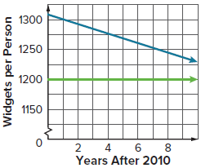
a. Develop explicit formulas for the population and annual widget production, in millions, as functions of the number of years n after 2010.

b. The graph of $y=\frac{1700+10x}{1.3{\left(1.012\right)}^{x}}$ represents the annual widget production per person for County A from 2010 to 2020, where x is the number of years after 2010. The next highest widget-producing county produces widgets at a constant rate of 1200 widgets per person. Use a graphing calculator to extend the graph and find the year when County A will no longer be the leader in widget production. Explain your results.

33. USE A MODEL Ramon has been tracing his family tree with his parents. He claims that he has over 250 great- great- great- great- great- great-grandparents. Is this possible? Write both an explicit and recursive formula for this situation.

34. REASONING Carl Friedrich Gauss, a German mathematician of the 1700s, was asked as a young boy for the sum of the integers from 1 to 100 and he unhesitatingly replied with the correct answer.

a. Identify the type of the sequence 1, 2, 3, … 100, and explore a way to find its sum based on grouping pairs of numbers from each end of the sequence. Then explain how Gauss was able to find the sum so quickly.

b. Find an explicit formula for the sum S of n terms of an arithmetic sequence in which n is an even number, the first term is a₁ and the nth, or last term is a_{n}.

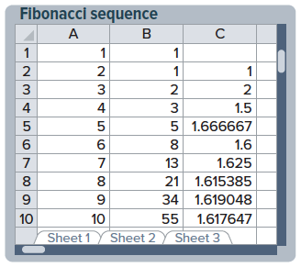
35. REGULARITY The first ten numbers in the Fibonacci sequence can be defined by a_{n + 1} = a_{n} + a_{n − 1}, and each ratio $\frac{a_{n}}{a_{n - 1}}$ can be computed using a spreadsheet (see column C).
a. Which spreadsheet formulas could have been used to calculate the entries in cells B3 and C2?
b. Compute the ratio $\frac{a_{n}}{a_{n - 1}}$ up to n = 50. What do you observe?


36. STRUCTURE There is a famous puzzle called the “Tower of Hanoi.” There are three pegs, and a certain number of disks of varying sizes can be set on each peg. The puzzle starts with the disks in a stack on the left-most peg, with the largest disk on the bottom and the disks getting smaller as they are stacked. The goal is to move the disks from the left-most peg to the right-most peg while obeying three rules. First, only one disk can be moved at a time. Second, only the top disk on any peg can be moved. Third, at no time can a larger disk be placed on a smaller disk.
a. If a_{n} is the number of moves it takes to solve a puzzle consisting of n disks, discuss why the recursive formula a_{n} = a_{n – 1} + 1 + a_{n – 1} makes sense.

b. Simplify the recursive formula. What is a₁? Why?

37. FIND THE ERROR Pati and Linda are working on a math problem that involves the sequence
2, –2, 2, –2, 2, … . Pati thinks that the sequence can be written as a recursive formula. Linda believes that the sequence can be written as an explicit formula. Is either of them correct? Explain your reasoning.

38. PERSEVERE Find a₁ for the sequence in which a₄ = 1104 and a_{n} = 4a_{n – 1} + 16.

39. ANALYZE Determine whether the following statement is true or false. Justify your argument.
There is only one recursive formula for every sequence.

40. PERSEVERE Find a recursive formula for 4, 9, 19, 39, 79, … .

41. WRITE Explain the difference between an explicit formula and a recursive formula.

42. CREATE Give a counterexample for the following statement:
In a recursive sequence, if a₁ = a₂, then a₂ = a₃, and so on.

