Measures of Center ⸱ Practice

Example 1
Find the mean, median, and mode for each data set.
1. {17, 11, 8, 15, 28, 20, 10, 16} 2. {2.5, 6.4, 7.0, 5.3, 1.1, 6.4, 3.5, 6.2, 3.9, 4.0}

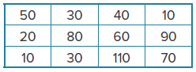
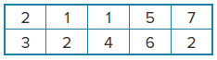
3. 4.

5. number of students helping at a booth each hour: 3, 5, 8, 1, 4, 11, 3

6. weight in pounds of boxes loaded onto a semi-truck: 201, 201, 200, 199, 199

7. car speeds in miles per hour observed by a highway patrol officer: 60, 53, 53, 52, 53, 55, 55, 57

8. number of songs downloaded by students last week in Ms. Turner’s class: 3, 7, 21, 23, 63, 27,
29, 95, 23

9. ratings of an online video: 2, 5, 3.5, 4, 4.5, 1, 1, 4, 2, 1.5, 2.5, 2, 3, 3.5

Example 2
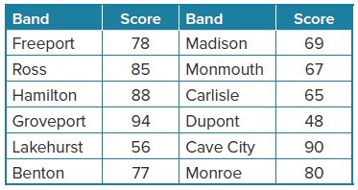
MARCHING BAND A competition was recently held for 12 high school marching bands. Each band received a score from 0 through 100, with 100 being the highest.

10. Find Hamilton High School’s percentile rank.

11. Find Monmouth High School’s percentile rank.

12. Find Freeport High School’s percentile rank.

Mixed Exercises
13. REASONING The mean number of people at the movies on Saturday nights throughout the year is 425, and the median is 412. Explain why the mean could be slightly higher.

14. REASONING The mode length of time it takes to fly from New York City to Chicago is 2 hours
35 minutes, and the mean is 3 hours 15 minutes. Explain why the mode could be slightly lower.

15. FOOTBALL Find the mean, median, and mode for the data set. The weights in pounds of
5 offensive linemen of a football team: 217, 212, 285, 245, 301

16. WEB SITES The ratings for a new recipe Web site varied from very low, 1 point, to very high,
10 points, with half of the scores receiving a rating of 7. If a new rating of 7 were added to the data set, how would the mode be affected? Explain.

17. Find the mean of {16, 19, 22, 27, 33, 19, 25}.

18. SINGING In a singing competition that involved 50 contestants, Reina’s score ranked higher than 40 of the contestants. In what percentile did Reina score?

19. SPORTS The table shows the number of points scored by a basketball team during their first several games. Find the mean, median, and mode of the number of points scored.
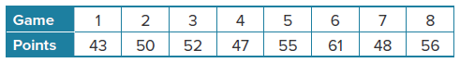

20. PERFORMANCE At a body building competition, Shawnte earned a score of 42 points. There were 19 competitors who received a lower score than Shawnte and 5 competitors who earned a higher score. What was Shawnte’s percentile rank in the body building competition?

21. GRADES On her first four quizzes, Rachael has earned scores of 21, 24, 23, and 17 points. What score must Rachael earn on her fifth and final quiz so that both the mean and median of her quiz scores is 21?

22. QUIZZES Sequon scored 95, 86, 81, 83, and 95 on his math quizzes this quarter. Find the mode of his quiz scores.

23. BAND Out of the 30 bands at the competition, Coastal High School’s band scored higher than
27 others. Find the percentile rank for Coastal High School’s band.

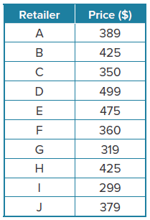
24. SHOPPING The table shows the prices of comparable laptop computers at different retailers.

a. Find the mean, median, and mode of the prices.

b. Why are the mean and median much lower than the mode?

c. After deliberation, Nikki is interested in buying a laptop from either retailer C, F, or J. What are the percentile ranks for the laptop at each of these retailers?

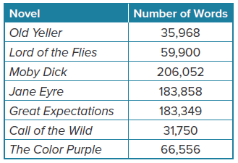
25. NOVELS The table shows the lengths (in words) of the seven novels on the required reading list of Miguel’s language
arts class.

a. Find the mean, median, and mode for the data set.

b. Predict which novels will be lower than the 50th percentile in length. Verify your prediction.

c. If Lord of the Flies comes with an additional 10,020-word online reading assignment, then how will the median length be affected? How will the mean be affected?

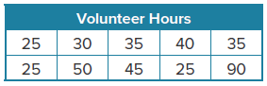
26. VOLUNTEERING The table shows the number of hours different students spent volunteering as part of a community outreach program. Find the mean, median, and mode of the data set.

27. USE A SOURCE Research the total medal counts for Canada, France, Japan, Russia, Brazil, and Great Britain at the 2016 Rio de Janeiro Olympics. Make a table of the data you collect. Then find the percentile rank of each country.

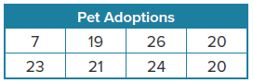
28. CONSTRUCT ARGUMENTS The table shows the number of pet adoptions each week for a shelter over a two-month period. If
there are 65 pets adopted next week, how are the mean, median,
and mode affected?

29. STATE YOUR ASSUMPTION A data set has a mean of 37, a median of 36.5, and a mode of 37. What assumption(s) can you make about the data set?

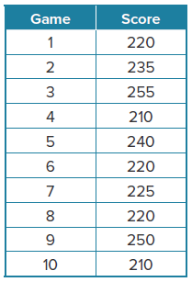
30. BOWLING The table shows Lucinda’s score for each of her last ten
bowling games.
a. Find the mean, median, and mode of the scores. Round to the nearest
whole number.

b. Why is the mean slightly higher than the median?

31. DANCE COMPETITION At a dance competition, Pascal earned a score of
73 points. There were 12 competitors who received a lower score than Pascal and 3 competitors who earned a higher score. What was Pascal’s percentile rank in the dance competition?

32. CREATE Create a data set that has a mean of 11, a median of 10, and a mode of 8.
33. WRITE Describe how an outlier value that is greater than the numbers in the data set affects each measure of center.

34. ANALYZE Determine whether the statement is true or false. If it is false, explain how to make the statement true.

To find percentile rank, divide the selected value by the total of all the values.

35. PERSEVERE Describe the effect on the mean, median, and mode of a set when all the items in the set are multiplied by the same number.
36. WHICH ONE DOESN’T BELONG Analyze each situation. Which situation is NOT best described by the median of the data? Explain.
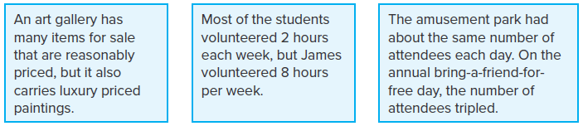

37. FIND THE ERROR Julio is studying Botany and has been tracking the growth of 10 tomato
plants each week. The first week the plants measured the following growth: 1 in., 1.5 in.,
2.2 in., 0.5 in., 1 in., 1.25 in., 1.4 in., 2 in., 2.1 in., 1.9 in. In his research paper, Julio includes
the median growth value for the week. Has Julio chosen the best measure of center to
describe the plant growth? Explain.

38. STRUCTURE Explain how you determine that a data set is best described by the mean.

39. WRITE Explain in your own words the process for finding a percentile rank.

