Representing Data ⸱ Practice

Examples 1 and 2
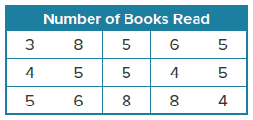
1. READING The table shows the number of books read by students in a summer reading program. Make a dot plot of the data.

2. QUIZ SCORES Represent the quiz scores as a dot plot. Scale the number line as needed.
50, 45, 24, 28, 27, 38, 21, 22, 23, 42, 41, 35, 37, 25, 43
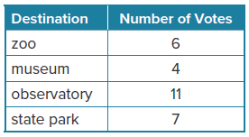

Examples 3 and 4
3. SURVEY A survey was conducted among students in Mr. Dalton’s science class to determine a field trip destination. The results are shown in the table. Make a bar graph to display the data.

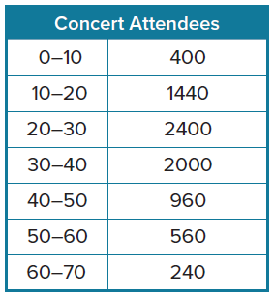
4. MOVIES In a survey, students were asked to name their favorite type of movie. Of those surveyed, 8 chose action movies, 6 chose comedies, 5 chose horror movies, 3 chose dramas, and 7 chose science fiction movies (sci-fi). Determine whether the data are discrete or continuous. Then make a graph.

5. CONCERT The table shows the number of attendees by age at a concert. Determine whether the data should be shown in a bar graph or histogram. Then make an appropriate graph for the data.

Mixed Exercises
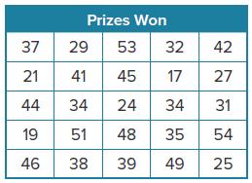
6. PRIZES The table shows the number of prizes won by customers at a carnival game each of the past several days. Determine whether the data are discrete or continuous. Then make an appropriate graph for the data.

7. JOGGING The number of miles Lisa jogged each of the last 10 days are
3, 4, 6, 2, 5, 8, 7, 6, 4, and 5.
a. Choose the most appropriate type of data display and graph the data.
b. How many days did Lisa jog 4 miles at least 4 miles?
c. What was the greatest number of miles she jogged in a day?

8. MOVIES The number movies that are released theatrically each year are shown in the table.
a. Select an appropriate display for the data. Explain your reasoning.
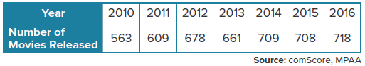
b. Make a graph of the data.

9. RUNNING The ages of the participants in a 10K race at Masonville are 65, 47, 23, 70, 41, 55, 32, 29, 56, 39, 12, 57, 25, 33, 15, 18, 35, 22, 63, 49, 23, 30, 37, 40, and 50.
a. Construct an appropriate data display for the data.
b. How many participants are less than 30 years old?
c. In what interval is the most frequent age?

10. ORCHESTRA The ages of the members of an orchestra are 39, 43, 31, 53, 41, 25, 35, 46, 27, 34, 37, 26, 51, 29, 36, 40, 33, 28, 48, 26, 42, and 38 years. Make a graph of the data.

11. PRECISION A scientific research study tracks the growth of an insect in millimeters. The growth data for each insect in the study during week 1 are 1.1, 1.25, 1.3, 1.67, 1.9, 2.35, 2.1, 2.3, 1.5, 1.7, 2.25, 2.1, 2.45, 1.37, 1.83. The scientist is preparing a histogram to show the distribution of growth across the population. How should the scientist break down his data into categories?

12. PETS The pets owned by Liza’s classmates are rabbit: 2, dog: 6, cat: 3, horse: 2, bird: 5,
mouse: 1, fish: 3, and other: 1.
a. Make a dot plot of the data.
b. How many types of pets are represented by the dot plot?
c. Which pet is the most popular?

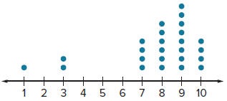
13. ANALYZE Make two conclusions about a product that received the ratings shown in the dot plot. Justify
your conclusions.

14. REGULARITY Explain when a histogram is the best model for data, and describe the process of creating a histogram.

15. WRITE Explain why it may be necessary to scale the
number line of a dot plot.
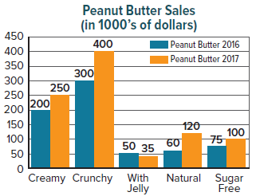

16. PERSEVERE Using the data provided in the double bar graph about peanut butter, what are two conclusions the grocery store could infer?

17. STRUCTURE How is a bar graph similar to a histogram?
How is it different?

