Using Data ⸱ Practice

Example 1
1. SPORTS Awan wants to know what the favorite sport is among students. To find out, he asks everyone he sees leaving school after basketball practice. Identify the intended population and determine the potential sample bias.

2. STORES Raya wants to conduct a survey at a nearby mall to determine which are the mall’s most popular stores. How could she choose a sample that is unbiased?

Example 2
3. MUSIC Shea is shopping online, and a survey question pops up that says, “Music education enriches student learning. Do you support music education in schools?”
a. Identify potential bias in the question.
b. Identify whose interests may be served by the question.

4. CANDIDATES There are three candidates for mayor. To investigate how the townspeople feel about the candidates, a newspaper posts a poll that lists the three candidates and asks which candidate people support. The poll appears on the same page as an opinion piece in support of one of the candidates.
a. Identify potential bias in the question.
b. Identify whose interests may be served by the question.

Example 3
5. BUTTERFLIES Tania recorded the number of butterflies she saw on her daily runs each day for a week. The numbers are: 1, 8, 2, 2, 5, 6, and 4. Find the mean, median, and mode of the data. Which measure(s) are appropriate to accurately summarize the data?

6. OUTLIERS In a data set with an outlier, which measure of center, mean or median, is the better measure to use to describe the center of the data? Explain your reasoning.

Example 4
7. SALES The graphs show the number of T-shirts sold at a baseball tournament for two years by two different vendors. The tournament director wants to compare the vendors. Do the graphs misrepresent the data? How does that difference affect the interpretation?
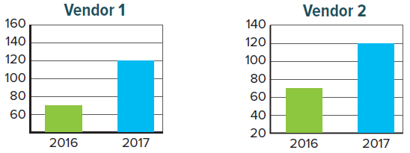

8. SCALE If the same set of data is graphed with a scale of 0 to 10 on the y-axis and then with a scale of 0-100 on the y-axis, what effect does that have on the representation of the data?

Mixed Exercises
9. SCIENCE A school wants to know which area of science; physics, biology, or chemistry, is most interesting to its students. Would it be better to survey students in a class that is an elective or required to get a sample with the least bias? Explain your reasoning.
10. TAX Before surveying people about whether they favor or oppose a proposed tax, the surveyors want to present information about the tax. Suppose the surveyors give facts about the tax without giving opinions. How could the facts given by the surveyors introduce bias?

11. CONSTRUCT ARGUMENTS The weights, in pounds, of several dolphins at a sea animal care facility are 185, 222, 755, 801, 835, 990, and 1104. Which measure of center best represents the data? Justify your conclusion.

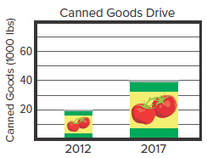
12. FOOD DRIVE The chart shows the number of canned goods collected by Valley High School in 2012 and 2017. Is the graph misleading? Explain.

13. REASONING The number of participants at reading club for six weeks are 11, 12, 10, 13, 10, and 10. Without calculating the measures of center, how would adding an outlier of 24 participants affect which measure of center most appropriately represents the data?

14. PRECISION A community garden has 8 tomato plants with heights ranging from 0.4 to 0.9 meters. Regina found the median to be 0.7 meters, which she rounded and reported as 1 meter. Is Regina’s report of the median accurate? Explain your reasoning.

15. REGULARITY Describe a general method for assessing a sample for bias.

16. STRUCTURE How are the median and mean scores affected if all data values in a set are increased by a specific value, such as 10?

17. CREATE Create two sets of data and display them in a graph or chart that shows bias towards one of the sets of data.

18. WRITE Write two scenarios that have different examples of sample bias. Have a classmate rewrite your statements without bias.

19. CREATE Think of a topic about which you can survey the teachers at your school. Conduct the survey. Explain if your survey question(s) introduce bias.

20. ANALYZE Is a biased sample sometimes, always, or never valid? Justify your argument.
21. PERSEVERE If the mean, median and mode of a data set are equal, the data set is symmetric.
If a data set has a mean that is less than its median, what does that tell you about the data set?

22. FIND THE ERROR Two students collected data on the sizes of box turtle shells. Olivia measured
8 turtles from a pond near her school. Caleb measured 2 turtles from each of 4 ponds around town. Which is more likely to be free of sample bias? Explain your reasoning.

