Measures of Spread ⸱ Practice

Example 1
Find the range of each data set.
1. 12, 27, 43, 52, 43, 18, 45, 53, 26 2. 132, 127, 129, 130, 141, 125, 138, 129

3. 56, 101, 78, 49, 55, 108, 111, 64 4. 5.9, 6.2, 3.9, 3.7, 8.5, 6.2, 9.0, 8.7, 4.5, 9.3

5. EXERCISE Kent tracked his daily number of minutes of exercise. Find the range of the data set.
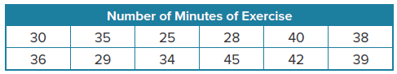

Example 2
Determine the five-number summary and draw a box plot of the data.
6. prices in dollars of smartphones: 311, 309, 312, 314, 399, 312

7. attendance at an event for the last nine years: 68, 99, 73, 65, 67, 62, 80, 81, 83

8. books a student checks out of the library: 17, 9, 10, 17, 18, 5, 2

9. ounces of soda dispensed into 36-ounce cups: 36.1, 35.8, 35.2, 36.5, 36.0, 36.2, 35.7,
35.8, 35.9, 36.4, 35.6

10. ages of riders on a roller coaster: 45, 17, 16, 22, 25, 19, 20, 21, 32, 37, 19, 21, 24, 20,
18, 22, 23, 19

Example 3
Find the interquartile range of each data set.
11. 43, 36, 51, 68, 50, 27, 38, 81, 33 12. 201, 225, 217, 240, 232, 252, 228, 231

13. 94, 87, 105, 99, 118, 97, 102, 85 14. 8.4, 7.1, 6.3, 6.8, 9.2, 7.3, 8.8, 7.9, 5.3, 8.2

15. HEART RATE A nurse tracked the heart rates of several patients. Find the interquartile range (IQR) of the data set: 108, 88, 119, 75, 96, 88, 100, 99, 125, 81.

Example 4
Find the standard deviation of each data set.
16. {10, 9, 11, 6, 9} 17. {6, 8, 2, 3, 2, 9}

18. {23, 18, 28, 36, 15} 19. {44, 35, 40, 37, 43, 38, 40}

20. PARKING A city councilor wants to know how much revenue the city would earn by installing parking meters on Main Street. He counts the number of cars parked on Main Street each weekday: {64, 79, 81, 53, 63}. Find the standard deviation.

Mixed Exercises
21. REASONING A hockey team keeps track of how many goals it scores each game: {2, 4, 0, 3, 7, 2}. Find and interpret the standard deviation of the data.

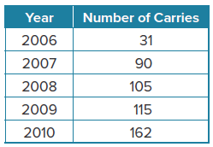
22. FOOTBALL The table shows information about the number of carries a running back had over a number of years. Find and interpret the standard deviation of the number of carries.

23. MOVIES The manager at a movie theater kept track of the age of each person in a matinee movie: 67, 62, 65, 38, 69, 67, 59, 41, 43, 36, 45, 22, 69, 68, 18, 15, 9, 60, 64.

a. Determine the five-number summary for the data set.

b. Draw a box plot of the data.

24. GAS PRICES Renee is planning a road trip to her aunt’s house. To estimate how much the trip will cost, she goes online and finds the price of a gallon of gasoline for 5 randomly selected gas stations along the route: $2.09, $2.19, $3.99, $2.39, $2.29.

a. Determine the five-number summary for the data set.

b. Draw a box plot of the data.

Find the range, five number summary, interquartile range, and standard deviation for each data set. Then draw a box plot of the data.
25. SEASHELLS Jorja collected the following number of seashells for the last nine trips to the beach: 5, 11, 7, 12, 13, 17, 3, 15, 14.

26. SHOE SIZE The following shoe sizes of students at a high school were randomly recorded for one hour: 6, 8, 8.5, 10, 12, 6.5, 7, 8, 8.5, 7.5, 9, 11.5, 10, 13, 5.5, 6.5, 5, 9.5.

27. FIND THE ERROR Jennifer and Megan are determining one way to decrease the size of the standard deviation of a set of data. Is either correct? Explain your reasoning.
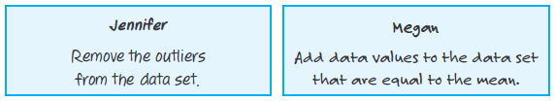

28. ANALYZE Determine whether the statement: Two random samples taken from the same population will have the same mean and standard deviation. is sometimes, always, or never true. Justify your argument.

29. CREATE Write your own survey question and collect data about your question from 8 classmates. Use that data to find the range, five number summary, interquartile range, and standard deviation for the data set. Then draw a box plot of the data.

30. WRITE What does the interquartile range tell you about how data clusters around the median of the data?

