Distributions of Data ⸱ Practice

Example 1
Use a graphing calculator to construct a histogram and a box plot for the data. Then describe the shape of the distribution.
1. 55, 65, 70, 73, 25, 36, 33, 47, 52, 54, 55, 60, 45, 39, 48, 55, 46, 38,
50, 54, 63, 31, 49, 54, 68, 35, 27, 45, 53, 62, 47, 41, 50, 76, 67, 49

2. 42, 48, 51, 39, 47, 50, 48, 51, 54, 46, 49, 36, 50, 55, 51, 43, 46, 37,
50, 52, 43, 40, 33, 51, 45, 53, 44, 40, 52, 54, 48, 51, 47, 43, 50, 46

Example 2
Describe the center and spread of the data using either the mean and standard deviation or the five-number summary. Justify your choice by constructing a histogram for the data.
3. 32, 44, 50, 49, 21, 12, 27, 41, 48, 30, 50, 23, 37, 16, 49, 53, 33, 25,
35, 40, 48, 39, 50, 24, 15, 29, 37, 50, 36, 43, 49, 44, 46, 27, 42, 47

4. 82, 86, 74, 90, 70, 81, 89, 88, 75, 72, 69, 91, 96, 82, 80, 78, 74, 94,
85, 77, 80, 67, 76, 84, 80, 83, 88, 92, 87, 79, 84, 96, 85, 73, 82, 83

Example 3
Describe the center and spread of the data using either the mean and standard deviation or the five-number summary. Justify your choice by constructing a box plot for the data.
5. 47, 16, 70, 80, 28, 33, 91, 55, 60, 45, 86, 54, 30, 98, 34, 87, 44, 35,
64, 58, 27, 67, 72, 68, 31, 95, 37, 41, 97, 56, 49, 71, 84, 66, 45, 93

6. 64, 36, 32, 65, 41, 38, 50, 44, 39, 34, 47, 35, 46, 36, 53, 35, 68, 40,
36, 62, 34, 38, 59, 46, 63, 38, 67, 39, 59, 43, 39, 36, 60, 47, 52, 45

Example 4
7. FLYING The various prices of a flight from Los Angeles to New York are shown.
$182, $234, $264, $271, $277, $314, $317, $455
a. Make a box plot of the data.
b. Calculate the statistics which best represent the data.
c. Describe the effect of the outlier.

8. EXERCISE Yoshiko tracked her minutes of exercise each day for 10 days as shown.
57, 60, 53, 59, 57, 61, 61, 54, 62, 10
a. Make a box plot of the data.
b. Calculate the statistics which best represent the data.
c. Describe the effect of the outlier.

Mixed Exercises
USE TOOLS Use a graphing calculator to construct a histogram and a box plot for the data. Then describe the shape of the distribution.
9. 14, 71, 63, 42, 24, 76, 34, 77, 37, 69, 54, 64, 47, 74, 59, 43, 76, 56,
78, 52, 18, 54, 39, 28, 56, 74, 68, 36, 20, 49, 67, 47, 69, 68, 72, 69

10. 53, 34, 36, 38, 43, 49, 52, 36, 39, 37, 58, 45, 37, 38, 46, 52, 45, 39,
55, 39, 40, 55, 38, 40, 42, 38, 45, 36, 46, 39, 35, 41, 49, 43, 52, 34

11. 51, 19, 46, 64, 29, 51, 58, 30, 55, 31, 34, 31, 50, 37, 40, 39, 40, 41,
42, 32, 24, 48, 43, 45, 38, 43, 58, 47, 34, 36, 50, 54, 46, 28, 60, 22

12. TRACK Daryn recorded the number of laps he walked around the track each week.
Use a graphing calculator to construct a histogram for the data, and describe the shape
of the distribution.

17, 21, 23, 26, 27, 28, 28, 27, 33, 34, 33, 27, 29, 22, 19, 28, 35

13. GOLF Mr. Swatsky’s geometry class’s miniature golf scores are shown below. Use a
graphing calculator to construct a box plot for the data, and describe the shape
of the distribution.
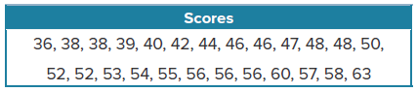
14. HAIR LENGTH Ruth recorded the lengths, in centimeters, of hair of students in her school. Describe the center and spread of the data using either the mean and standard deviation or the five-number summary. Justify your choice by creating a box plot for the data.
40, 39, 37, 26, 25, 40, 35, 34, 26, 39, 42, 33, 26, 25, 34, 38, 41, 34,
37, 39, 32, 30, 22, 38, 36, 28, 27, 39, 34, 26, 36, 38, 25, 39, 23, 8

15. PRESIDENTS The ages of the presidents of the United States at the time of their inaugurations are shown. Describe the center and spread of the data using either the mean and standard deviation or the five-number summary. Justify your choice by creating a box plot for the data.
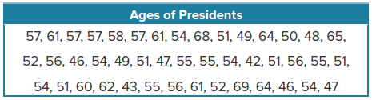
16. AUTOMOTIVE A service station tracks the number of cars they service per day.
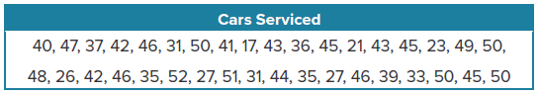
a. Use a graphing calculator to construct a histogram for the data, and describe the shape of
the distribution.

b. Describe the center and spread of the data using either the mean and standard deviation or the five-number summary. Justify your choice.

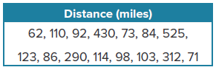
17. COMMUTE The number of miles that Armando drove each week during a 15-week period is shown.
a. Use a graphing calculator to construct a box plot. Describe the center and spread of the data.

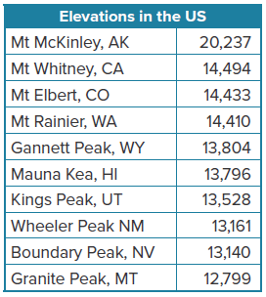
b. Armando visited four colleges during this period, and these visits account for the four highest weekly totals. Remove these four values from the data set. Use a graphing calculator to construct a box plot that reflects this change. Then describe the center and spread of the new data set.

c. Calculate and compare the mean and median for the original data set to the mean and median for the data set from part b.

18. ELEVATION The table contains data about 10 elevations in the United States.
a. Use a graphing calculator to construct a box plot for the data, and describe the shape of the distribution.
b. Describe the center and spread of the data using either the mean and standard deviation or the five-number summary. Justify your choice.
c. If there is an outlier, describe its effect on the statistics.

19. USE A MODEL The histograms show the weight of sample boxes of two brands of pasta.
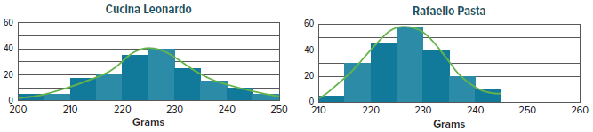

a. Do the two packages of pasta likely have the same advertised weight? Which manufacturer’s quantity control appears better? Explain your answers based on the distributions.
b. Infer the two population distribution shapes by analyzing the smooth curves across the tops of the histograms. Describe the shapes you observe.

20. STRUCTURE The United States has been sending astronauts up in the Space Shuttle since 1981. The table provides data regarding the duration of Space Shuttle flights from 1981 to 1985, and then from 2005 to 2011.
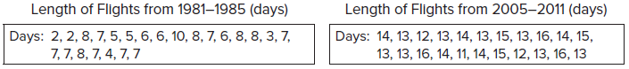

Choose and calculate the statistics appropriate for the distribution of the data sets. Use the statistics to compare the two sets.

21. REASONING Gerardo live streams with 15 of his friends. Most of his streams have lasted 10-15 days so far, however he has two streams that have lasted 93 days. Describe what Gerardo’s data distribution would look like currently and how it would be affected if he lost his longest streams.

22. CONSTRUCT ARGUMENTS Examine the two box plots shown. Without knowing the data points but assuming the same scale, what conclusion can be made? Justify your argument.

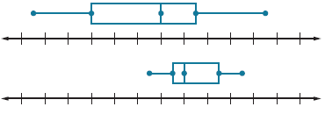

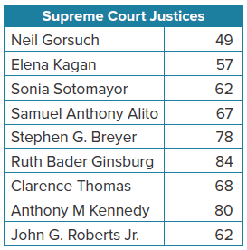
23. SUPREME COURT The table gives the ages of the current Supreme Court Justices in 2017.
a. Use a graphing calculator to construct a histogram for the data, and describe the shape of the distribution.
b. Describe the center and spread of the data using appropriate statistics. Justify your choice.
c. If there is an outlier, describe its effect on the statistics.

24. PERSEVERE Identify the box plot that corresponds to each of the following histograms.
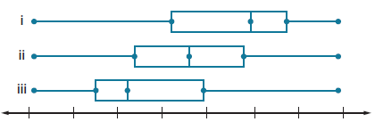


A. B. C.

25. ANALYZE Research and write a definition for a bimodal distribution. How can the measures of center and spread of a bimodal distribution be described?

26. CREATE Give an example of a set of real-world data with a distribution that is symmetric and one with a distribution that is not symmetric.

27. WRITE Explain why the mean and standard deviation are used to describe the center and spread of a symmetrical distribution and the five-number summary is used to describe the center and spread of a skewed distribution.

