Comparing Sets of Data ⸱ Practice

Example 1
Find the mean, median, mode, range, and standard deviation of each data set that is obtained after adding the given constant to each value.
1. 52, 53, 49, 61, 57, 52, 48, 60, 50, 47; + 8 2. 101, 99, 97, 88, 92, 100, 97, 89, 94, 90; + (–13)

3. 27, 21, 34, 42, 20, 19, 18, 26, 25, 33; + (–4) 4. 72, 56, 71, 63, 68, 59, 77, 74, 76, 66; + 16

Example 2
Find the mean, median, mode, range, and standard deviation of each data set that is obtained after multiplying each value by the given constant.
5. 11, 7, 3, 13, 16, 8, 3, 11, 17, 3; $×$ 4 6. 64, 42, 58, 40, 61, 67, 58, 52, 51, 49; $×$ 0.2

7. 33, 37, 38, 29, 35, 37, 27, 40, 28, 31; $×$ 0.8 8. 1, 5, 4, 2, 1, 3, 6, 2, 5, 1; $×$ 6.5

Examples 3 and 4
9. BASEBALL The total wins per season for the first 17 seasons of the Marlins are shown. The total wins over the same time period for the Cubs are also shown.
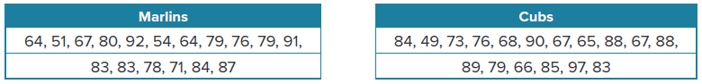
a. Use a graphing calculator to construct a box plot for each set of data. Then describe the shape of each distribution.

b. Compare the data sets using either the means and standard deviations or the five-number summaries. Justify your choice.

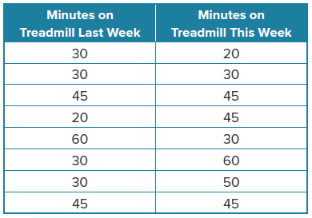
10. HEALTH CLUBS To plan their future equipment purchases, the Northville Health Club randomly chooses 8 patrons and tracks how many minutes they spend on the treadmill.

a. Use a graphing calculator to construct a histogram for each set of data. Then describe the shape of each distribution.

b. Compare the data sets using either the means and standard deviations or the five-number summaries. Justify your choice.

Mixed Exercises
Find the mean, median, mode, range, and standard deviation of each data set that is obtained after adding or multiplying each value by the given constant(s).
1 1. 98, 95, 97, 89, 88, 95, 90, 81, 87, 95; + 2 12. 32, 30, 27, 29, 25, 33, 38, 26, 23, 31; × 1.6

13. 14, 17, 13, 9, 15, 7, 12, 16, 8, 9; × 5 14. 5, 12, 7, 3, 8, 5, 7, 1, 4, 7, 3, 9; + 22

15. 12, 15, 16, 12, 12, 15, 17, 16. 49, 43, 26, 39, 40, 30, 33, 64,
19, 22, 27, 42, 42; + 5 26, 45, 23, 26; × 3, + (–8)

17. 71, 72, 68, 70, 72, 67, 68, 72, 65, 70; × 0.2 18. 112, 91, 108, 129, 80, 99, 78, 80; + (–15)

19. 57, 38, 42, 51, 39, 44, 33, 55; + (–7), × 2 20. 55, 50, 58, 52, 56, 57, 50, 55, 50; × 2, +5

21. BOWLING The scores of 15 bowlers are shown in the table.
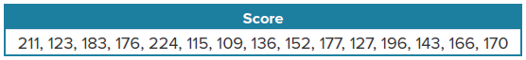

a. Find the mean, median, mode, range, and standard deviation of the scores.
b. The handicap of the bowling team will add 56 points to each score. Find the statistics of the scores while including the handicap.

22. COMPETITION The distances that 18 participants threw a football are shown in the table.
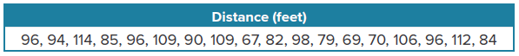

a. Find the mean, median, mode, range, and standard deviation of the participants’ distances.

b. Find the statistics of the participants’ distances in yards.

23. TEMPERATURE The monthly average high temperatures for Lexington, Kentucky are shown in the table.
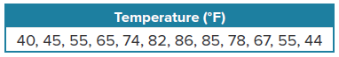

a. Find the mean, median, mode, range, and standard deviation of the temperatures.
b. Find the statistics of the temperatures in degrees Celsius. Recall that C = $\frac{5}{9}$(F – 32).

24. FANTASY SPORTS The weekly total points of Scott’s and Azumi’s fantasy baseball teams are shown in the table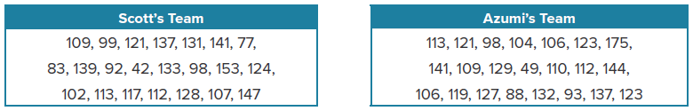

a. Use a graphing calculator to construct a box plot for each set of data. Then describe the shape of each distribution.
b. Compare the data sets using either the means and standard deviations or the five-number summaries. Justify your choice.
c. How does eliminating the outliers of each data set affect the statistics and comparison from part b?

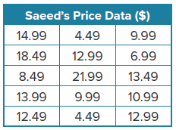
25. BUSINESS Saeed owns an electronics store. He is revising his pricing for phone accessories. His current prices for an assortment of accessories are listed at the right. He has also determined that the mean price for the same assortment of accessories at a rival store is $10.99.
a. Saeed wants to match his rival’s prices. Make a table to list the new prices. Explain.

b. Compare the mean and standard deviation of the current prices to the new prices.

26. REASONING Two different samples on the shell diameter of a species of snail are shown.
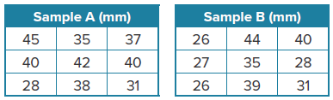

a. Use the median and interquartile range to compare the samples.
b. Based on your findings and on the data points in each sample, which sample appears to be more representative? Explain your reasons.

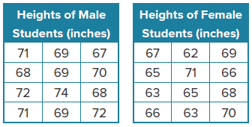
27. STRUCTURE Height data samples of 17-year-old male and female students are shown. Use the mean and standard deviation to compare the samples.

28. CONSTRUCT ARGUMENTS Francisca is planning a two-week vacation to one of two cities and wants to base her decision on the weather history for the same dates as her vacation. She has collected the number of days that it has rained during this two-week period for each city over the past 10 years. The results are shown.
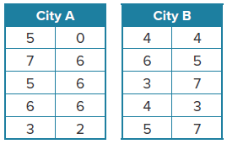

a. Determine the shape of each distribution, and use the appropriate statistics to find the center and spread for each set of data.

b. Which city do you think Francisca should visit on her vacation? Justify your argument.

29. WRITE Compare and contrast the benefits of displaying data using histograms and
box plots.

30. ANALYZE If every value in a set of data is multiplied by a constant k, k < 0, then how can the mean, median, mode, range, and standard deviation of the new data set be found?

31. PERSEVERE A salesperson has 15 SUVs priced between $33,000 and $37,000 and 5 luxury cars priced between $44,000 and $48,000. The average price for all of the vehicles is $39,250. The salesperson decides to reduce the prices of the SUVs by $2000 per vehicle. What is the new average price for all of the vehicles?

32. ANALYZE If k is added to every value in a set of data, and then each resulting value is multiplied by a constant m, m > 0, how can the mean, median, mode, range, and standard deviation of the new data set be found? Justify your argument.

33. WRITE Explain why the mean and standard deviation are used to compare the center and spread of two symmetrical distributions, and the five-number summary is used to compare the center and spread of two skewed distributions or a symmetric distribution and a skewed distribution.

