Summarizing Categorical Data ⸱ Practice

Example 1
TREATS The owner of a snow cone stand keeps track of the sizes and flavors sold one afternoon. He sold 125 snow cones in all. Of these, 40% were large snow cones, 32% were grape, and 12% were small watermelon snow cones. The stand sold 15 more cherry snow cones than grape. The most popular snow cone of day was small cherry, with a total of 35 sales.
1. Construct a two-way frequency table to organize the data.

2. How many large grape snow cones were sold?

3. How many watermelon snow cones were sold in all?

4. How many more small snow cones were sold than large snow cones?

Example 2
FOREIGN LANGUAGE Christy surveyed several students at her school and asked each person what foreign language he or she is studying. The results are shown in the table.
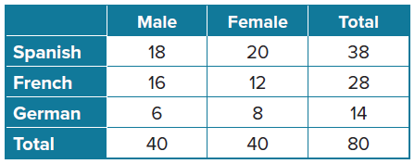
5. Construct a relative frequency table by converting the data in the table to percentages. Round to the nearest tenth, if necessary.

6. Find the joint relative frequency of a female student who is studying French.

7. Interpret the data.

Example 3
CLASS PRESIDENT In a poll for senior class president, 68 of the 145 male students said they planned to vote for Santiago. Out of 139 female students, 89 planned to vote for his
opponent, Measha.
8. Construct a conditional relative frequency table based on voter preference. Show
your calculations.

9. What does each conditional relative frequency represent?

10. What is the probability that a vote for Measha will come from a female student? How is this different from the probability that a female student intends to vote for Measha?

Mixed Exercises
VETERINARIAN The two-way frequency table shows the number of dogs and cats that were seen at a veterinarian’s office and the primary purpose of their visit.
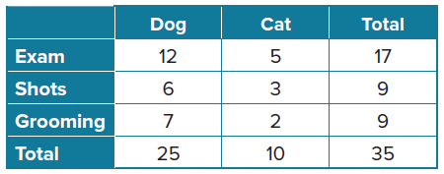
11. How many dogs were seen for an exam today?

12. How many more dogs than cats were seen at the veterinarian’s office?

BIRD WATCHING A group of bird watchers has been tracking the number of tree swallows, cardinals, and goldfinches in a region. Over the weekend, a total of 40 birds were observed. Of those, 45% were male, 37.5% were cardinals, and 12.5% were male tree swallows. Twice as many female cardinals were observed as male cardinals. There were 5 female goldfinches spotted.
13. Construct a two-way frequency table to organize the data.

14. How many more female tree swallows were seen than male cardinals?

15. How many male goldfinches and female cardinals were seen?

16. How many more female birds were seen than male birds?

SCHOOL ACTIVITIES The two-way frequency table shows the number of students who participate in school sports or clubs at Monroe High School.
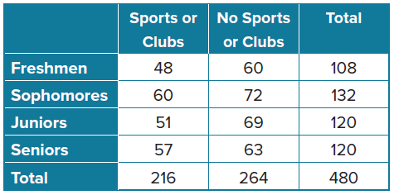
17. Construct a relative frequency table by converting the data in the table to percentages. Round to the nearest tenth, if necessary.

18. Find the joint relative frequency of a sophomore who participates in school sports or clubs.

19. What percentage of freshmen do not participate in school sports or clubs? Round to the nearest tenth percent, if necessary.

20. What percentage of seniors participate in school sports or clubs? Round to the nearest tenth percent, if necessary.

SCHOOL MASCOT The freshmen and sophomores at Lakeview High School are tasked with adopting a new school mascot next school year. The district asked a representative group of students to vote for one of the three mascot finalists and to indicate to which grade they belong. The results are shown in the table.
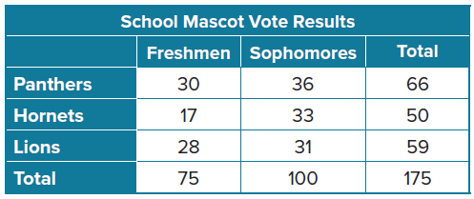
21. How many students voted for Panthers?

22. How many students voted for Lions?

23. How many sophomores were in the representative group?

24. Of the students who voted for Hornets, how many of them are freshmen?

25. Of the students who voted for Lions, how many of them are sophomores?

26. To the nearest whole, what percent of all the students voted for Lions?

27. To the nearest whole, what percent of all the students voted for Panthers?

28. To the nearest whole, what percent of all the students who voted were freshmen?

THANKSGIVING PIE An online poll collected a sample of Thanksgiving pie preferences for different U.S. regions.
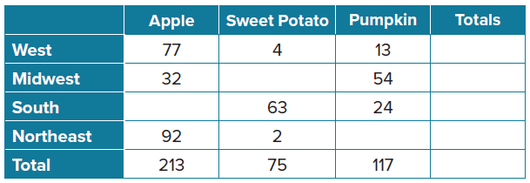
29. PRECISION Complete the table. Then find each relative frequency to the nearest tenth
of a percent.
30. USE A MODEL Assuming the poll is representative of the whole population, what is a reasonable estimate of the probability that a family will be from the northeast and will be eating pumpkin pie on Thanksgiving?
31. STRUCTURE Construct a table of conditional relative frequencies based on pie preference. Round each percent to the nearest tenth. Interpret the meaning of the probabilities in the context of the problem.
32. REGULARITY If we had found the conditional relative frequencies by dividing by the total replies from each region, what would be the meaning of the probability in each cell?

VEHICLES The table shows the relative frequencies of drive systems for different vehicle types in a school parking lot. There are 215 vehicles in the lot.
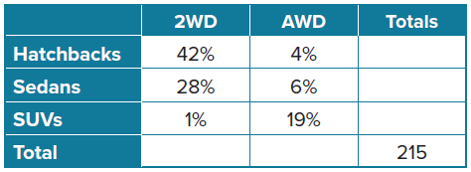
33. USE TOOLS Construct a table to show the joint and marginal frequencies.

34. REASONING Without calculating individual frequencies, how many times greater will the conditional relative frequencies based on drive systems for AWD be than the relative frequencies for AWD, and why?

35. PERSEVERE Len conducted a survey among a random group of 1000 families in his home state of California. He wanted to determine whether there is an association between gasoline prices and distances traveled on family vacations. He collected the following information. According to Len’s two-way frequency table, does there appear to be an association between gasoline prices and vacation distances traveled? Explain.
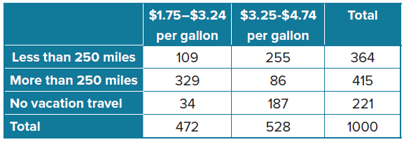

36. CREATE Select your own data for a two-way frequency table, write a question related to the data in the table, and provide the solution.

37. WRITE Compare two-way relative frequency tables and two-way conditional relative
frequency tables.

38. FIND THE ERROR Magdalena took a survey of students in her school to find out what snack was most popular.
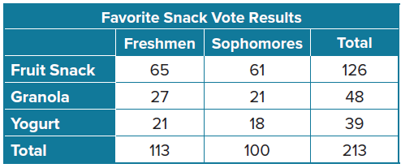

- Interpret the data based on the conditional relative frequency related to age groups.
- Magdalena claims that fruit snack is the most popular snack for freshmen and sophomores, and Ben claims that a higher percentage of sophomores prefer fruit snack than do freshmen. Is either correct? Explain your reasoning.

