The Geometric System ⸱ Practice

Example 1
1. BASKETBALL The Badgers’ basketball team has 10 players. During practice, half of the players wear red jerseys numbered 1–5, and the other half wear yellow jerseys numbered 6–10. The yellow team wins the practice game 32–26.
- Kylie wears number 5 and scores 9 points.
- Kelsey’s team wins the game.
- Marie and Kylie are on opposing teams.
Use the axioms to make three conclusions about the game played.

2. PRINTING Rico’s T-shirt Company sells customized short sleeve T-shirts, long sleeve T-shirts, and sweatshirts. Each type of shirt sells in multiples of 5. It costs $25.00 for 5 short sleeve T-shirts, $30.00 for 5 long sleeve T-shirts, and $40.00 for 5 sweatshirts. Short sleeve and long sleeve T-shirts can be made in any color except navy or black. Sweatshirts are only made in
navy and black.
  - Mercedes bought green shirts for $55.00.
  - Quinn bought 10 navy sweatshirts.
  - Rachel paid $30.00 for several red shirts.
  - Hector bought black and yellow shirts for $65.00.
Use the axioms to make four conclusions about the shirts sold.

3. LANDSCAPING Tom owns a landscaping business. He charges $40 for a yard clean up, $50 to mow a lawn, and $75 to mulch a yard. On average, it takes Tom 25 minutes for a yard clean up, 40 minutes to mow a lawn, and 2 hours to mulch a yard. Tom’s clients are Mr. Hansen, Ms. Martinez, and Mrs. Johnson.
- Mr. Hansen paid $125 for lawn services this week.
- Tom spent over an hour at Ms. Martinez’ house this week.
- Mrs. Johnson wrote Tom a check for $165 for the week.
- Tom made $405 from his three clients this week.
Use the axioms to make four conclusions about the landscaping that Tom did.

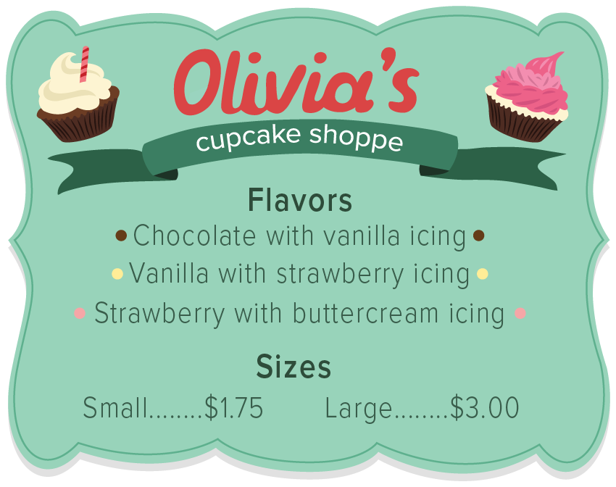
4. CUPCAKES Olivia’s Cupcake Shoppe sells small and large cupcakes in three flavors.
  - Niamh paid $3 for a cupcake with buttercream icing.
  - Bethany bought a small vanilla cupcake.
  - Mateo paid $3.50 for a cupcake with strawberry icing and a chocolate cupcake.
Use the axioms to make two conclusions about the
cupcakes that were purchased.

Example 2
Classify each figure as illustrating synthetic geometry or analytic geometry.
5. 6. 7.
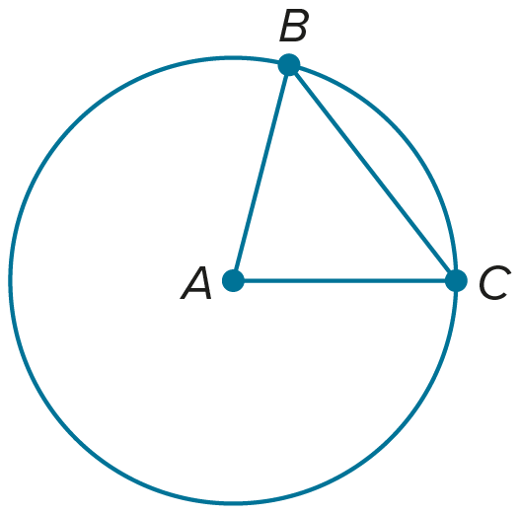
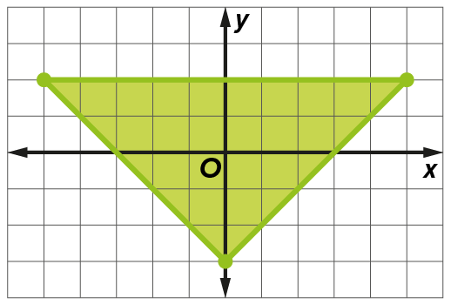
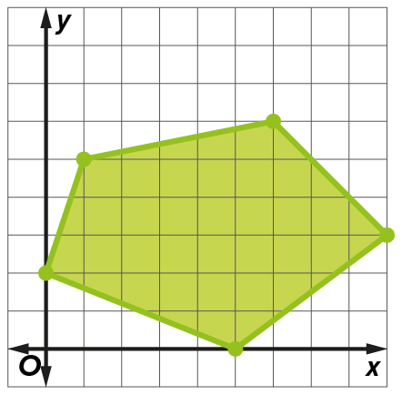

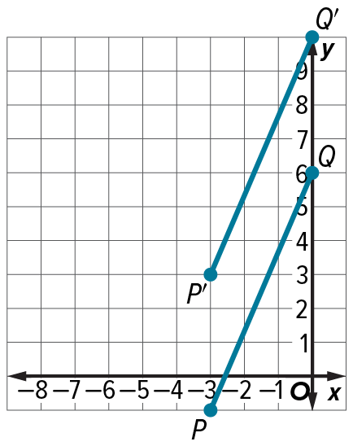
8. 9. 10.
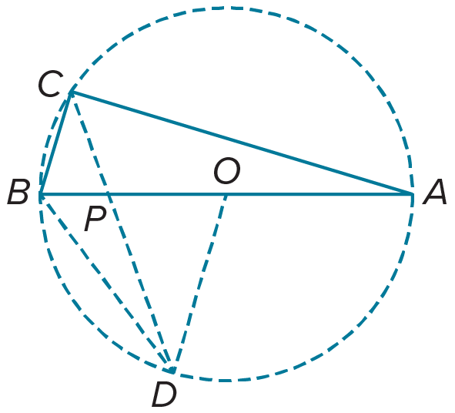
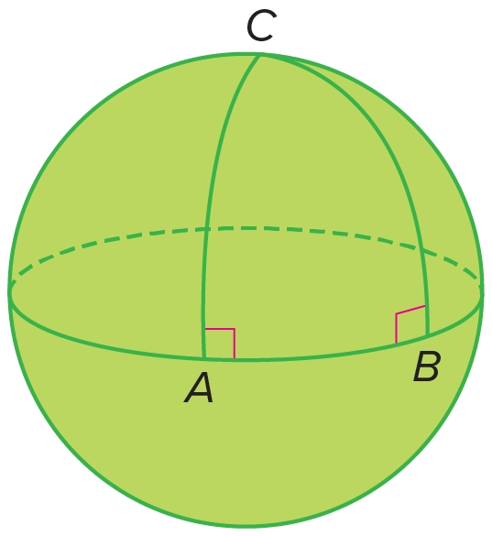

Mixed Exercises
11. RESTAURANT Damon sells three types of salads at his restaurant: cobb, wedge, and spinach. Each salad is served with 2 dinner rolls. The price of the cobb salad is $7.99, the price of the wedge salad is $8.99, and the price of the spinach salad is $5.99. Grilled chicken can be added to any salad for an additional $2.00.
  - Malik spent $7.99 on a salad.
  - Pedro and Deandra each spent $8.99 on their salads.
  - Rafael ate a wedge salad.
  - Drake did not add chicken to his salad.
Use the axioms to make a conclusion about the salads that are eaten.

12. CLASSROOM Mrs. Fields teaches high school geometry. Her classroom tools include a compass, straightedge, pencil, and protractor. Does Mrs. Fields likely teach analytic geometry or synthetic geometry? Explain your reasoning.

13. REASONING Theo is stuck on a problem on a test. The problem is asking him to use a given formula to find the distance between two points on a graph. Is Theo using analytic geometry or synthetic geometry? Explain your reasoning.

14. USE A SOURCE Survey a group of students in your classroom about favorite colors. Write three axioms about the data you collected. Then use your axioms to write a conclusion. Explain
your reasoning.

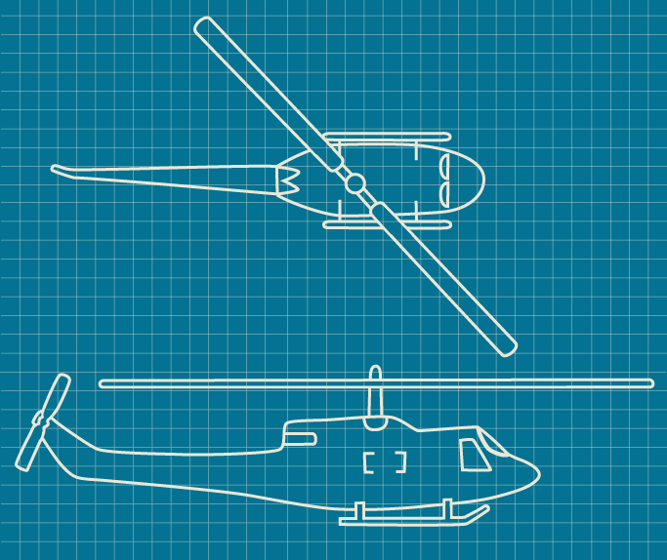
15. STATE YOUR ASSUMPTION Sydney is an engineer. She is using a blueprint for a project that is drawn on a grid, as shown. Is Sydney likely using analytic geometry or synthetic geometry? Explain any assumptions that you make.

16. Mr. Sail assigns a project where students identify shapes that represent real-world objects. Is this an example of analytic geometry or synthetic geometry? Explain your reasoning.

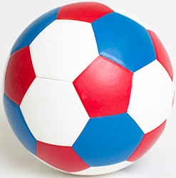
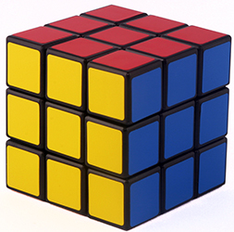
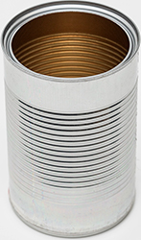

17. CONSTRUCT ARGUMENTS Consider the following axiomatic system for bus routes.
- Each bus route lists the stops in the order at which they are visited by the bus.
- Each route visits at least four distinct stops.
- No route visits the same stop twice, except for the first stop, which is always the same as the last stop.
- There is a stop called Downtown, which is visited by each route.
- Every stop other than Downtown is visited by at most two routes.

The city has stops at Downtown, King St, Maxwell Ave, Stadium District, State St, Grace Blvd, and Charlotte Ave. Are the following three routes a model for the axiomatic system? Justify your argument.
ROUTE 1: Downtown, King St, Stadium District, State St, Downtown
ROUTE 2: Stadium District, State St, Grace Blvd, Maxwell Ave, Downtown, Stadium District
ROUTE 3: King St, Stadium District, Downtown, Maxwell Ave, Stadium District, King St

18. SHOPPING The Clothing Shop is having a sale. All clothes are 20% off, and all accessories are 30% off.
- Jaisa bought two necklaces.
- Sheree bought a shirt and a purse.
Use the axioms to make one conclusion about Jaisa or Sheree’s purchases.

19. WRITE Write a comparison of the rules and plays of a game and the elements of an axiomatic system. Then choose a game or sport for which you know the rules. Explain a rule from the game or sport and a play from the game. Does the play violate or fall within the rule? Explain.

20. CREATE Given the following list of axioms, draw a model to properly represent the information.
- There exist five points.
- Each line contains only these five points.
- There exist two lines.
- Each line contains at least two points.

21. WHICH ONE DOESN’T BELONG? Three-point geometry is a finite subset of geometry with the following four axioms:
- There exist exactly three distinct points.
- Each pair of distinct points are on exactly one line.
- Not all the points are on the same line.
- Each pair of distinct lines intersect in at least one point.
Which of the following does not satisfy all the axioms of three-point geometry? Justify your conclusion.

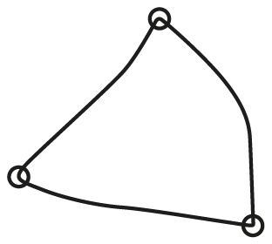
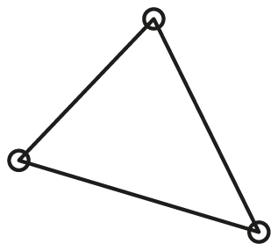


22. FIND THE ERROR Grant read the following axioms for a video game he is playing.
- There are four keys hidden on each level.
- Each level ends when the player collects the third key.
- The game has 10 levels.
From these axioms, Grant concluded:
- to complete the game, he will need to find 30 keys.
- there are 40 keys in the game.
- he can collect all 40 keys in the game.

Are Grant’s conclusions correct? Explain your reasoning.

23. WHICH ONE DOESN’T BELONG? Using your understanding of analytic and synthetic geometry, which of the following figures does not belong? Justify your conclusion.
