Points, Lines, and Planes ⸱ Practice

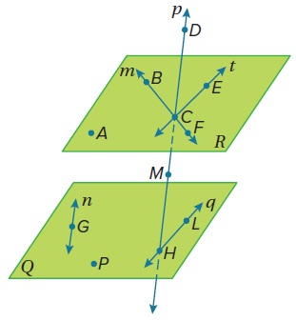
Example 1
Refer to the figure for Exercises 1-7.
1. Name the lines that are only in plane 𝒬.

2. How many planes are labeled in the figure?

3. Name the plane containing the lines 𝓂 and 𝓉.

4. Name the intersection of lines 𝓂 and 𝓉.

5. Name a point that is not coplanar with points A, B, and C.
6. Are points F, M, G, and P coplanar? Explain.

7. Does line 𝓃 intersect line 𝓆? Explain.

Example 2
Name the geometric terms modeled by each object or phrase.
8. roof of a house 9. a tabletop 10. bridge support beam


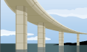

11. a chessboard 12. 13.
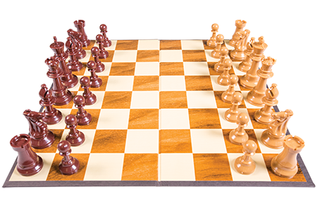
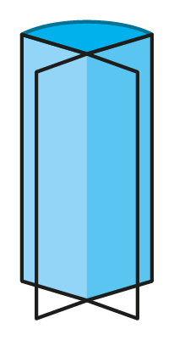
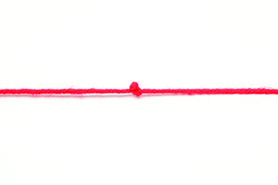

14. a wall and the floor 15. the edge of a table 16. two connected walls

17. a blanket 18. a telephone pole 19. a tablet computer

Example 3
USE TOOLS Draw and label a figure for each relationship.
20. Points X and Y lie on $\overset{⃡}{CD}$.

21. Two planes do not intersect.

22. Line 𝓂 intersects plane ℛ at a single point.

23. Three lines intersect at point J but do not all lie in the same plane.

24. Points A(2, 3), B(2, –3), C, and D are collinear, but A, B, C, D, and F are not.

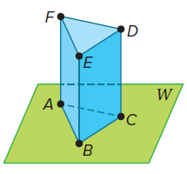
Example 4
Refer to the figure for Exercises 25-28.
25. How many planes are shown in the figure?

26. How many of the planes contain points F and E?

27. Name four points that are coplanar.

28. Are points A, B, and C coplanar? Explain.

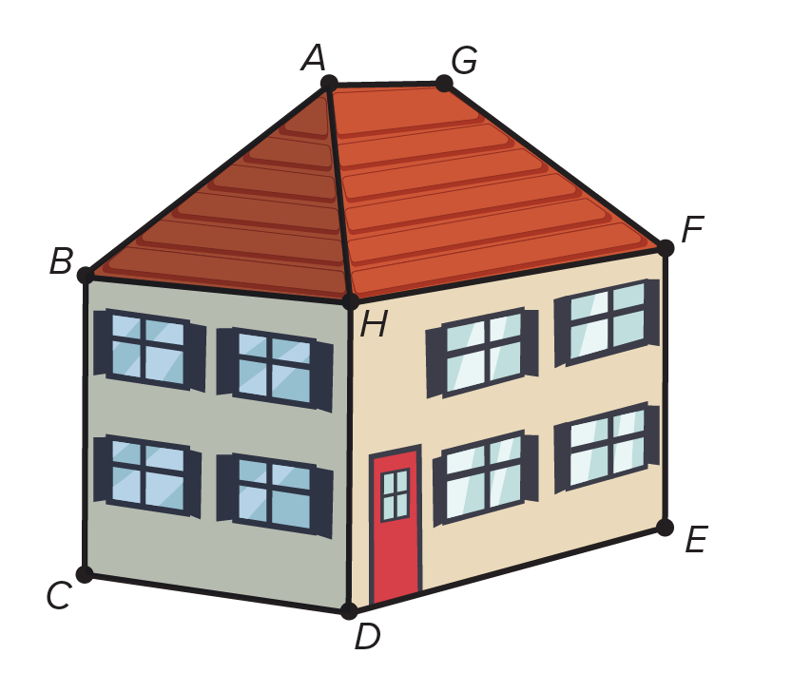
Example 5
29. BUILDING The roof and exterior walls of a house represent intersecting planes. Using the image, name all the lines that are formed by the intersecting planes.
30. If the surface of a lake represents a plane, what geometric term is represented by the intersection of a fishing line and the lake’s surface?

31. ART Perspective drawing is a method that artists use to create paintings and drawings of three-dimensional objects. The artist first draws the horizon line and two vanishing points along the horizon. Buildings or other objects are created by drawing receding lines and vertical lines.
a. Where do the receding lines and horizon lines intersect?
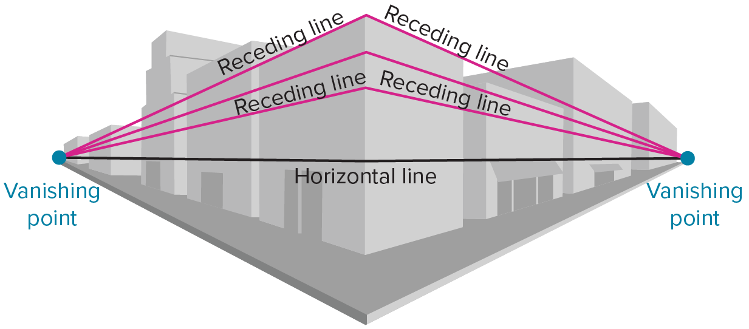
b. Identify examples of planes within this picture.

Mixed Exercises

USE TOOLS Draw and label a figure for each relationship.
32. $\overset{⃡}{LM}$ and $\overset{⃡}{NP}$ are coplanar but do not intersect.

33. $\overset{⃡}{FG}$ and $\overset{⃡}{JK}$ intersect at P(4, 3), where point F is at (–2, 5) and point J is at (7, 9).

34. Lines 𝓈 and 𝓉 intersect, and line 𝓋 does not intersect either one.

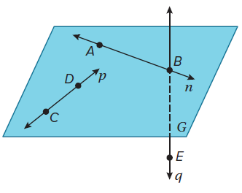
Refer to the figure for Exercises 35-38.
35. Name a line that contains point E.

36. Name a point contained in line 𝓃.

37. What is another name for line 𝓅?

38. Name the plane containing lines 𝓃 and 𝓅.

USE TOOLS Draw and label a figure for each relationship.
39. Point K lies on $\overset{⃡}{RT}$.

40. Plane 𝒥 contains line 𝓈.

41. $\overset{⃡}{YP}$ lies in plane ℬ and contains point C, but does not contain point H.

42. Lines 𝓆 and 𝒻 intersect at point Z in plane 𝒰.

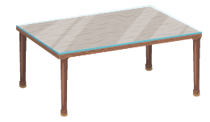
43. Name the geometric term modeled by the object.

44. Name the geometric term modeled by a partially-opened folder.

45. CREATE Sketch three planes that intersect in a point.

46. ANALYZE Is it possible for two points on the surface of a prism to be neither collinear nor coplanar? Justify your argument.

47. FIND THE ERROR Camille and Hiroshi are trying to determine the greatest number of lines that can be drawn using any two of four random points. Is either correct? Explain your reasoning.

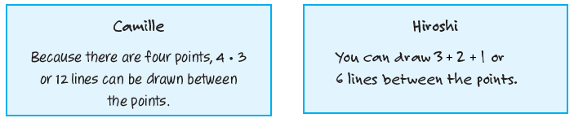

48. PERSEVERE What is the greatest number of planes determined using any three of the points A, B, C, and D if no three points are collinear?


49. WRITE A finite plane is a plane that has boundaries, or does not extend indefinitely. The sides of a cereal box shown are finite planes. Give a real-life example of a finite plane. Is it possible to have a real-life object that is an infinite plane? Explain your reasoning.

50. CREATE Sketch three planes that intersect in a line.

